Report of FOSM Volunteers Painting Stripes in Parking Lots at Two Sites along the Crest Highway
on August 2, 2022

Anne Hickman and Sam Beard

On Tuesday, August 2, three FOSM volunteers painted stripes in parking lots at two sites along the Crest Highway. At the Crest, we painted stripes in the small upper parking lot. In Sulphur Canyon Picnic Area, we painted stripes in the two lowest parking lots. On the way down the mountain, we checked stripes at the following sites, but stripes were visible in all the parking lots: lower large Crest lot, 10 K Trailhead, Capulin Spring PA, Balsam Glade PA, Tree Spring Trailhead, Doc Long PA, and Cienega PA.
The volunteers were Anne Hickman, Sue Mealy, and Sam Beard.
Project photos are presented below.

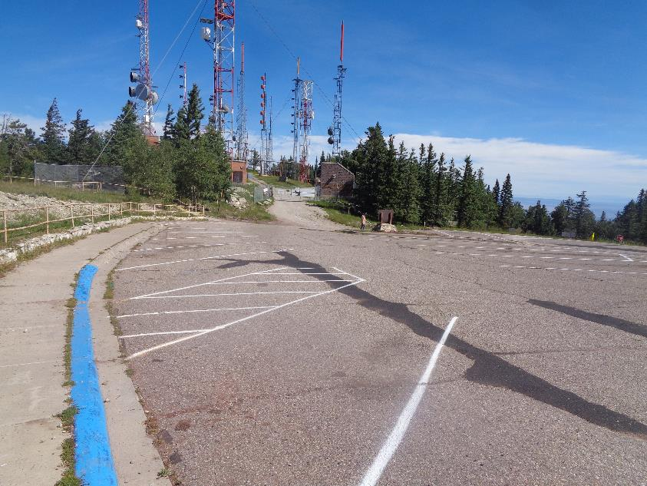
We painted stripes in the upper small parking lot at the Crest. All photos by Sam Beard
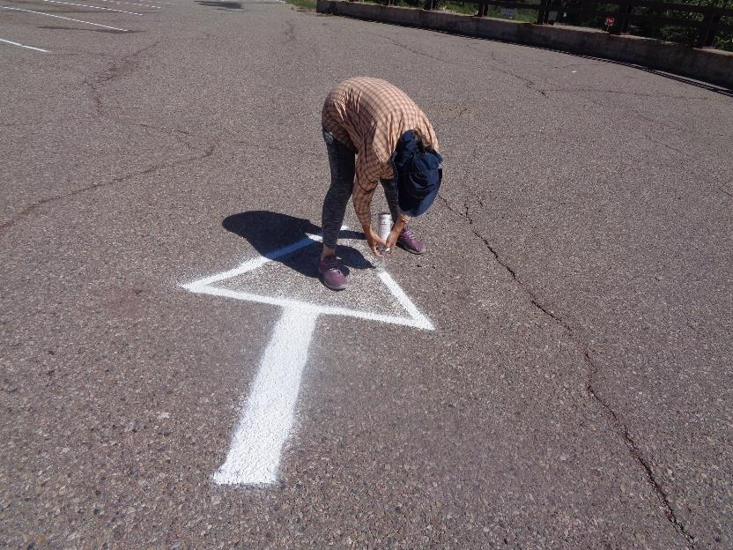
Sue Mealy manually pressing the tip of the paint can while she paints an arrow at the Crest parking lot.

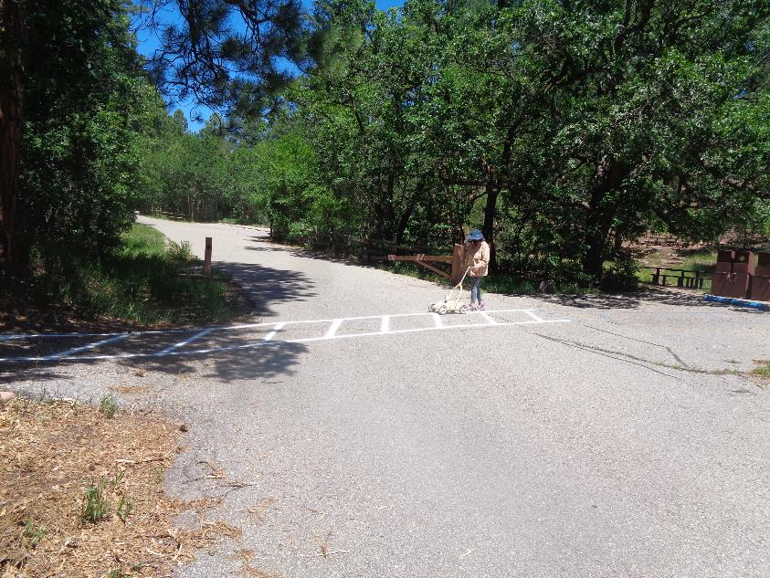
Sue painting a cross walk at the lower parking lot in Sulphur Canyon Picnic Area.
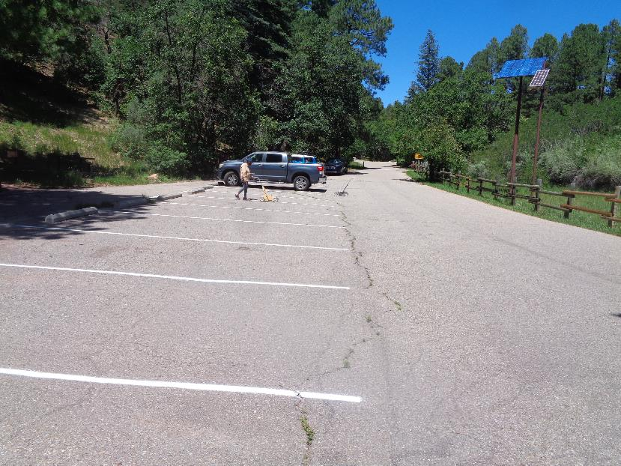
Sue painting stripes in the second parking lot in Sulphur PA. The owner of the pickup returned and moved his truck so
that we could paint a stripe where it had been parked. We do not paint near vehicles, because there is always a small cloud of white paint
spray around the painting cart.
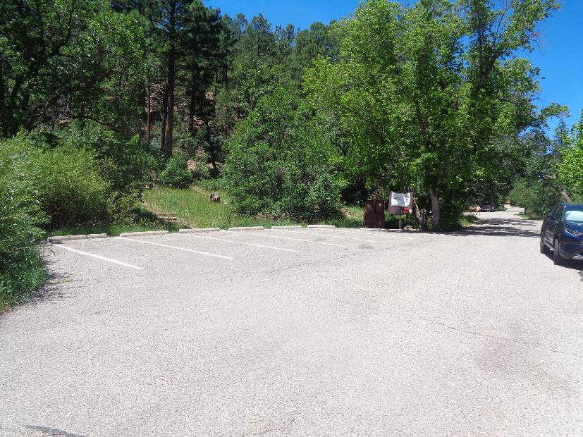
New stripes in the lowest parking lot in Sulphur PA. At some parts of these stripes, none of the old paint was visible. We always
apply two coats of paint at each stripe.

