**Report of FOSM Project to Fell Seven Hazard Trees at Three Sites**

**along the Crest Highway on Wednesday, August 3, 2022**

Sam Beard

On Wednesday, August 3, nine FOSM volunteers felled a total of seven hazard trees at Cienega Canyon Picnic Area, lower Capulin Spring PA, and 10K North Trailhead.

The volunteers were Sim Cook, Dennis Crowther, Byron Garner, Eric Russell, Cliff Giles, Jerry Carroll, Steve Roholt, Lou Romero, and Sam Beard,

Project photographs and more narrative are presented below.

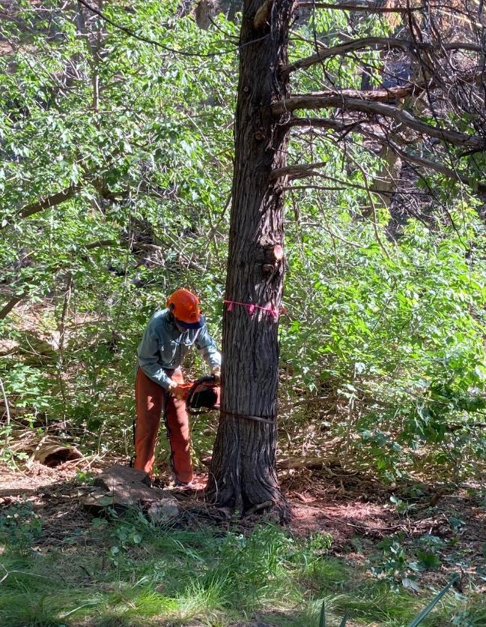

Byron Garner felling a hazard tree on Acequia Trail between the Group Area Road and the

Upper Cienega PA parking lot. All photos by Cliff Giles

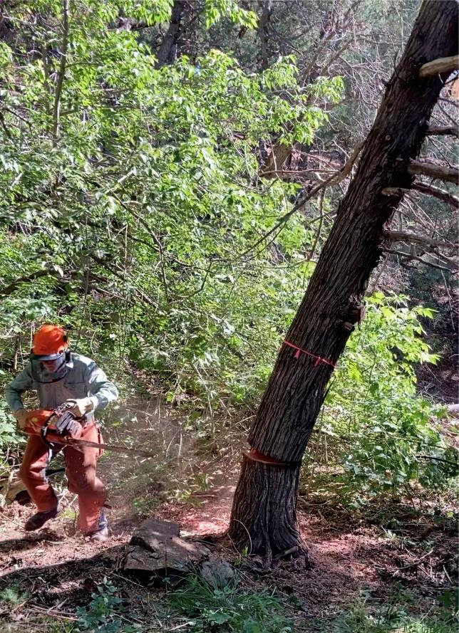

Byron running away from the falling tree.

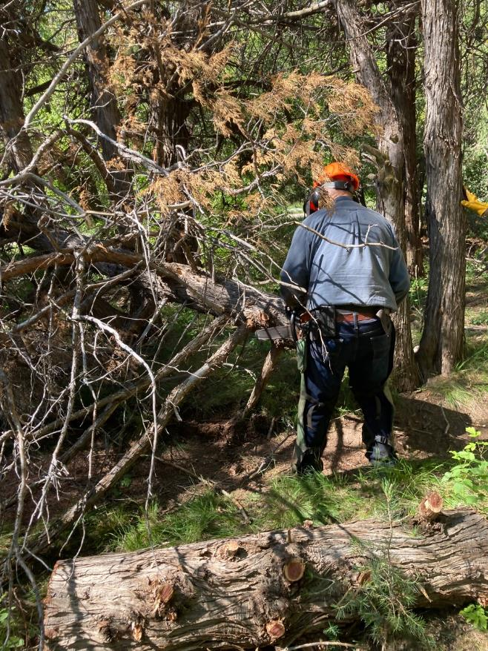

Jerry Carroll bucking the felled Rocky Mountain Juniper.

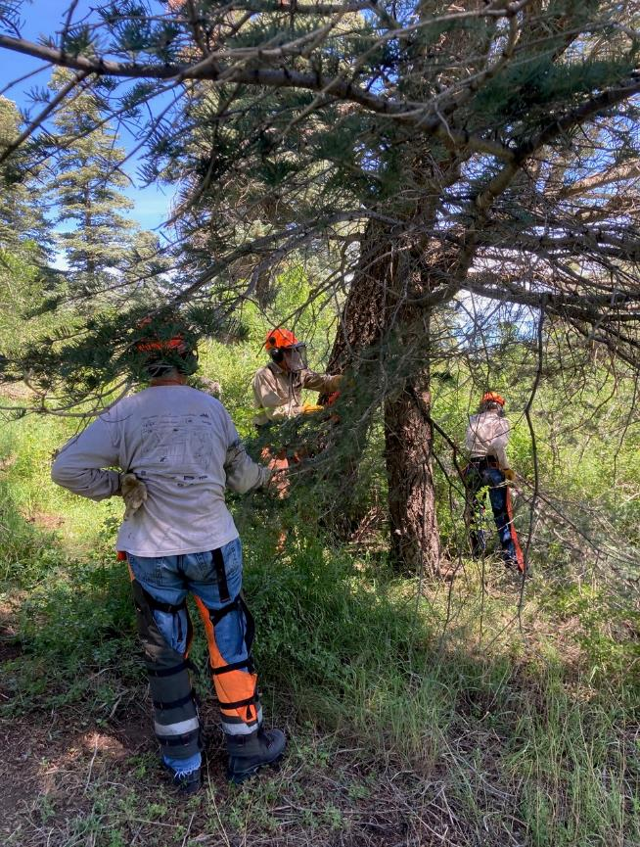

Steve Roholt observing Sam Beard who is limbing the small tree

that Steve will be felling.

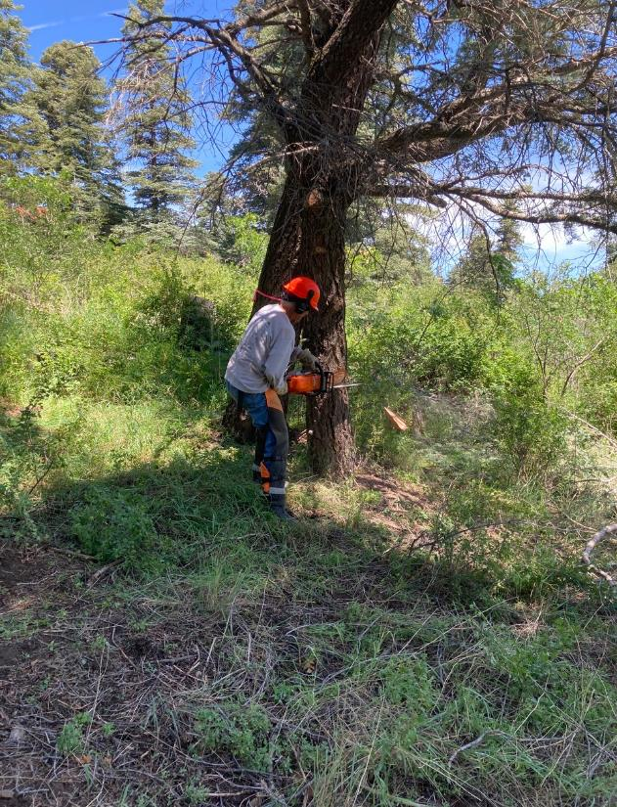

Steve felling the small white fir in the lower part of Capulin Picnic Area.

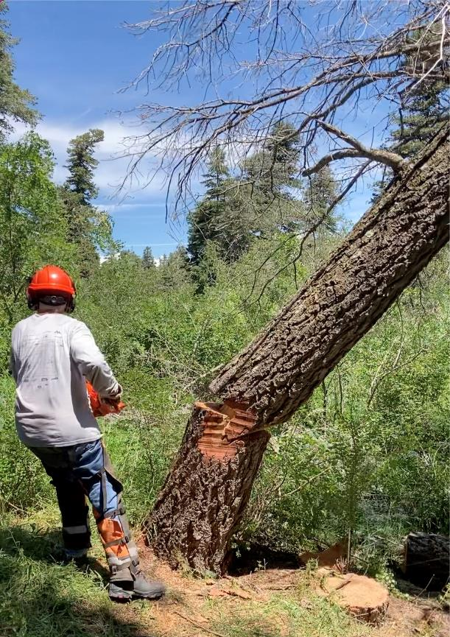

Steve running away from the white fir hazard tree he has just felled.

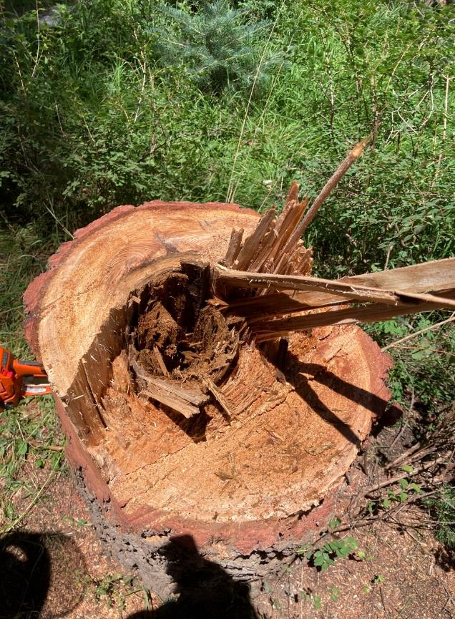

The stump of the white fir felled by Steve shows that the tree

had a rotten center.

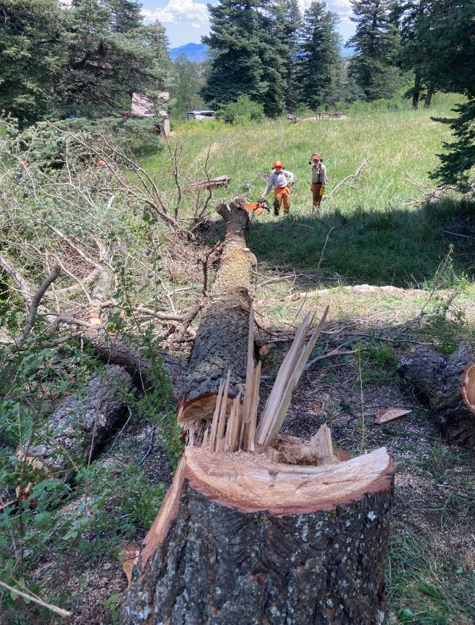

Sam Beard and Steve limbed the white fir that Steve just felled.

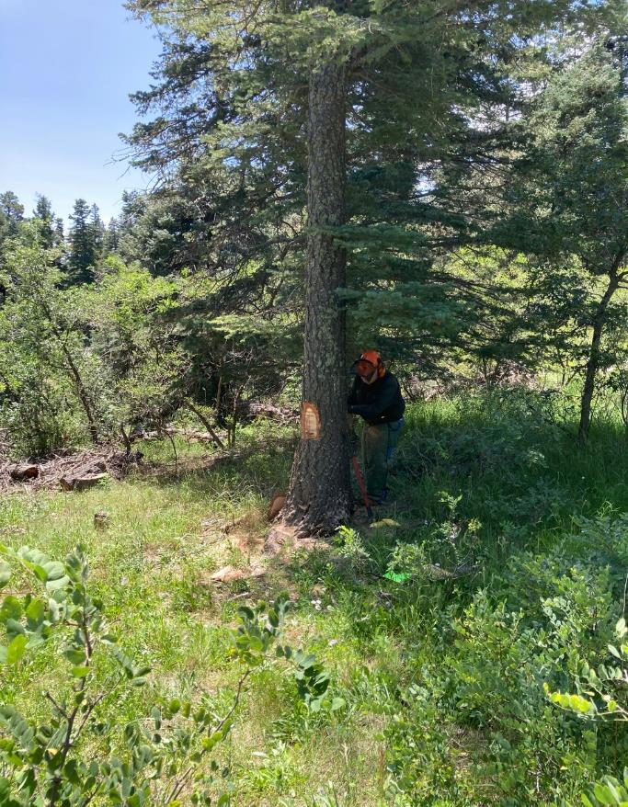

Dennis Crowther felling a white fir in lower Capulin PA.

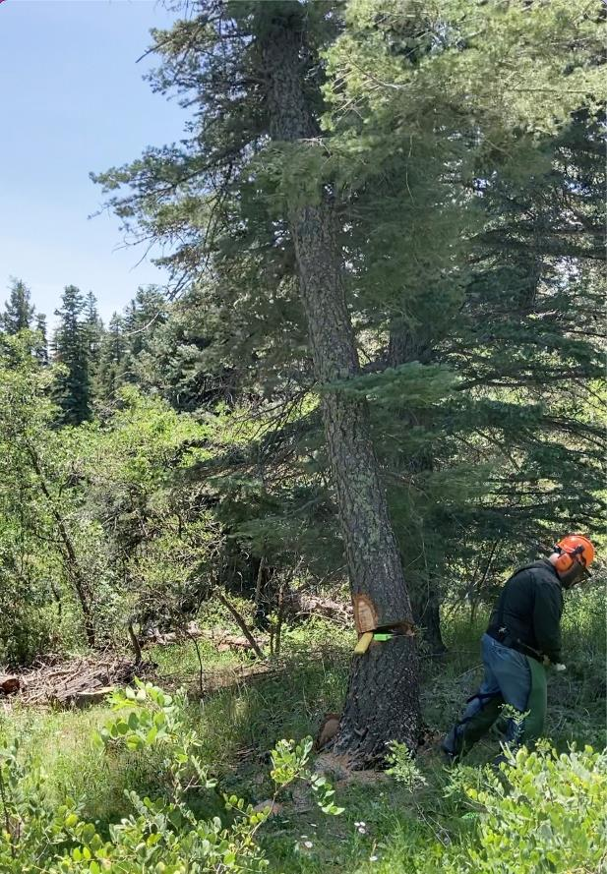

Dennis running away from the falling tree.

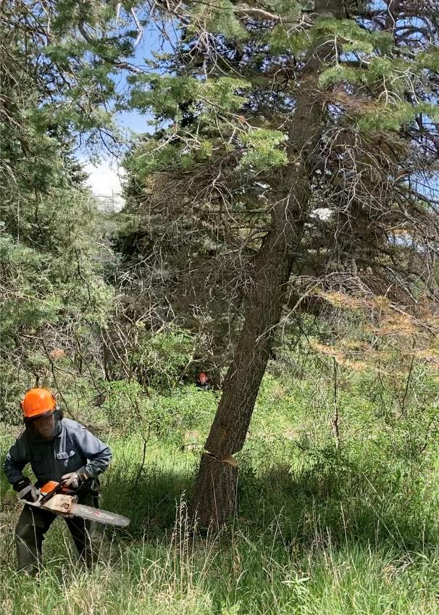

Jerry Carroll running away from the dead white fir that he has just felled

in the lower part of Capulin PA.

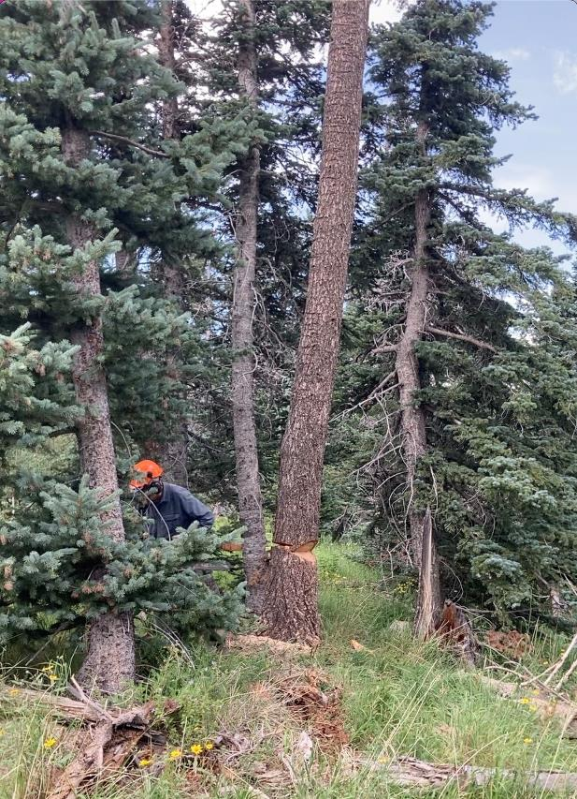

Jerry running away from the dead white fir he has just felled

at 10K North Trailhead.

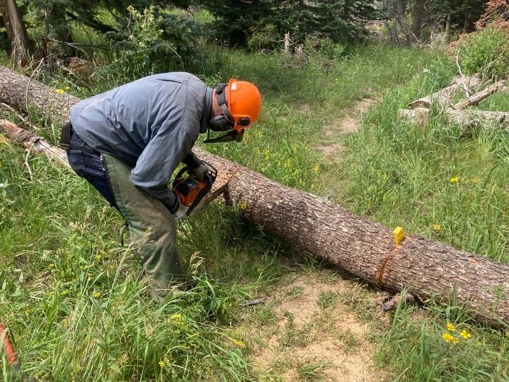

Jerry cutting out a piece of the trunk that was lying across a trail.

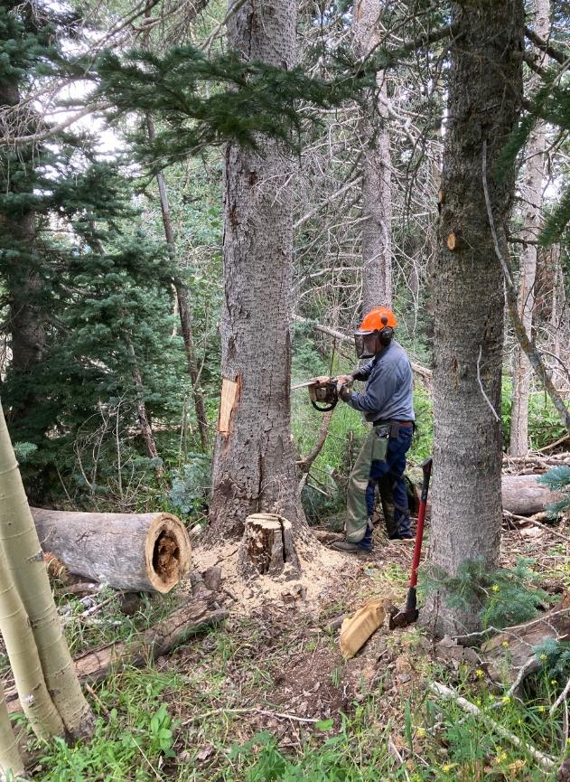

Jerry felling a cork bark fir hazard tree at 10K North Trailhead.

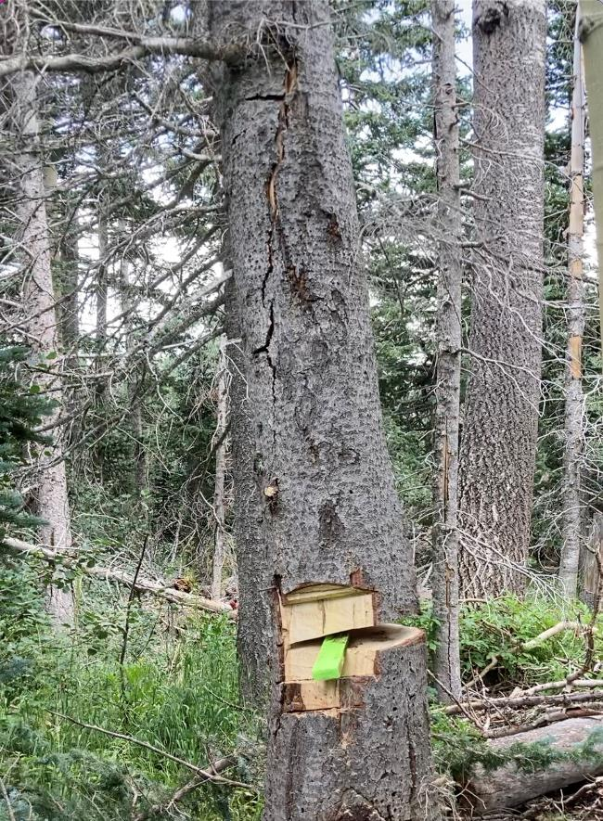

After Jerry completed his back cut, this hazard tree is falling.