Report of Projects at Six Sites Where the FOSM Paint Crew
Worked on Tuesday, August 9, 2022

Sam Beard

The FOSM Paint Crew worked on the following projects on Tuesday, August 9, 2022: parking stripes at Tree Spring Trailhead, yellow stripes at certain locations in the upper parking lot at Sandia Crest, paint over graffiti on the Crest House propane tank, removal of graffiti from 12 aluminum sign posts along the Crest Nature Trail, painting the helicopter pad, and started painting stripes on the large Crest parking lot.
The volunteer painters were Anne Hickman, Jane Harrison, Rick Buss, Pauline Ho, and Sam Beard.
Project photographs are presented below.

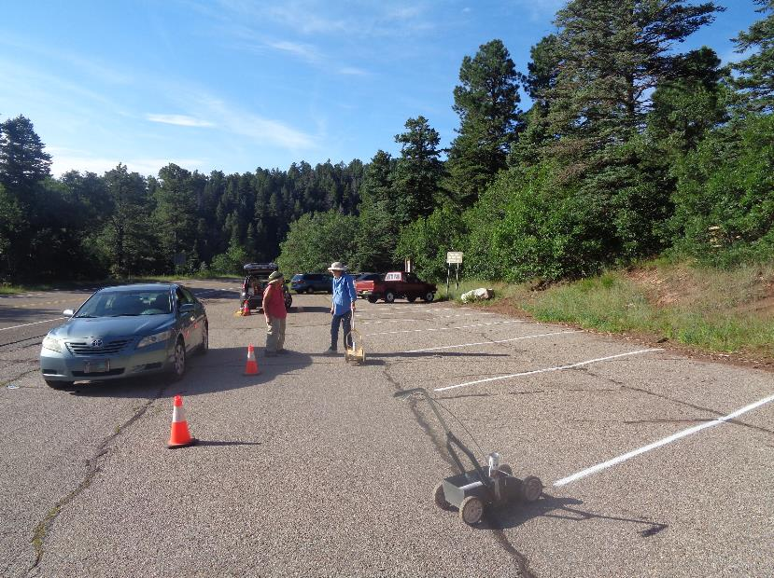
L to R: Jane Harrison and Anne Hickman in the Tree Spring Trailhead parking lot where they have been painting stripes.
All photos by Sam Beard
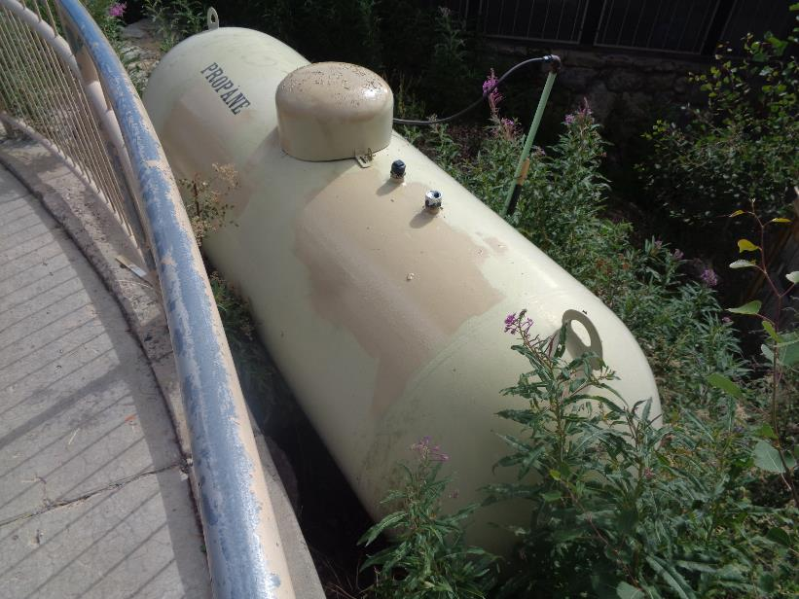
The graffiti on the Crest House propane tank was painted over, because last week
the chemical for use on painted surfaces did not completely remove the black graffiti.
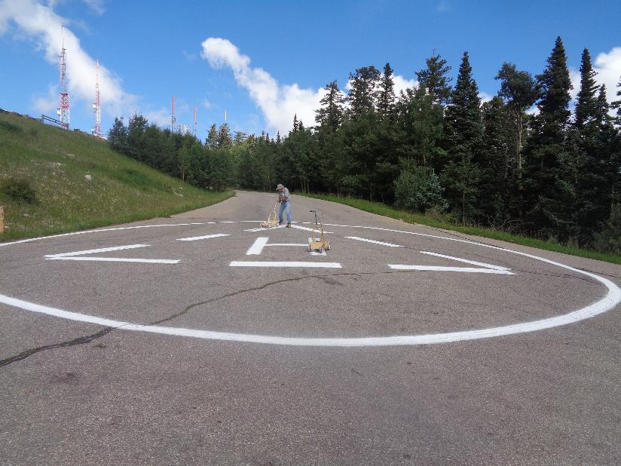
Rick is finishing the painting of the helicopter pad symbols on the Crest parking lot exit road – circle and letter “H”.
The triangle points to the north.
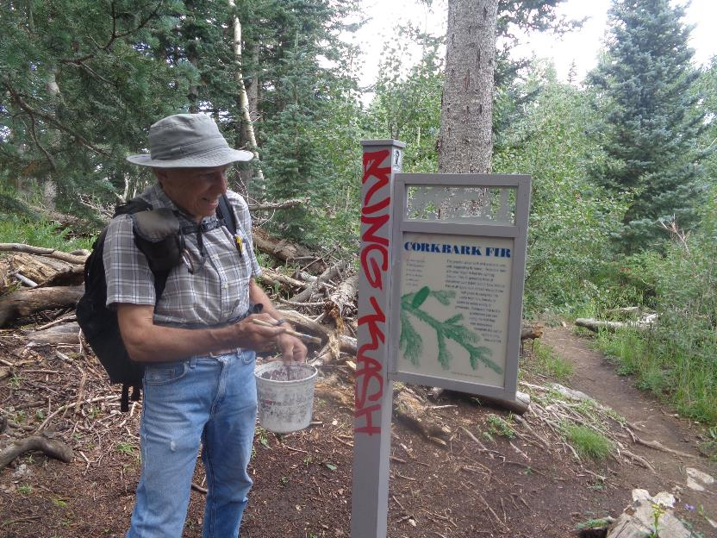
Rick is ready to apply the chemical used to remove graffiti on painted surfaces.
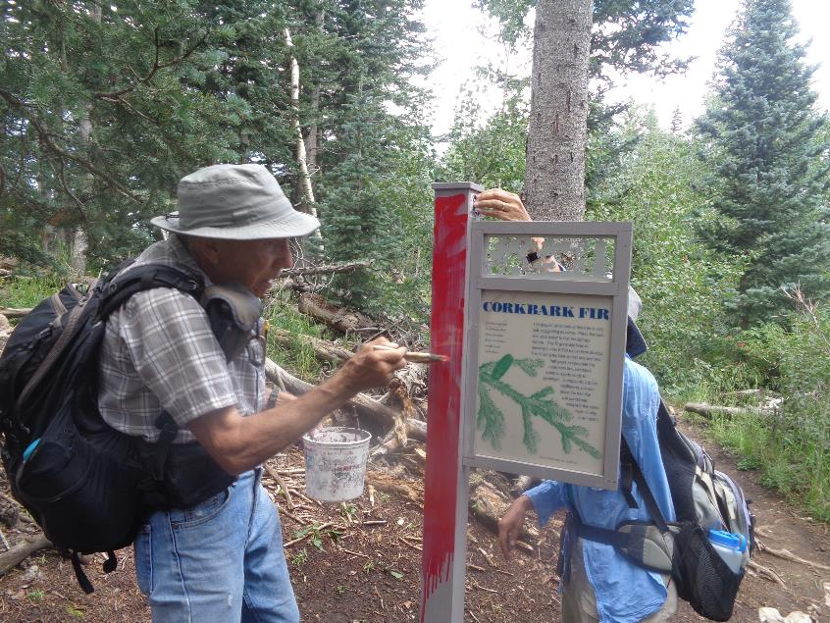
The chemical has dissolved the red graffiti, and it is flowing down the post.
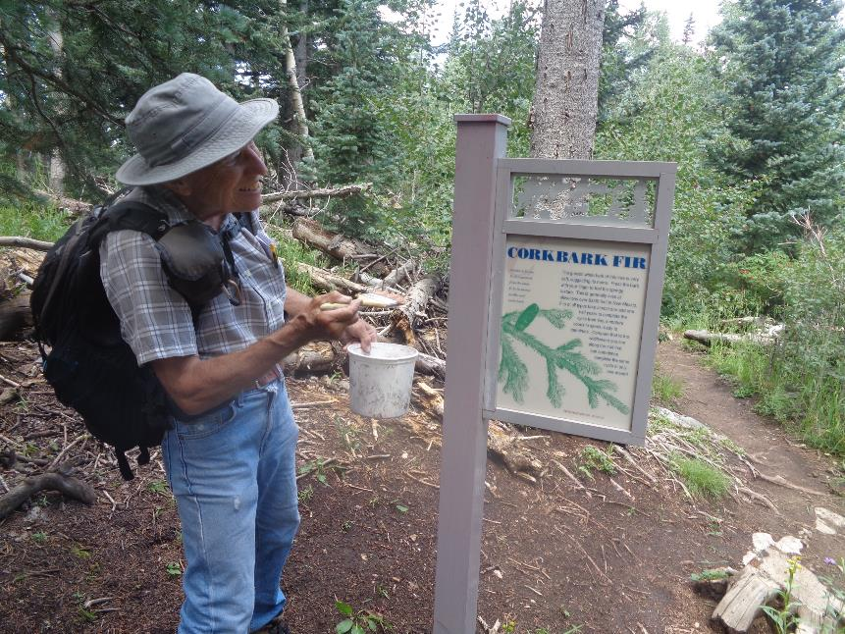
The dissolved red graffiti and chemical have been washed off with water.
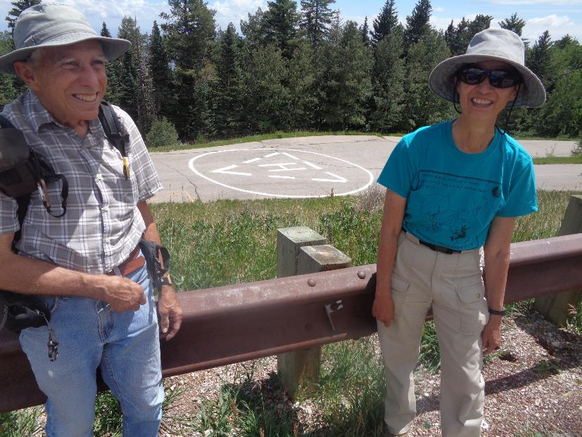
Rick and Pauline are at the guard rail on the large Crest parking lot with the repainted helicopter pad in the background.
A few very small graffiti tags were removed from the guard rail.

