**Report of FOSM Project to Buck and Split 24-inch Pine at Tree Spring Trailhead and Haul It to Mountain Christian Church Wood Ministry Woodlot on Wednesday, August 10, 2022**

Sam Beard

On Wednesday, August 10, eleven FOSM volunteers bucked a fallen 24-inch diameter ponderosa pine at Tree Spring Trailhead into 12-inch-long pieces. The heavy rounds were rolled down the hill to Lou Romero’s splitter where they were split into 4 to 8 pieces and stacked in Joe Meade’s dump trailer. Several large branches were cut into 15-inch-long pieces for fire wood. The split wood was hauled to the Mountain Christian Church Wood Ministry woodlot located about a half-mile south of the intersection of NM-4 and NM-536. A total of approximately 2 cords was processed.

The volunteers were Joe Meade, Jory Meade, Tami Jo Meade, Lou Romero, Dennis Crowther, Eric Russell, Jerry Carroll, Steve Roholt, Sam Beard, Cliff Giles and Dan Benton.

Project photographs are presented below with additive narrative.

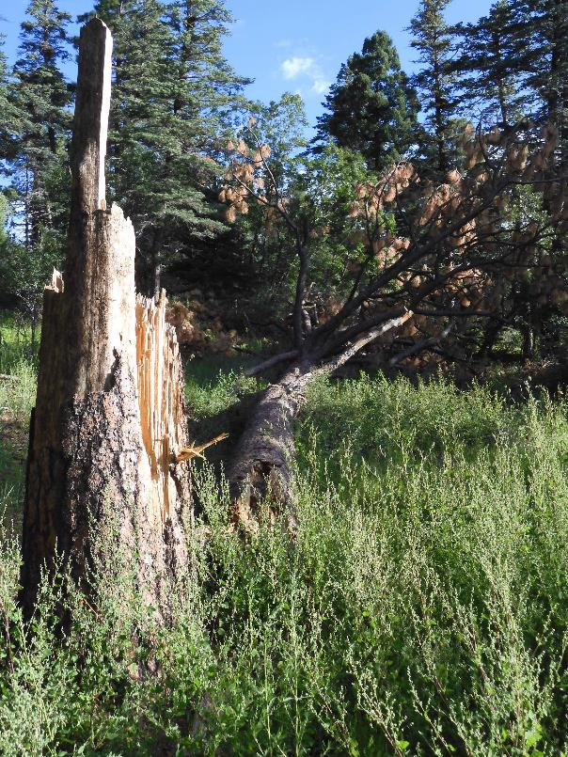

Large ponderosa pine that fell near Tree Spring Trailhead several months ago.

Photo by Dan Benton

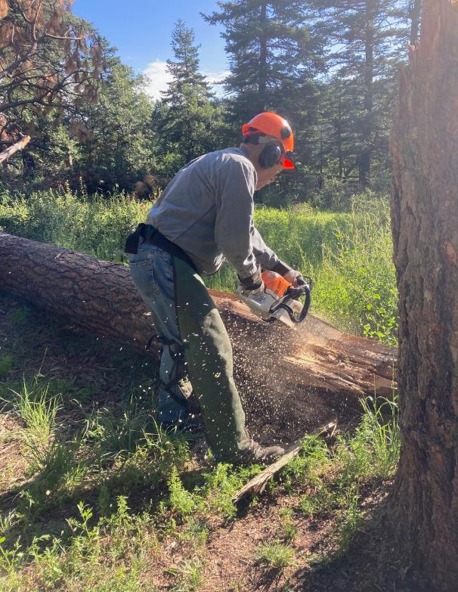

Jerry Carroll is making the first cut in the log near the stump.

All photos by Cliff Giles unless noted otherwise

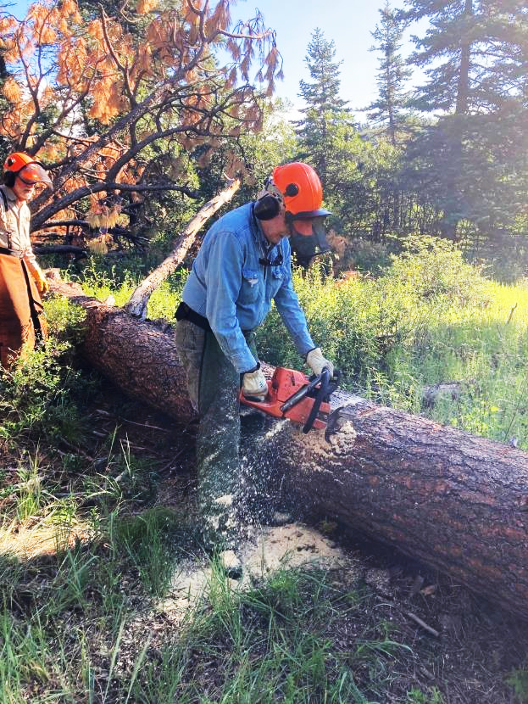

Eric Russell bucking the large log.

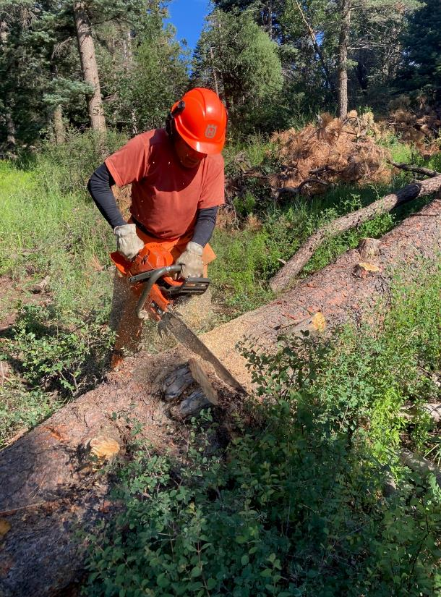

Steve Roholt bucking the log with a Husqvarna chain saw with a 24-inch bar.

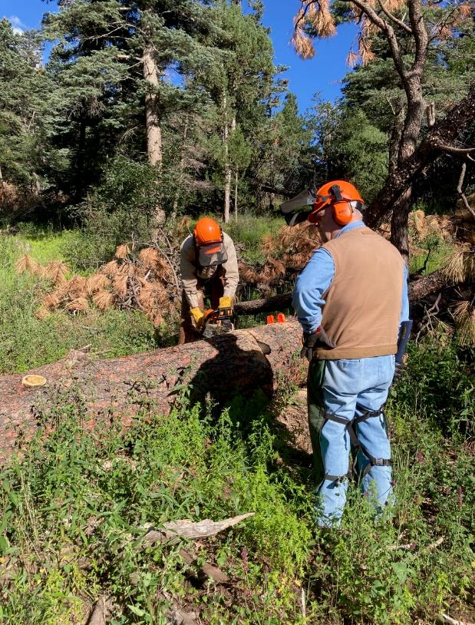

Dennis Crowther observing Sam Beard bucking the log near where the branches start.

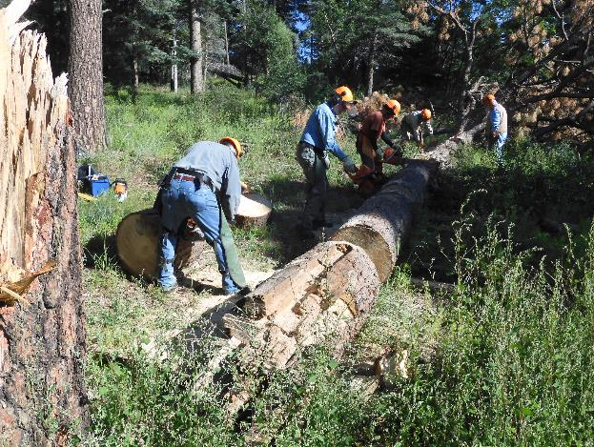

L to R: Jerry Carroll, Eric Russell, Steve Roholt, Sam Beard and Dennis Crowther. The sawyers are bucking the log into 10-foot lengths so that each sawyer will be working on a separate segment of the log.

Photo by Dan Benton

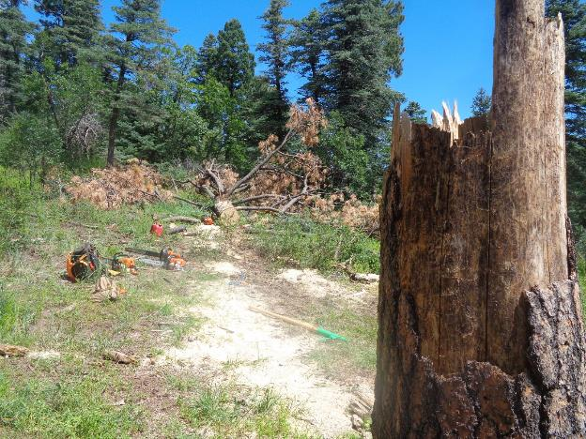

The log area after most of the trunk had been bucked into 12-inch pieces. The wood was still green

and each 24-inch diameter piece was very heavy. Photo by Sam Beard

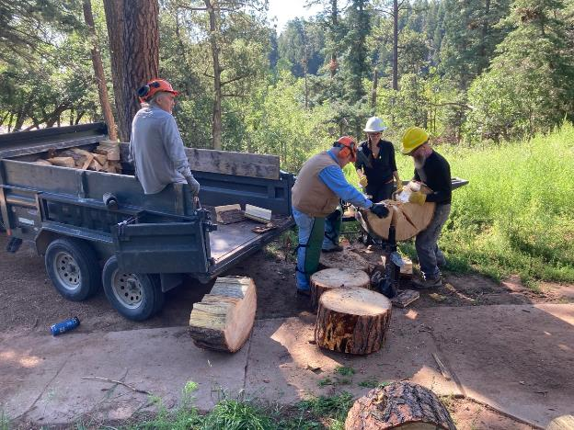

L to R: Joe Meade, Dennis Crowther, Tami Jo Meade, and Jory Meade. Dennis, Tami Jo, and Jory

are using Lou Romero power splitter to split each large round into 4 to 8 pieces. Each round

was rolled manually down the hill from the bucking area to the splitter on the sidewalk.

Joe was stacking the split wood in his dump trailer with a capacity of 1.5 cords.

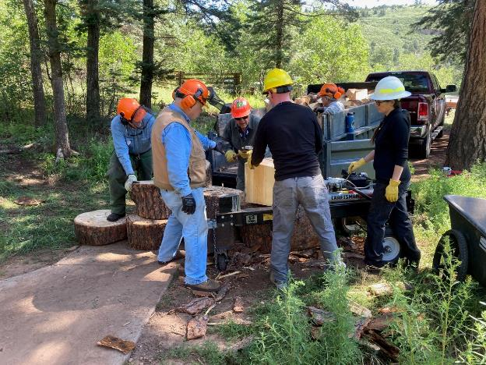

L to R: Eric Russell, Dennis Crowther, Lou Romero, Jory Meade, and Tami Jo Meade.

Joe Meade is in the trailer. Tami is operating the splitter control, and the others are

placing each round on the splitter and handling the split pieces.