**Report of FOSM Felling Hazard Trees along Sandia Cave Trail and in Las Huertas Picnic Area on Wednesday, August 17, 2022**

Sam Beard

On Wednesday, August 17, Cliff Giles, Byron Garner, Jerry Carroll, and Sam Beard felled 19 hazard trees in Las Huertas Picnic Area and along Sandia Cave Trail. The erosion due to recent rains made this rocky dirt road (NM-165) even rougher than it usually is.

Jerry Carroll and Byron Garner felled the following hazard trees (a total of 10) along the Sandia Cave Trail: 26-inch ponderosa pine, 3 white firs with 6-inch to 10-inch diameters, 4 junipers with 8-inch to 18-inch diameters, and two pinons with 6-inch and 12-inch diameters. They also felled two hazard trees (12 inches and 15 inches) in the upper part of the picnic area.

Sam and Cliff felled 9 white fir hazard trees with diameters of 7 inches to 15 inches in the upper part of Las Huertas PA.

Photos and more narrative are presented below.

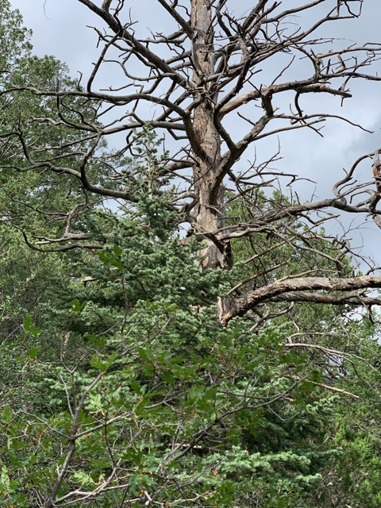

Tall 24-inch diameter dead ponderosa pine on the mountain side above the Sandia Cave Trail.

Photo by Byon Garner

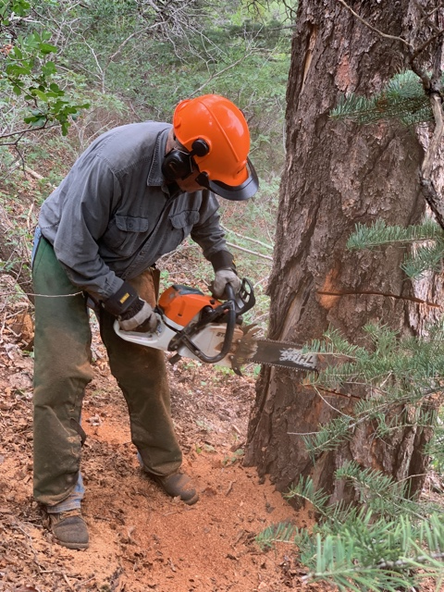

Jerry Carroll slabbing the side of the large pine so that the distance across the trunk

Is less than the length of his chain saw bar. Photo by Byron Garner

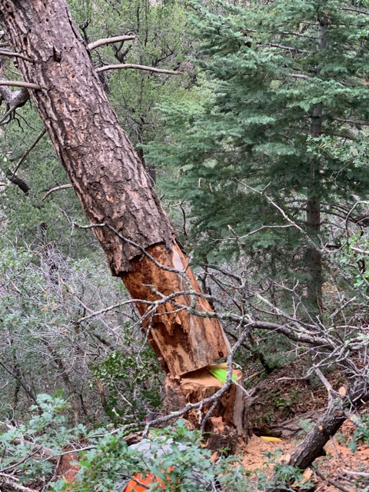

Jerry felled this large tree using wedges. Note the large decayed areas in the trunk.

Photo by Byron Garner

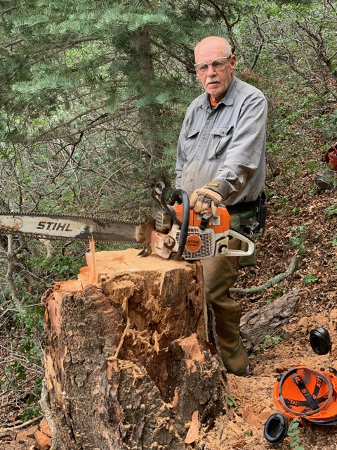

Jerry at the stump of the large decayed pine tree he has just felled.

Photo by Byron Garner

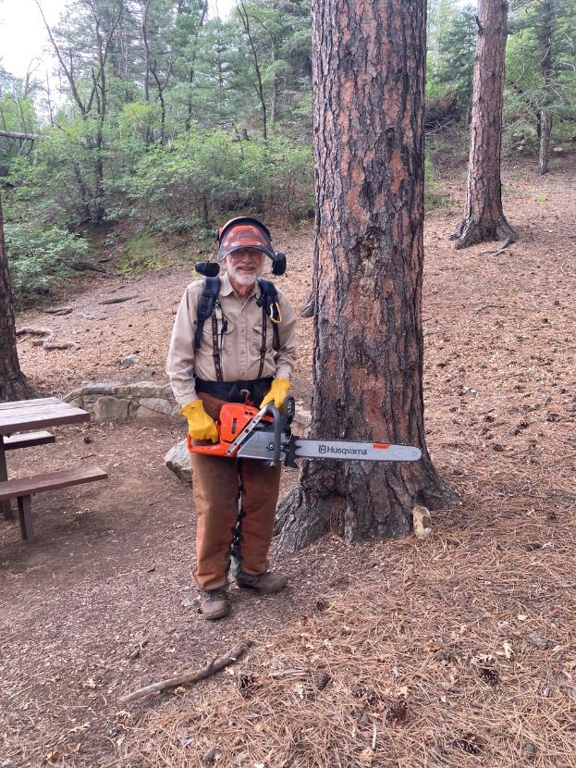

Sam Beard is holding one of the two new Husqvarna Model 572XP chain saws with a 24-inch bar

that FOSM has just purchased to replace two very old Husqvarna saws.

All photos by Cliff Giles unless noted otherwise

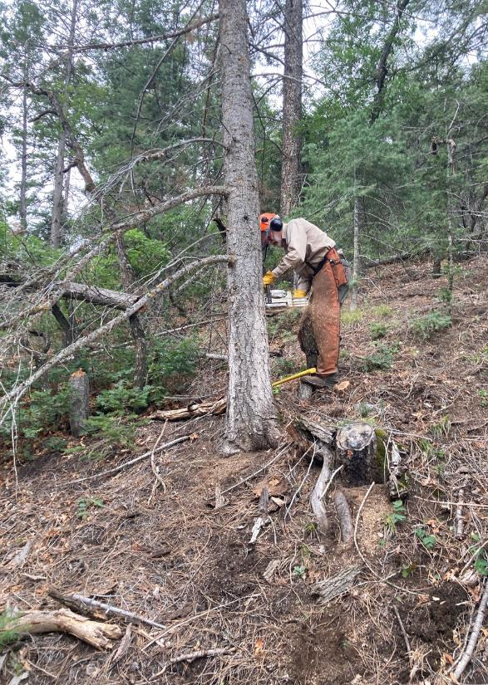

Sam is making the face cut on a 12-inch white fir hazard tree in the upper part of the Las Huertas picnic area

where Sam and Cliff Giles worked. The hazard trees were along both sides of the trail that goes

over the ridge to the lower part of the picnic area along Las Huertas Creek.

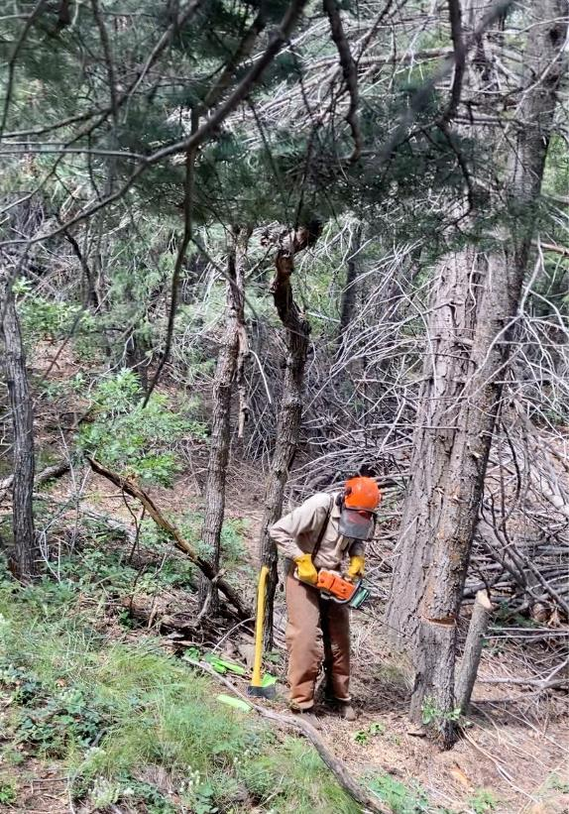

Sam starting to move away from the tree he has just felled. Four hazard trees in this grove

were felled.

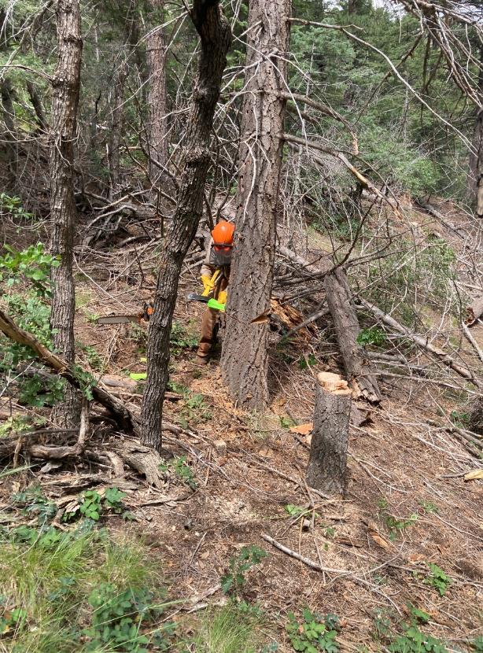

Sam driving wedges in the 12-inch diameter white fir cigar butt tree he is felling.

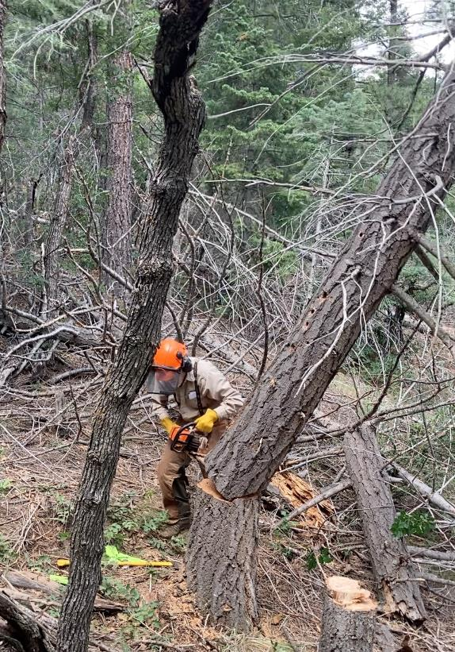

The cigar butt tree is falling as Sam moves away.

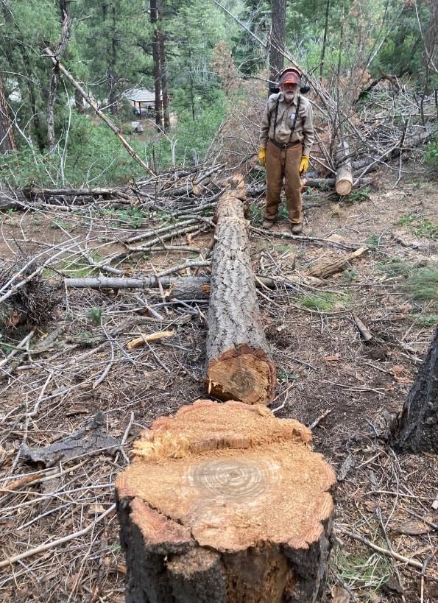

The cigar butt tree has been limbed. Note the decayed wood around the solid center of the tree.

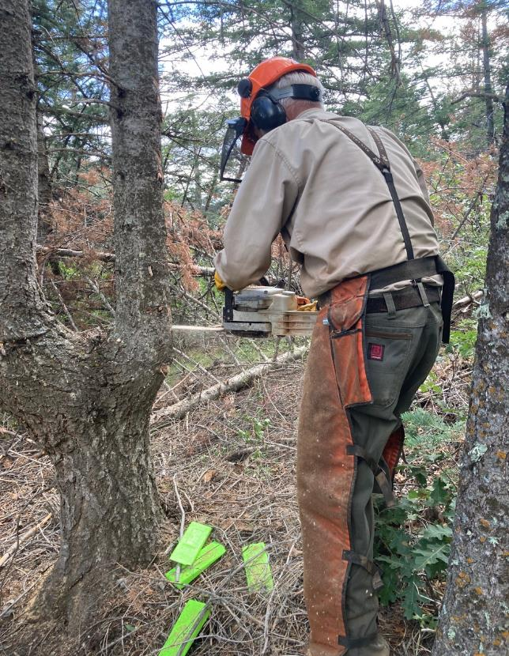

Sam starting to fell the small trunk of a two-trunk tree.

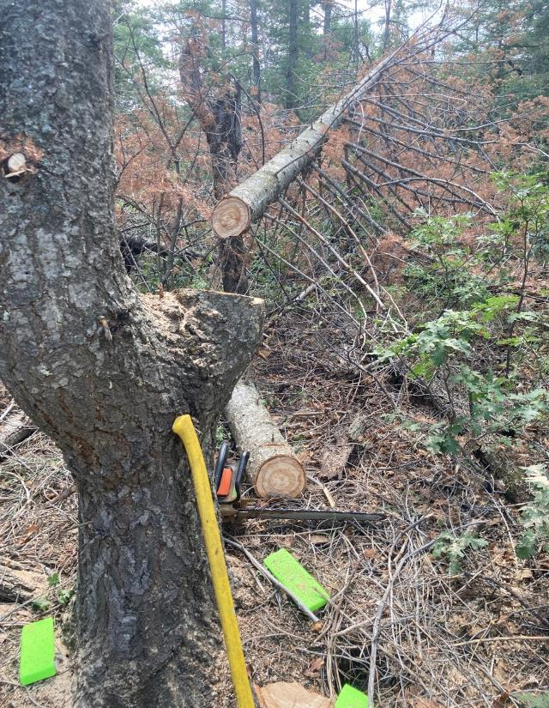

The small trunk has been felled and a piece of the trunk has been cut off.

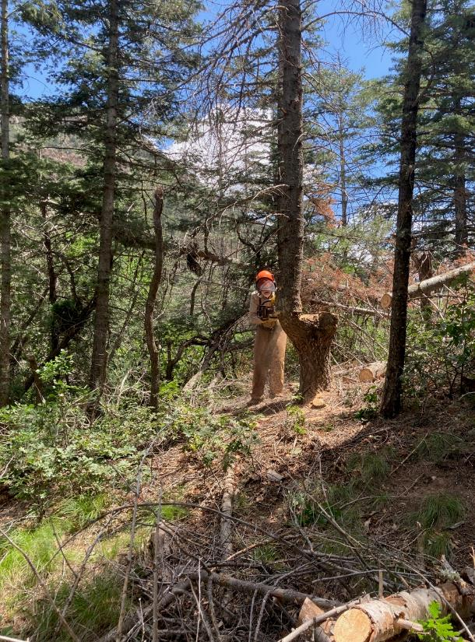

Sam cutting the large trunk on the double trunk tree.

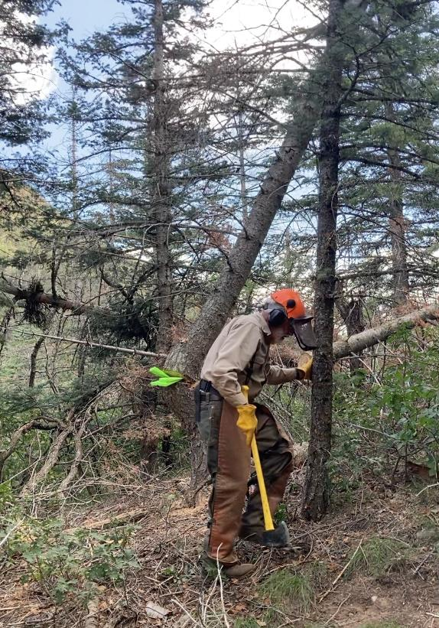

Sam moving away from the tree as the large trunk falls.

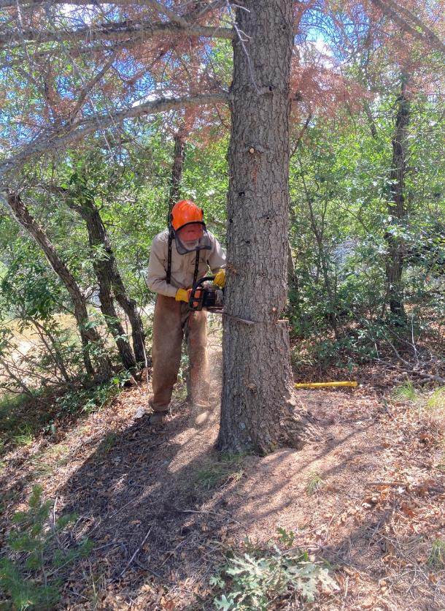

Sam making the back cut on this 15-inch tree. He soon noticed that this cut was too low and

made a back cut higher than the face cut.

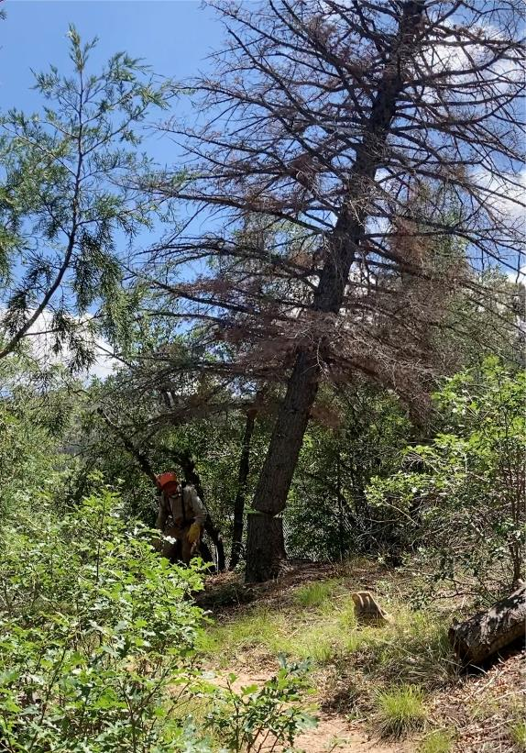

The dead white fir is falling as Sam leaves the area.

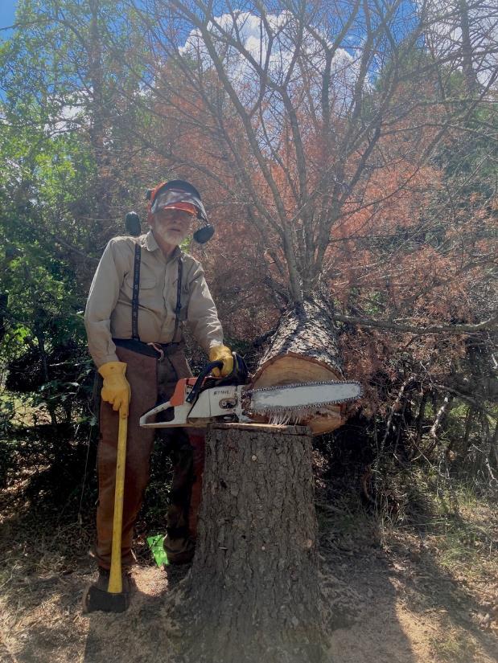

Sam at the stump of the fir he has just felled.

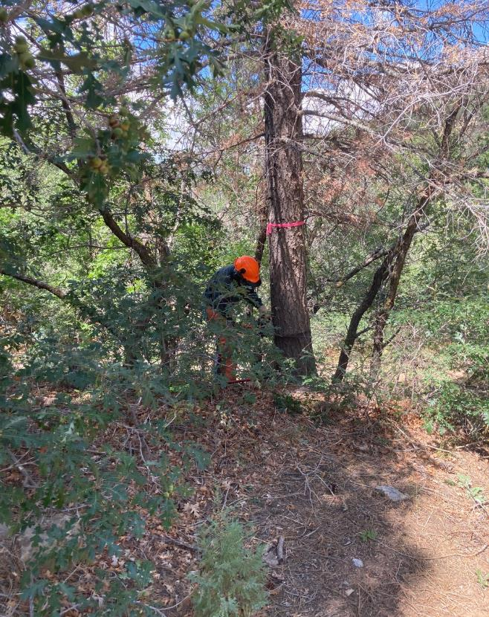

Jerry making the face cut on a white fir below the trail leading to the lower part of the picnic area.

He and Byron had completed felling the hazard tree along the Sandia Cave Trail.

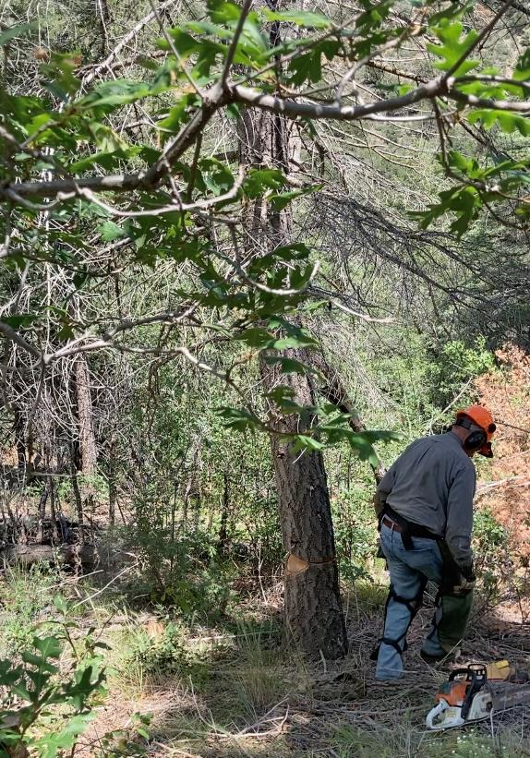

Jerry moving away from the tree as it starts to fall.

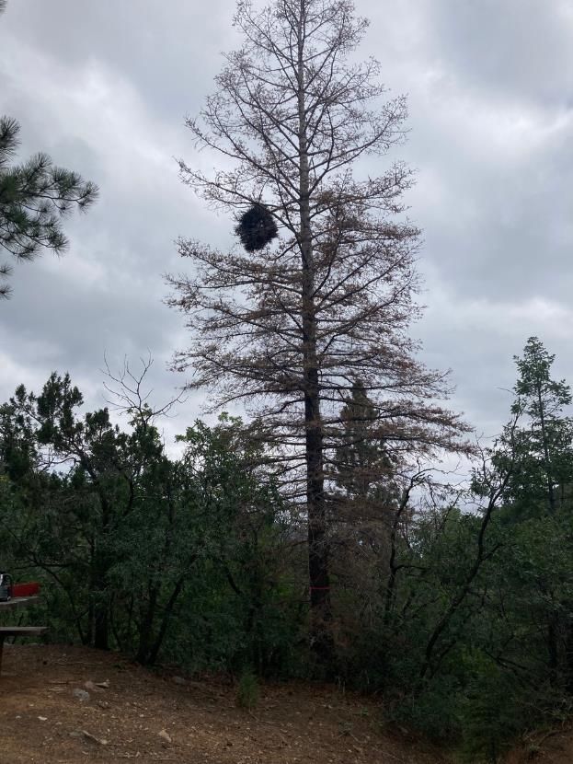

A dead white fir at the top of a steep slope on the north side of the upper part of the picnic area.

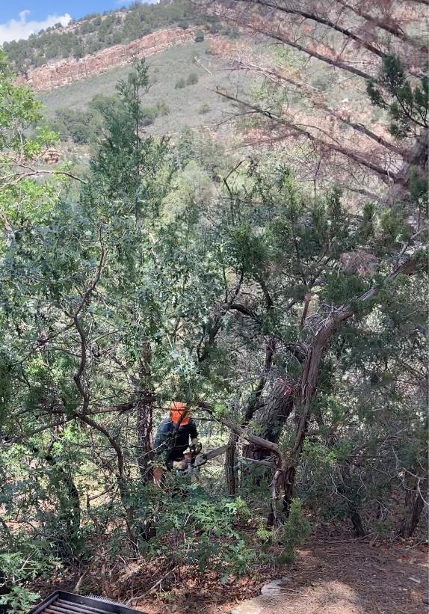

Byron has just felled this 14-inch white fir on the north side of the picnic area.

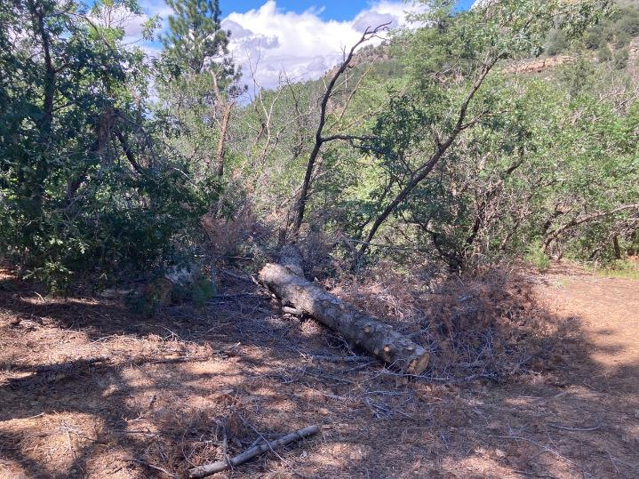

The trunk of Byron’s tree after it was limbed and bucked.