**Report of FOSM Projects to Remove a Hazard Tree and Replace Damaged Wooden Benches**

**in Pine Flat Picnic Area on August 24 and 25, 2022**

Sam Beard

On Wednesday, August 24, ten FOSM volunteers worked on the two following tasks in Pine Flat Picnic Area: felling and limbing a large pine hazard tree and installing pressure-treated wooden timbers to replaced damaged benches.

Eric Russell felled the 29-inch diameter dead ponderosa pine using one of the new FOSM Husqvarna Model 572-XP chain saws with a 24-inch bar. In order to fell the 29-inch tree with this bar that has an effective cutting length of 22 inches, Eric slabbed the tree by cutting off material on the sides so that this bar would cut completely across the trunk. Branches were then cut off the trunk, and Jerry Carroll’s pick up was loaded with the branches. Jerry has a permit to collect fire wood on the Sandia Ranger District. The trunk will be processed later when transportation is available. Also, a second large dead pine will be felled and processed.

Volunteers removed the ten most damaged benches by two methods: (1) unscrewing rusty ½-inch by 3-inch bolts after penetrant had been applied or (2) cutting wood away from bolts that could not be unscrewed. A hacksaw was used to cut bolts that could not be unscrewed. Six new benches were installed with either ½-inch bolts or a chain and bolt arrangement in which a 38-inch chain was attached to the bench on one side of the concrete base, run under the 4-inch-wide concrete base and attached to the bench on the other side of the base. The chain is tightened by turning the nuts on the carriage bolts through the bench of both sides of the base.

The volunteers working on Wednesday were Eric Russell, Don Carnicom, Dennis Crowther, Steve Roholt, Joelle Hertel, Sam Beard, Cliff Giles, Jerry Carroll, Michael Arndt, and Dan Benton.

On Thursday, August 25, Joelle Hertel and Sam Beard installed four new benches to complete the project to replace the ten most damaged benches at the site. The FOSM battery-powered reciprocating saw instead of a hacksaw was used to cut the rusted bolts that could not be unscrewed.

Photos of both projects are presented below.

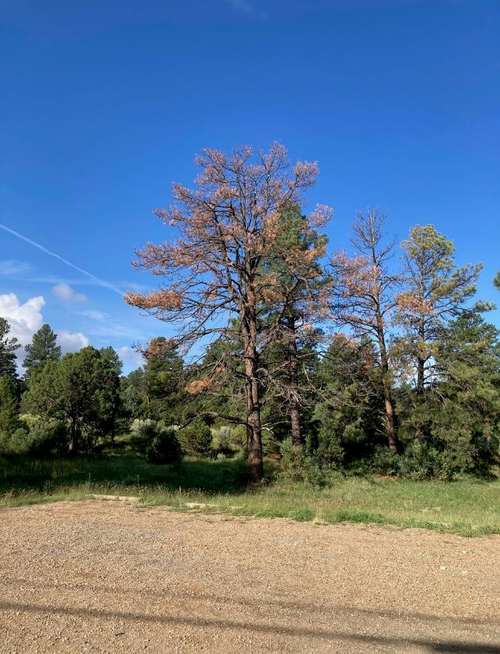

Dead 29-inch diameter ponderosa pine in Pine Flat Picnic Area.

All photos by Cliff Giles unless noted otherwise

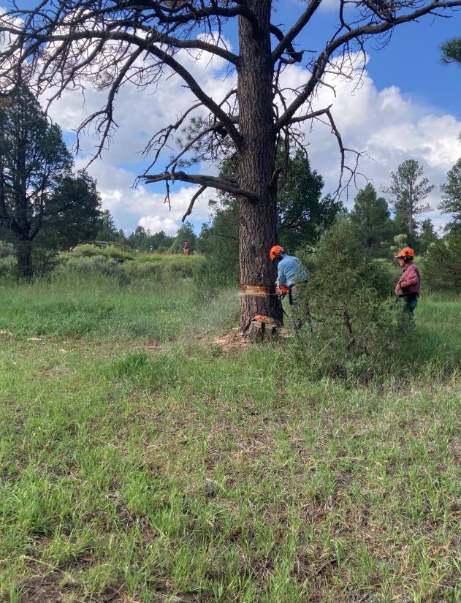

Eric Russell felling the large pine in Pine Flat PA. Jerry Carroll is observing.

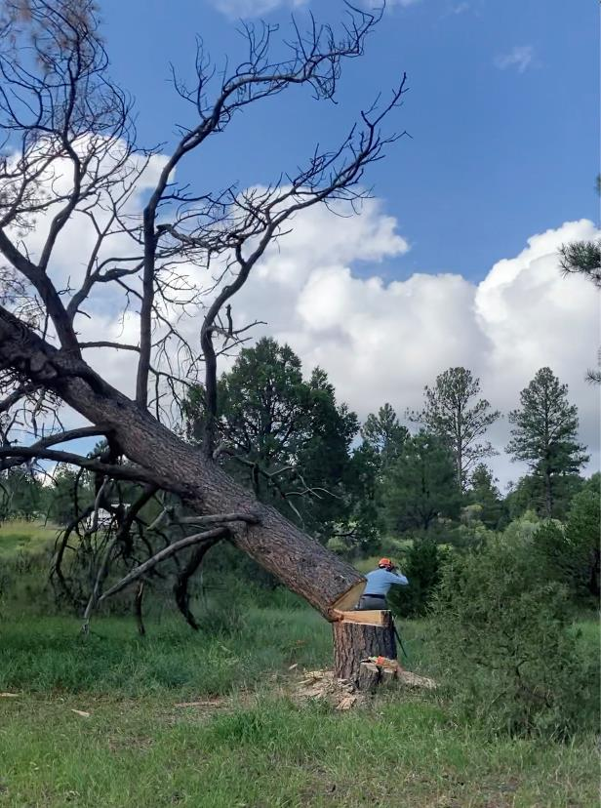

Eric is moving away from the falling tree.

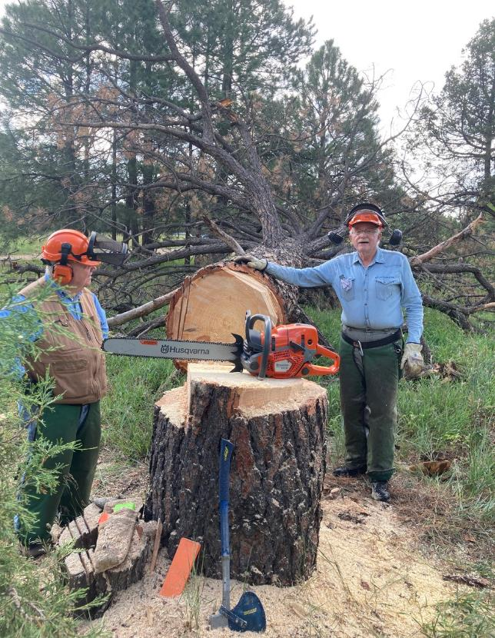

L to R – Dennis Crowther and Eric Russell at the stump of the felled tree.

Eric was using one of the new FOSM Husqvarna Model 572-XP chain saws with a 24-inch bar.

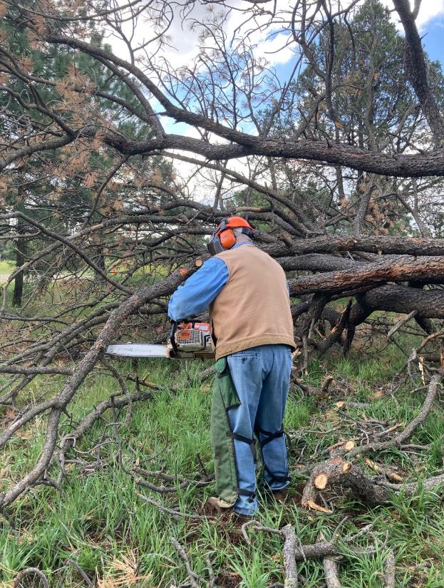

Dennis limbing the felled pine.

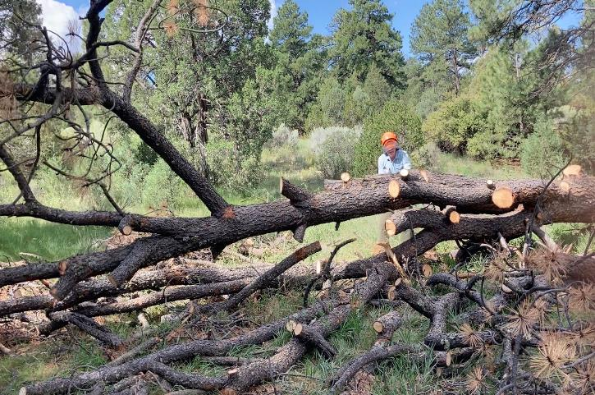

Eric continuing to limb the large pine.

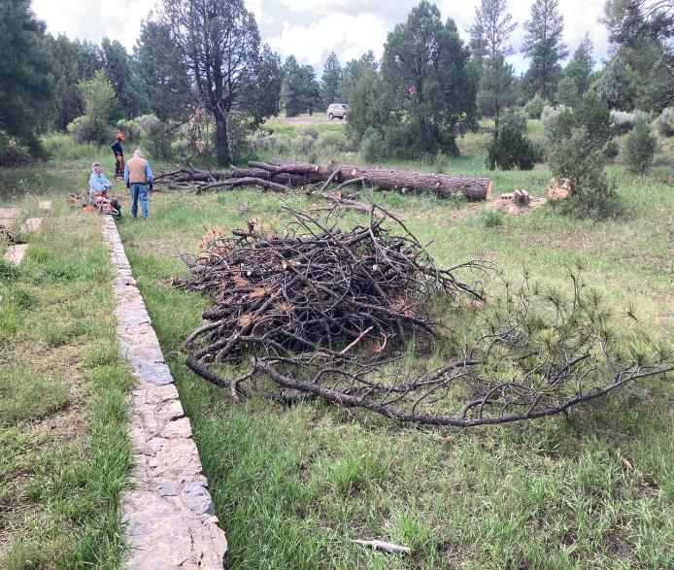

The project to fell and limb this hazard tree has been completed.

The pile of slash in the foreground will be chipped later.

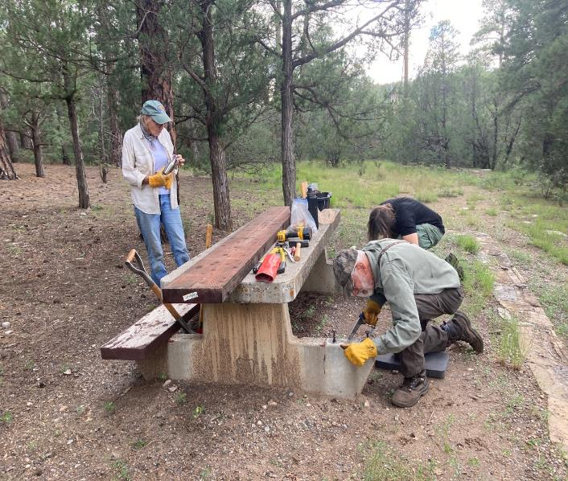

L to R- Joelle Hertel, Sam Beard, and Michael Arndt are preparing to replace a damaged bench on this table.

Sam is using a hacksaw to cut off an old bolt in the concrete base that could not be unscrewed

due to excessive rust. The replacement 3x12x96 pressure-treated bench is on the table.

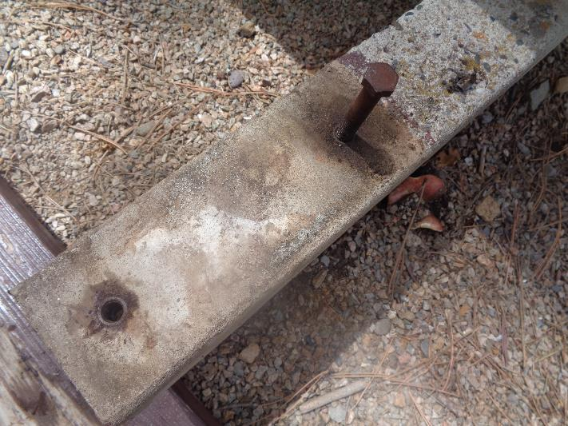

The concrete base of this table to which the replacement bench will be attached.

Note the rusty steel insert on the left into which a ½-inch bolt will be screwed to secure the bench.

The rusty bolt on the left was cut off, because it could not be removed from the insert.

All following photos by Sam Beard

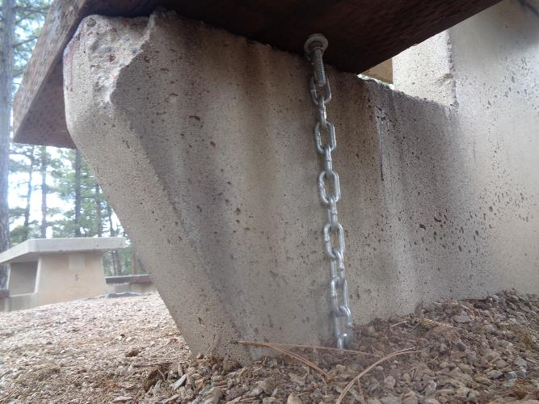

On the tables where both of the rusty bolts on one base were cut off, the bench was secured to the concrete base

by attaching one end of a chain on one side of the base to the bench with a long 5/16-inch carriage bolt and nut, running the chain under the concrete base, and attaching the other end to the bottom of the bench with a bolt and nut.

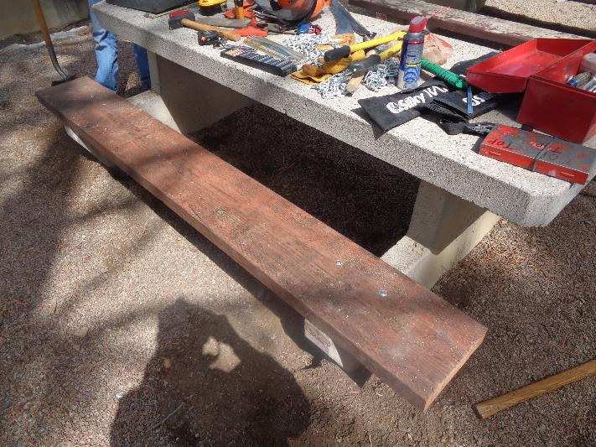

Each end of this bench was secured to the concrete base with a chain, bolts, and nuts.

Joelle Hertel and Sam Beard used this ingenious method to attach some benches after seeing that it had been

used in the past to secure benches to the bases where bolts could not be screwed into the inserts in the base.

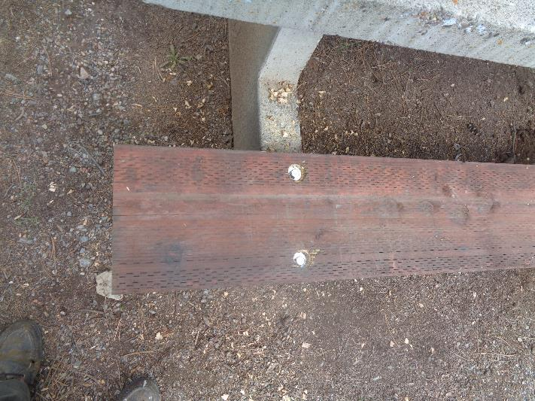

This end of a bench was secured to the base with ½-inch bolts screwed into inserts in the concrete base.

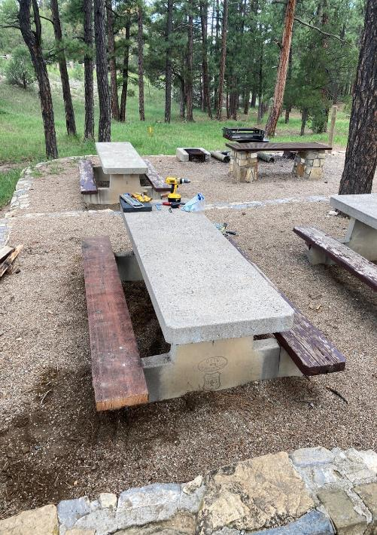

A table on which a new bench was installed on the left side. Note the old benches

on the right side of the photo that need paint.