**Report of FOSM Project to Removal Brush around Barro Wildlife Drinkers**

**on Wednesday, September 7, 2022**

Sam Beard

September 8, 2022

On Wednesday, September 7, seven FOSM volunteers removed brush around both Barro Wildlife Drinkers so that prey wildlife can see predators earlier. Although the original objective was to clear an area with a radius of 50 feet around each drinker, the distance cleared from each drinker ranged from 30 feet to 50 feet due to the heat and relatively small number of volunteers. In the future we will probably clear around just one drinker each year.

These wildlife waters are located near the Old Crest Road between Doc Long Picnic Area and Tree Spring Trailhead. Jean Payne and Joelle Hertel have adopted the rain collectors and drinkers at this site as part of the Adopt-A-Drop Program. They will report the condition of the drinkers to the Sandia Ranger District and possibly do minor maintenance.

The volunteers working on this project were Mike Madden, Steve Roholt, Jerry Pekarek, Jerry Carroll, Sam Beard, Byron Garner, Eric Russell, and Dennis Crowther.

Project photographs are presented below.

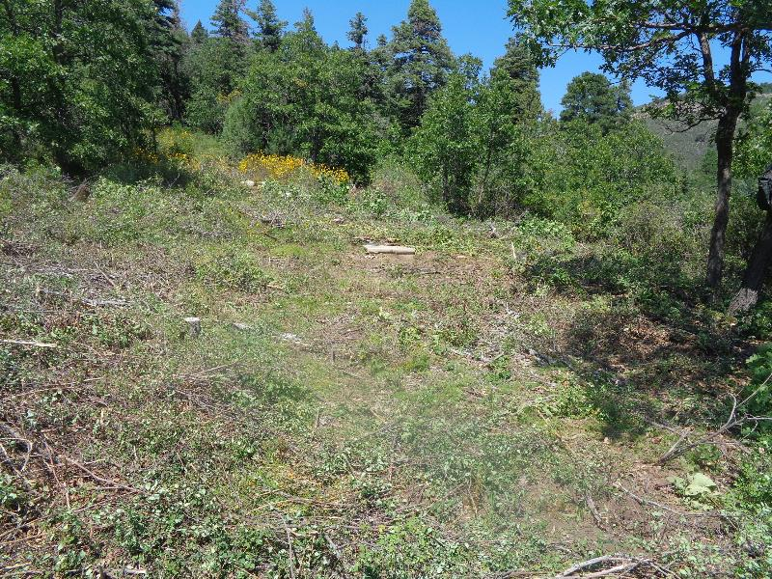

The area cleared around the new drinker shown in the center of the photograph. The rain collector is the small white

object uphill and to the left of the drinker. Water flow from the collector to the drinker is controlled by a flow valve.

Photos by Sam Beard

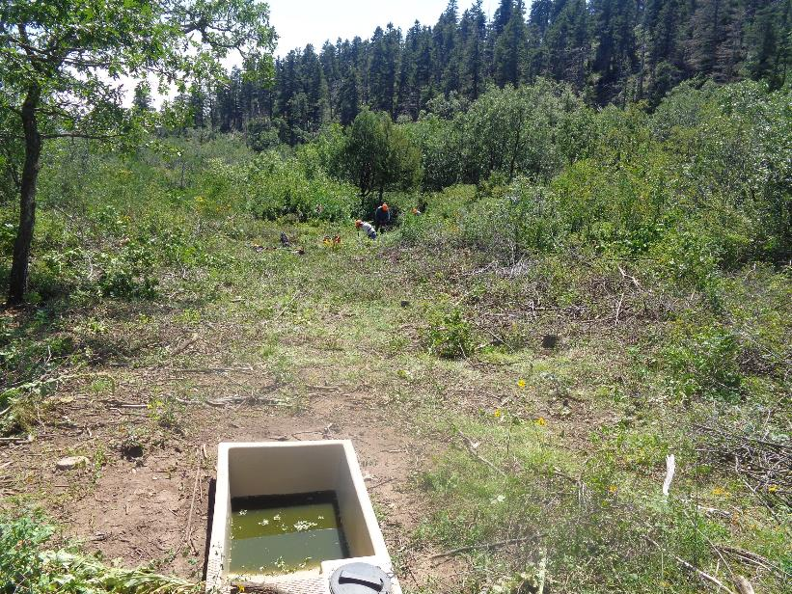

Looking from the new drinker down the hill to where the volunteers are working around the old drinker. Access to the float valve

assembly is through the opening with the black cover. Brush is cut with chain saws and power brush cutters.

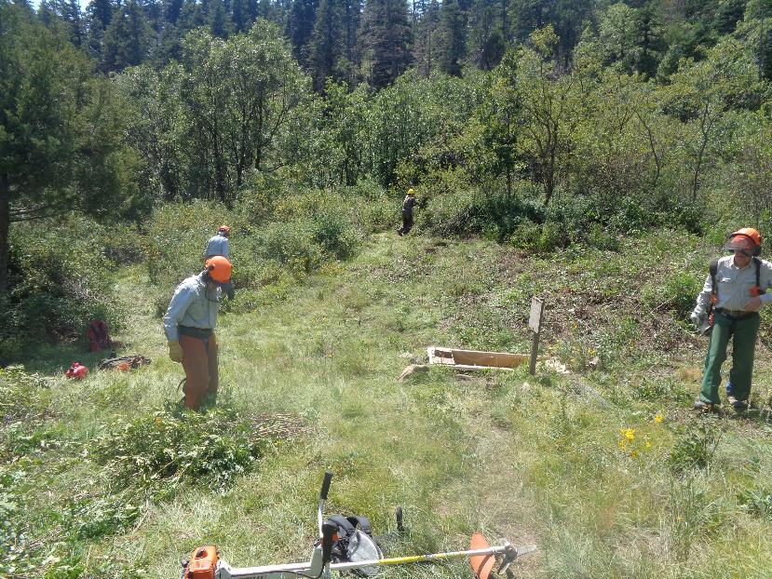

L to R: Byron Garner, Eric Russell, Mike Madden, and Jerry Pekarek. Note the triangular area of brush left of the photo center

where Eric is working.

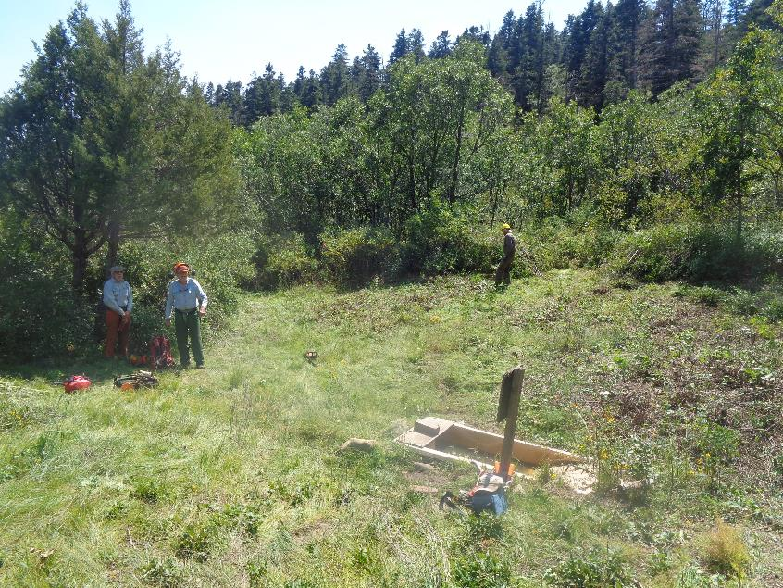

L to R: Byron, Eric, and Mike. Note that the triangular area of brush left of the photo center has been removed.

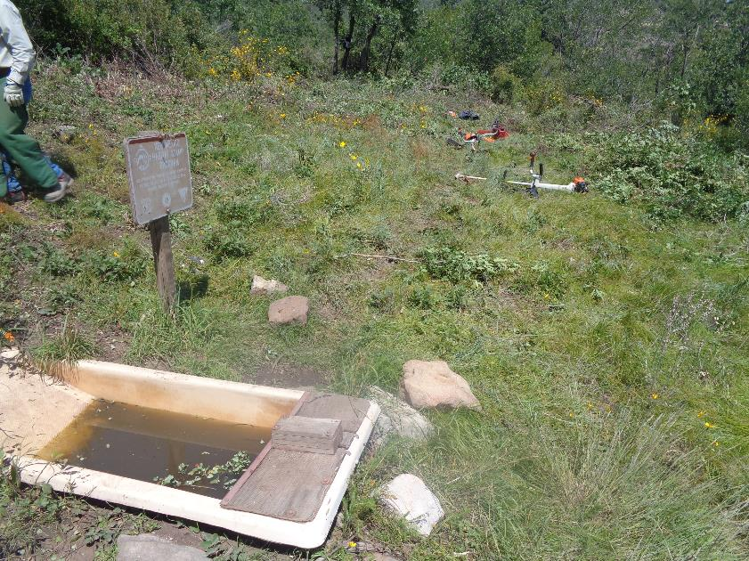

Another cleared area around the old drinker with brush cutters and chain saws lying in the grass.

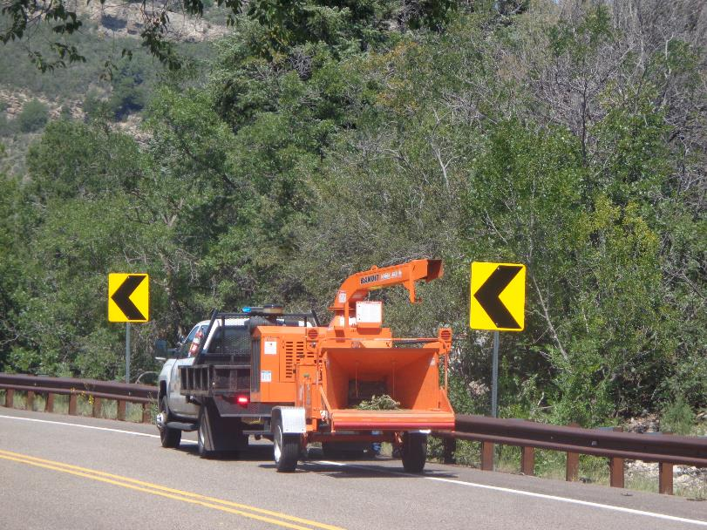

When we returned to the highway, the NMDOT was cutting brush along the shoulder with chain saws and chipping it.

If the brush cutting extends to the FOSM Adopt-A-Highway mile segment, volunteers can begin picking up trash on the shoulders.