**Report on the FOSM Project in Capulin Picnic Area**

**with Los Ranchos Boy Scout Troop 9 on Saturday, September 10, 2022**

Lou Romero and Sam Beard

September 13, 2022

On September 10, 2022, four FOSM volunteers, six Boy Scouts from Troop 9, four other youths, and six parents worked on a project in lower Capulin Picnic Area to buck, split, and haul fire wood for donation to the Mountain Christian Church Wood Ministry. One of the parents, Chris Weil, had been Lou’s contact with the Scout Troop. At 9 am all the participants signed the JHA form in the picnic area parking lot, and hard hats were handed out. The group then moved down to the area near the restroom.

The FOSM members were Sam Beard, Jerry Carroll, Michael Arndt, and Lou Romero. Lou managed the project, Jerry and Michael bucked down trees, and Sam organized the movement of the rounds from the field to the splitter. All ten youths rolled or carried rounds to the splitter where the parents helped with the splitting and loading Chris Weil’s large dump trailer.

The project bucking and splitting began at the restroom level. Most of the two down trees above the road had disappeared, but several rounds were bucked and taken to the splitter. Jerry then bucked the tall fir that he had felled a few weeks ago, and all these rounds were moved, split, and loaded. The trailer was not full; therefore, the splitter was moved up the road to a location just below the gate. Jerry and Michael bucked two logs below the road, and the youths moved the rounds up to the road where they were split and loaded on the trailer. The full trailer contained 1.5 cords of split wood. The operation at the picnic area was completed by noon.

Lou led the truck and trailer and the youths and parents to the Mountain Christian Church woodlot to watch the trailer dump the load of wood. The group concluded the project by forming a circle and reciting the Boy Scout Law.

Project co-leaders, Lou and Sam, were very satisfied with the accomplishments and the overall success of the project. All ten youths eagerly participated in moving the rounds to the splitter and in loading the trailer.

Project photographs are presented below.

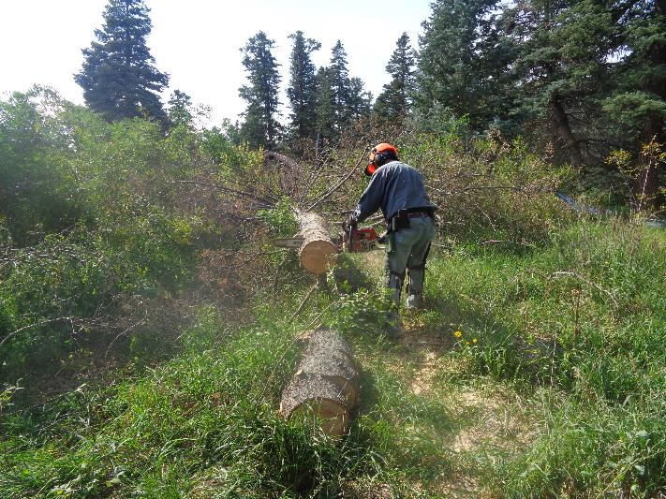

Jerry Carroll bucking the down fir near the lower restroom. The splitter is on the road a short distance to the right.

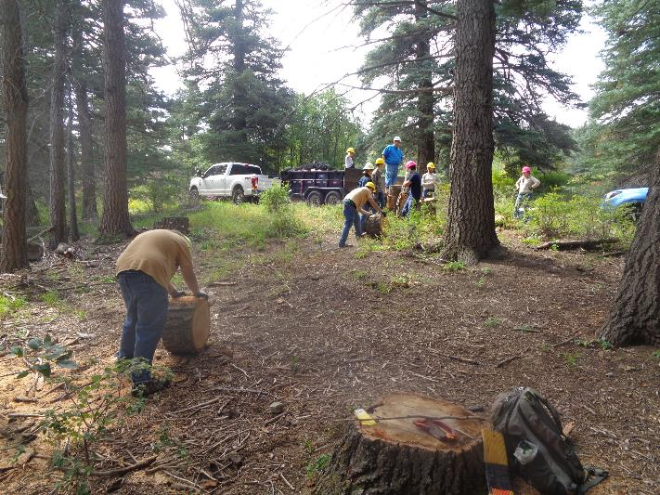

Moving the rounds up to the splitter near the gate to the lower area. Two trees were bucked here.

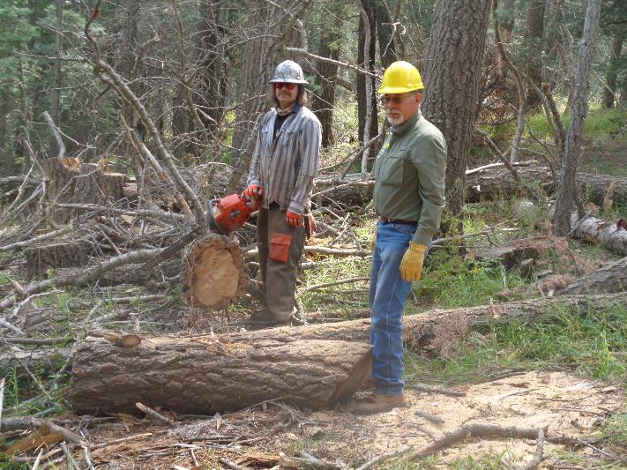

Michael at the log he was bucking. The grandfather of one of the Scouts was helping move the wood up to the splitter.

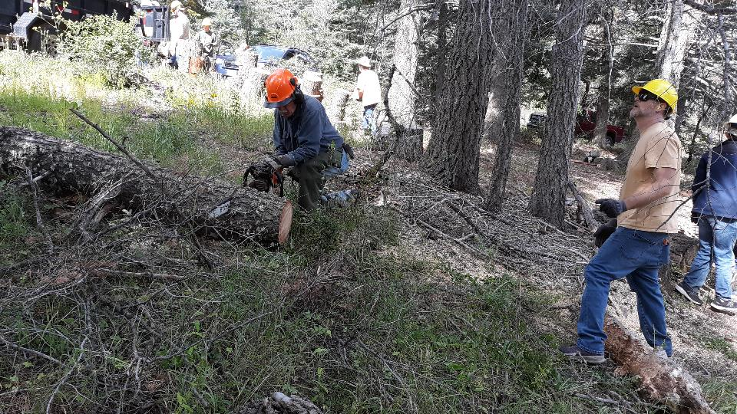

Jerry bucking the second log at the upper level.

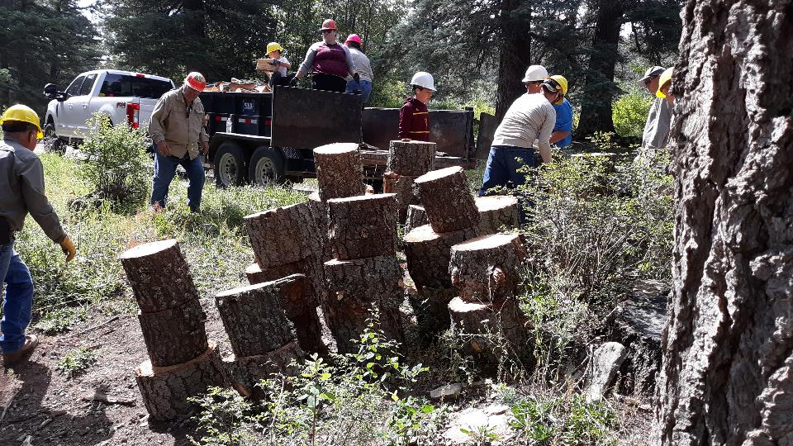

The stack of wood that the Scouts had moved up to be split. This wood filled the second half of the trailer.

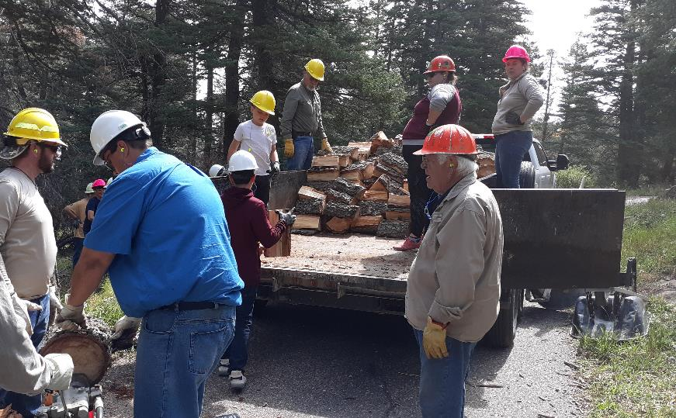

Everyone was participating in splitting and loading the wood.