**Report of FOSM Project to Cut Brush at the Intersection of Cienega Road and Crest Highway,**

**at Intersection of Capulin Picnic Area Road and Crest Highway, and on Sledding Slopes**

**at Capulin Snowplay Area on Wednesday, September 21, 2022**

Sam Beard

September 22, 2022

On Wednesday, September 21, Dan Benton, Jerry Carroll, and Sam Beard cut brush at the three following sites on the Crest Highway: intersection of Crest Highway and Cienega Road, intersection of Crest Highway and Capulin Picnic Area Road, and at the Capulin Snowplay Area. Tall locust brush was cut on the new sledding hill, but no tall brush was found on the old hill.

Photographs and more narrative are presented below.

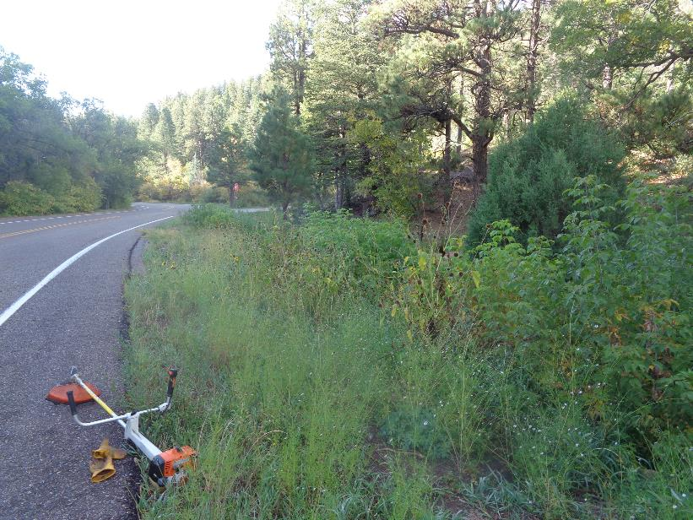

Brush at the intersection of Crest Highway and Cienega Road. The intersection is at the red stop sign near the center

of the photo. All photos by Sam Beard

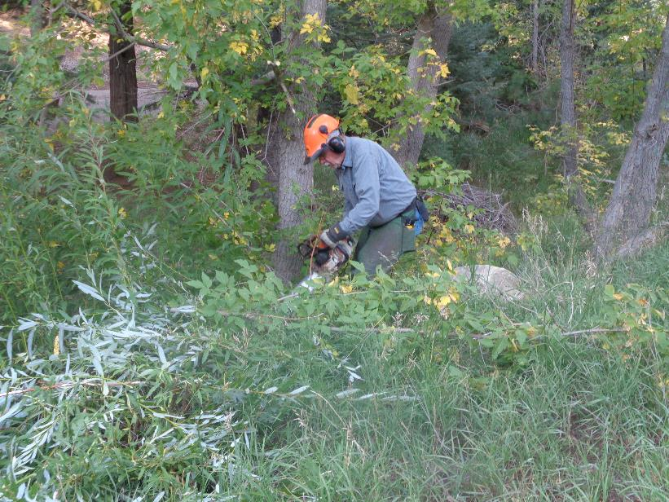

Jerry cutting brush on the shoulder of the Crest Highway near the intersection with Cienega Road.

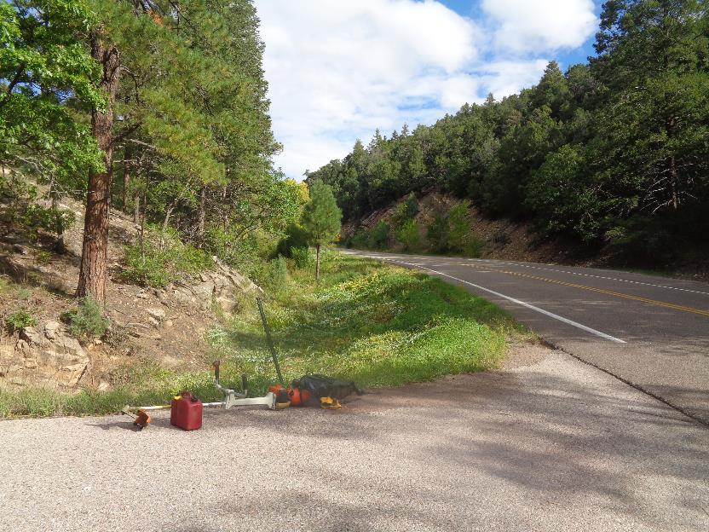

Brush cut for better sight distance at the intersection of Cienega Road and Crest Highway.

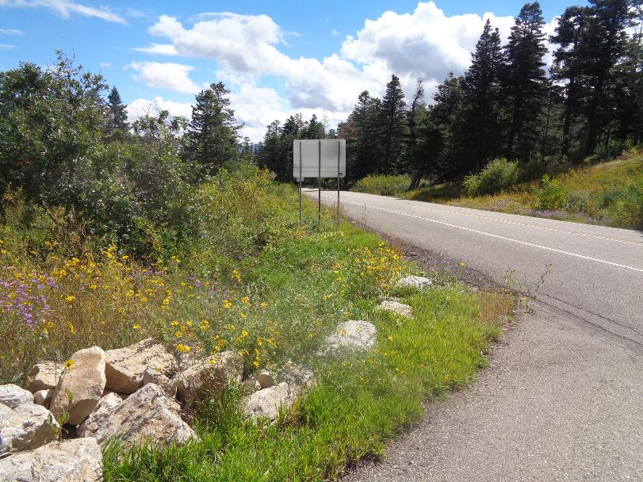

Cut brush along the Crest Highway just below Capulin Picnic Area Road.

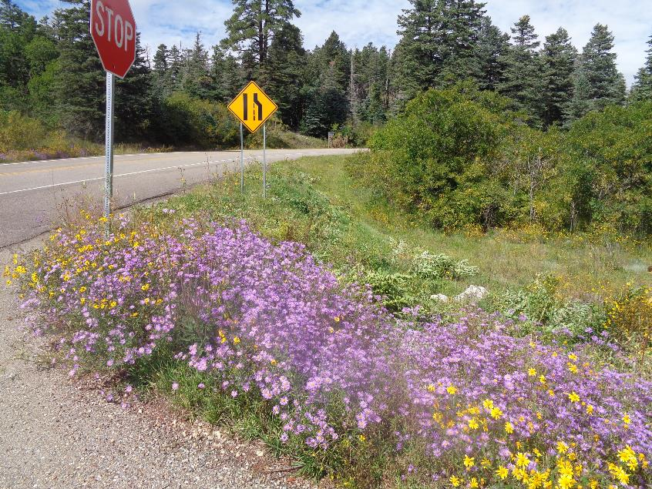

Cut brush along the Crest Highway just above Capulin Picnic Area Road.

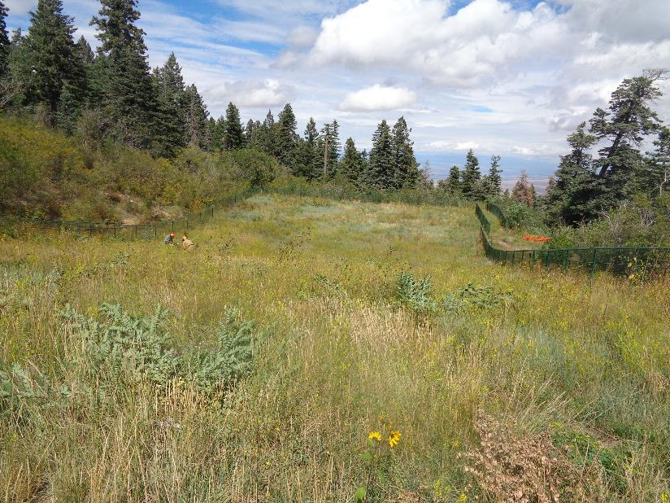

Dan Benton and Jerry Carroll (left of the photo center) are cutting brush on the new sledding slope at the Capulin

Snowplay Area. The slope is ready to be mowed with the large SRD power mowers that cannot cut the tall locust plants.