This lengthy hang-up has been safely brought to the ground.

The crew limbs the tree shown in the previous photo.

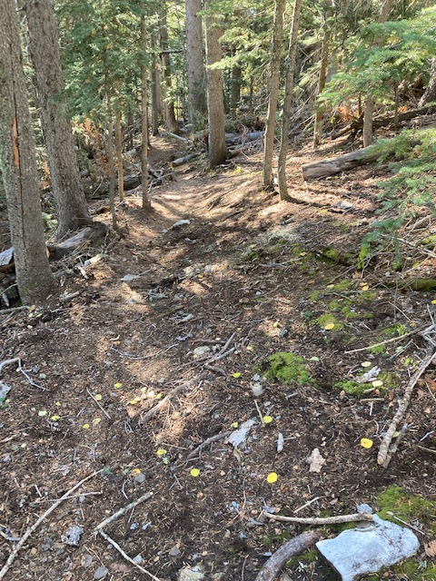

The tree shown in the previous photos has been removed

and the trail is clear.

This previously unreported tree had fallen over Survey

Trail a short distance below the Crest Road crossing

Cleve and Paul use the crosscut saw to remove the fallen tree from the trail.

The trail is clear.

Another hang-up has been brought down and is being

cut to remove it from the trail.

Monday’s crew – (Left to right) Jerry Pekarek, Paul

Karas, Bob Lowder and Cleve Sharp. (Not shown – Jamey

Browning)

This tall hang-up was brought down. It landed on the

root ball of an old previously fallen tree.

Bob is starting the first cut on the tree in the

previous photo after it had been brought down.

After the tree in the previous photo has been cut

away, the root ball of the old fallen tree that it

had been resting on is checked for pointed protrusions

that must be removed for the safety of trail users.

This sixteen-inch diameter dead fir was hanging into

head space over Survey Trail.

This photo captures the moment that the crosscut

saw passes through the tree and the two cut sections

begin their fall to the ground.

Cleve is making a cut on the upper portion of the

big tree. The cut section was moved away to the downhill side of the trail. The lower portion of the tree and its root ball were

also moved off the downhill side of the trail. The hole

left by the root ball was repaired.

These sharply pointed branches were discovered

on a previously cut fallen tree on Survey Trail.

They were a bit too close to head space on the

trail and were removed.

This photo taken at the Del Agua overlook on Monday shows the current status of this year’s Aspen color display.

These Aspen trees are shown on Ellis Trail as the

crew was returning at day’s end.