**Report of Cutting Brush in the Traffic Island at the Capulin Snow Play Area**

**on Wednesday, October 12, 2022**

Sam Beard

October 13

On Wednesday, October 12, four FOSM volunteers cut brush in the traffic island at the Capulin Snow Play Area so that there would be a place to push snow when the parking lot is plowed. The brush was cut with small chain saws and two power brush cutters. Primarily, just tall brush such as one-year old locust plants were cut. By cutting the brush here annually, the plants are not too large, and we can continue to cut them with brush cutters. The slash on the upper parking lot was raked into about a half-dozen piles, and we requested that Manny Chavez, SRD Maintenance Supervisor, dispose of the slash.

The volunteers were Sim Cook, Jerry Carroll, Eric Russell, and Sam Beard.

A couple of photos are presented below.

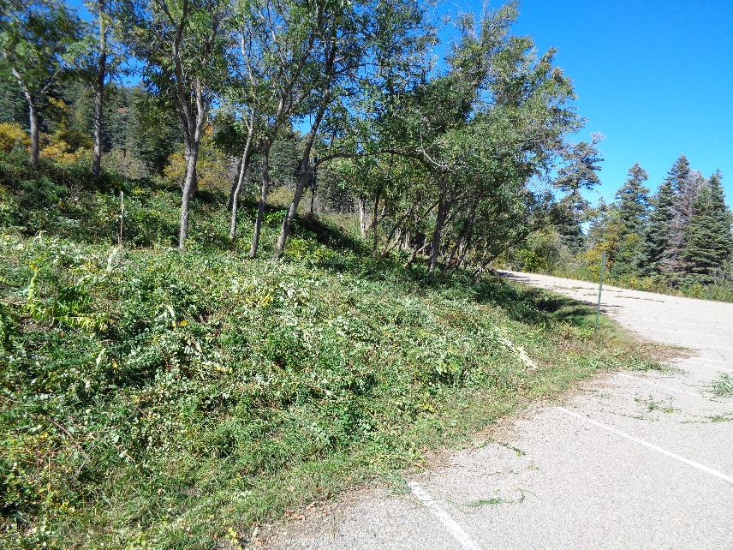

Cut brush on the traffic island. Photos by Sam Beard

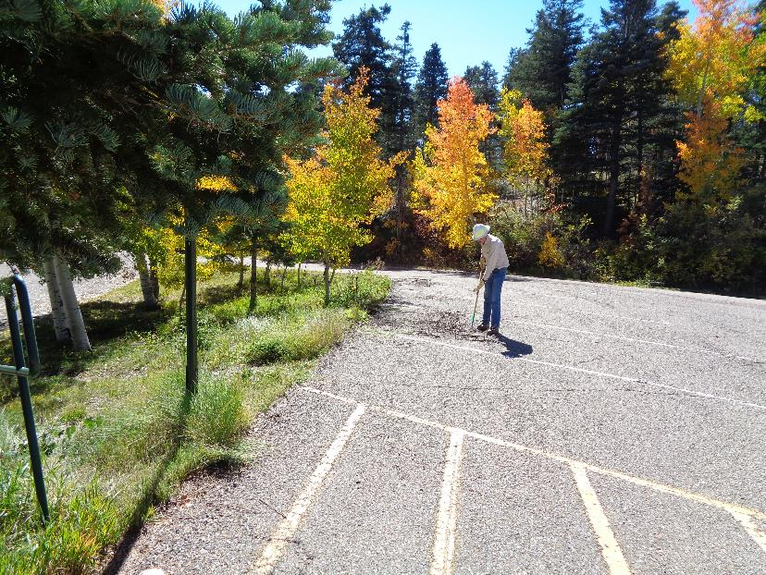

Sim Cook raking the slash into piles on the upper parking lot. These aspens were yellow and orange, but other aspens

had already dropped their leaves.