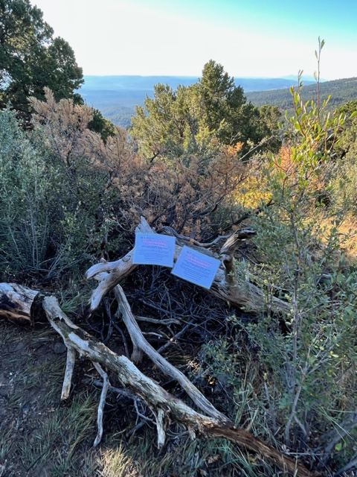

This photo shows the closure of the illegal trail at its

top, located at the south end of the Tecolote Trail loop.

USFS information and advisory notices have been attached

to the barrier. The closed trail went steeply downhill from

here.

This photo, taken a short distance downhill from the previous

picture, displays examples of the various materials used to

obliterate the illegal trail. (Existing slash, broken branches, etc.)

In this area the illegal trail followed the escarpment

overlooking the Crest Highway far below. Covering materials

are being raked in from the upper side.

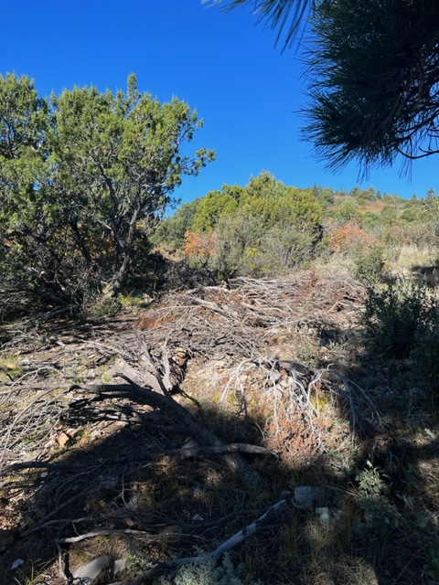

In some flat areas, the rogue trail was wide. This required

considerable amounts of slash and other materials to completely

cover it.

This photo shows the bottom end of the illegal trail at its

junction with North Faulty/Mystery Trail. Official Forest Service information and advisory signs were posted here also.

The closed trail was about 1.3 miles in length.