**FOSM Report of Clearing the Corridor for the Rerouted Segment**

**of Kiwanis Meadow Trail on Friday, October 21, 2022**

Sam Beard

On Friday, October 21, Eric Russell, Michael Arndt, and Sam Beard completed clearing the corridor for the rerouted segment of Kiwanis Meadow Trail. This reroute begins near the mid-point of this trail. The lower end of the rerouted Kiwanis Meadow Trail terminates at the upper end of the rerouted segment of Switchback Trail. This reroute of Kiwanis Meadow Trail eliminates the steep “chute” that leads to the Service Road. The lower end of the original Kiwanis Meadow Trail will be obliterated beginning at the Service Road.

The upper part of the Kiwanis Meadow Trail reroute corridor was cleared several days ago. The lower end of the reroute at the junction with Switchback Trail is shown in the first photograph below. We were working in about 4 inches of snow, but the temperature when we started was 45F. When we left Ellis Trailhead at about 1230, the temperature was 51F.

The following photographs include additional narration.

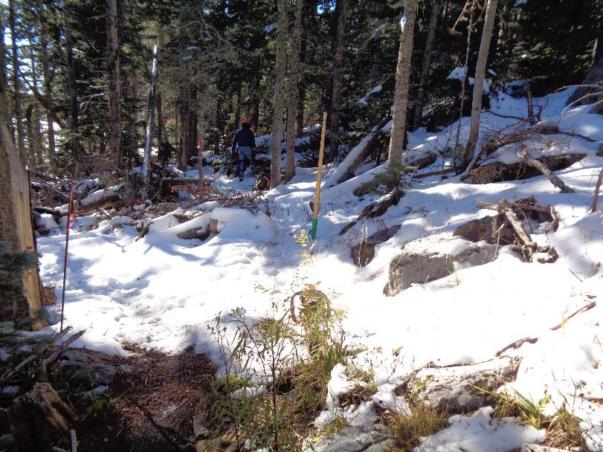

This photograph shows the intersection of the Kiwanis Meadow (KM) Trail reroute with Switchback Trail. The photographer was standing

on Switchback Trail, and the KM reroute starts in the center of the photograph where the peavy with the green base is located. Eric Russell

in the blue clothes is standing at the lower end of the long log lying along the reroute. Photos by Sam Beard unless noted otherwise

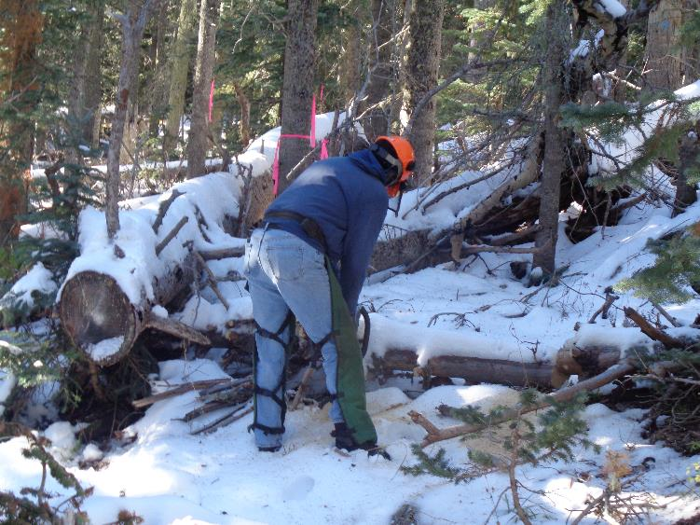

Eric is cutting the first of several small logs supporting the large log on his left.

Note that the long log lies along the reroute flag line.

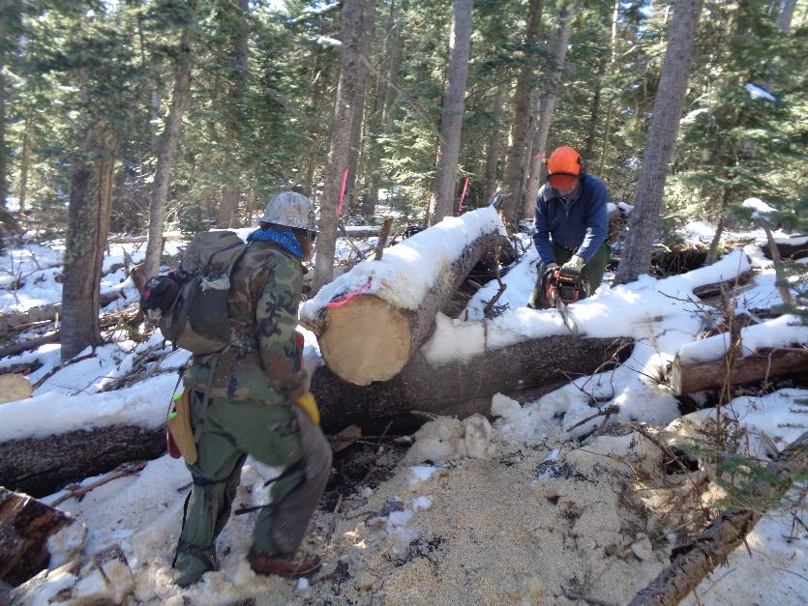

Michael Arndt is bucking the long log into 12-inch-long pieces that can be handled by one person.

Eric continues to cut logs supporting the very large long log lying along the flag line.

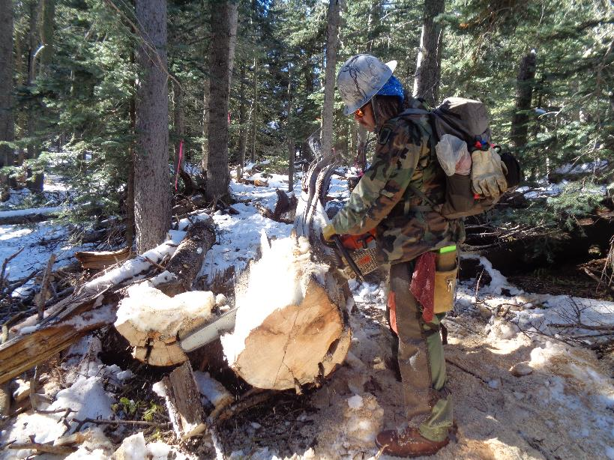

Michael is using the FOSM Stihl Model 460 chain saw with a 36-inch bar to make the final cut in the long log at the stump.

This tree was probably blown over by high winds, and the lower end of the trunk was splintered.

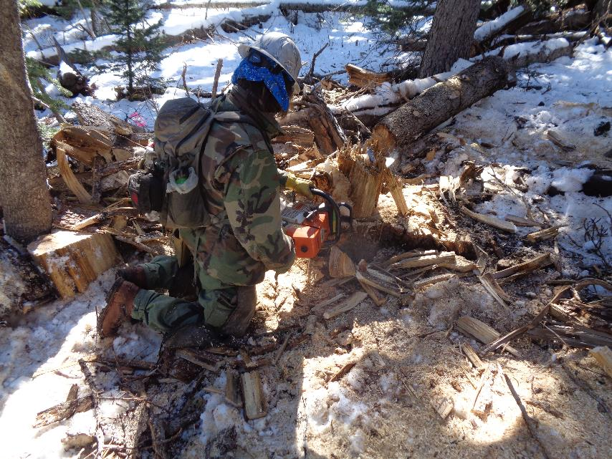

Michael is cutting the splintered stump at near ground level with the large Model 460 saw with a long bar.

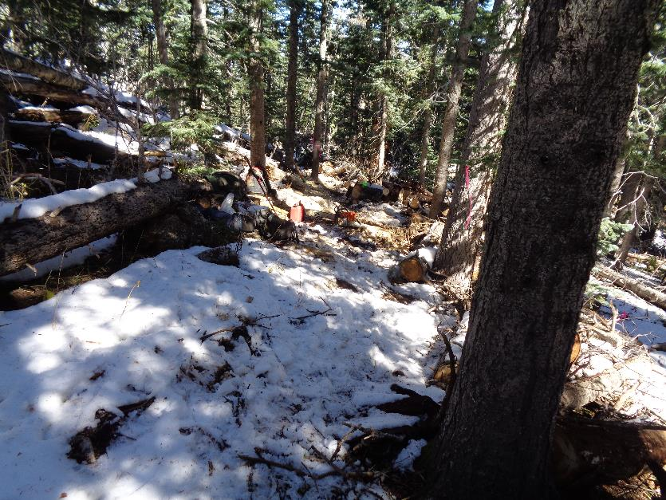

This photograph shows the lower segment of the reroute after the long log was removed.

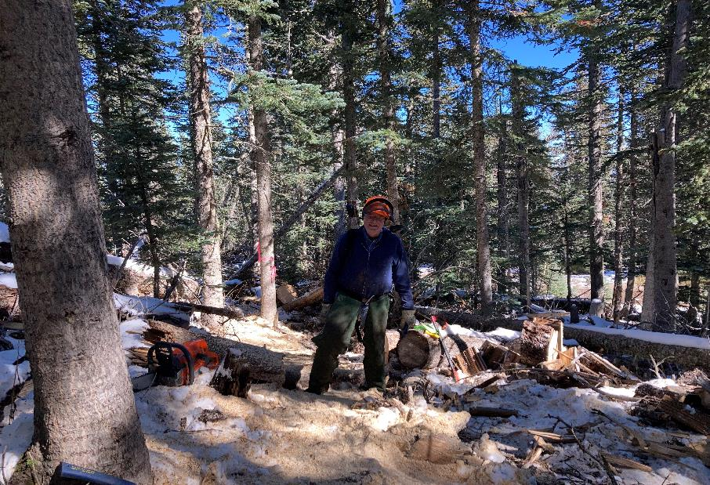

Eric Russell standing in the corridor after the long log was removed. Photo by Michael Arndt

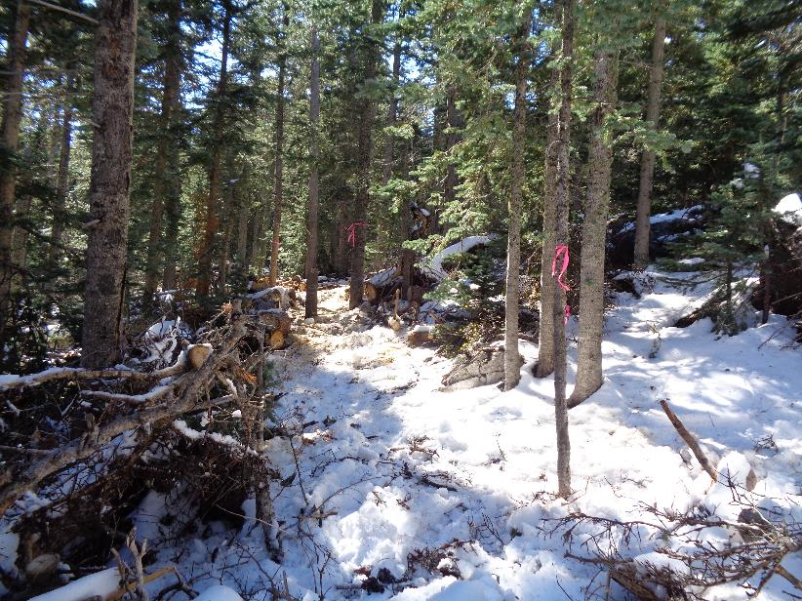

Another view of the lower end of the reroute where the long log had been lying. Note the flagged tree in the center of the photograph.

It was standing in the center of the corridor, and Eric felled it to the right.

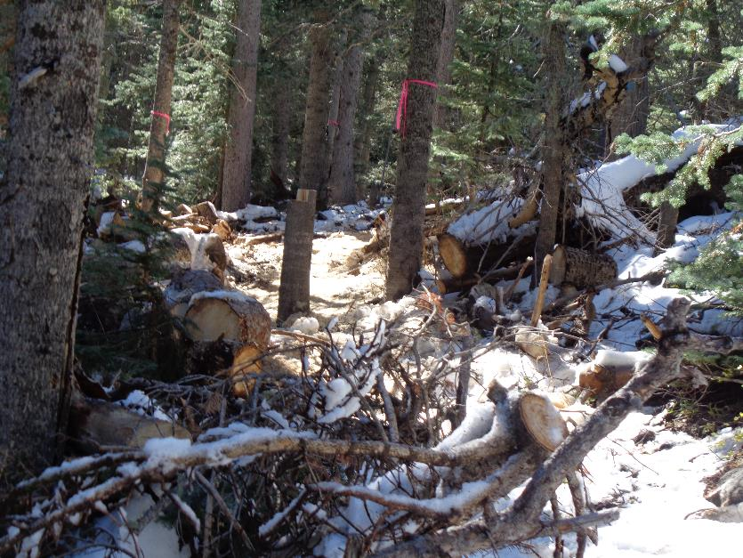

The lower end of the reroute after the 6-inch tree was felled. The stump is about 4 feet high so that it can be used as a lever

when Jerry Blackmore’s crew removes it while constructing the trail tread.

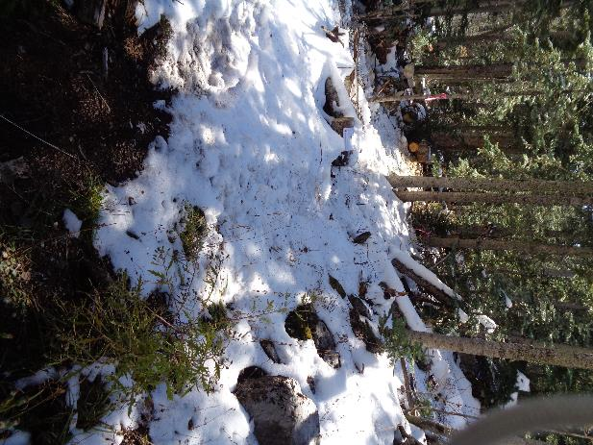

The intersection of the KM reroute with Switchback Trail. The pink flag is near

where the lower end of the long log had been.

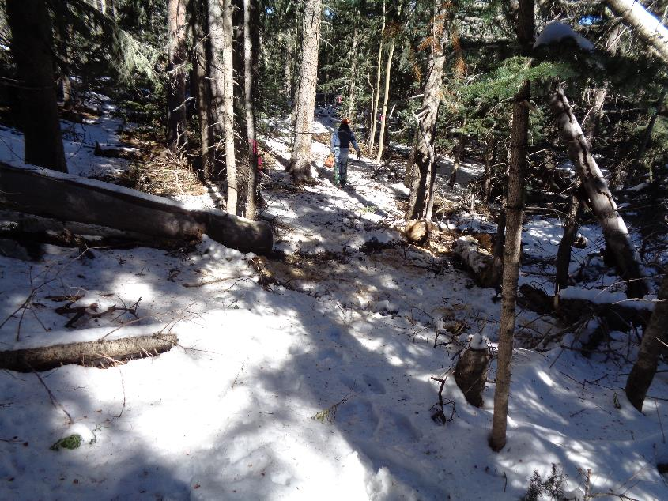

An upper part of the KM reroute with Eric carrying out a chain saw.

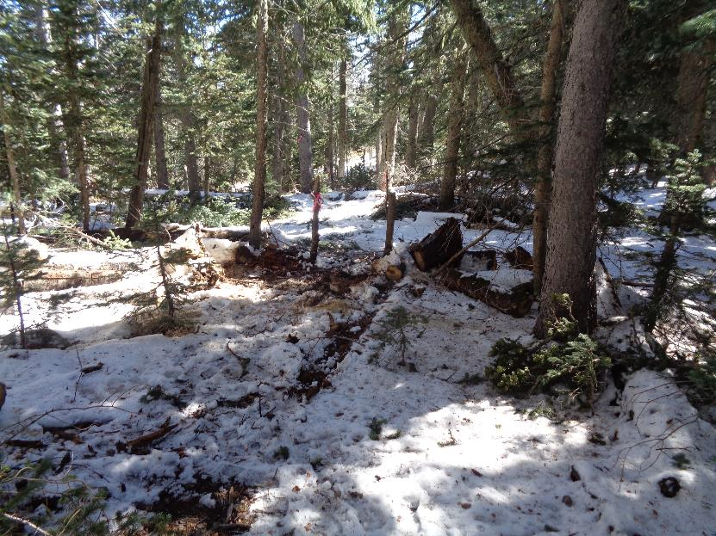

Looking along the cleared corridor just above the curve in the background where the long log had been lying.