**Report of FOSM Projects to Remove Down Trees from Gravel Pit Trail**

**and Other Trails on Monday, Oct. 31, and Wed., Nov. 2, 2022**

Sam Beard and Jerry Carroll

On Monday and Wednesday, Oct. 31 and Nov. 2, FOSM crews removed numerous down trees on Rocky Point Trail, Four Seasons Nature Trail, and Gravel Pit Trail.

1. **Monday, Oct. 31 – Jerry Carroll and Andre Biane -** Today Andre Biane and I cleared previously reported down trees on Rocky Point, Four Seasons, and Gravel Pit Trails. We removed three walkovers on Rocky Point (12-inch maximum) and multiple walkovers, head and knee-knockers, and hang-ups on northbound Four Seasons and Gravel Pit (up to 18 inches). Rocky Point and Four Seasons to the intersection of Gravel Pit are now clear of obstructions. At Gravel Pit we met Trails Boss Joseph and his crew doing the same job, so we began to leap-frog along the trail. As we departed first, we left several walkovers for Joseph, while removing any obstructions other than stepovers, leaving the trail passable. Joseph will have to report on the final status of Gravel Pit. The trails were getting snow packed and a little icy, traction devices helped but were not necessary. Also helpful was the mattock we carried along for removing branches in the snow and ice. (Jerry Carroll)
2. **Wednesday, Nov. 2 – Gravel Pit Trail** – The FOSM crew of Dan Benton, Byron Garner, Sim Cook, Cliff Giles, Jerry Carroll, and Sam Beard continued removing down trees on Gravel Pit Trail. The obstructions on this trail appeared to be the tops of live fir and spruce trees that had been brought down by a high wind event. The diameters of the tree trunks were small, and the tops were covered with green needles. Snow fell on the branches and froze, and it was difficult to pull the them from the under the snow and ice. Jerry and Joseph’s crews had cleared the lower one-third and upper one-third of this trail on Monday. On Wednesday, the FOSM crew cleared the middle third of the trail so that this trail was then completely clear from Kiwanis Meadow to the Four Seasons Nature Trail. It was estimated that three to four dozen down trees had been removed from this trail. (Sam Beard)

Project photographs from both days are presented below.

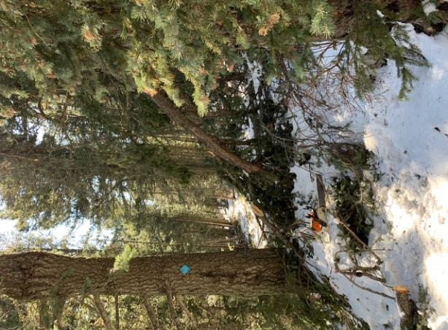

Train wreck on Four Seasons Nature Trail on Monday, Oct. 31. Photo by Jerry Carroll

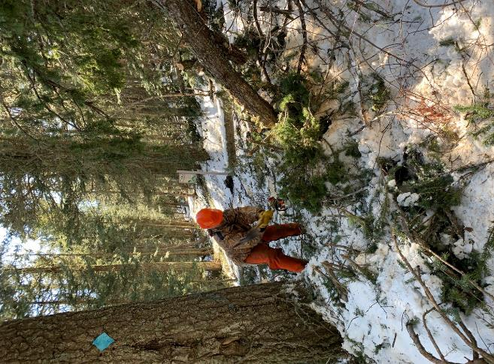

Andre Biane removing branches from the Nature Trail. Photo by Jerry Carroll

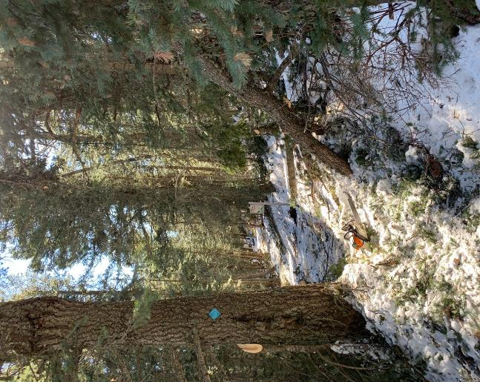

This segment of the Nature Trail is now clear. Photo by Jerry Carroll

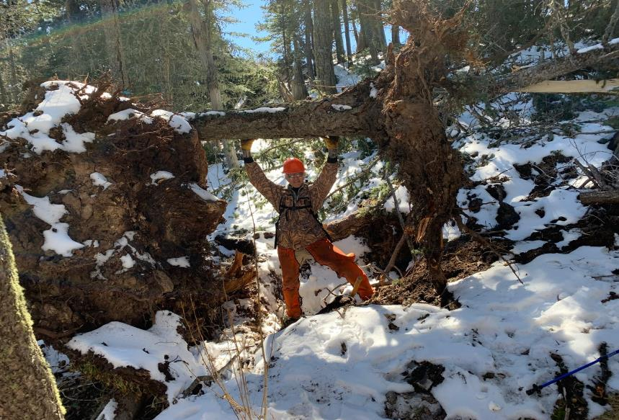

Andre Biane holding up a root ball on Gravel Pit Trail on Monday.

On Wednesday, the crew routed the trail around the right side of the root ball. Photo by Jerry Carroll

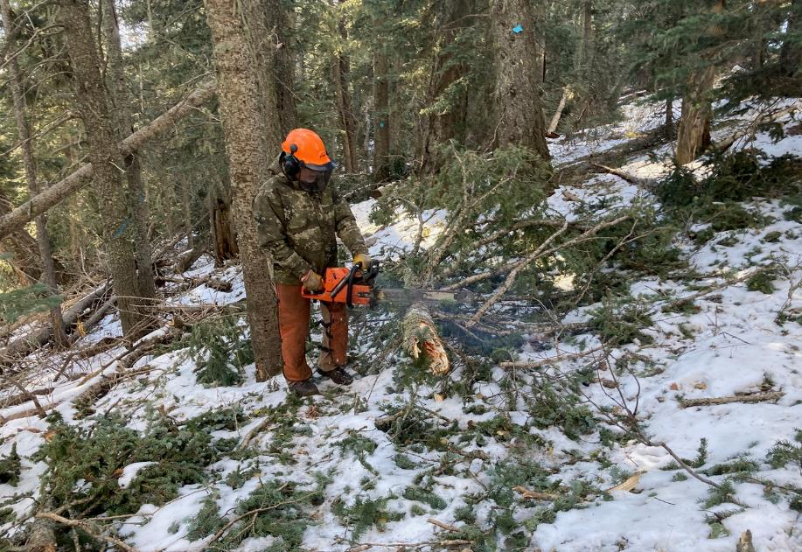

Dan Benton cutting a tree trunk on the trail on Wednesday. Photo by Cliff Giles

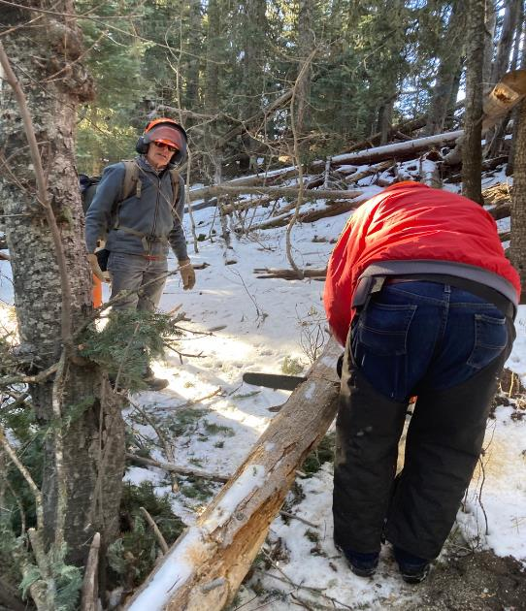

Jerry Carroll cuts a log on the trail while Sim Cook observes. Photo by Cliff Giles

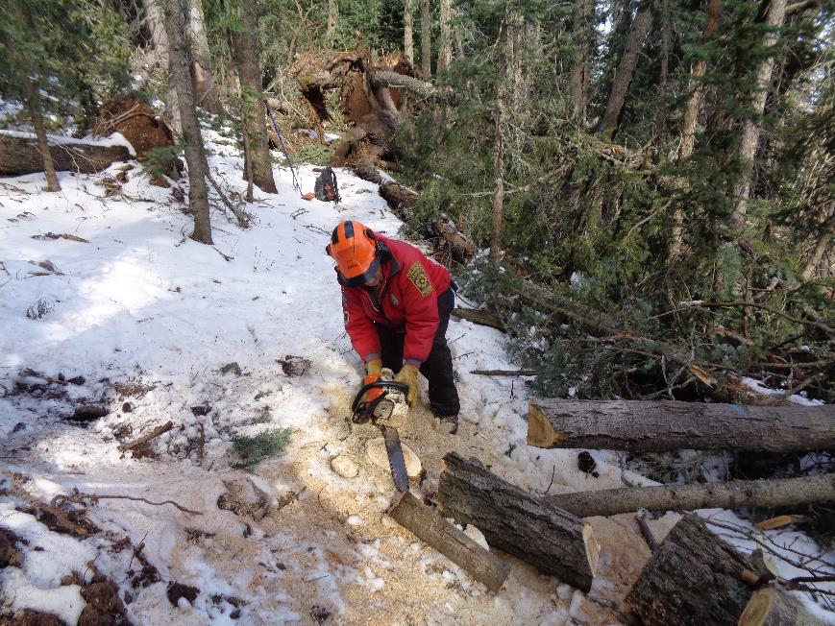

Jerry completing low stumping a dead 10-inch tree that he felled adjacent to the trail tread. Photo by Sam Beard

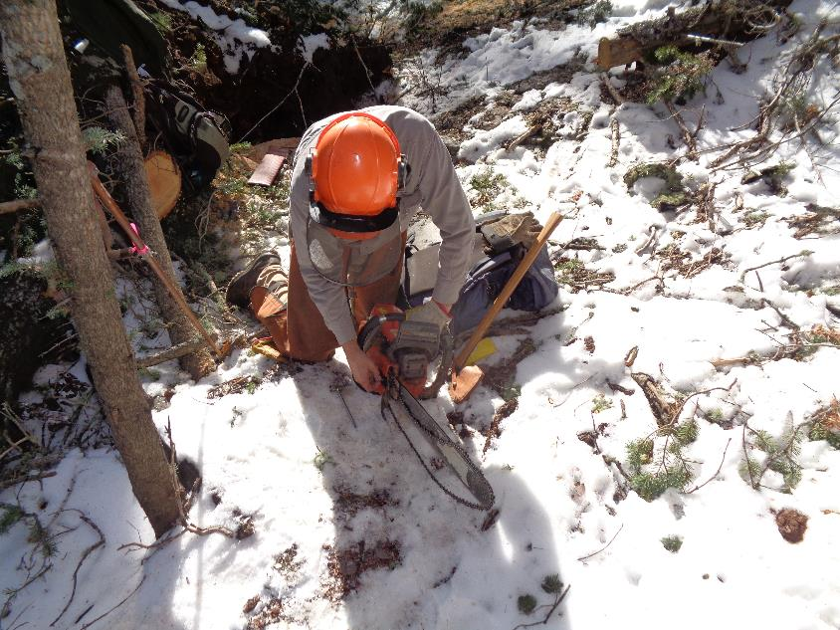

Dan Benton putting a sharp chain on the saw he was using. Photo by Sam Beard

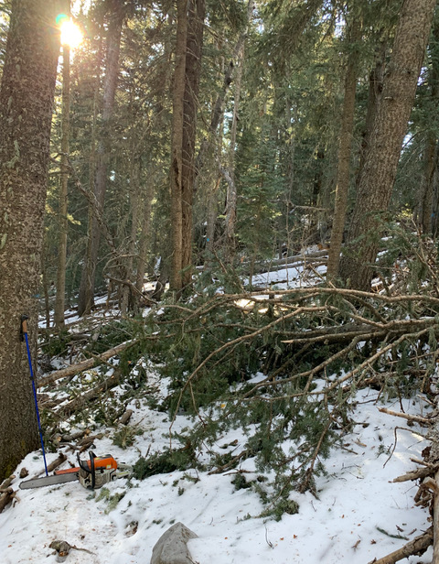

Train wreck on Gravel Pit Trail. Photo by Jerry Carroll

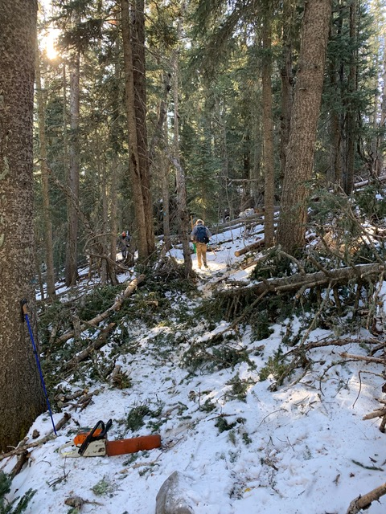

Clear trail after the train wreck was removed on Wednesday. Photo by Jerry Carroll

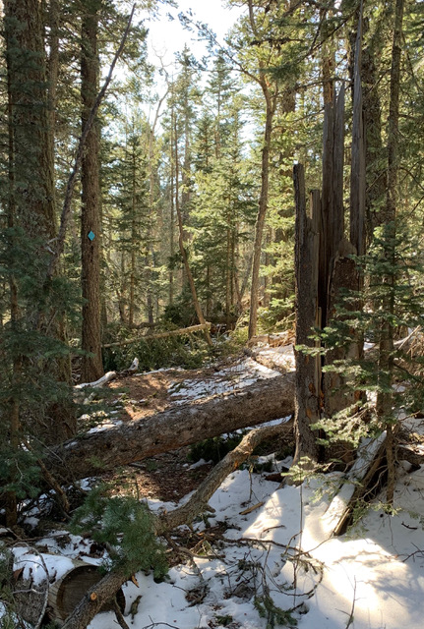

A large tree down on Gravel Pit Trail. Photo by Jerry Carroll

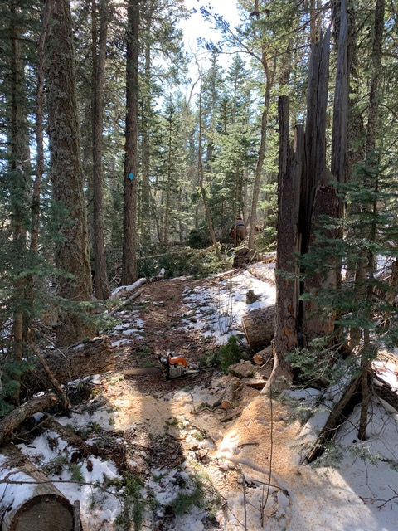

Trail after the log was removed. Photo by Jerry Carroll

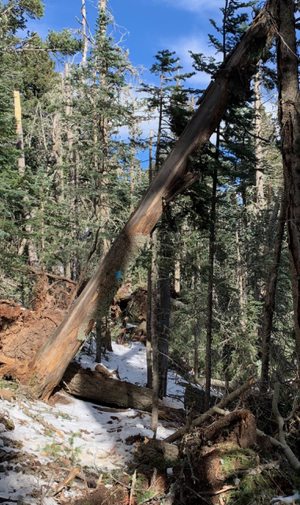

A log on the trail under a hang-up. Photo by Jerry Carroll

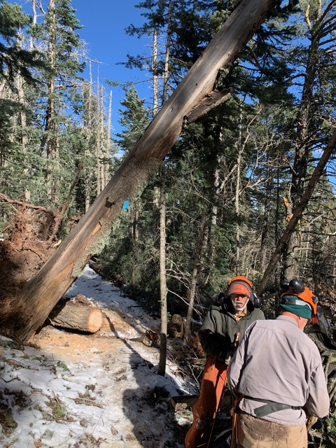

The log on the trail has been removed. Photo by Jerry Carroll