This was the scene that greeted the crew upon arrival at the 10K

North Trailhead. This photo is looking toward the east end of the parking lot. The bright blue sky was only intermittent during the day when overcast skies were the norm.

This shot looks toward the west end of the parking lot. The foggy looking cloud in the background eventually enveloped the entire mountain top for most of the day. The temperature remained a constant 20 degrees most of the day. An occasional breeze made it seem colder.

Hi-Ho, Hi-Ho, it’s off to work we go. The snow varied

in depth from about two to eight inches depending on elevation, sunny vs. shady areas and drifting. Snowshoes were not required but traction devices were worn all day.

Jamey is unfolding a large Silky saw in preparation

for removal of a large hang-up over the trail. This

was one of several which were removed that day.

While snow is being cleared from the cut location on the hang-up, the crew puts the finishing touches on the sawyer’s escape

route.

The hazard has been removed. After the top of the

hang-up had been cut away, the lower end sank to

near the ground as seen in the right side of the photo.

Yet another in the string of hang-ups removed on Monday.

The top of this fallen tree was protruding into the

trail and was cut back.

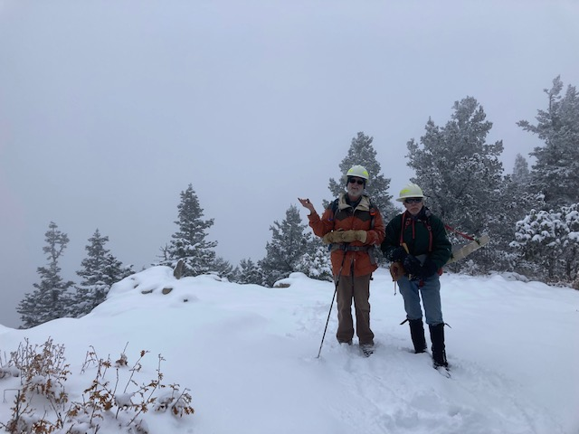

After the work had been completed along 10K North Trail, crew members Cleve Sharp and Byron Garner pose at the Del Agua overlook. (Not pictured - Silke Bletzer.)

Finishing lunch near the War of Roses medallion tree

on Survey Trail. Given the artic conditions, it was no

surprise that the break did not last long.

The crew discovered this 17-inch diameter fallen fir blocking

Survey Trail. It had not been reported.

The first cut on the fallen fir is progressing.

Dave waits for the crew to finish the first cut. Once

that was done, the second cut was completed and the removed

section was rolled off the lower side of the trail.

The large fallen fir has been removed. The cut section with its blue diamond still attached is at the right of the photo. Monday’s crew, from left to right; John Cooper, Dave Gabel, Bob Lowder, Jamey Browning, Byron Garner, David McCreery, and Cleve Sharp. (Not pictured – Silke Bletzer)