**Report of FOSM Project to Complete Clearing the Corridor for Challenge Trail Extension**

**in the Area between the large Culvert under the Crest Highway**

**and Bill Spring Trailhead in Tejano Canyon on Wednesday, December 7, 2022**

Sam Beard

On Wednesday, December 7, eight FOSM volunteers completed clearing the corridor for Challenge Trail Extension in Tejano Canyon between the large culvert under the Crest Highway and Bill Spring Trailhead. The tasks completed in three segments of the route here are presented in the Google Earth Satellite photograph below.

The volunteers working on this project were Cliff Giles, Dennis Crowther, Byron Garner, Eric Russell, Sim Cook, Dan Benton, Jerry Carroll, and Sam Beard.

Additional photographs are also presented below.

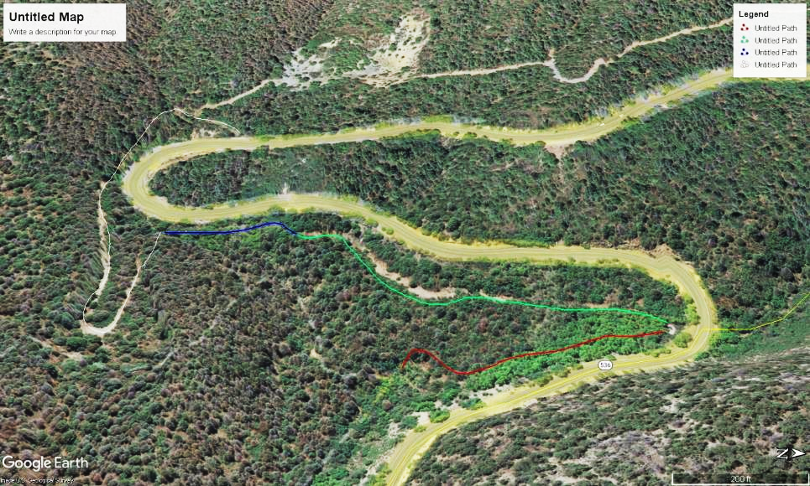

(Note that on this rotated map north is to the right.) Google Earth Satellite photograph of the Challenge Trail Extension route in and adjacent to Tejano Canyon about 1.5 miles up the Crest Highway from Doc Long Picnic Area. In the segment indicated by a blue line, pink flags were added to better mark the route. Clearing of the corridor in the green segment was completed in the past. Most of the clearing on Wed., Dec. 7, was along the red line between the large culvert under the Crest Highway and Bill Spring Trailhead. The 200-foot scale is located in the lover right corner of the map.

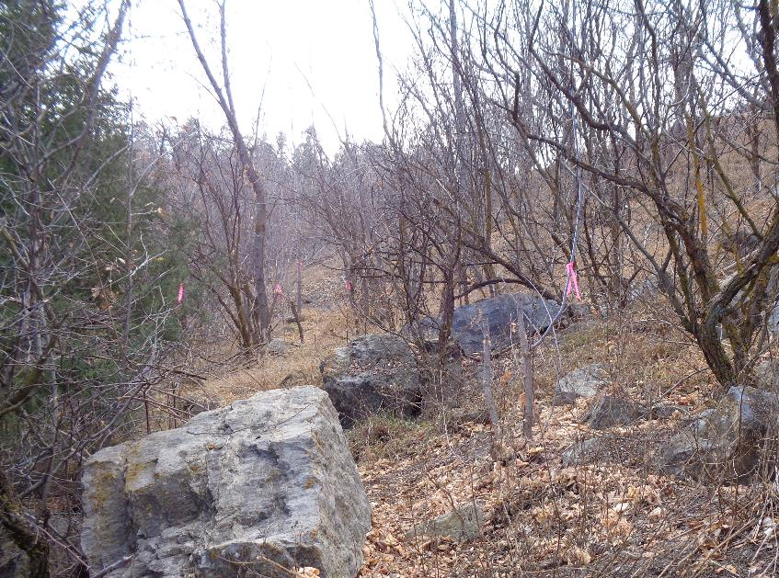

Additional pink flags were added on this segment of the trail just below the Crest Highway in the upper right corner of the photograph.

Photo by Sam Beard

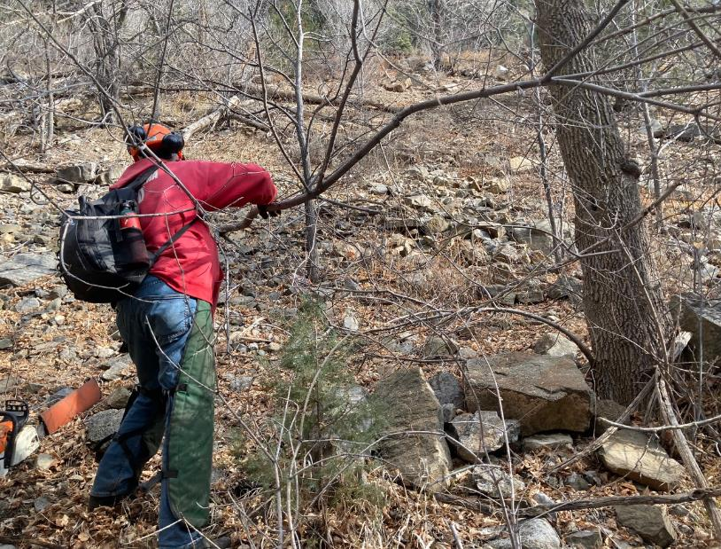

Jerry Carroll removing a branch from the corridor. Photo by Cliff Giles

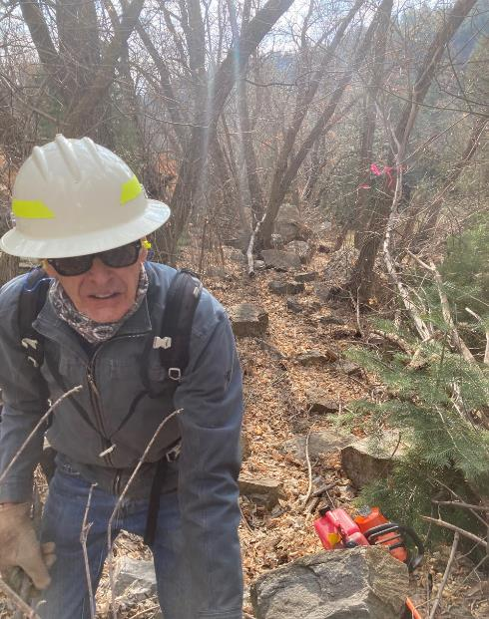

Sim Cook with the route behind him going from the hillside below the highway to the bottom

of Tejano Canyon. Photo by Cliff Giles.

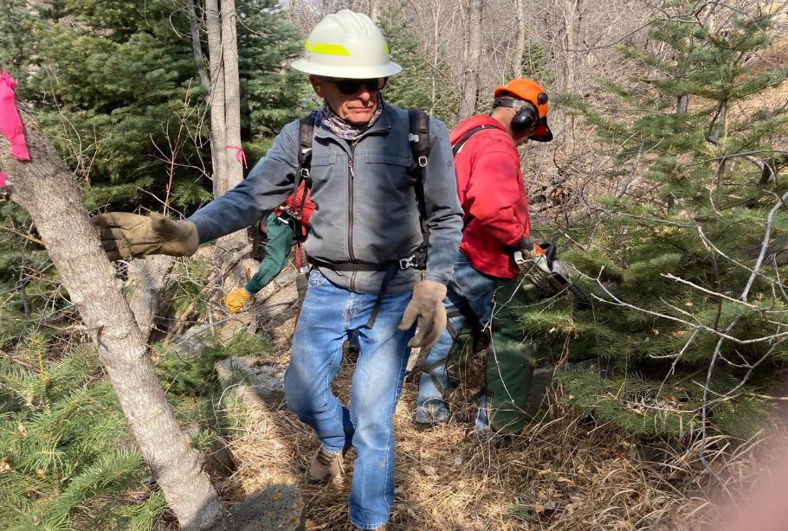

Jerry limbing a tree with his chain saw and Sim swamping for him. Photo by Cliff Giles

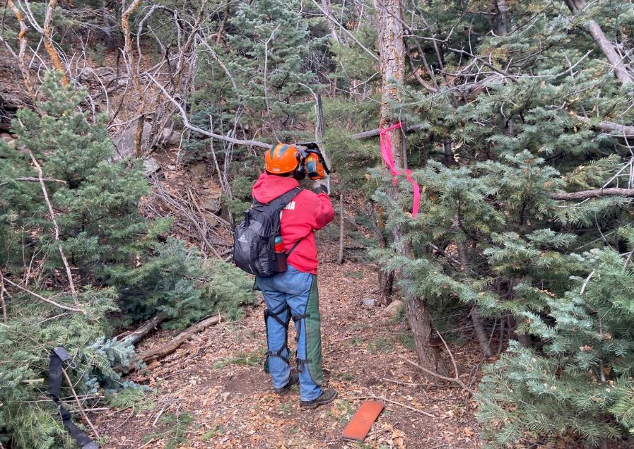

Jerry cutting an overhead branch on the corridor. Photo by Cliff Giles