**Report of Removal of Graffiti from Boulder in Juan Tabo Picnic Area**

**on Sunday, December 11, 2022**

Sam Beard

On Sunday, December 11, I removed purple and white graffiti on a large boulder at the small parking lot at the Juan Tabo Picnic Area restroom. A small tag inside the restroom was also removed.

As I was driving out, I found black graffiti on three boulders at one of the parking lots in the picnic area. This graffiti will be removed later.

I saw no graffiti at the La Luz Trailhead parking lot.

Project photographs are presented below.

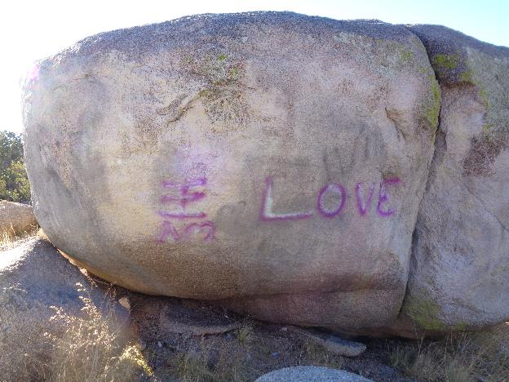

Graffiti on large boulder at the small parking lot at the Juan Tabo Picnic Area restroom.

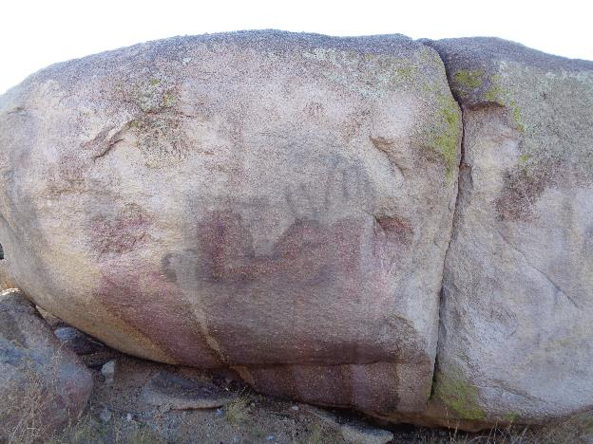

Large boulder after most of the purple and white graffiti was removed.

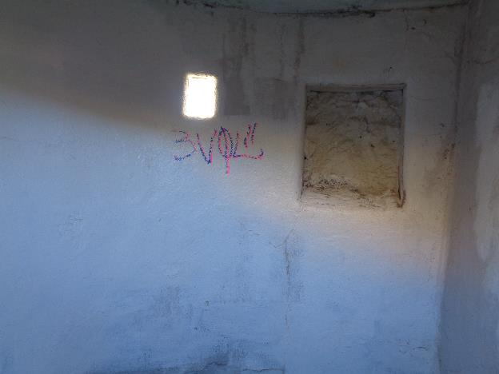

Small tag inside the Juan Tabo PA restroom. Most of it was removed with chemicals. Painting over graffiti on painted surfaces is permitted.

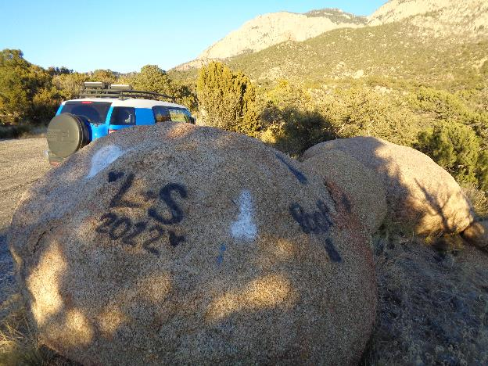

As I was leaving the Juan Tabo PA, I found black and white graffiti on boulders at a parking lot that we will remove later.

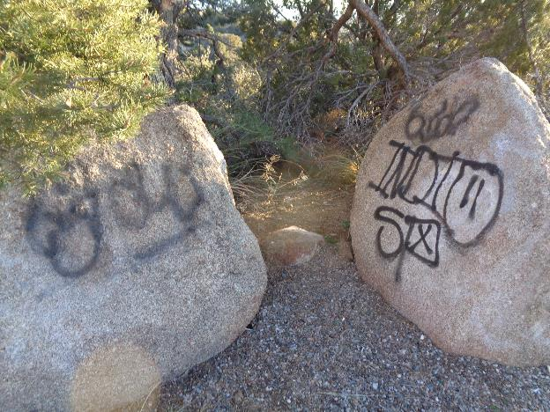

More graffiti on boulders at the same parking lot.