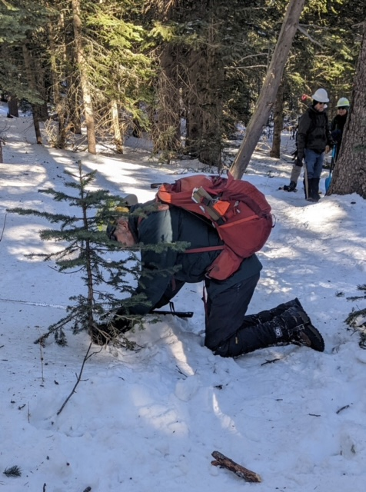
Clearing a tree from a snowshoe race re-route. It is assumed that a USFS
certification in felling was not required.
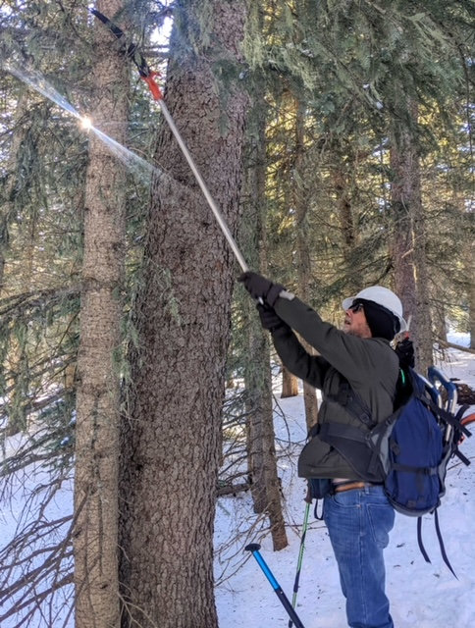
High limbing was done along the race re-route to prevent snow-covered branches from
dropping down into racers head space during the race.
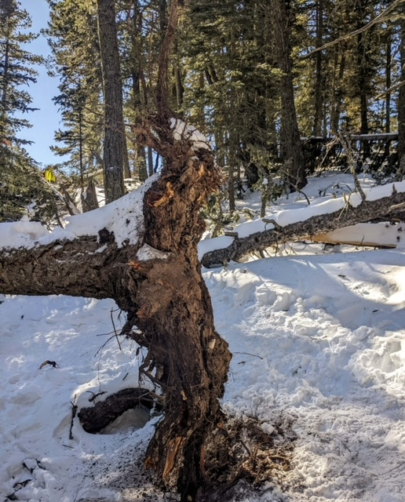
This nasty looking root ball is located on Gravel Pit trail. It is part of a group
of three trees that fell adjacent to the trail. The trail now goes around to the
right in this photo.
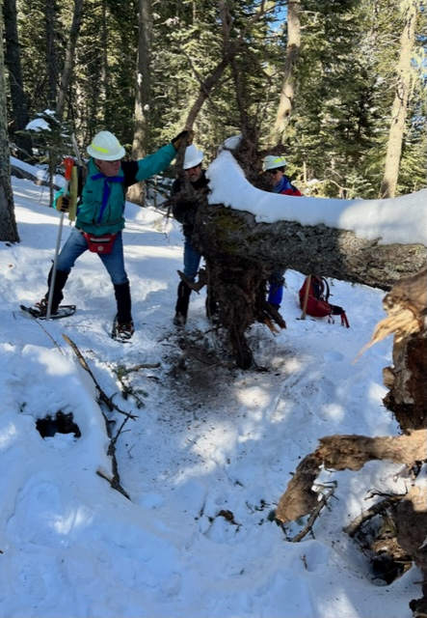
This is a view of the tree in the previous photo from the opposite direction.
there is a deep hole beneath the trees as the roots pulled out a lot
of soil and even a very large rock when they fell. Sharp protrusions were
cut off the root ball, but major work will have to wait until the snow
is gone.

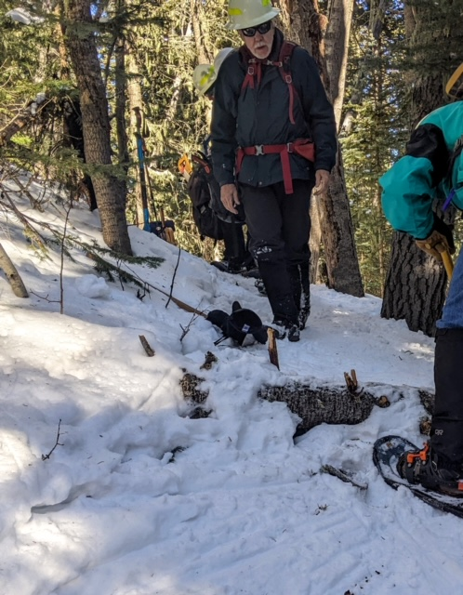
This previously reported mostly buried log was on Gravel Pit Trail.
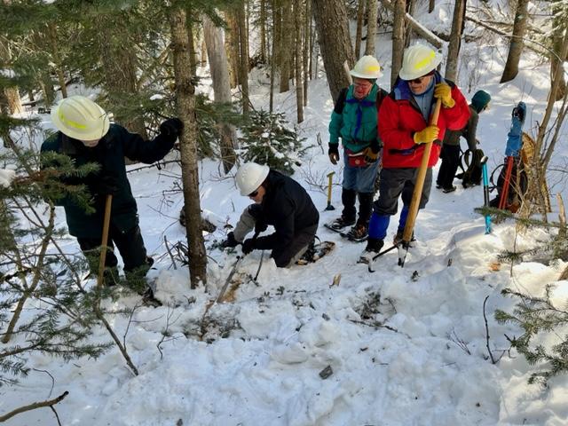
The lower end of the fallen log is being cut as the first step in its removal.

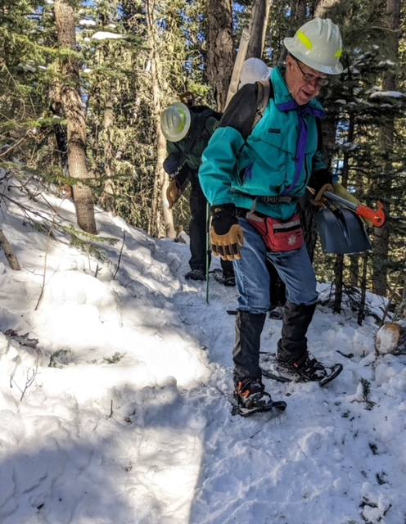
Fallen log has been removed.
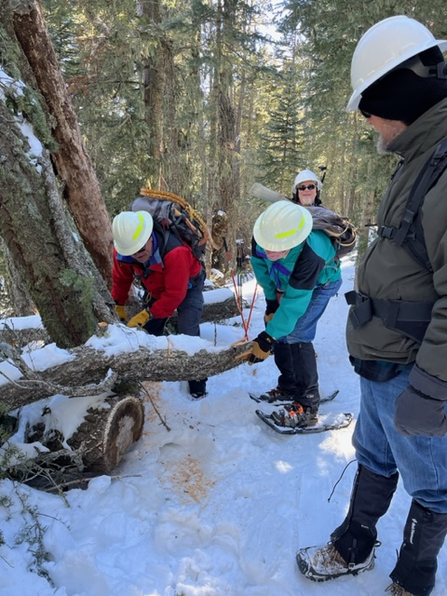
This fallen branch had a sharp end protruding into Gravel Pit trail. It was cut back.
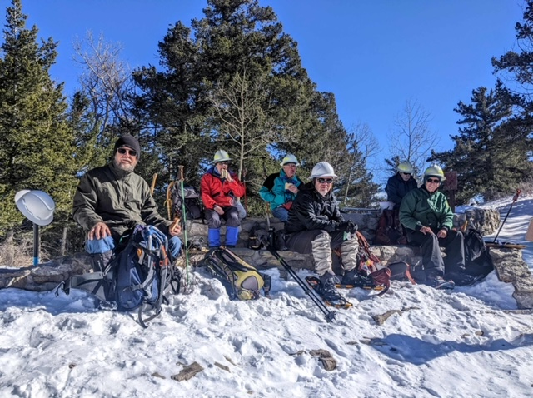
The crew having lunch at the Crest prior to returning to the Ellis parking lot via Rocky Point trail.
(Left to right) Phil Cromer, David McCreery, Jerry Pekarek, Jamey Browning, Byron Garner and Bob Lowder. Not pictured – Jenny Blackmore

