**Report of FOSM Project to Prune La Cueva Trail and Tramway Trail**

**on Wednesday, January 11, 2023**

Dan Benton and Sam Beard

**Report by Dan Benton**  
The team of Sim Cook, Eric Russell and Dan Benton pruned brush and cacti on the La Cueva Trail and the Tramway Trail from the junction with La Cueva Trail south to where the trail had been pruned by SRD crew member Jeff Cervantes working north from the Tramway trailhead last week. Following the prescription by Kerry Wood, currently detailed to the Southwest USFS Region as Trails, Dispersed Rec & Travel Mgmt Program Manager, the crew removed oak, juniper, piñon, mountain mahogany, sumac, cholla, and prickly pear. On the return the crew visited the nearby former Jaral Ranger Station and found the fountain there still had a flow of water from the pipe into the drinking basin.  
  
**(Sam Beard’s report follows Dan’s photographs.)**

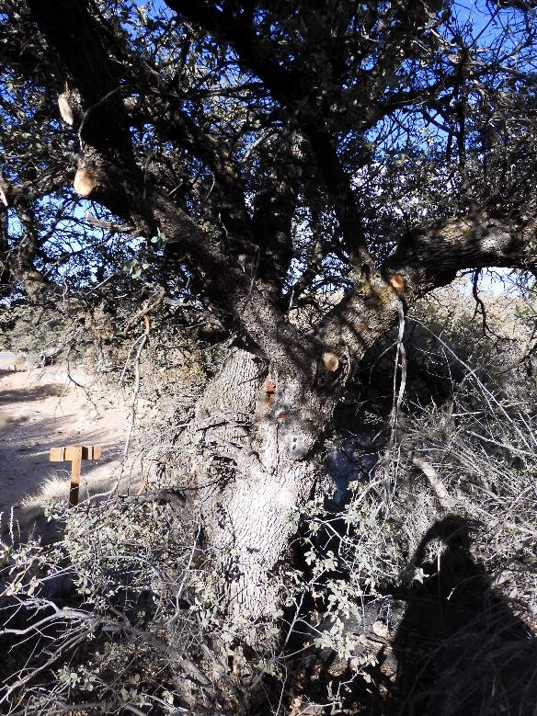

Oak pruned at the west trailhead of La Cueva Trail

All photos by Dan Benton

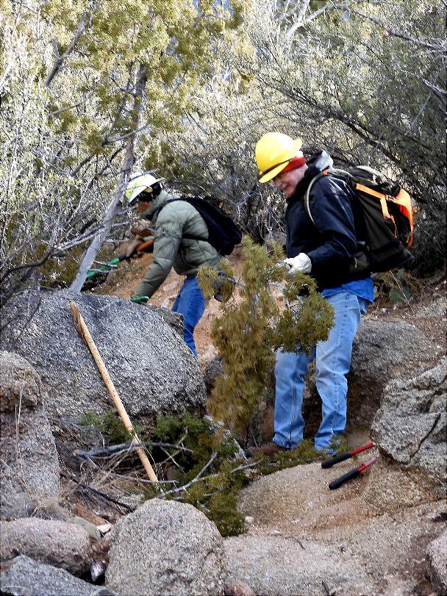

Sim and Eric pruning a one-seed juniper.

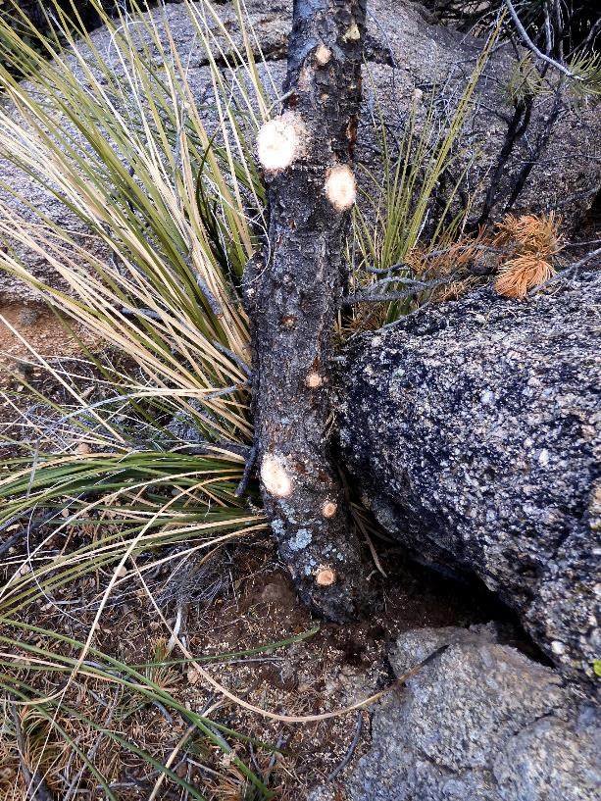

Pinon pruned by Dan’s crew.

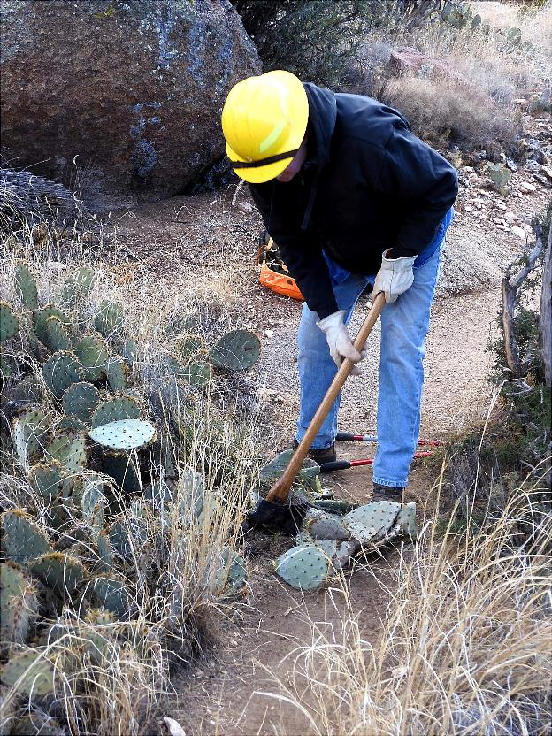

Eric using a Pulaski to remove cacti near the trail tread.

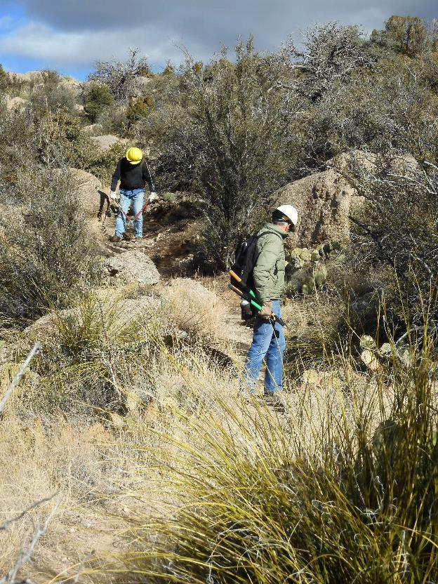

Eric pruning a plant and Sim looking for one to prune.

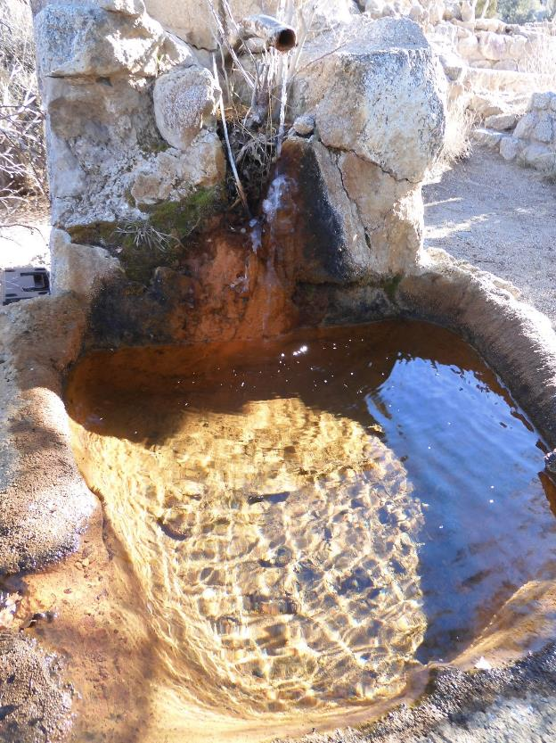

Spring water in the drinker at Jaral Ranger Station.

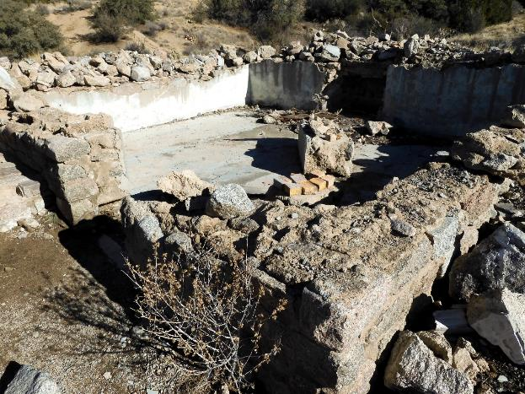

Jaral Ranger Station after explosives were used to remove the walls decades ago.

**Report of Pruning Tramway Trail North of the Intersection with La Cueva Trail**

The crew of Cliff Giles, Karen Grief and Sam Beard pruned Tramway Trail north of the intersection with La Cueva Trail. We also pruned oak, juniper, piñon, mountain mahogany, sumac, cholla, and prickly pear. This crew went about a quarter-mile north and turned around near the southeast corner of the Tierra Monte development. (Sam Beard)

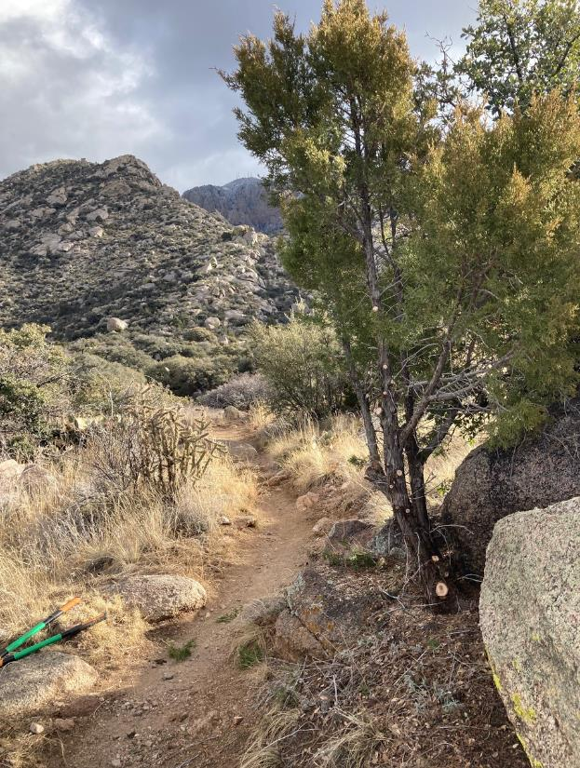

One-seed juniper after it was pruned. All photos by Cliff Giles.

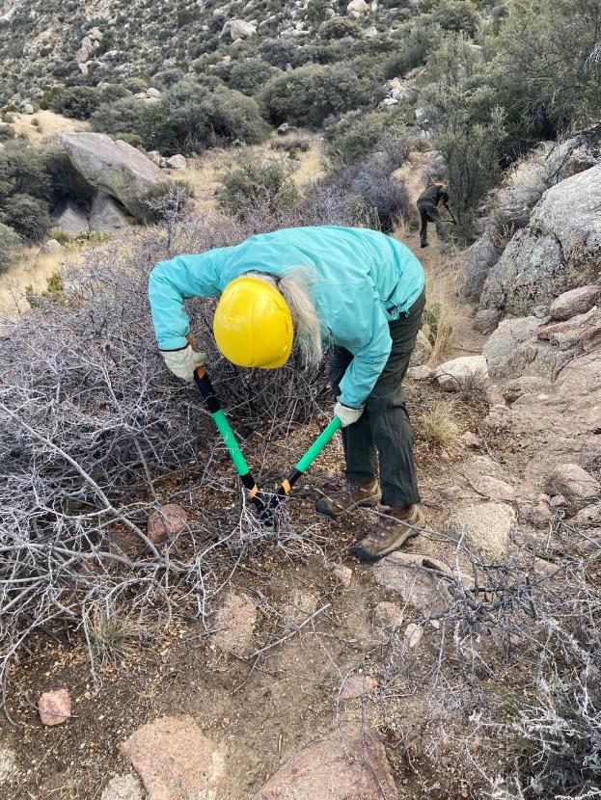

Karen trimming a sumac with Sam in background pruning a mountain mahogany.

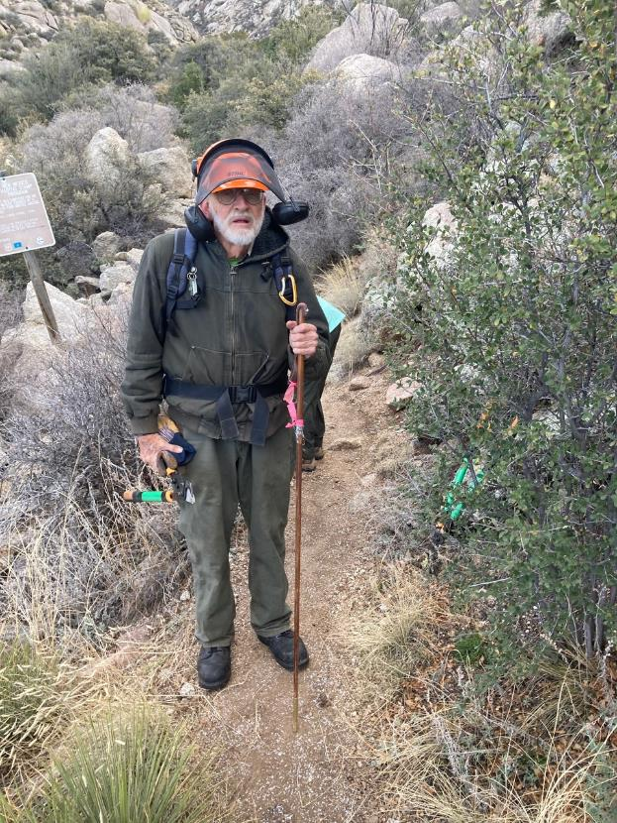

Sam beside a mountain mahogany he will remove.

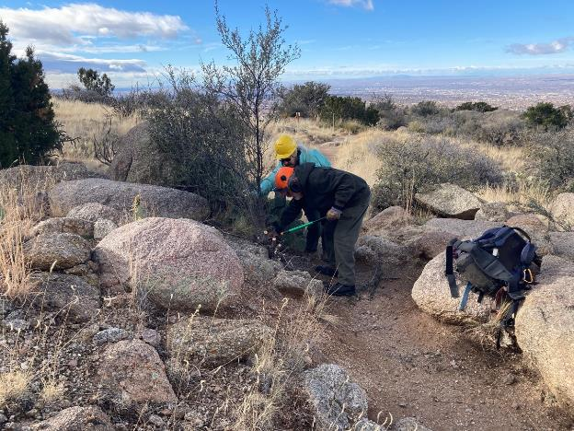

Karen and Sam pruning a mountain mahogany.