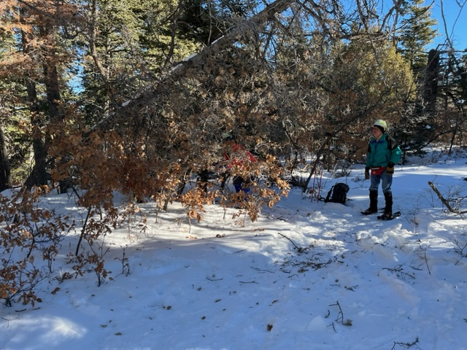

This approx. six-inch diameter dead fir had broken about four feet up its trunk and was leaning over Capulin Peak Trail. It was being held up by small oaks.

The crew is clearing brush and small trees from the work area.

This photo shows the top end of the fallen fir

suspended over Capulin Peak trail. Jerry is picking up the broken-off tip of the fallen tree. He is also discovering that hard hats put on over stocking caps do not always stay in place when one bends over.

Ropes were used to get the fallen tree off some of its supports so that it could be safely cut.

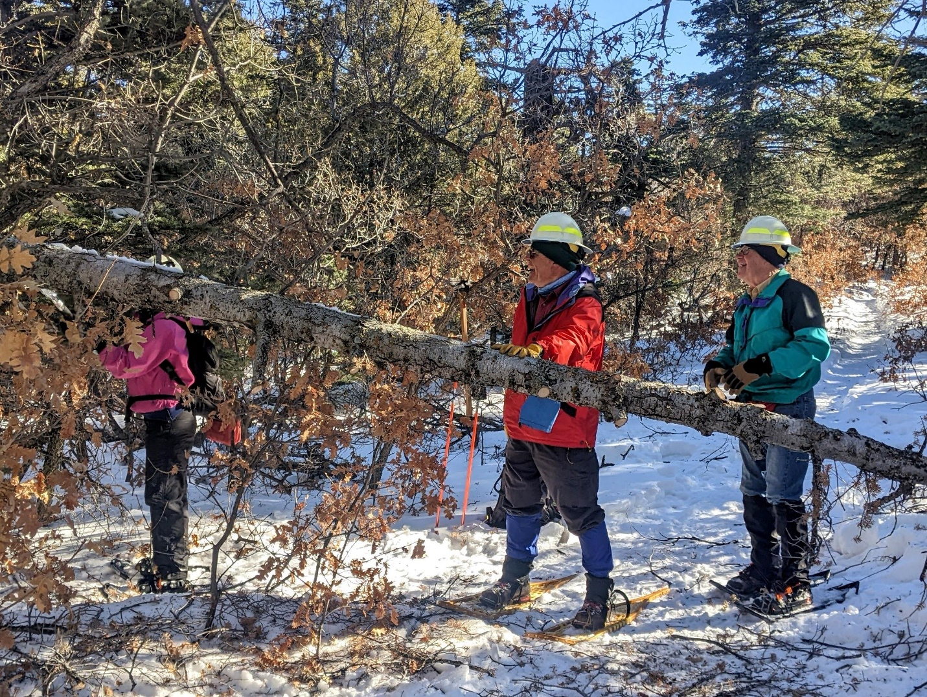

Once the fallen tree was lowered and protruding branches cut away, Rav begins the cut to remove it.

With the fallen tree finally on the ground, Jerry cuts it once more for easier removal.

All portions of the fallen tree have been removed.

Remaining debris was swept off the trail with a small

shovel.

This small dead leaner was a short distance up the

trail from the previous fallen tree. It was cut away

after being pushed to the ground.

Small leaner has been removed.

The crew has made it to the end of the trail at the Palomas Peak lookout. Great views in almost every direction.

A clear sunny day overlooking Palomas Peak, Las Huertas Canyon and a big chunk of New Mexico. In foreground, Rav Nicholson, and new crew member Bill Perkins.

Taking it all in….