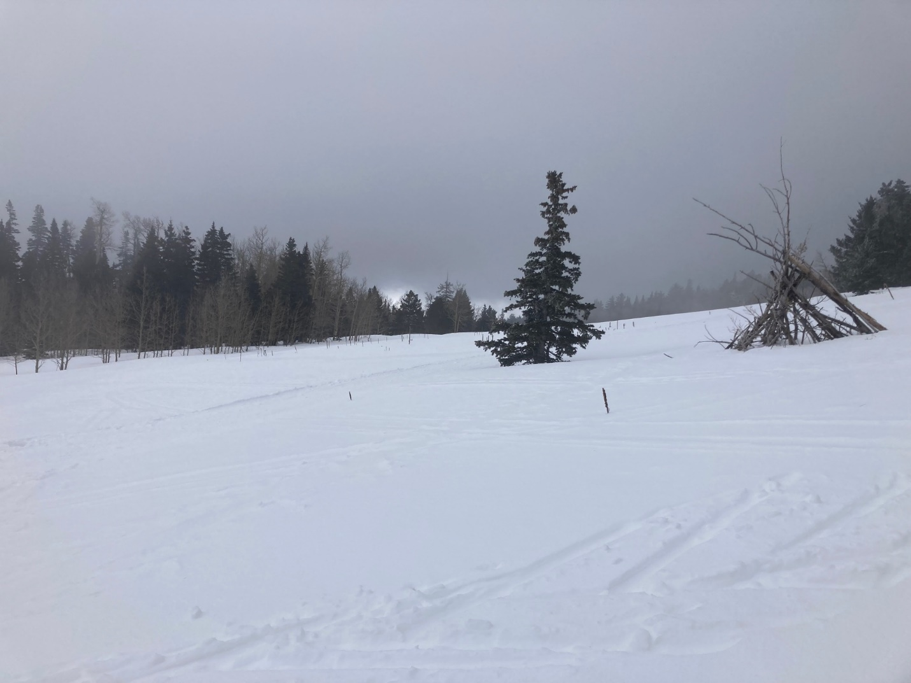

This photo is looking south from a large meadow on the Challenge
Re-Route between the Ellis parking lot and the 10K South junction.
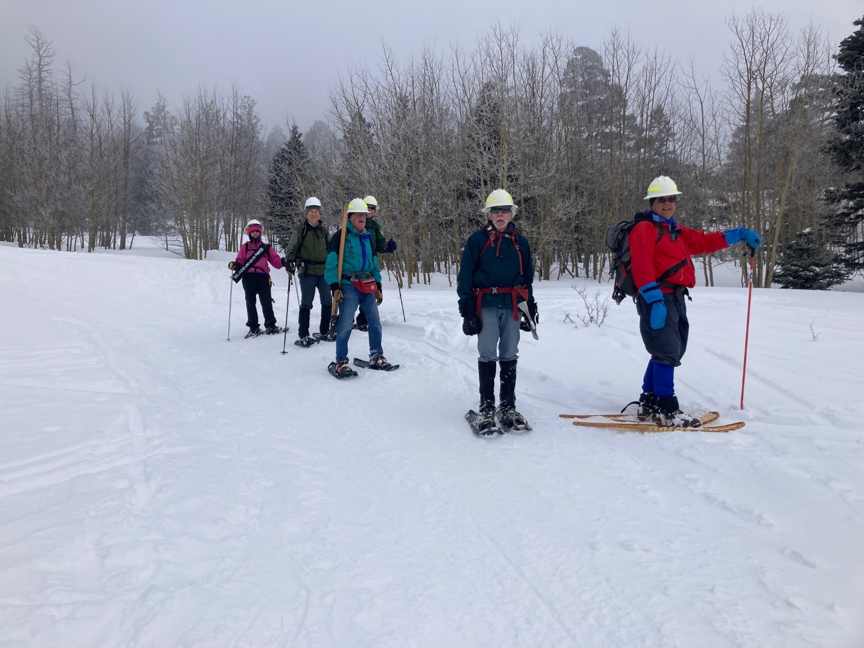

This photo is looking north from the same location as the previous photo. Snow accumulation varied widely due to drifting with a measured depth of three feet at one location.

Monday’s crew, from left to right; Rav Nicholson, John Cooper,
Jerry Pekarek, Bob Lowder, Byron Garner and David McCreery. (Not shown – Jamey Browning)

