This dead tree had fallen along the lower margin of Faulty Trail

a short distance uphill from another fallen tree previously reported by David Galbraith. The protruding branches were a bit too close to the trail tread to be safe. They were cut back. The tree itself should provide support to the downhill side of the trail.

This photo shows the stump of the tree in the previous

photo. No wonder the tree fell over!

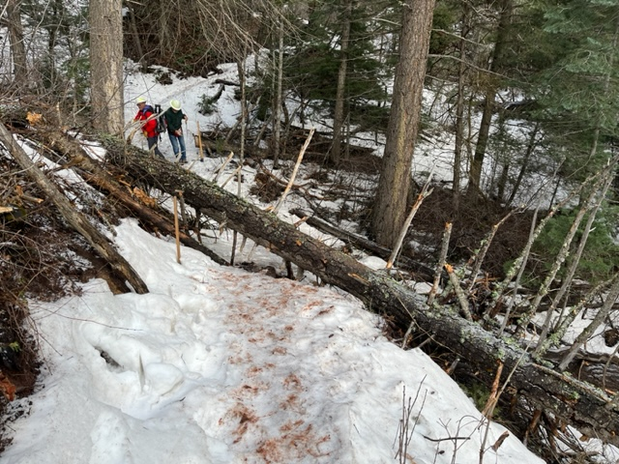

This 15-inch diameter fallen tree was blocking Faulty Trail about a quarter mile north of the Sulphur Canyon trail junction. It had been reported by David Galbraith. The tree extended from the lower right portion of the photo to beyond the light colored upright tree in the far upper left.

Rav is using her crosscut saw to make a cut on the fallen tree. The job was complicated by the fact that the wood was frozen, tended to swell as the cut was made, and the trunk was subject to heavy top and end bind. After inserting a wedge, the cut was completed using a large folding Silky saw as it created a narrower kerf.

Big fallen tree removed, and the trail is clear. The crew, left to right – David McCreery, Jerry Pekarek and Rav Nicholson (Not pictured – Bob Lowder)