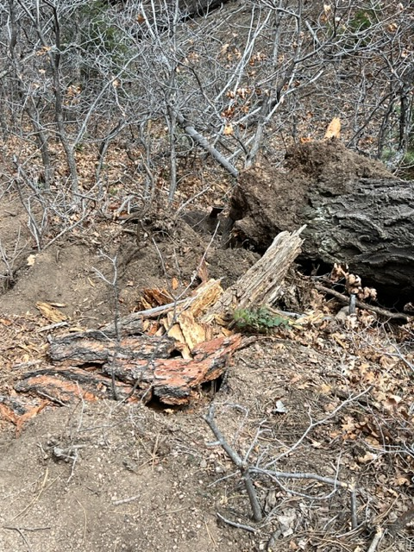
This photo shows the temporary repair done on the hole
left on the lower margin of the trail by the root ball
of the fallen tree.

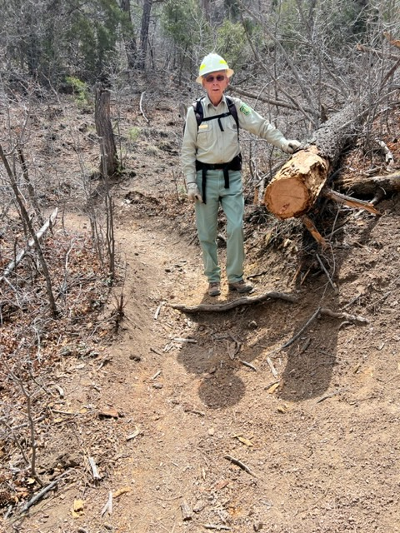
The lower portion of the fallen tree had been moved downhill
off the trail. We decided to cut back the upper portion
of the trunk a bit.

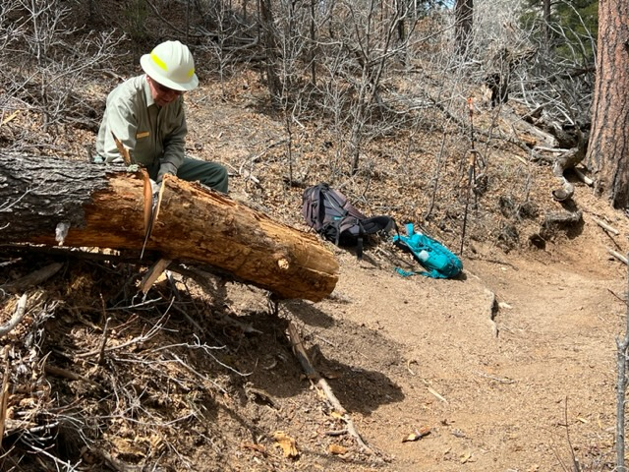
The protruding portion of the upper trunk is falling away from the cut.
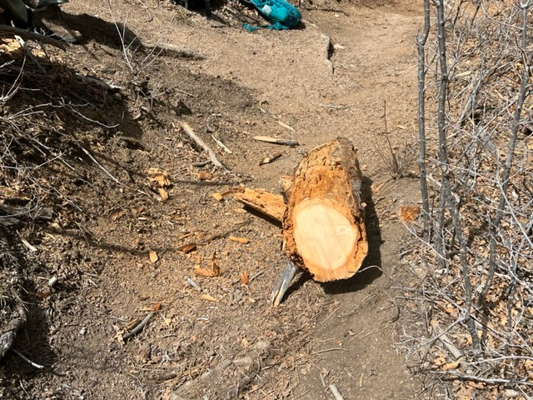
The cut away portion of the upper trunk lies on the trail prior to being moved to the bottom side of the trail. This is a good illustration of a common condition found on some fallen trees. The outer portion of the trunk has begun to rot and the saw passes though it quickly. This is good news to the sawyer, then, oops! The remaining wood is as hard to cut as it ever was. Oh well, when the saw eventually passes through to the rotted wood on the bottom side of the trunk it cuts faster again.
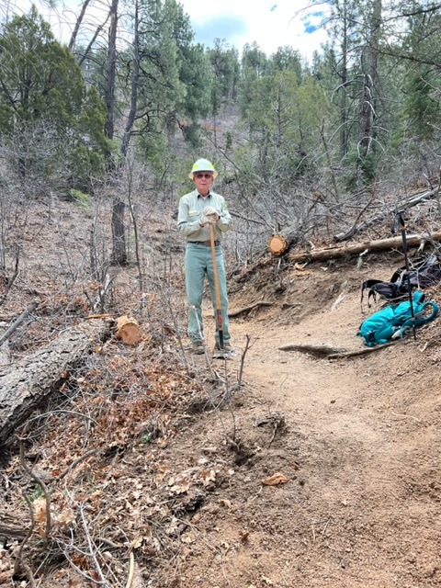
All done! The fallen log has been cut back, the trail tread
has been repaired and the root ball hole has been filled in.

