Monday Trail Crew Report: April 17, 2023
Byron Garner

On April 17, the Monday Trail Crew hiked 6.1 miles beginning on Horse Bypass from Cienega Picnic Area to remove three trees previously reported, the first of which was a 5"Fir protruding into the trail at 1.14 miles from the parking area. Continuing on a short distance beyond the Cienega junction on Faulty( 2 miles), we found and removed a 16" oak across the trail which was stretching the limits of our Katana saw. Moving on, we arrived at the Faulty/Armijo junction to find a beautiful cascading mountain stream with sunlight filtering down through the forest canopy which compelled an extended stay to enjoy this rare opportunity. As a bonus, Dave McCreery found us an unreported 4" Aspen at the Medallion Tree across that trail. Moving on down Armijo, at mile 3.6., we arrived at the reported leaner which was soon recognized from previous efforts. It continues to have a complex and well supported structure including more than adequate clearance which led to the conclusion as best left alone. We all enjoyed a restful lunch at the Cienega T-intersection picnic area to round out what was a classic spring day with "as good as it gets" conditions. The crew included Jamey Browning, Bill Perkins, Silke Bletzer, John Cooper, Ken Wilson, Jerry Pekarek, Sim Cook and Dave McCreery. Photo and map credit: Jamey Browning; Photo and Trail Note credit: Silke Bletzer

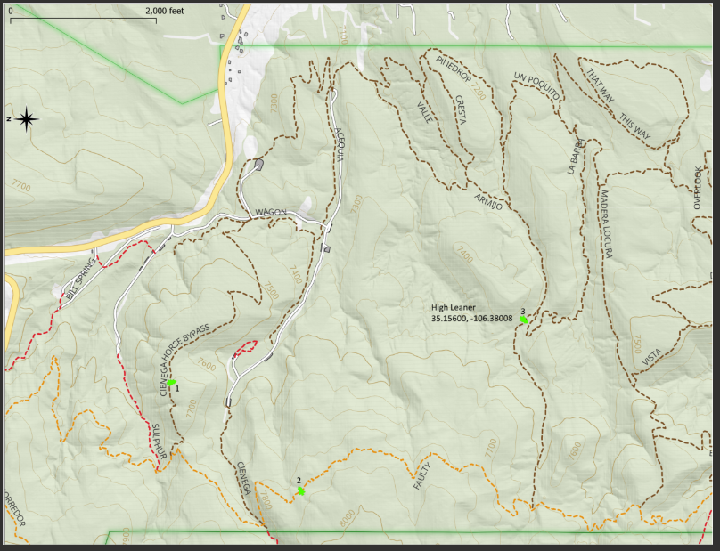

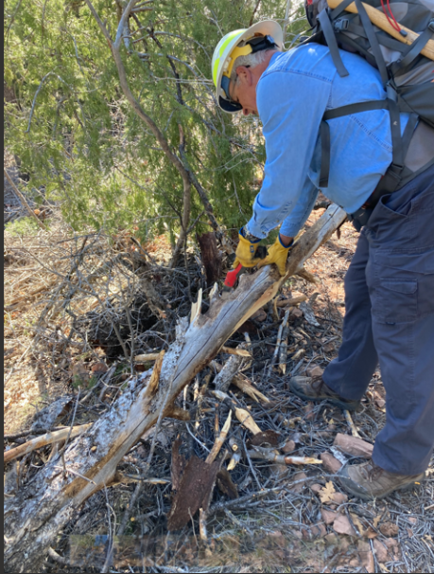

Dave putting the polish on the first tree

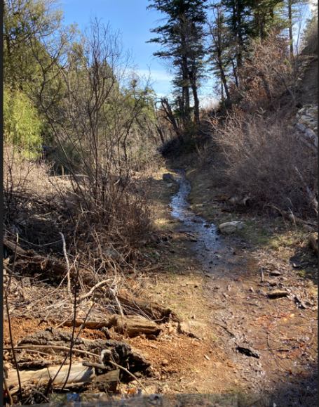
Cienega Trail

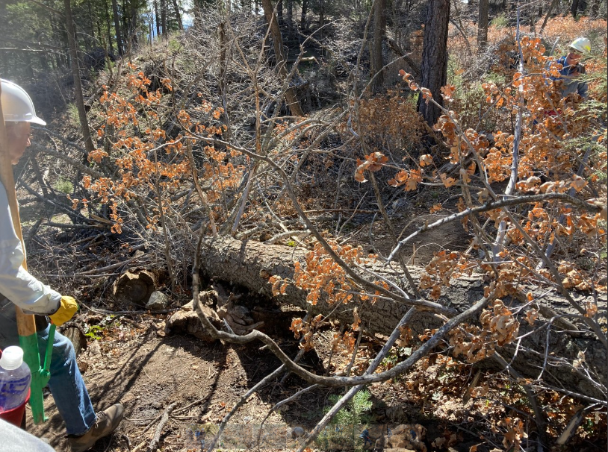

16" of oak to cut

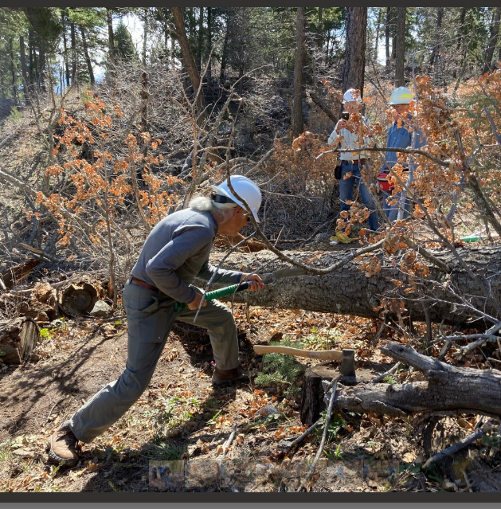
Bill earns his stripes with gusto

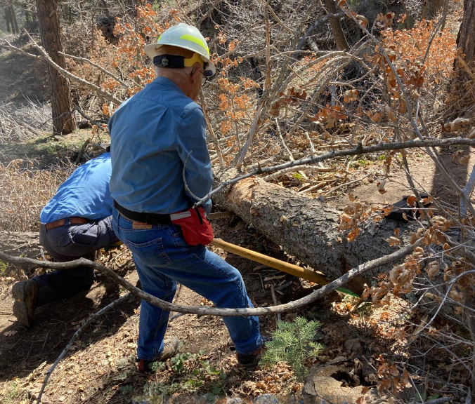
Jerry and Dave wrap things up

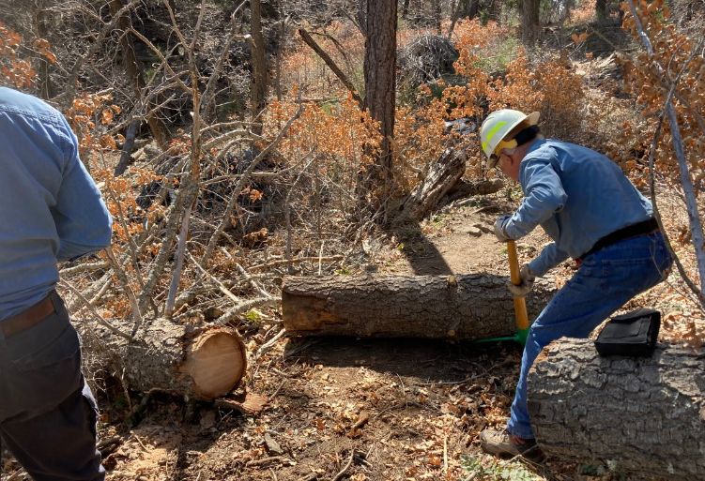
Dave keeps things rolling

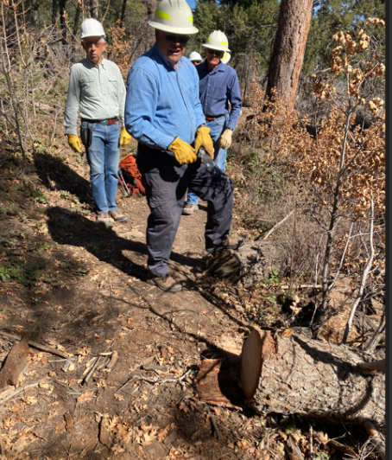

John, Dave and Sim finished with text book results

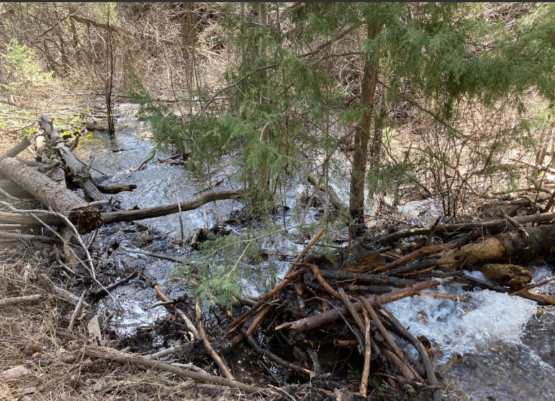
Cascading stream at Armijo/Faulty junction

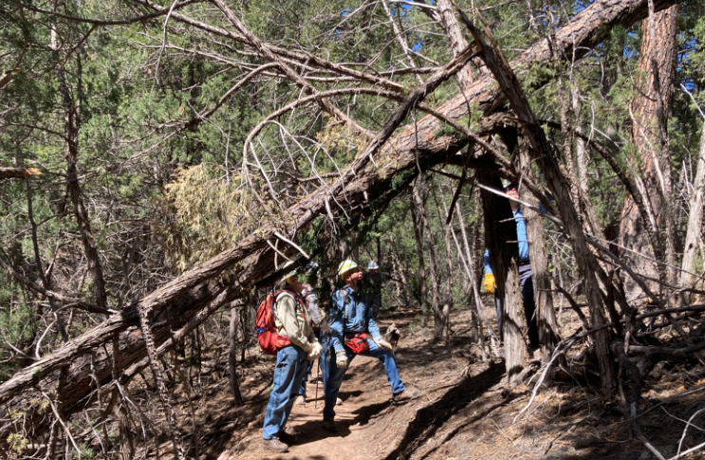

the challenge that will have to wait

