Monday Trail Crew Report: April 24, 2023

Byron Garner

On April 24, the Monday Trail Crew hiked Embutito Trail 2.5 miles to the switchbacks to remove a12.5" firreported by Galbraith which was found to be one of the more interesting of our recent projects. It had fallen upgrade and was intersecting and completly blocking both the lower and upper legs of the switchback while being supported above ground level with spring poles and binding support trees. After initial assessment and limbing, two teams were formed to address their respective upper and lower segments. Support trees were eliminated allowing the aspen to drop with the upper segment cantilevering on a support rock. With a little team effort using the Katana saw, the upper segment was on the ground allowing the second team to begin their work with Rav's crosscut, better known as Zeus. With a couple of cuts latter, team two had the lower segment of the switchback clear. We had the good fortune of our worksite being located in a beautiful wooded canyon with large granite boulders and a quietly running spring to make for the perfect lunch venue with friendly conversation before confronting our return on the rough trail ahead. The crew included Jenny Blackmore, Dave McCreery, Rav Nicklson, Jamey Browning, Bill Perkins, John Cooper and Ken Wilson. Photo Credits: Jenny Blackmore

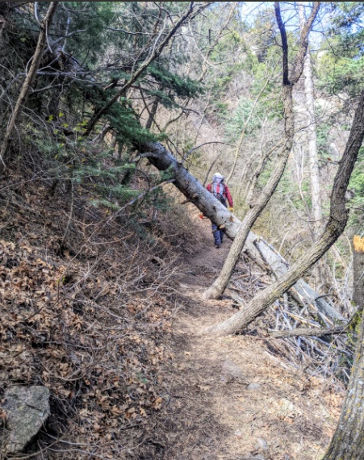

Challenge 1

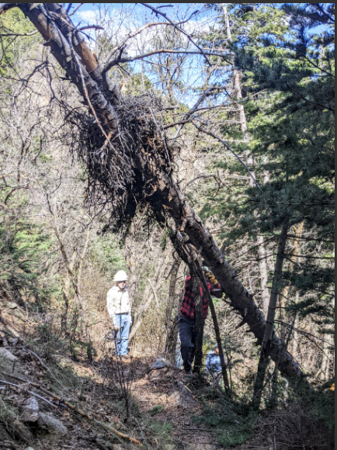

Challenge 2

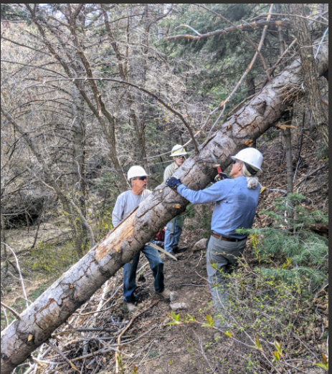

Bill and Ken "limbing it up"

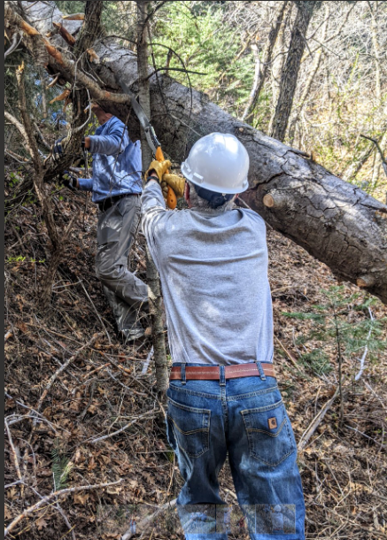

Ken reaching with gusto

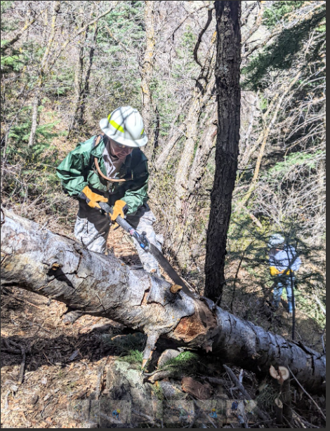

Rav makes the first cut for team 1

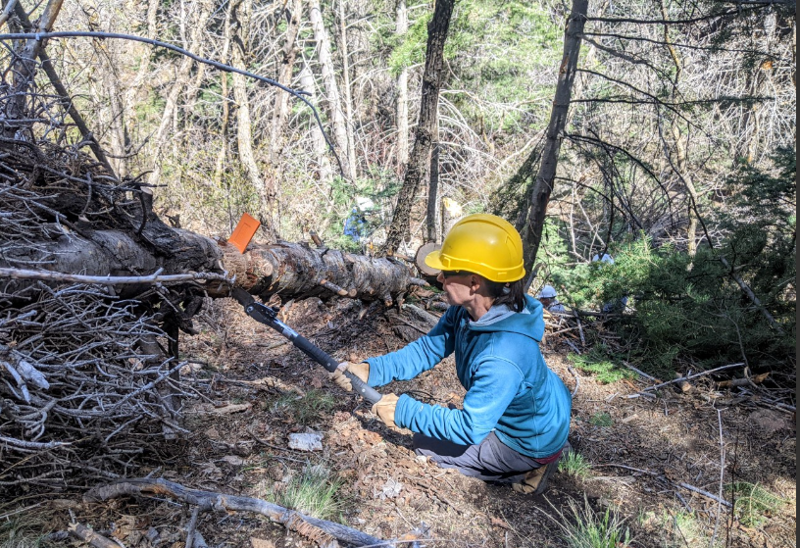

Jenny finishes the second cut

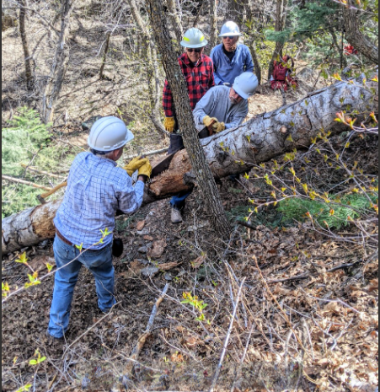

John and Ken get in some good crosscut time

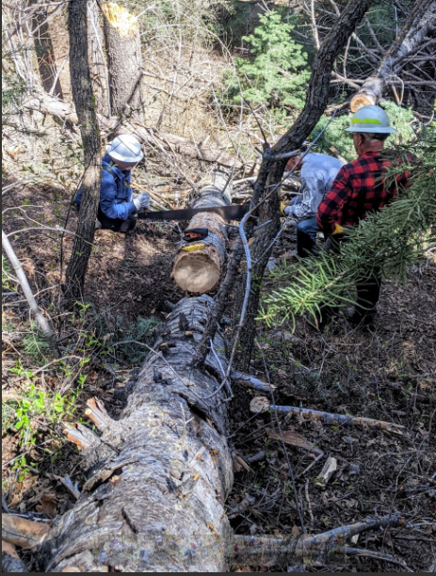

Jenny gives us an interesting angle as Jamey and John make the final cut while Dave checks the progress

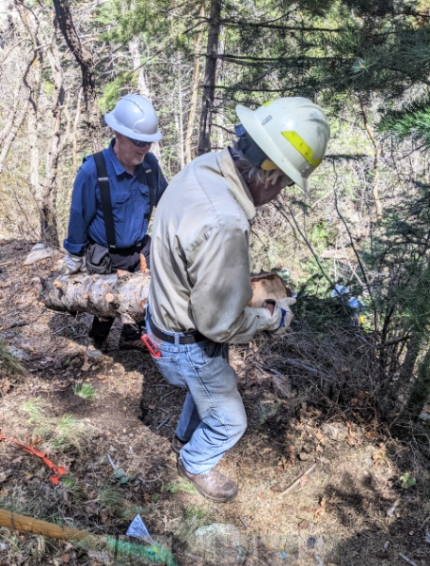

Jamey helps clear the upper trail