**Hazard Tree Maps for April 2023 for Sulphur PA and Doc Long PA**

Sam Beard

April 24, 2023

The Tree Risk Assessment Form for each hazard tree was completed. Location coordinates were obtained from Sam’s cell phone using the Gaia mapping app. All entries were written on the forms. Using Google Earth Satellite photographs, a placemark for each hazard tree was placed on the GE photo at the recorded coordinates. Tree number, species, and diameter were entered in a Word table that was taped to the GE photo that was scanned. The scanned photos were then copied into this Word document.

Hazard tree maps for Sulphur PA and Doc Long PA are presented below.

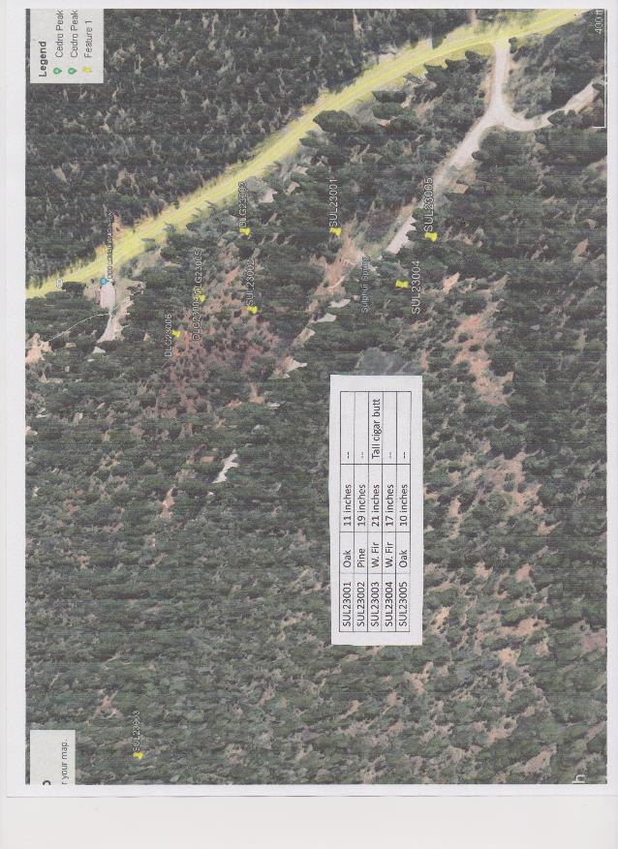

Hazard tree map for Sulphur PA.

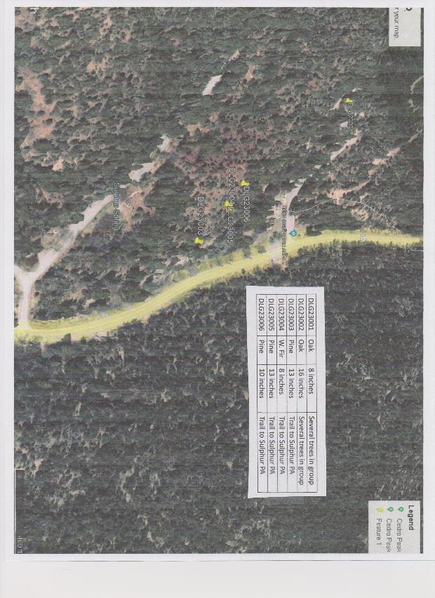

Hazard tree map for Doc Long PA. Tree number DLG23002 is not on the map. The tree is located on the old road below the picnic area.