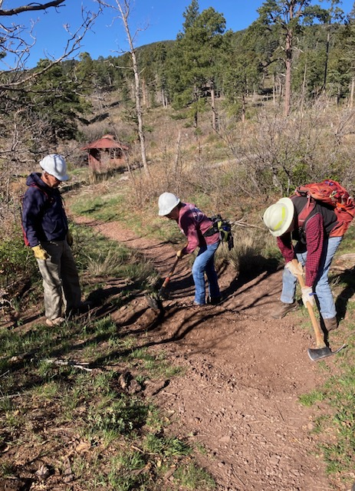
This water bar, located a short distance uphill
from the Tecolote Trailhead had been badly eroded.
Rene and Byron are working on the repairs.
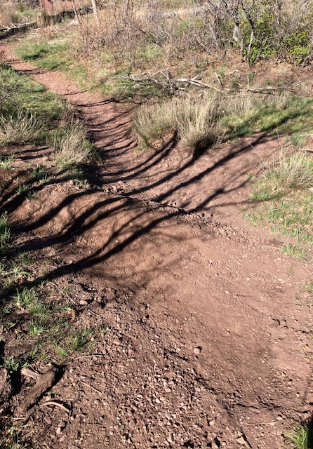
The water bar has been completely rebuilt and
will once again route water off the trail to the
downhill side.

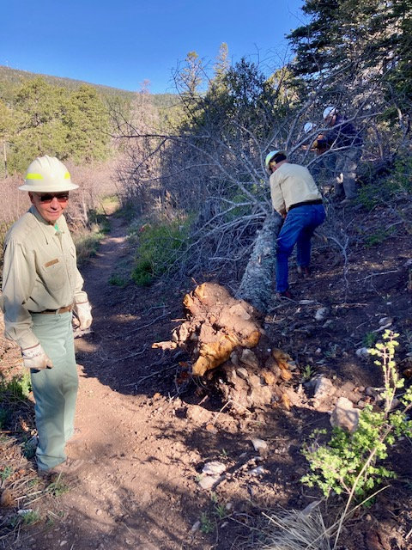
The root ball of this tall fallen dead fir was
protruding into Tecolote Trail creating a hazard
for users. Jerry is removing branches from the lower
end; other crew members check things out near its top.
When trees are fallen along a slope like this, all
cutting is done from the uphill side.

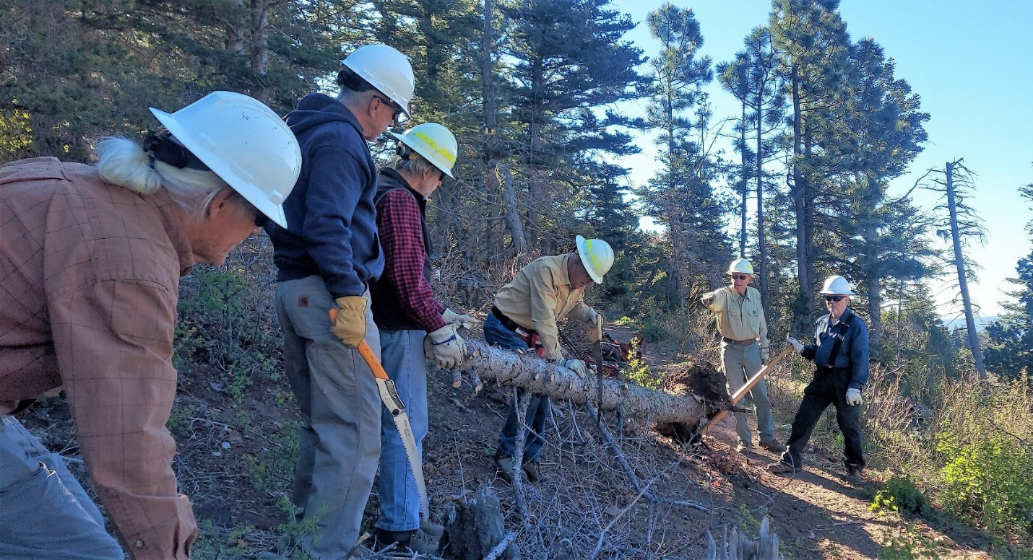
After the top has been removed, Byron and Jamey stabilize the tree shown in the previous photo while Jerry finishes the final cuts to remove it.

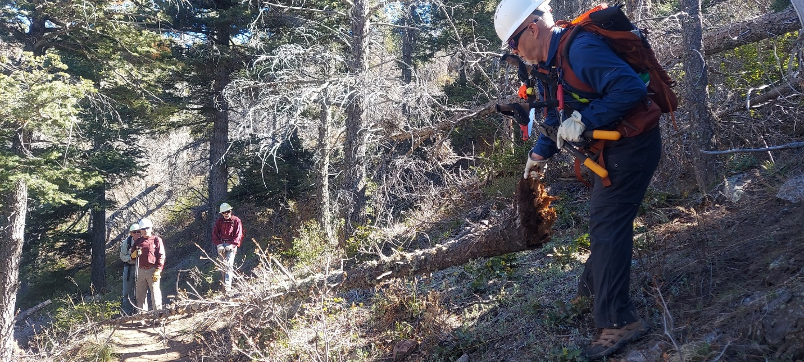
Jamey moves another fallen tree downhill for removal.

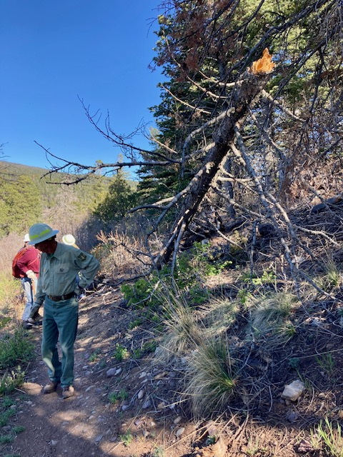
Yet another interesting bit of work to do. Bob walks
along the trail looking for a spot to put the tree
after it is pulled down and cut.

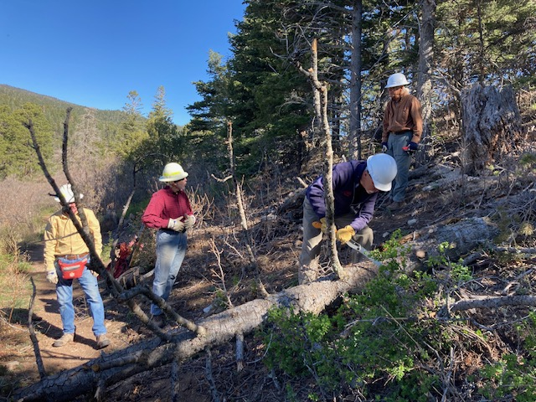
It is not uncommon for our crew to unexpectedly come upon dead trees that have fallen and are parallel to and just above a trail. This was another one of those trees. In most cases, it is only a matter of time before gravity does its work and the tree slowly moves down into the trail. If we have the time, we operate under the assumption that “We’re here with the gear” so we pulled it downhill and removed it.

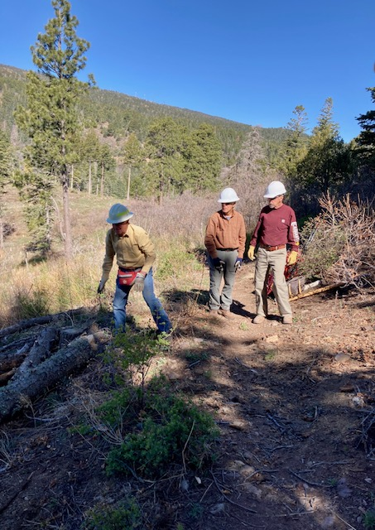
And so another fallen tree finds its final resting
place below a newly cleared trail.

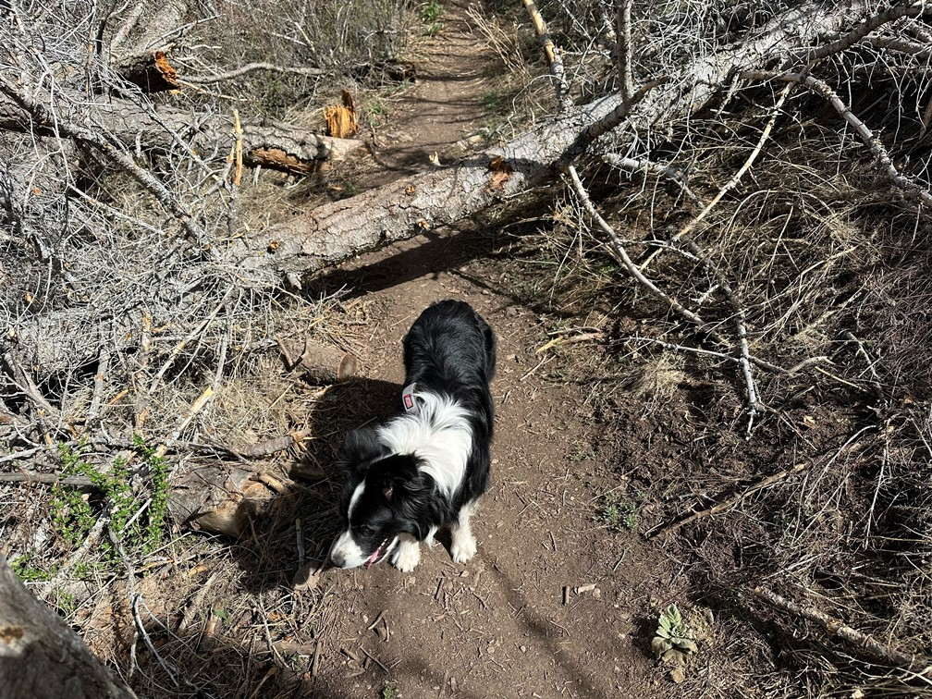
This dead tree had fallen over Tecolote trail about ½ mile up from the trailhead. It was discovered and reported by
Steve Miller on a hike with his dog Aurora.

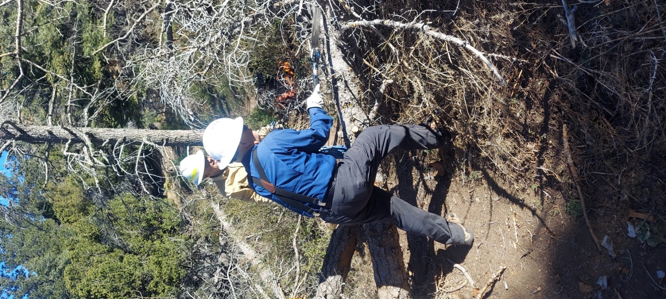
Jamey cuts branches from tree in previous
photo.

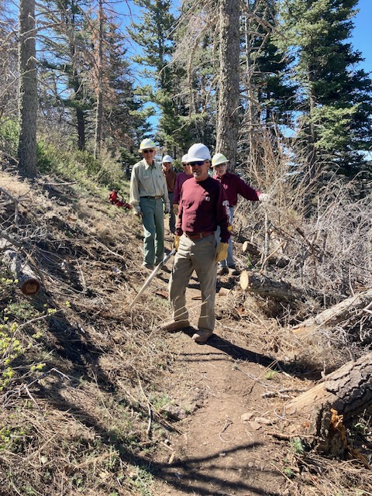
Fallen tree removed from Tecolote Trail.

