**Report of FOSM Projects to Replace a Cienega PA Fence Pole, Check Water Flow at the Bird Log, Low Stump in Certain Picnic Areas, Fell Hazard Trees in Balsam Glade PA, Capulin PA and in the Snow Play Area, and Begin Restoration of Doc Long PA Entrance Sign on Wednesday, May 10, 2023**

Sam Beard

May 11, 2023

On Wed., May 10, five FOSM volunteers completed the following tasks: replaced a broken fence pole in Cienega Picnic Area, checked water flow at the Bird Log at Capulin PA, cut stumps lower in Cienega PA, and felled one hazard tree at each of these sites: Balsam Glade PA, Capulin PA, and the Snow Play Area.

After being informed that the entrance sign at Doc Long Picnic Area needed restoration, Sam scraped the loose paint and painted what he could with a 3-inch-wide brush and brown paint that were in his truck. The paint crew will soon complete this project.

Volunteers working of these tasks were Jerry Carroll, Dan Benton, Steve Roholt, Sim Cook, and Sam Beard.

Project photos are presented below.

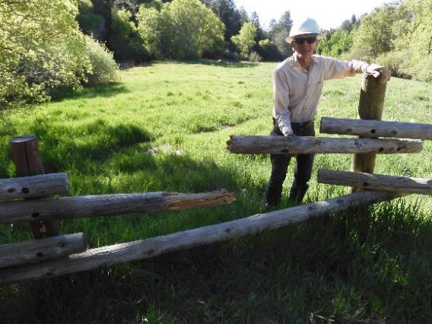

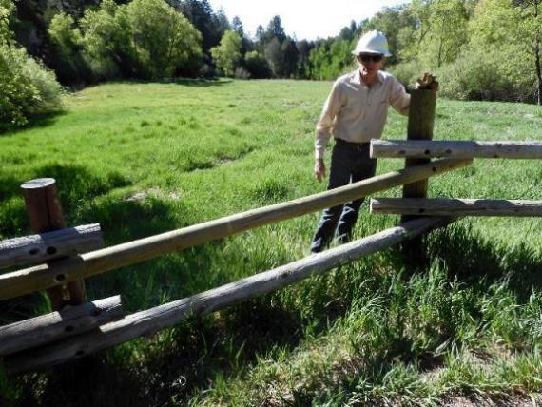

Sim Cook at the Cienega Picnic Area fence where he and Dan Benton replaced a broken pole.

Photo by Dan Benton

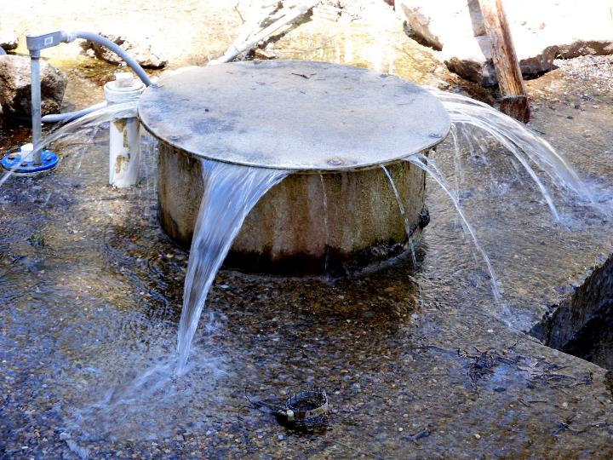

Water overflowing the concrete spring box at Capulin Spring due to melting snow increasing the flow from the spring that is located at the Bird Log. A small amount of water from the spring flows to the Bird Log. Dan reported that the flow through the log is somewhat higher than usual from the white pipe, but the log itself is not in jeopardy. The excess flow from the spring is going down the hillside south of the log, which is elevated from the flow. Photo by Dan Benton

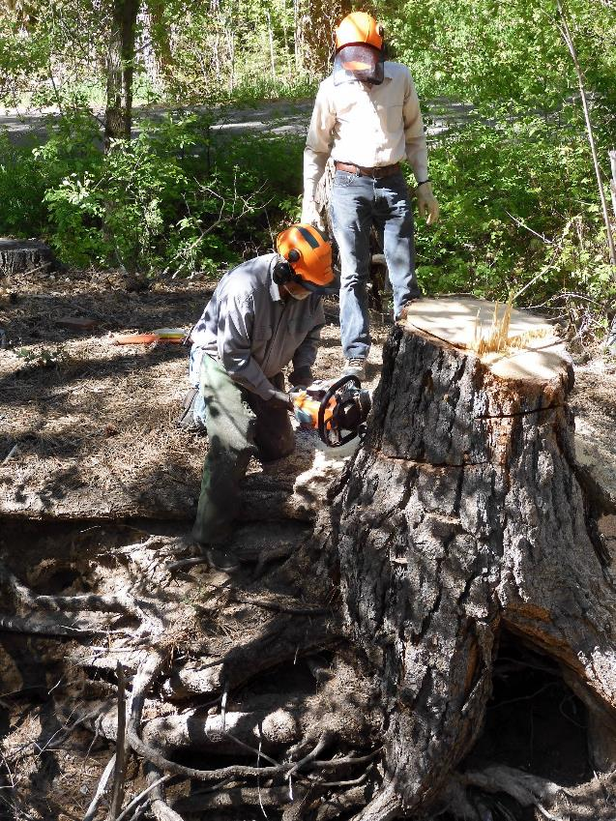

Jerry Carroll cutting a stump lower at the edge of Cienega Creek in the picnic area. Note that the 24-inch

bar on his chain saw is not long enough to extend through the stump. Photo by Dan Benton

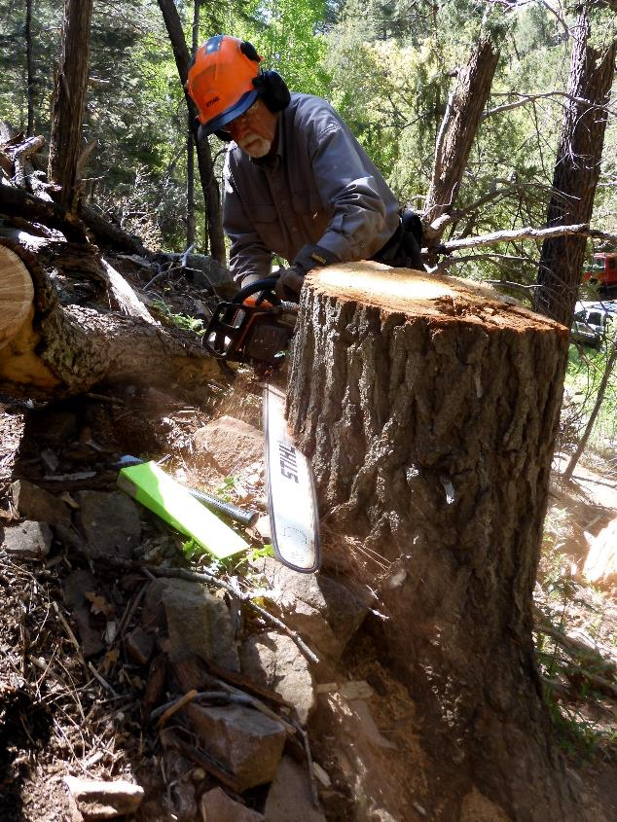

Jerry low stumping where a white fir tree was earlier felled. He is using the FOSM Stihl Model 460 chain saw

with a 36-inch bar. Photo by Dan Benton

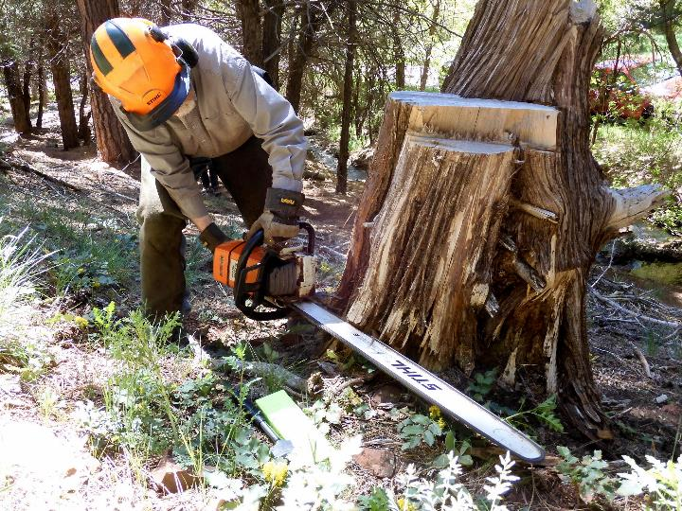

Jerry cutting the stump lower where a very large Rocky Mountain juniper was felled on the Acequia Trail in the upper part of Cienega PA. The 36-inch bar was longer than the diameter of the stump. Photo by Dan Benton

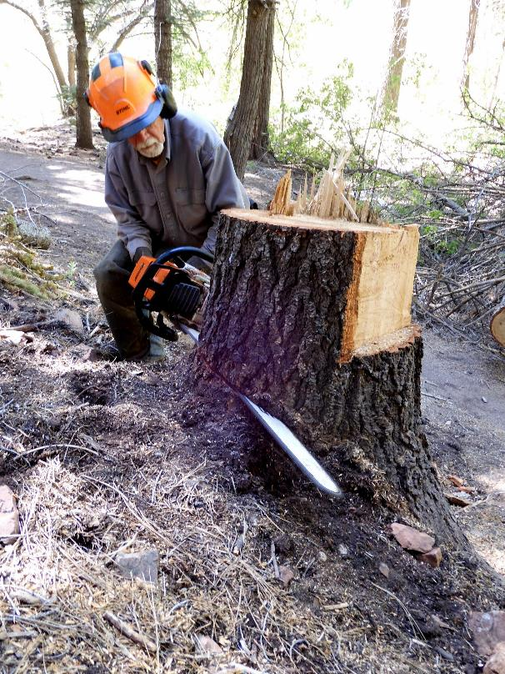

Jerry low stumping where a large white fir was felled in Cienega PA. Photo by Dan Benton

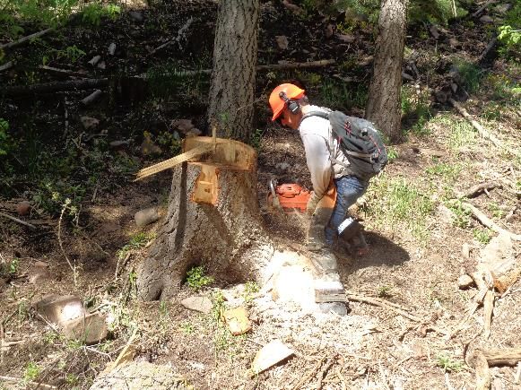

Steve Roholt low stumping where he felled a white fir earlier in Cienega PA. Photo by Sam Beard

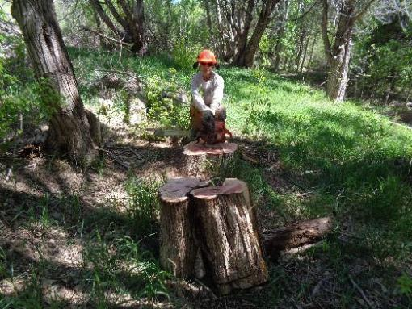

Steve cut this Rocky Mountain stump lower across the road from the middle restroom.

Photo by Sam Beard

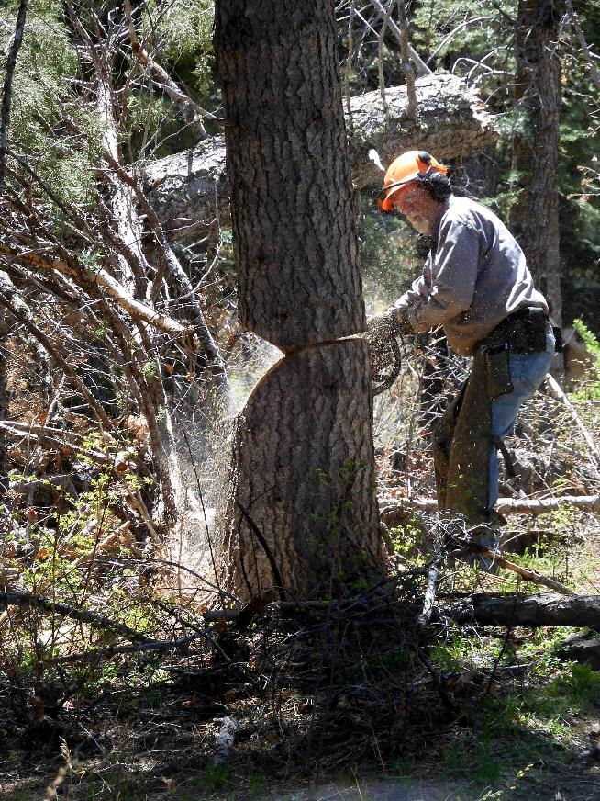

Jerry making the back cut on the large white fir hazard tree that he is felling in Capulin PA.

Photo by Dan Benton

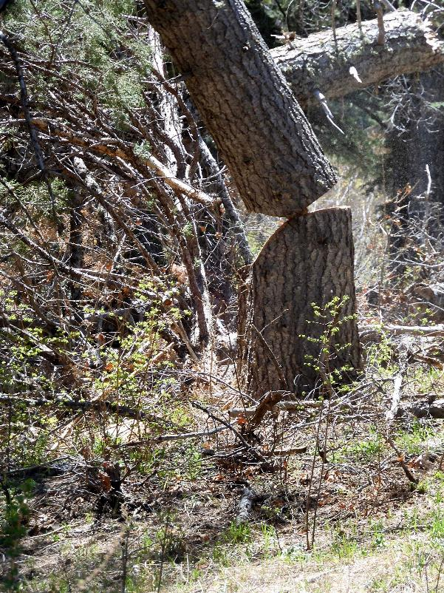

The hazard tree is falling, and the hinge wood is bending between the face cut and the back cut.

Photo by Dan Benton

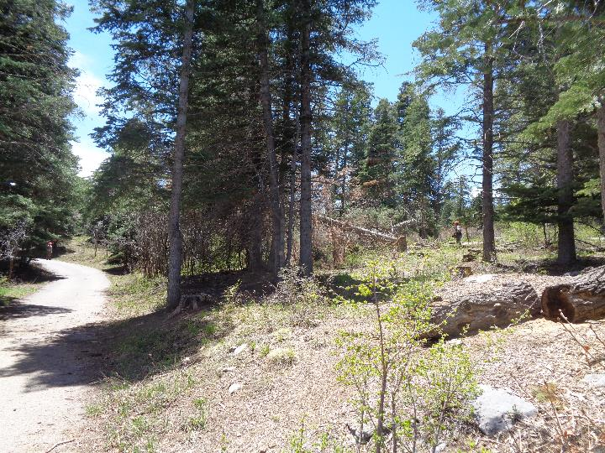

The tree that Jerry was cutting in the above two photographs is falling in Capulin PA.

Photo by Sam Beard

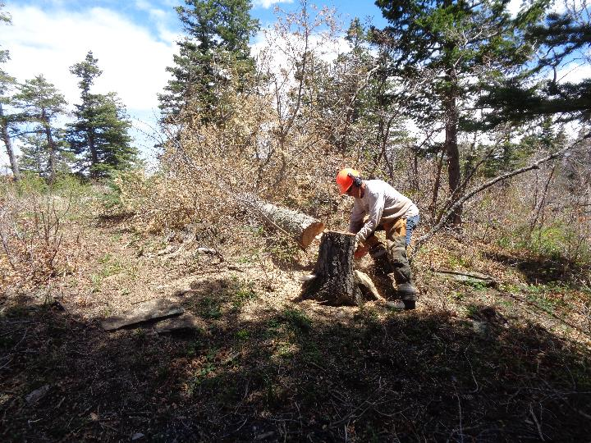

Steve is low stumping the white fir hazard tree he has just felled at the shelter at the Capulin Snow Play Area.

Photo by Sam Beard

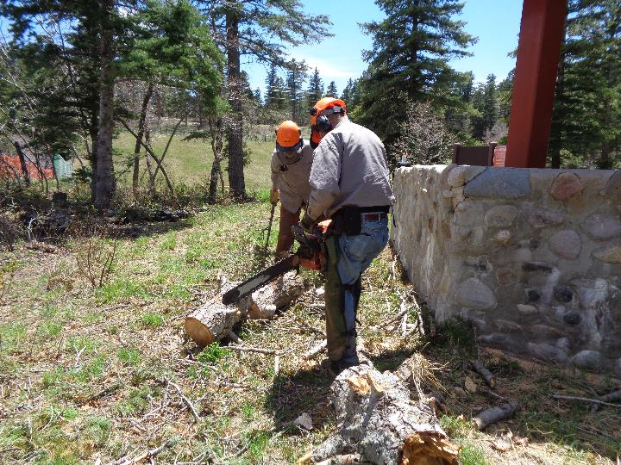

Jerry has just completed bucking the upper trunk of a white fir tree that fell at the shelter in the Snow Play Area.

Dan Benton is moving the wood from the path beside the shelter. Photo by Sam Beard

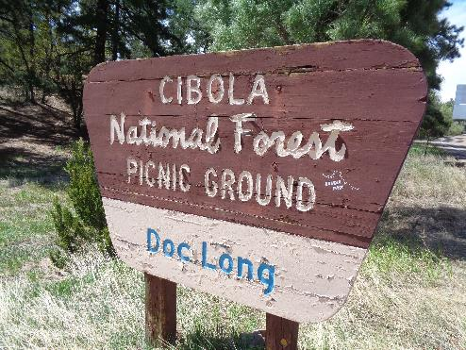

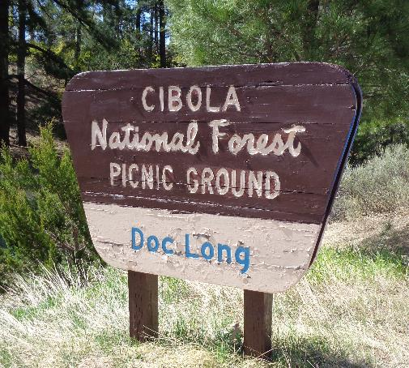

The entrance sign at Doc Long Picnic Area before and after Sam applied brown paint

on the east side of the sign. The FOSM paint crew will complete the restoration of

this sign later. Photo by Sam Beard