|  |  |  |  |  |  |  |  |  |  |  |  |
| --- | --- | --- | --- | --- | --- | --- | --- | --- | --- | --- | --- |
| NML23001 | W. Fir | 24 in. | Dead top | NML23006 | Aspen | 6 in. |  | NML23011 | Aspen | 19 in. |  |
| NML23002 | Aspen | 6 in. |  | NML23007 | Aspen | 7 in. |  | NML23012 | W. Fir | 19 in. |  |
| NML23003 | W. Fir | 17 in. |  | NML23008 | Aspen | 8 in. |  | NML23013 | W. Fir | 16 in. |  |
| NML23004 | W. Fir | 12 in. | Plus adjacent 4-in. tree | NML23009 | Aspen | 8 in. |  | NML23014 | W. Fir | 12 in. | Dead top |
| NML23005 | W. Fir | 15 in. | Plus adjacent 5-in. tree | NML23010 | Aspen | 21 in. |  |  |  |  |  |

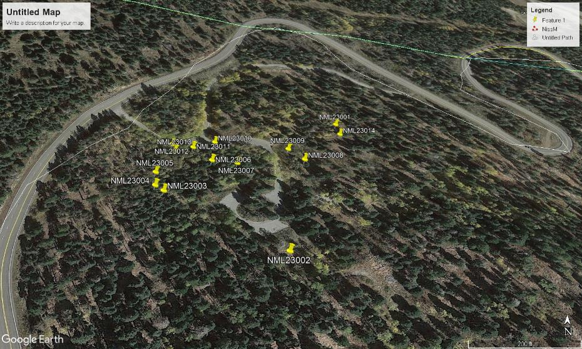

Nine Mile Picnic Area hazard tree map, May 11, 2023