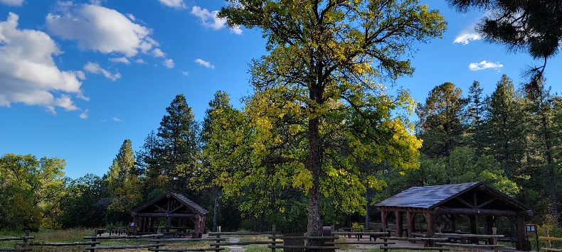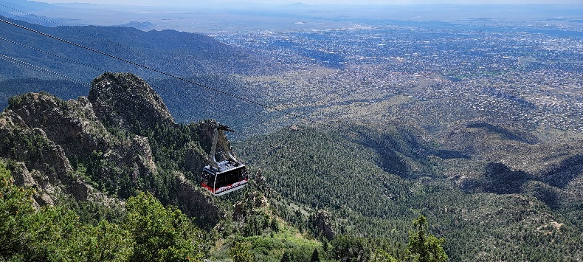

Public Engagement and Volunteer Program Manager

1035/0301(Recreation Management Specialist) GS-07/09

Detail, Temp Promotion 120 or Less, or Permanent Appointment

**Sandia Ranger District – Tijeras, NM**

*Reply Due: 5/30/2023*

The Cibola National Forest and National Grasslands is filling a detail for Public Engagement and Volunteer Specialist position and is conducting an outreach to identify qualified and highly skilled candidates for a detail and/or permanent appointment position with a duty station in Tijeras, New Mexico. This notification is being circulated to inform prospective applicants of this potential upcoming opportunity and to determine interest in the position, including grade-level eligibility of potential applicants.

**\*\*OUTREACH RESPONSE\*\***

If you are interested in this position, please complete and send the attached response form along with a resume to FS-R3 Cibola Outreach Inbox, [SM.FS.CibolaOutRch@usda.gov](mailto:SM.FS.CibolaOutRch@usda.gov) by **COB 5/30/2023**

For more information regarding the position, please contact: Tara Carver, Acting Recreation Staff Officer, Sandia Ranger District, [tara.carver@usda.gov](mailto:tara.carver@usda.gov).

**\*\*THE POSITION\*\***

The Sandia Ranger District is uniquely situated as Albuquerque’s backyard playground with a population of nearly one million people. This high urban interface brings with it a hefty responsibility and demand for public interaction and multiple volunteer and partnership opportunities. This position will serve as the main interface for providing public information and engagement, including developing interpretive plans, resource materials, educational opportunities and managing the robust volunteer program consisting of two friends groups and 9 organizations.

Specific Duties will include:

* Visitor center oversight and coordination of a partner run gift shop.
* Serving as a liaison between Friend’s groups and district staff.
* Volunteer program management, including annual orientations and recognition event planning, awards management and hour tracking.
* Developing interpretation plans and materials for the public.
* Maintaining public information on our website and developing social media campaigns.
* Utilizing graphic design and layout skills to provide resource materials for the public on recreation opportunities.
* Developing public education programs and strategies that meet the demands of the public and capitalize on volunteers.
* Developing partnership agreements.
* Develops newsletters and annual reports for sharing volunteer and partner contributions.
* Responsible for volunteer safety, trainings and uniforms, ensuring volunteers are trained for interacting with public and representing the agency professionally.
* Responsible for tracking engagement and volunteer hours in databases.

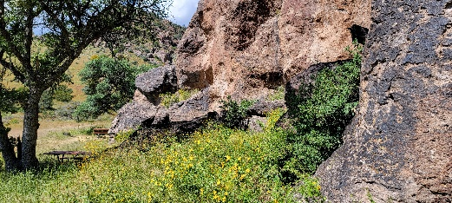

**Cibola National Forest and National Grasslands:**  The Forest and Grasslands covers approximately 1.9 million acres scattered eastward from west central New Mexico into northeastern New Mexico, Texas and Oklahoma Panhandles, and western Oklahoma. Elevations range from 2,700 to 11,300 feet spanning four ranger districts and four National Grasslands. Cibola, pronounced See’ bo-lah, is thought to be the original Zuni Indian name for their group of pueblos or tribal lands. Later, the Spanish interpreted the word to mean, “buffalo.”

* The Cibola National Forest & Grasslands is divided into 6 Ranger Districts with the Forest Supervisor’s Office located in Albuquerque, NM. More information about the Cibola National Forest can be found at [www.fs.usda.gov/cibola/](http://www.fs.usda.gov/cibola/)

**About Sandia Ranger District:** The duty station for this position is in Tijeras, New Mexico, just east of Albuquerque, the state’s largest city. The District employs 37 permanent and a variety of seasonal positions and administers approximately 100,000 acres of land including the Sandia and Manzanita Mountains. One of New Mexico’s sky islands, the Sandias rise above 10,000 feet offering panoramic views from the top of Sandia Crest accessed by the Sandia Crest National Scenic Byway, the Sandia Peak Tram or hiking through the Sandia Mountain Wilderness. This is busy wildland-urban interface District which serves the greater Albuquerque community and receives over 2 million visitors per year. The District has a large year-round recreation program with over 300 miles of multiple use trails and twenty plus developed recreation sites including group day use and overnight reservation areas and a snow play area. The outdoor recreation opportunities are diverse with hiking, mountain biking, horseback-riding, road biking, motorcycle riding, picnicking, wildlife viewing, scenic viewing, rock climbing, birdwatching, paragliding, and visiting historical sites. There are multiple historic and cultural sites including two national historical landmarks, Tijeras Pueblo and Sandia Cave as well as many civilian conservation corps structures. The lands within the District are traditionally and culturally significant and serve many tribal and non-tribal historic communities. The district engages with a variety of partners and has a large volunteer program including two long- standing friends groups, Friends of the Sandia Mountains and Friends of the Tijeras Pueblo. The District is also working with both government and non-governmental partners to implement landscape scale restoration projects; restoration is a key focus across all resource areas.

**Climate:** Elevation at the Sandia Ranger Station is 6300’, surrounded by pinyon-juniper hillsides. Summer days have temperatures from 70-90 degrees, nights 50-60. Winter days can be below freezing or into the 70’s, and nights often drop to low 20’s. Temperatures at the top of the Crest (10,687’) are generally much cooler.

**Recreation:** Because of its proximity to mountain, desert, and river settings Albuquerque also offers year-round outdoor recreational opportunities. Within the area there are six public golf courses, 31 parks and public tennis courts, several public swimming pools, multiple libraries and community centers, and over 200 miles of biking routes and trails. Along with the Sandia Ranger District east of Albuquerque, there are additional state and federal public land management areas nearby, including the Rio Grande Nature Center State Park, National Park Service Petroglyph National Monument, Fish & Wildlife Service Valle de Oro National Wildlife Refuge. Albuquerque is also known for its annual Balloon Fiesta which hosts over 800 hot air balloons in early October. The City of Albuquerque offers a wide variety of opportunities in history, cultural, art, sports, outdoor recreation, education and community events, tours and facilities including NM United Soccer team, NM Ice Wolves hockey team, Indian Pueblo Cultural Center, Albuquerque Bio Park – Zoo, Aquarium & Botanical Gardens, African American Performing Arts Center & Exhibit Hall, and much more. Santa Fe, New Mexico is located 60 miles north and offers many more cultural and recreational opportunities.

**Access/Airports/Transportation:**  Airports include the Albuquerque International Airport, and the Double Eagle airport. Amtrak and bus lines also serve Albuquerque. There is a city bus system, which also provides transportation for those with special needs. The Albuquerque “Rail Runner” train provides commuter service for Albuquerque, Bernalillo, Santa Fe and Belen. Route 66, Interstate 25, and Interstate 40 are the major connector roads for Albuquerque. In addition, there is a city-wide designated network of paved bike routes.

**Contacts:** For additional information, visit the following web sites:

|  |  |
| --- | --- |
| Greater East Mountain Chamber of Commerce: | <https://gem-nm.com/> |
| City of Albuquerque | [www.cabq.gov](http://www.cabq.gov) |
| Albuquerque Visitor and Convention Bureau | <https://www.visitalbuquerque.org/> |
| Greater Albuquerque Chamber of Commerce | https://greaterabq.com/ |
| Albuquerque Hispano Chamber of Commerce | [www.ahcnm.org](http://www.ahcnm.org) |
| Albuquerque Public Schools | [www.aps.edu](http://www.aps.edu) |
| New Mexico community information | https://sharenm.org/ |

Public Engagement and Volunteer Program Manager

0301 or 1035 series GS-07/09

Detail, Temp Promotion 120 or Less, or Permanent Appointment

**If you are interested in this position, please complete and send the following information along with a resume to FS-R3 Cibola Outreach Inbox,** [**SM.FS.CibolaOutRch@usda.gov**](mailto:SM.FS.CibolaOutRch@usda.gov) **by COB 5/30/2023.** If you have any questions regarding the position please contact Acting Recreation Staff Officer, Tara Carver, [tara.carver@usda.gov](mailto:tara.carver@usda.gov).

Please take a moment to review the hiring authorities below and see if you qualify. The following hiring authorities assist us with hiring a diverse workforce. Please Click the link for more information on hiring authorities <https://www.fs.usda.gov/working-with-us/jobs/dream-job/eligibility>.

**IMPORTANT: If you qualify, please check the corresponding box.**

|  |
| --- |
| [30% Disabled Veterans Appointing Authority](https://www.fs.usda.gov/working-with-us/jobs/dream-job/eligibility/veterans) *(disabled veterans who were retired from active military service with a 30% or more disability rating; disabled veterans rated by the Veterans Affairs as having a compensable service-connected disability of 30% or more)*  Lateral Reassignment *(a reassignment is defined as the change of an employee to another appropriate position without promotion or change to lower grade. Must have held the target grade on a permanent basis in the competitive series.)*  [Military Spouse Hiring Authority](https://www.fs.usda.gov/working-with-us/jobs/dream-job/eligibility/veterans) *(Military spouses eligible under Non-competitive Appointment of Certain Military Spouses do not have a hiring preference; however, this appointing authority does provide for non-competitive entry into the competitive service. There are three categories that determine eligibility: those who are relocating with their service-member spouse as a result of permanent change of station (PCS) orders, spouses of service members who incurred a 100% disability because of the service member's active-duty service, and spouses of service members killed while on active duty.)*  [Pathways Student Hiring Authority](https://www.fs.usda.gov/working-with-us/jobs/students-and-recent-graduates) *(Internship Program: current students in an accredited high school, college [including 4-year colleges/universities, community colleges, and junior colleges]; professional, technical, vocational, and trade school; advanced degree programs; or other qualifying educational institution pursuing a qualifying degree or certificate; Recent Grads Program: recent graduates who have completed, within the previous two years, a qualifying associates, bachelors, masters, professional, doctorate, vocational or technical degree or certificate from a qualifying educational institution)*  [Prior AmeriCorps/VISTA](https://www.usajobs.gov/help/working-in-government/unique-hiring-paths/peace-corps/) *(persons are granted a one-year period to be non-competitively appointed to a normally competitive Federal position after leaving the Peace Corps or AmeriCorps VISTA with a certification of eligibility)*  [Prior Peace Corps](https://www.fs.usda.gov/inside-fs/delivering-mission/excel/forest-service-uses-special-hiring-authority-hire-returned-peace) *(former Peace Corps volunteers who have satisfactorily completed 3 years of continuous service into career or career-conditional permanent positions)*  [Reinstatement Rights](https://www.fs.usda.gov/working-with-us/jobs/recruitment-and-hiring) *(agencies may reappoint people previously employed under a career or career-conditional appointment by reinstatement to a competitive service position)*  [Schedule A Disabled Persons Hiring Authority](https://www.fs.usda.gov/working-with-us/jobs/dream-job/eligibility/schedule-a) (*For a list of qualifying disabilities,* [*review the Self-Identification of Disability form from the Office of Personnel Management (OPM).*](https://www.opm.gov/forms/pdf_fill/sf256.pdf) *Documentation of disability from a licensed medical professional, licensed vocational rehabilitation specialist, or an agency that issues disability benefits is required.)*  [Veterans Employment Opportunity Authority](https://www.fs.usda.gov/working-with-us/jobs/dream-job/eligibility/veterans) *(allows eligible veterans to apply for merit promotion vacancies otherwise not open to external candidates without career status)*  [Veterans Recruitment Appointment Authority](https://www.fs.usda.gov/working-with-us/jobs/dream-job/eligibility/veterans) *(disabled veterans, veterans who served in a declared war, or in a campaign for which a campaign badge has been authorized, or awarded a Armed Forces Service Medal, and separated from active duty in the past 3 years. Up to a GS-11 Only.)* |

**Name**: **Date:**

## Address:

**Phone**:

## E-Mail Address:

**Are you a current Federal employee?** **Yes** **No**

***\*\*\*If you answered “YES” to the question above, please fill out the following:***

**Current Agency and Location:**

**Current Title/Series/Grade**:

**Indicate the type of appointment you are currently under:**

***(Career, Career-Conditional, Excepted, Excepted VRA, Temporary, Term, PWD, Other)***