Monday Trail Crew Report: May 15, 2023
Byron Garner

On May 15, 2023 the Monday Trail Crew hiked 10 K-S from the 10 k parking lot to clear a three tree cluster reported by Galbraith and located one mile north of the Tree Spring junction. Along the way, six additional and unreported trees ranging from three to nine inches were found either protruding, blocking or leaning into the trail and yielding a full chorus "Happy Days are Here Again" spirit of the moment in appreciation for the bonus work. We arrived at our target tree to find an interesting crossing arrangement of fourteen and twelve inch trees topped off with a multi-branched leaner. After a bit of debate and vigorous effort, the work was done and the trail clear for all to enjoy. On the way back to the trail head, we paused for a needed rest and early lunch while enjoying the comforting coolness and misty fog of the forest which was very reminiscent of the Pacific Northwest with the cloud reaching Doug Firs as Bill Perkins so thoughtfully noted. Arriving at the cars, four of the crew members elected to continue on to the ski area parking to address an additional tree also reported by Galbraith and located on Challenge Trail .75 mile north of the ski slope. Removing this fourteen inch fir completed our work for what was a very satisfying days effort for us all. Trail note credit: Rav Nicholson

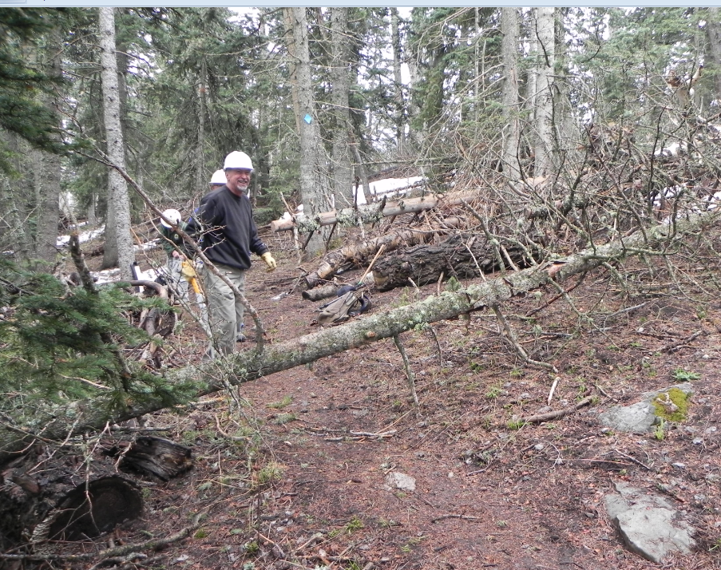
Ken checks out our first unreported tree

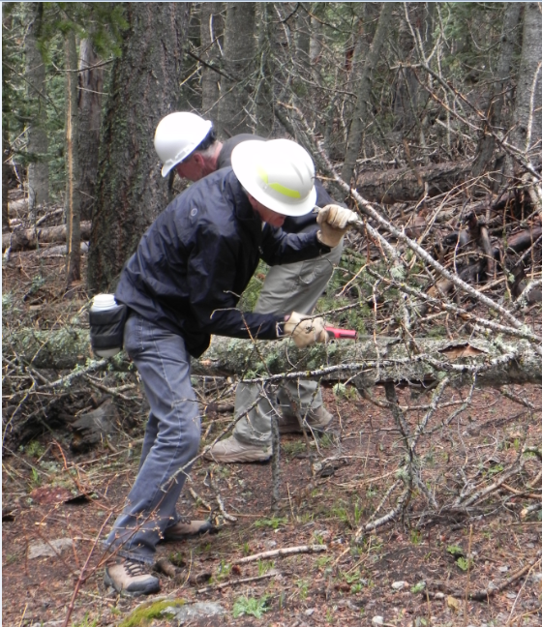
Sim lets the saw dust fly

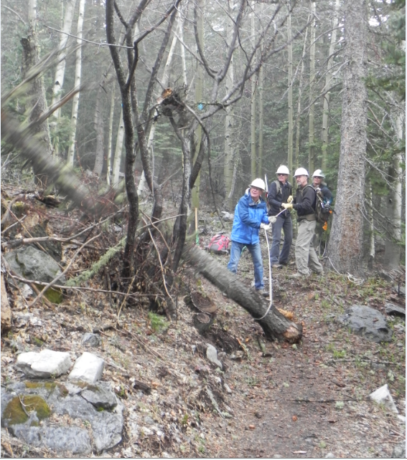
Jerry directs the roping down of an entangled leaner

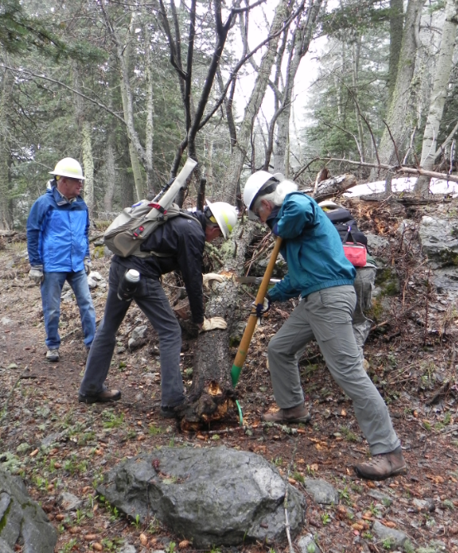
Sim and Bill leaning into the final push

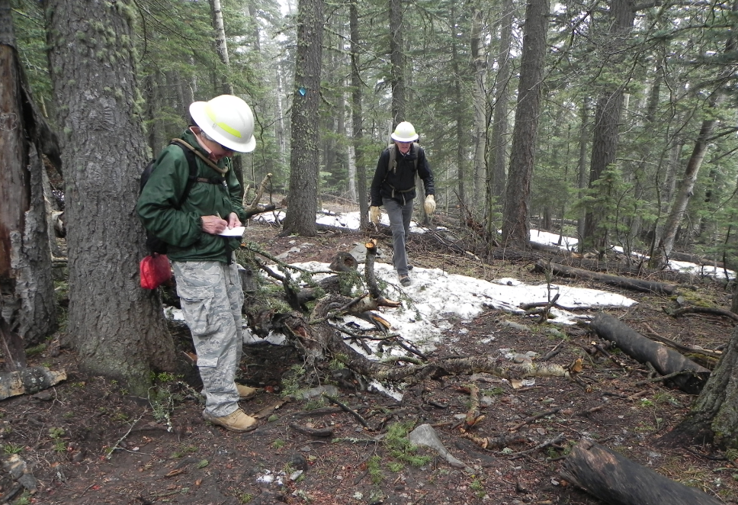
Rav catching up on her trail notes while Sim "enjoys" a late season snow experience

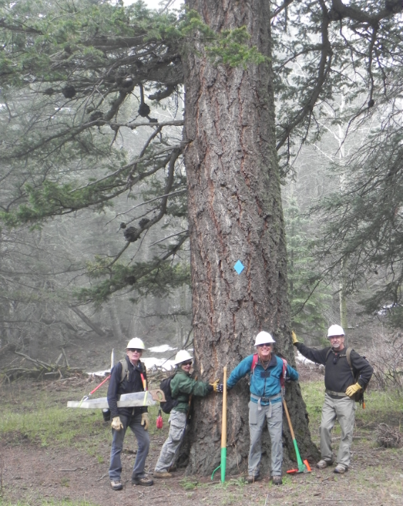
What medallion?

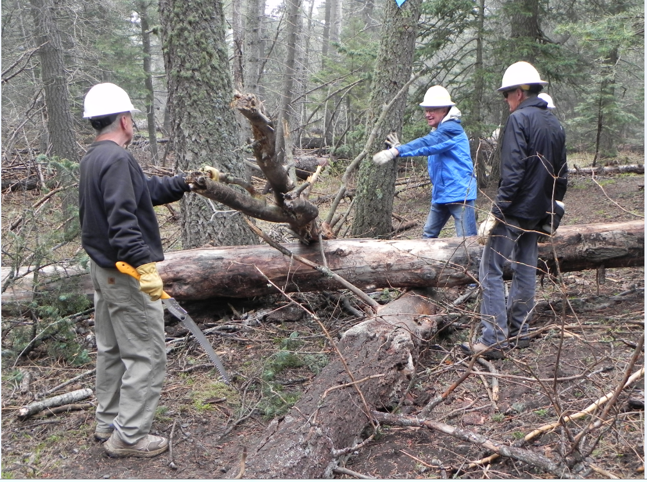

Well, what now?

Rav in assessment mode

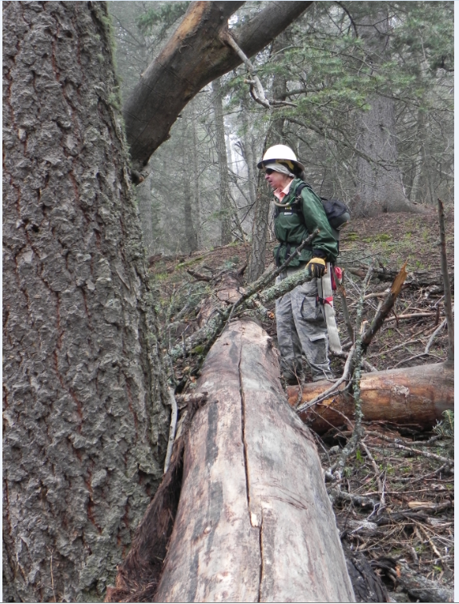

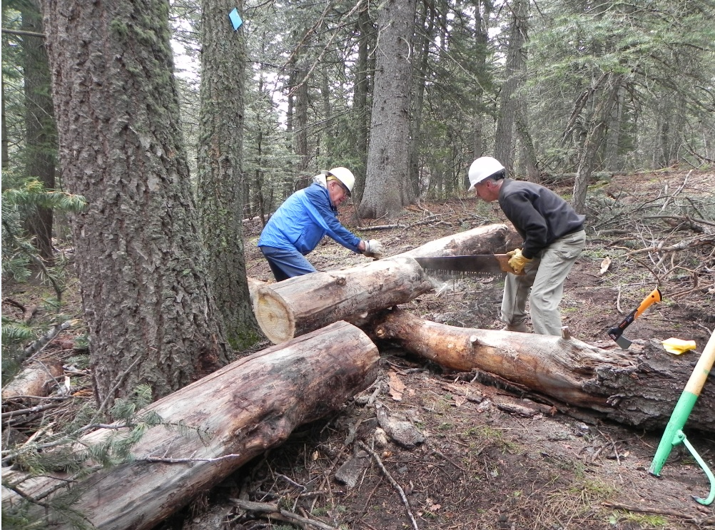
Jerry and Ken taking care of business

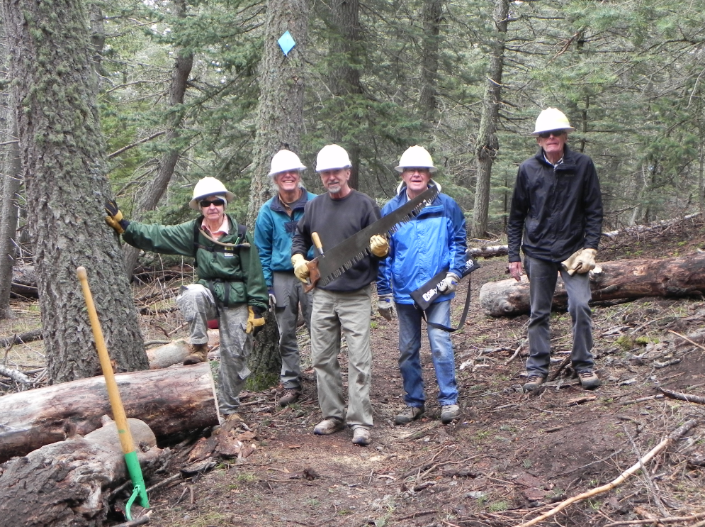
It's Miller Time

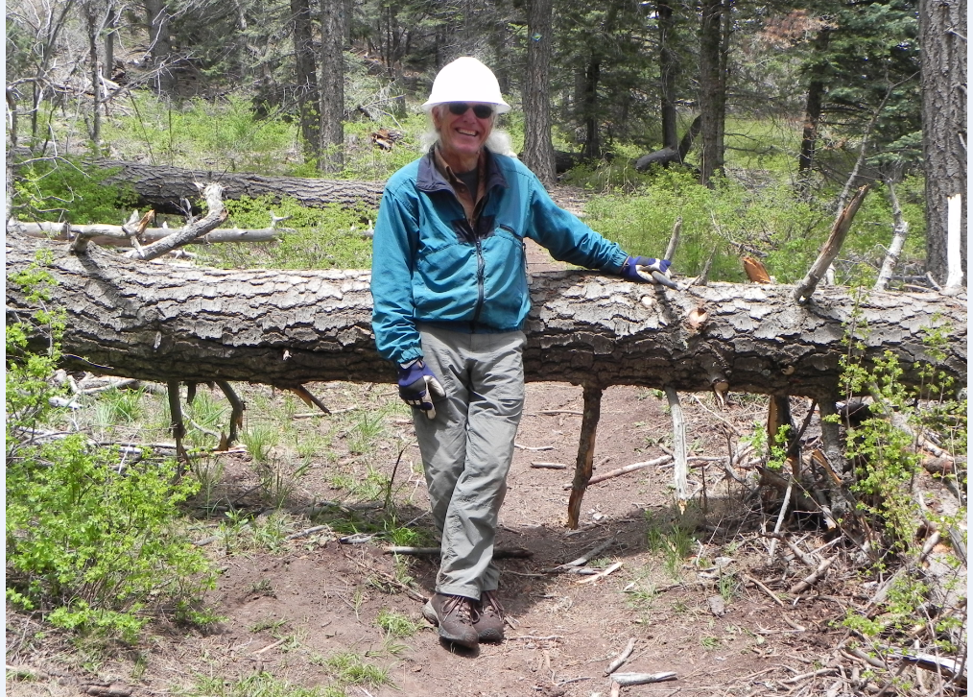
OK guys, you know what to do

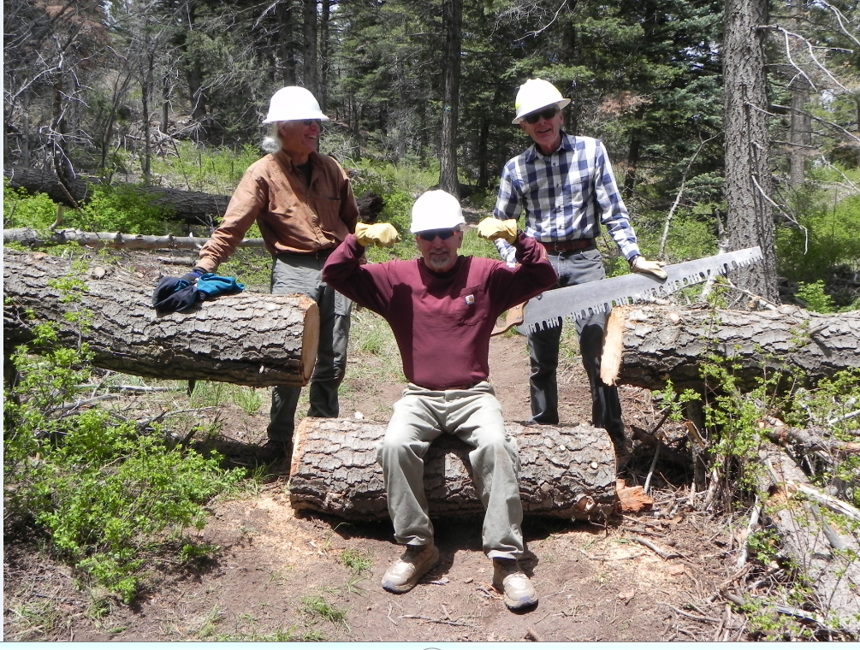
Bill, Ken and Sim enjoy the sweet taste of victory at the end of a good day

