**Report of Completing the Pruning of Tramway Trail on Wednesday, May 17, 2023**

Sam Beard and Dan Benton

May 20

On Wednesday, May 17, four FOSM members completed pruning Tramway Trail between the junction with La Cueva Trail and La Luz Trail. From La Cueva Picnic Area, the crew hiked the La Cueva Trail to the east to Tramway Trail that goes from the base of the Sandia Peak Tramway past Tierra Monte subdivision to La Luz Trail. From the junction with the Tramway Trail they hiked north and east to the La Luz junction. They used long handle loppers and pruning saws to cut three-leaf sumac, pinon, Gray oak, Gambel oak, Foothills Live oak, Apache plume, Prickly Pear and Cholla cacti, and mountain mahogany. During the almost 6-hour outing, the volunteers hiked 2.7 miles round-trip, and the elevation gain was 790 feet.

The volunteers were Jamey Browning, Ken Wilson, Dan Benton, and Sam Beard.

Project photographs are presented below.

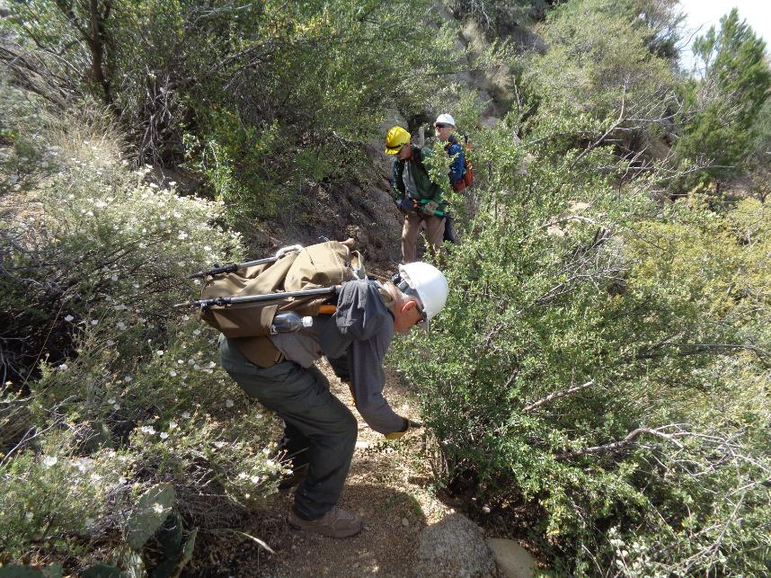

L to R: Ken Wilson, Dan Benton, and Jamey Browning pruning Apache Plume along the trail. Photo by Sam Beard

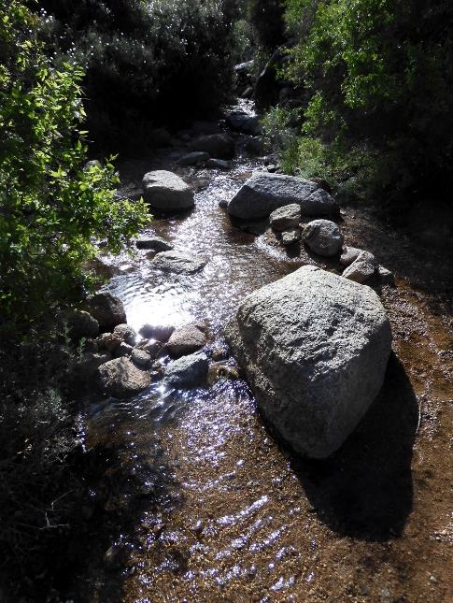

We crossed this stream of clear water. Photo by Dan Benton

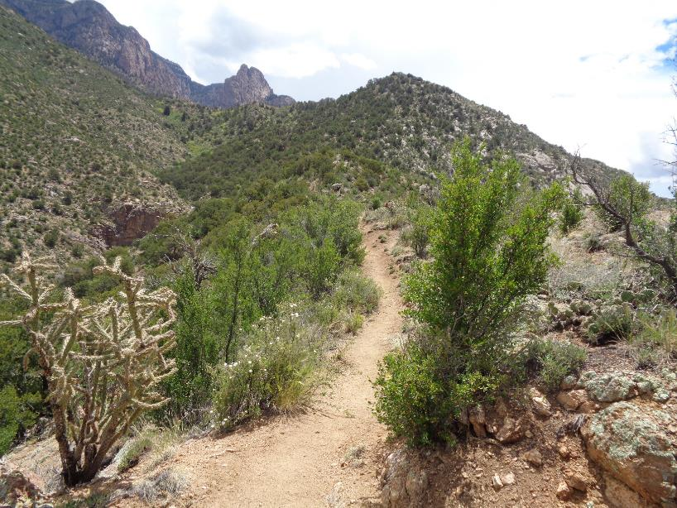

Tramway Trail going south along a ridge to a junction with La Luz Trail in the bottom of the canyon above the brown cliffs.

Photo by Sam Beard

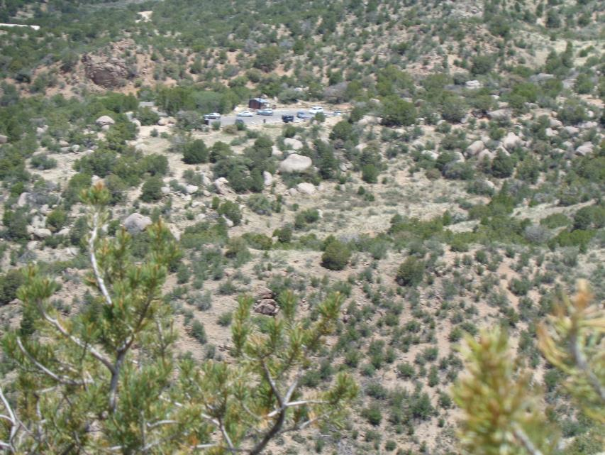

La Luz Trailhead parking lot north of Tramway Trail. Photo by Sam Beard

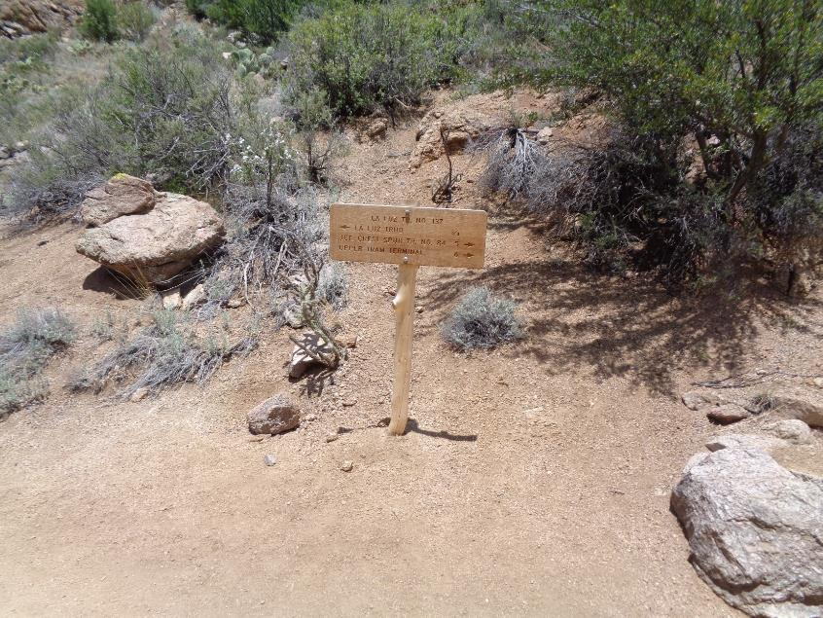

Sign on La Luz Trail at the junction with Tramway Trail. Photo by Sam Beard

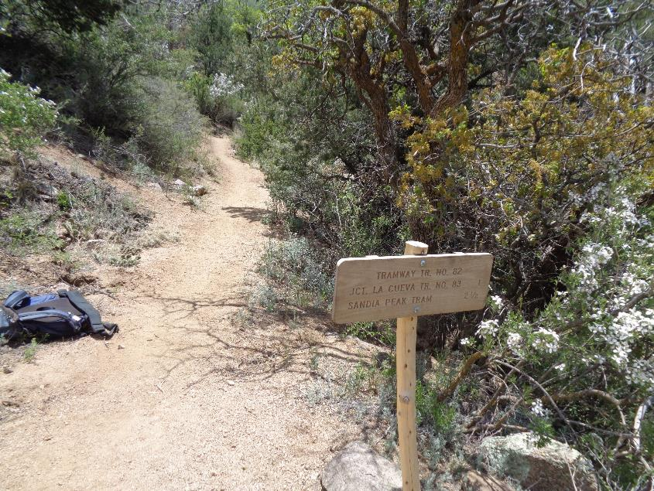

Sign on Tramway Trail beside a Cliff Fendler Bush at the junction with La luz Trail. Photo by Sam Beard

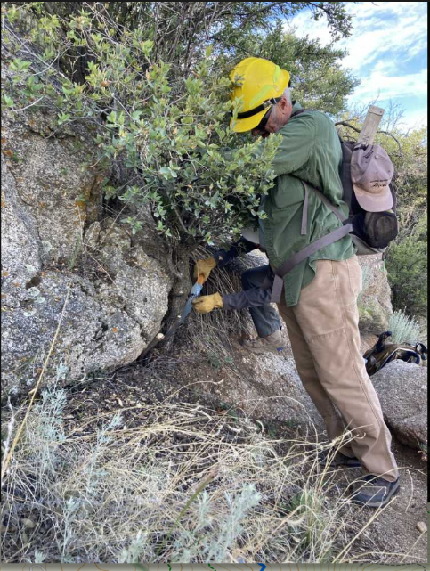

Dan holding an oak while Ken cut the stem. Photo by Jamey Browning

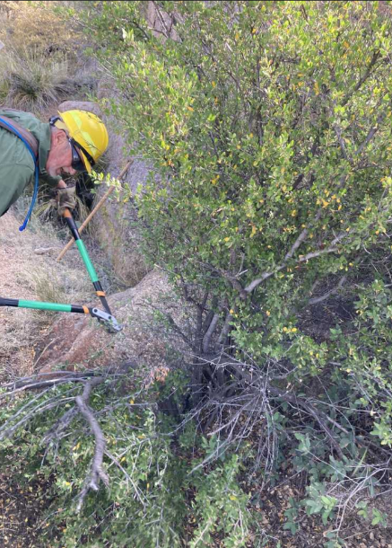

Dan preparing to cut a shrub along the trail with compound-action long handle loppers.

Photo by Jamey Browning