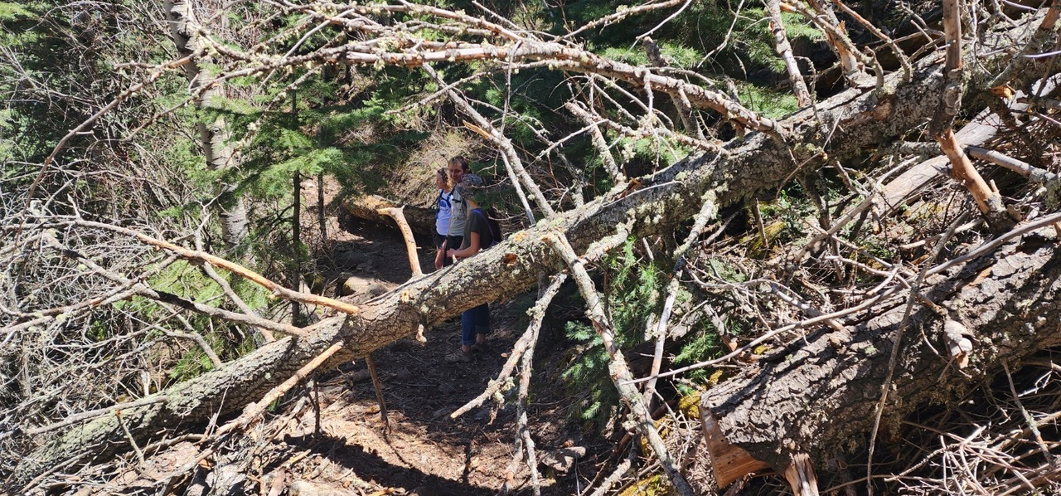
First of the two trees fallen over Pino Trail in the Switchbacks.
(Photo by James Whitfield on a previous hike)

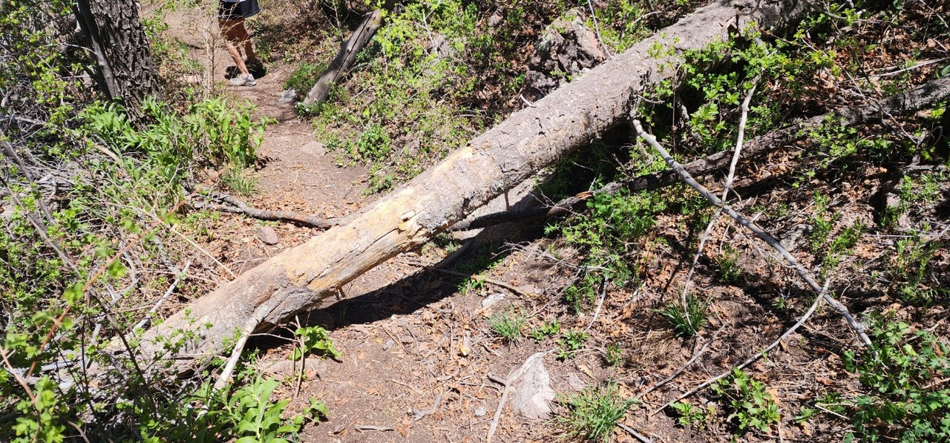
Second of the two trees fallen across Pino Trail in the Switchbacks.
(Photo by James Whitfield on a previous hike)
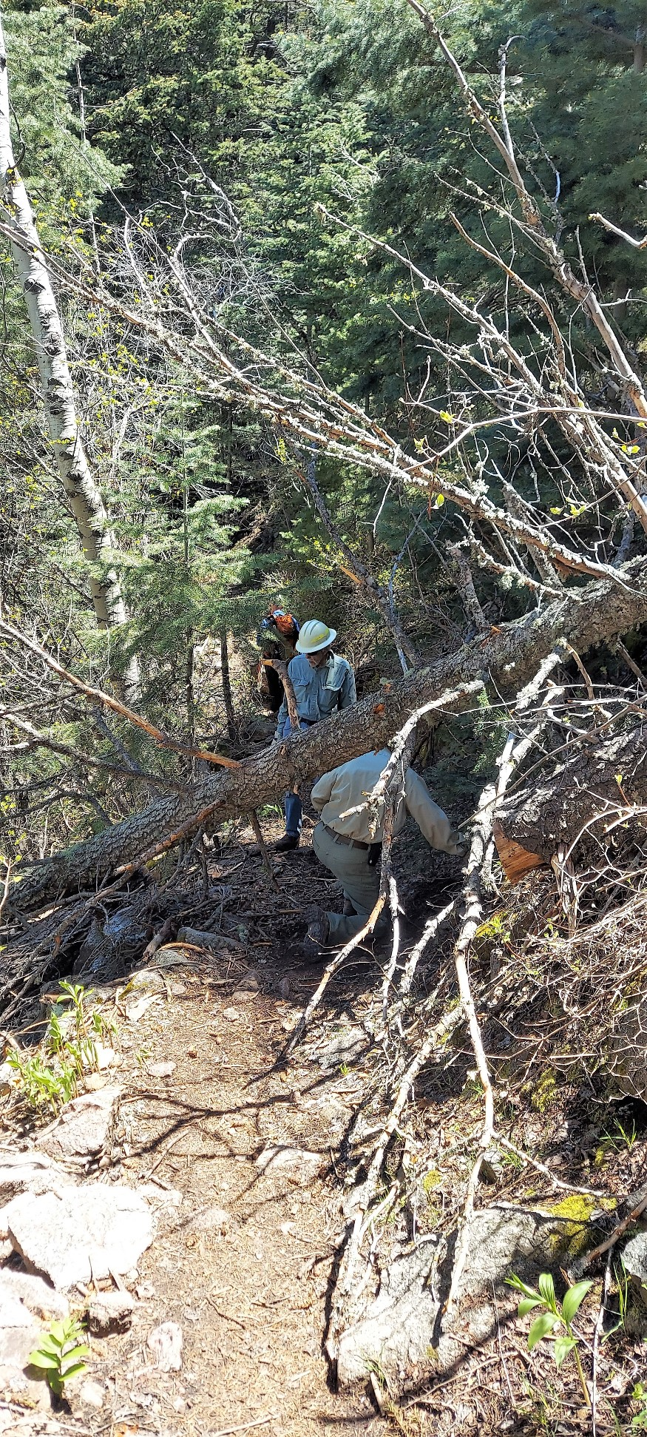
The crew sizes up the upper tree prior to
starting the removal process to determine
its stability.
(Photo by Rene Archer)

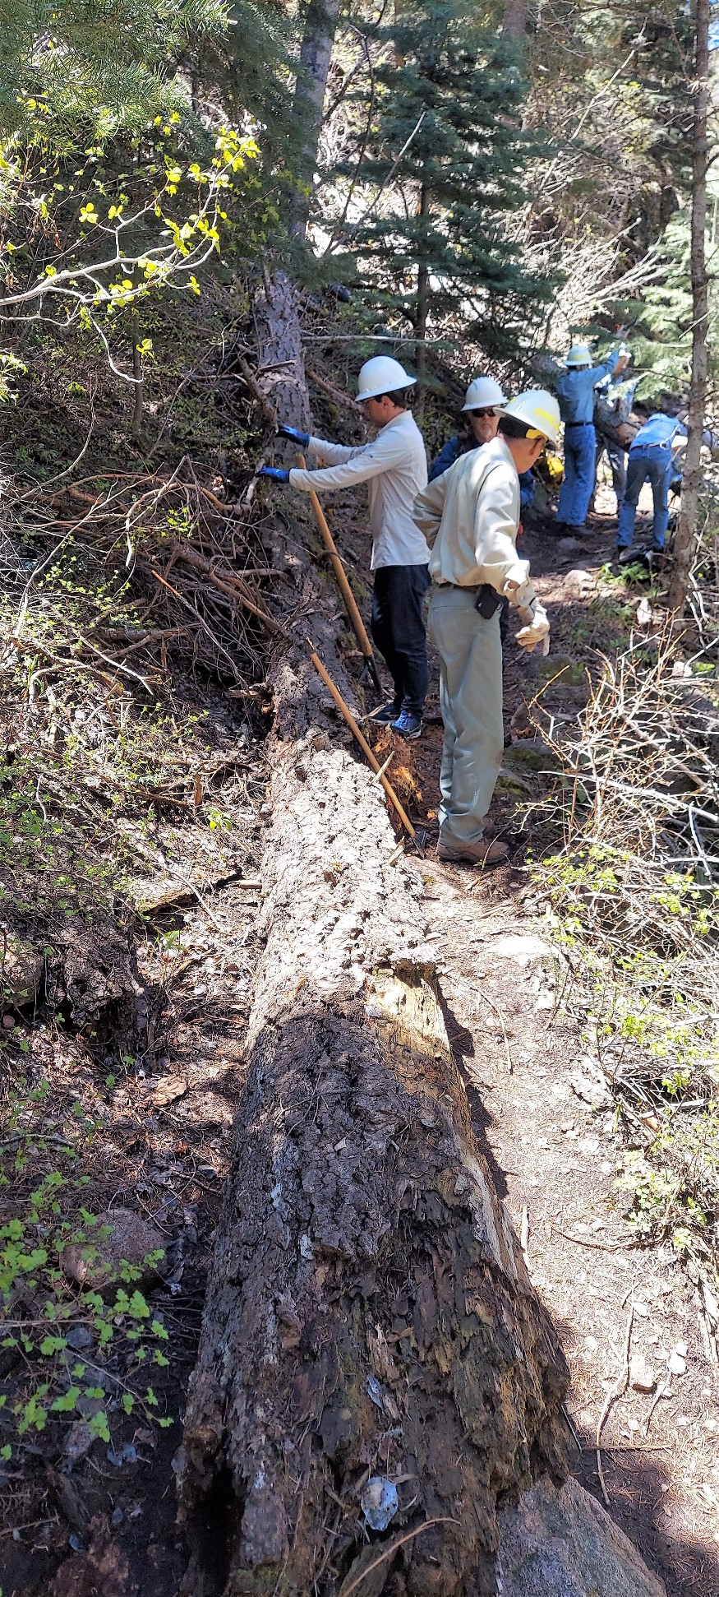
The crew prepares to remove the second tree
while the other half of the crew works on the
first tree in the background.
(Photo by Rene Archer)
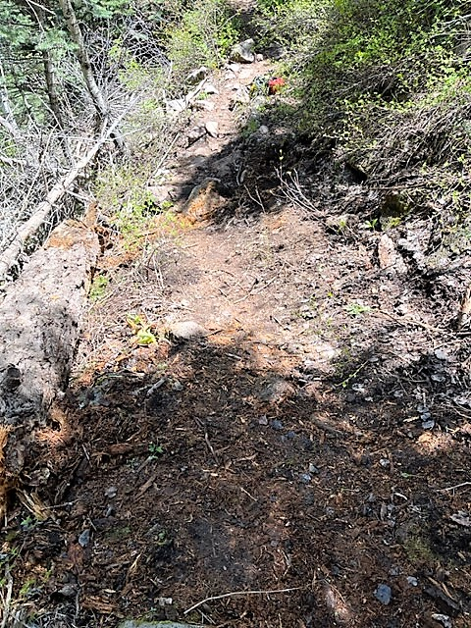
The second tree has been removed and now lies off
the bottom of the trail tread.
(Photo by Bob Lowder)

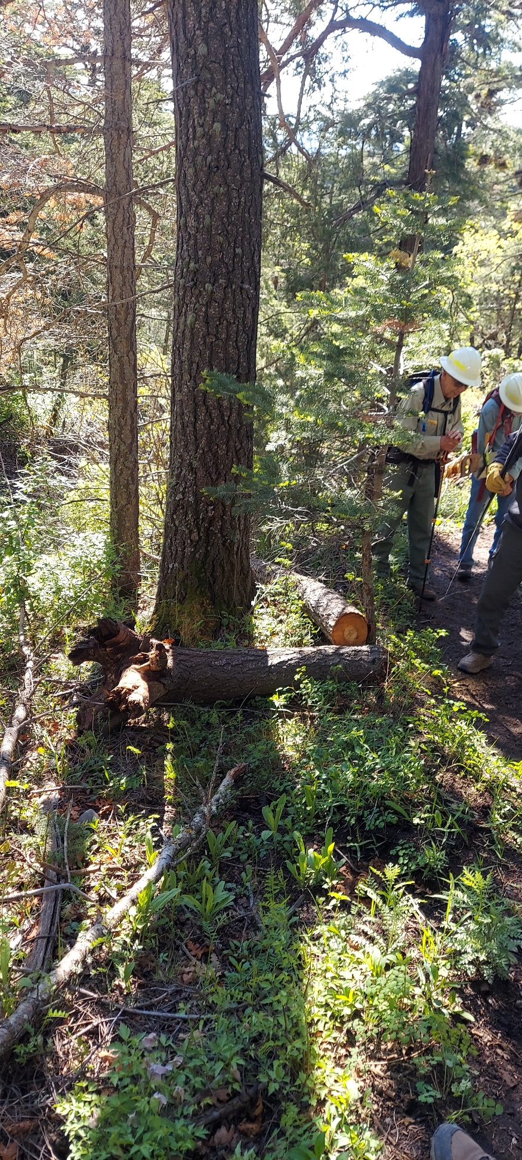
The crew also found a few things to do on
the way up and down Cienega Trail. The tree
on the ground in the center of the photo has
been cut off the trail and the cut sections
moved away.
(Photo by Rene Archer)
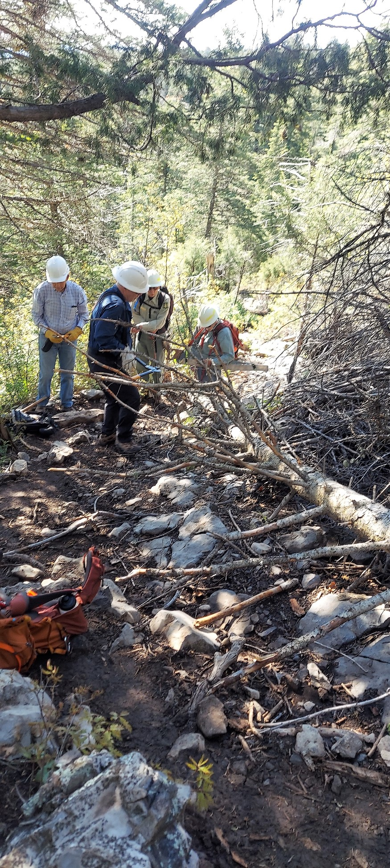
Another tree that had recently fallen over
Cienega Trail is being limbed prior to cutting
the trunk and moving it off the trail.
(Photo by Rene Archer)

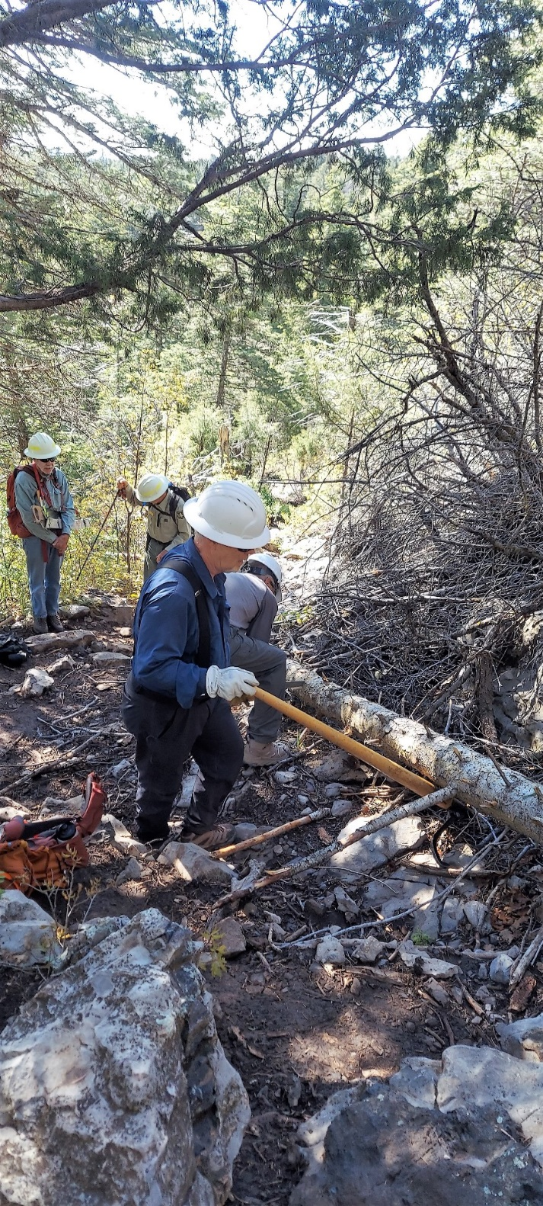
The crew is starting to move the
tree in the previous photo off the
trail.
(Photo by Rene Archer)

