Graffiti near Juan Tabo Stone Shelter on Thursday, May 25.

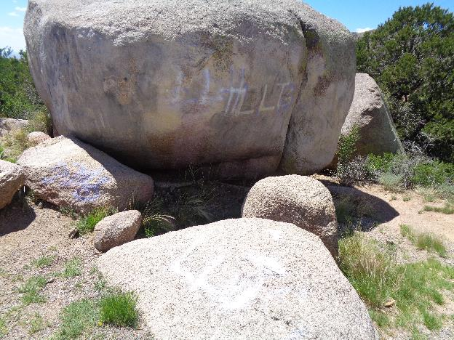

Graffiti on large and small boulders near the JT restroom.

The following photos show the graffiti on each boulder.

The last photo is on a boulder east of the restroom.

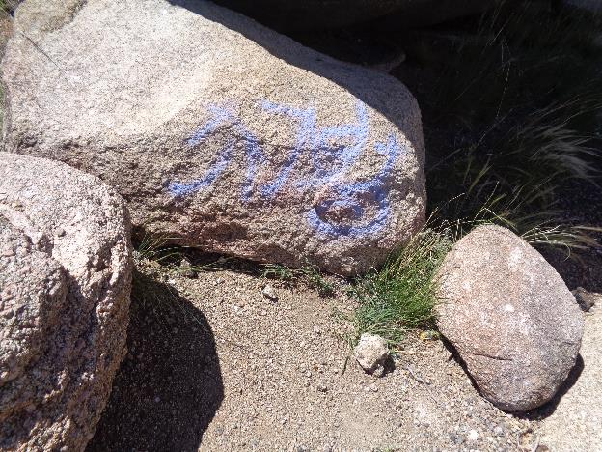

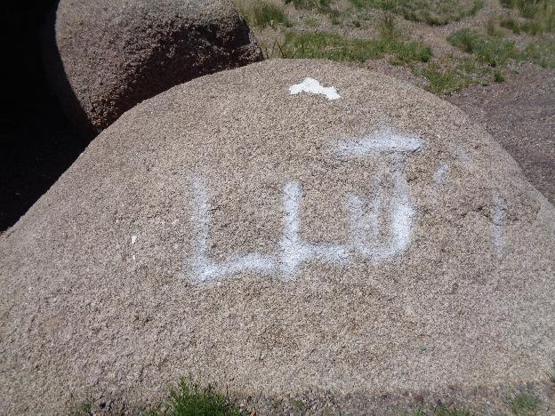

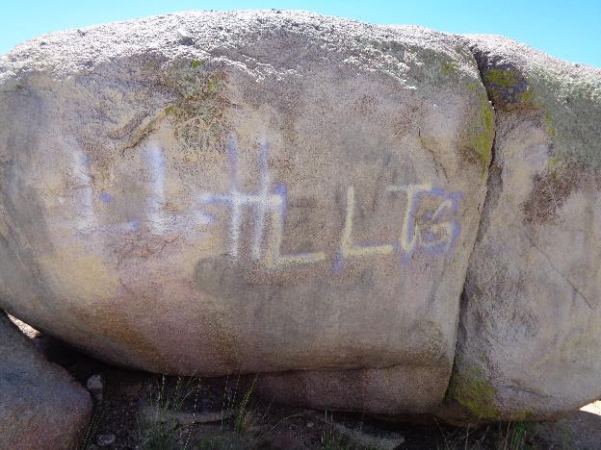

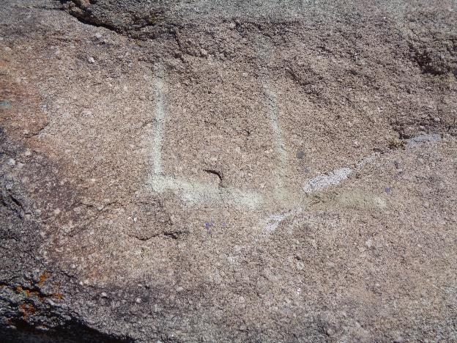

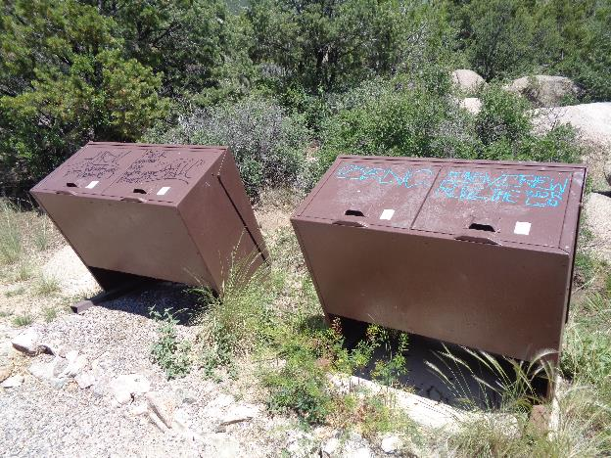

We will use sensitive surface chemical so that we will not damage the paint on these trash collectors.