**Report of Graffiti Removal in Juan Tabo Picnic Area**

**on Friday, May 26, 2023**

Sam Beard

May 28

On Friday, May 26, Sim Cook, Steve Roholt, Joelle Hertel, and Sam Beard removed graffiti tags at the following locations near the CCC stone shelter and the CCC stone restroom:

1. CCC Stone Shelter – Removed 4 small tags inside the shelter with World’s Best Graffiti Removal System.
2. Two Brown Trash Containers – Painted over graffiti with USFS brown paint.
3. Parking Lot at CCC Stone Restroom – Removed one large tag on a large boulder and 4 small tags on small boulders.
4. Pavement at CCC Stone Restroom – Removed one large tag on pavement.

Before and after project photographs are presented below.

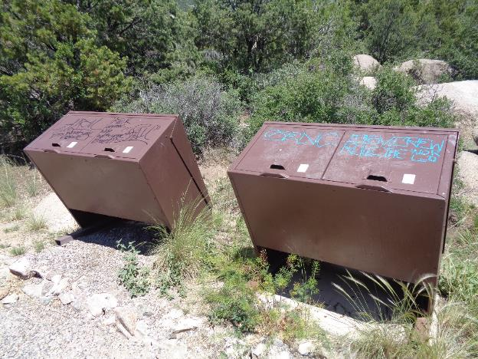

This graffiti on these trash containers was painted over with USFS brown paint. All photos by Sam Beard

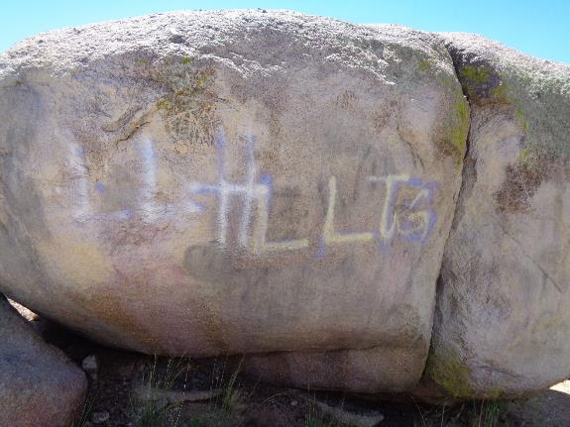

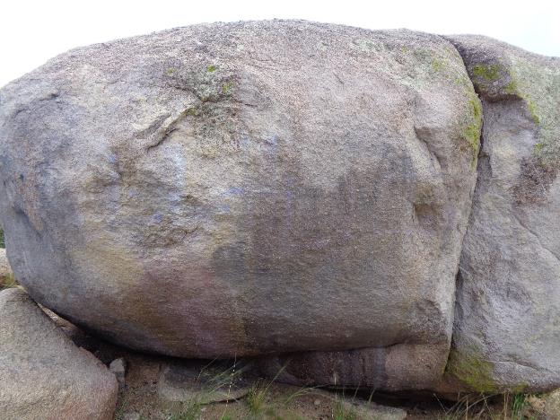

Graffiti on this large boulder was removed with World’s Best Graffiti Removal System chemical

for brick and stone.

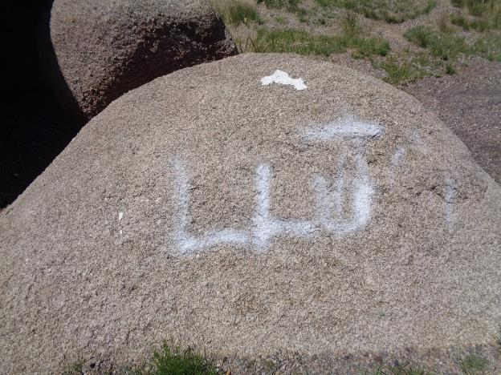

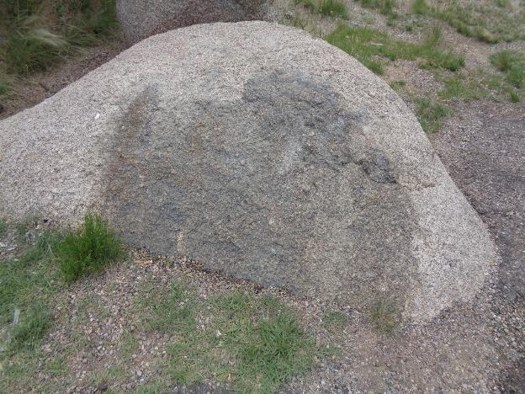

Small tag was removed from this boulder west of the parking lot. Joelle Hertel removed the

small thick white tag on top of the boulder with a screw driver.

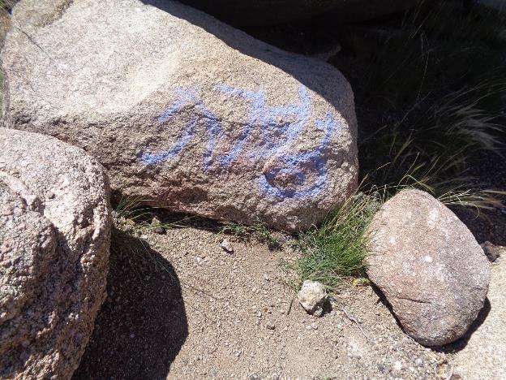

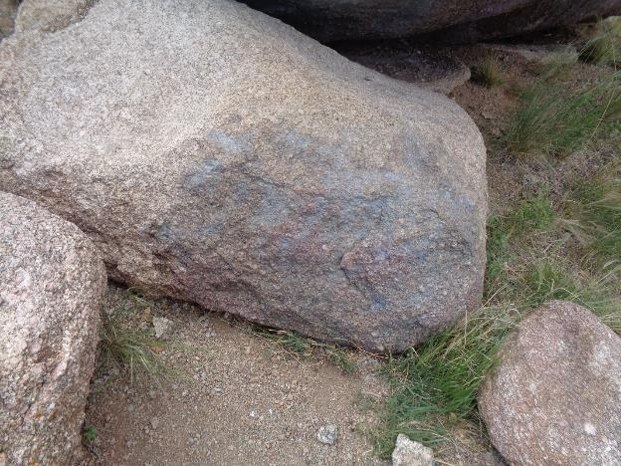

Most of the purple tag on this small boulder was removed.

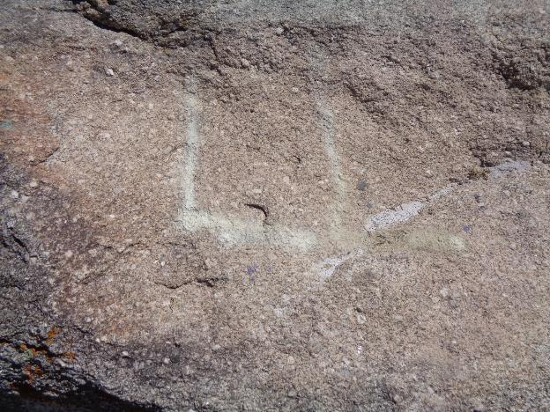

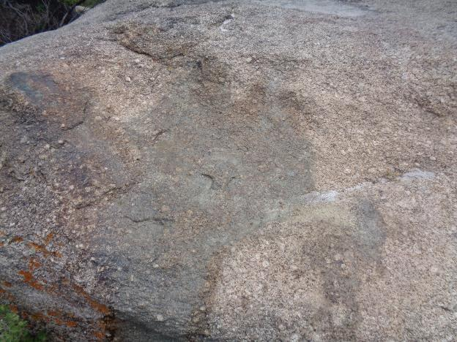

The white tag on this boulder east of the restroom was removed.

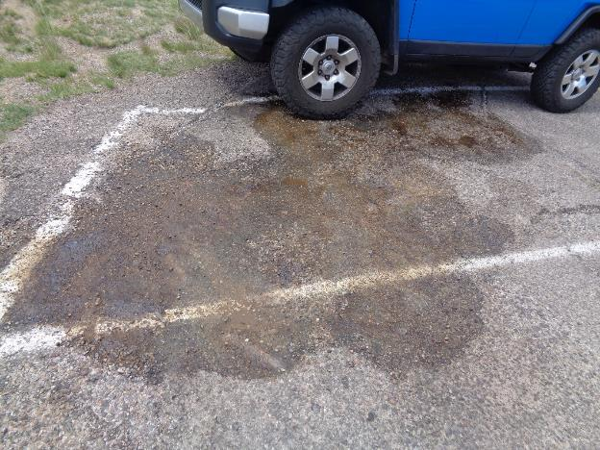

A large purple tag on the asphalt paving was completely removed.