**Report of FOSM Project to Process Donation Firewood in Sulphur and Cienega Picnic Areas**

**on Monday, June 5, 2023**

Sam Beard and Lou Romero

June 8

On Monday, June 5, eight FOSM volunteers and seven Talking Talons Youth Leadership (TTYL)/Youth Conservation Corp (YCC) crew members bucked, split, loaded, and hauled wood from Sulphur and Cienega PAs to the Mountain Christian Church Wood Ministry woodlot. The Wood Ministry will distribute the wood to those who need it in the East Mountain Area. The TTYL/YCC crew again contributed significantly to the project by bringing wood to the splitter or hauling it in wheelbarrows and helping load the truck and trailer.

The photos below demonstrate four principles we have emphasized in training the TTYL crew members:  Safety, Teamwork, Work Ethics and Leadership.  Working with TTYL has been an excellent cross-generational, collaborative experience.

The TTYL/YCC crew members were Jared Moyers, Crew Leader, Kineo Memmer, Assistant Crew Leader, Olivia Lopez, Ella Cook, Levi Gloetzner, Mari Salley, and Robbie Larrison. FOSM volunteers were Sim Cook, Lou Romero, Jerry Carroll, Jory Meade, Joe Meade, Tami Jo Meade, Sam Beard, and Rene Archer.

Project photographs are presented below.

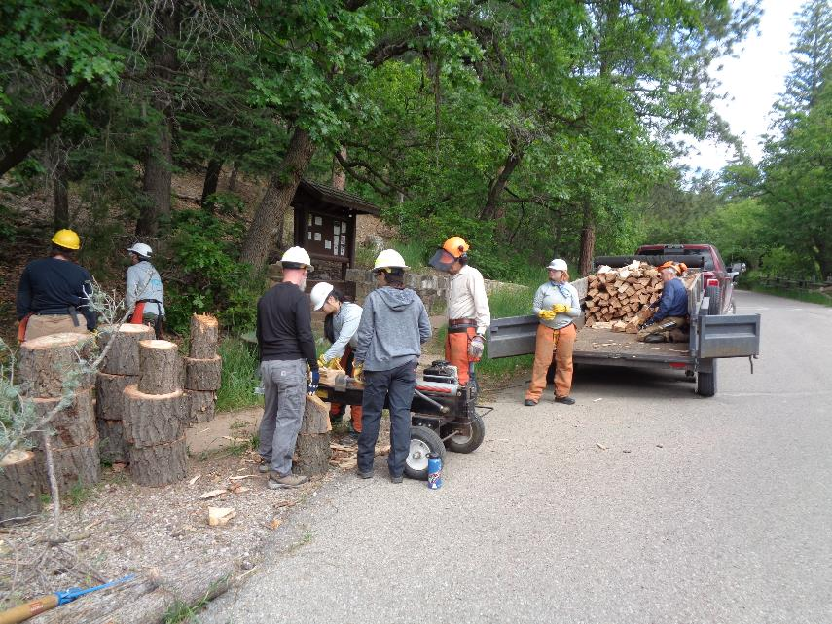

Splitting wood and loading the trailer in Sulphur Picnic Area. Photos by Sam Beard unless noted otherwise

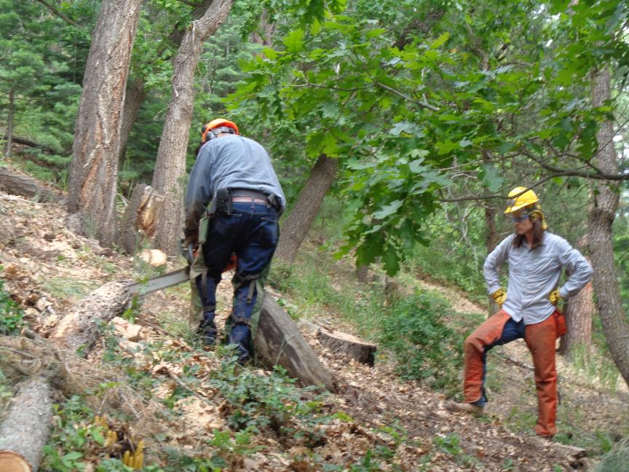

Jerry Carroll is bucking a log while Jared Moyers, TT/YCC Crew Leader, observes in Sulphur PA.

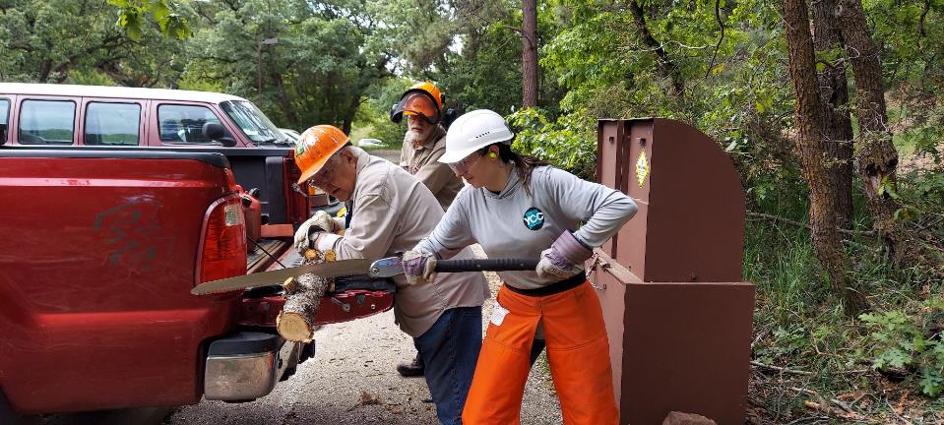

The TTYL crew members took turns sawing with the Silky saw.

Photo by Rene Archer

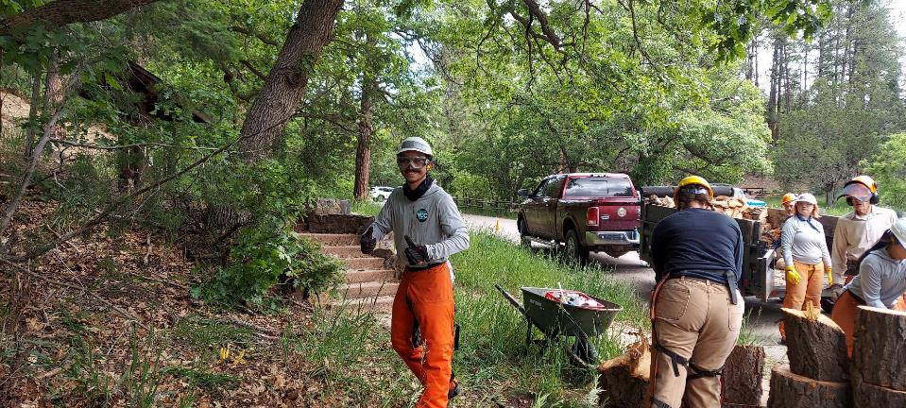

Levi giving the project a Thumbs Up. Photo by Rene Archer

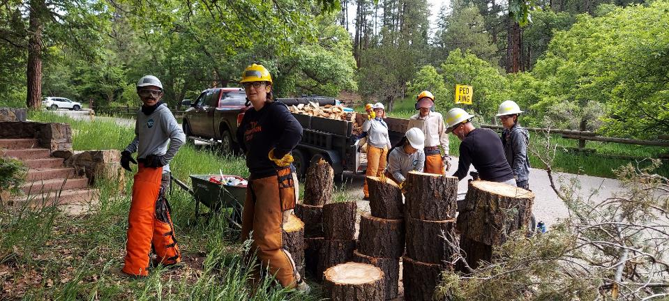

TTYL crew members working at the splitter and Joe’s trailer. Photo by Rene Archer

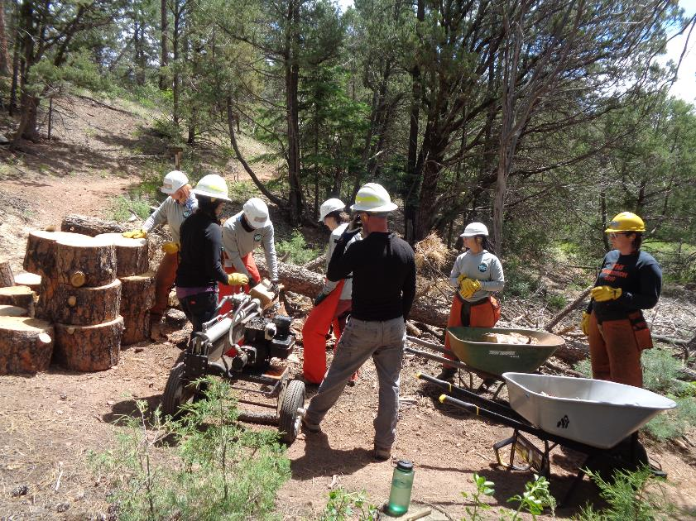

Splitting and hauling wood in wheelbarrows in Cienega PA. Jerry Carroll, the only sawyer working today, had

bucked all these rounds.

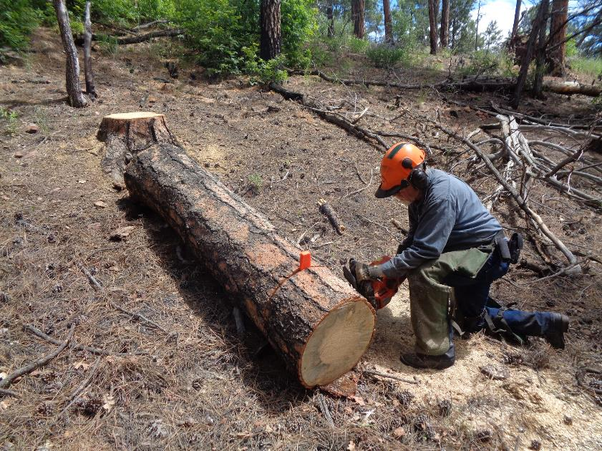

Jerry bucking a large log into 12-inch pieces in Cienega PA. This hazard tree had been felled by Steve Roholt

a few weeks ago.

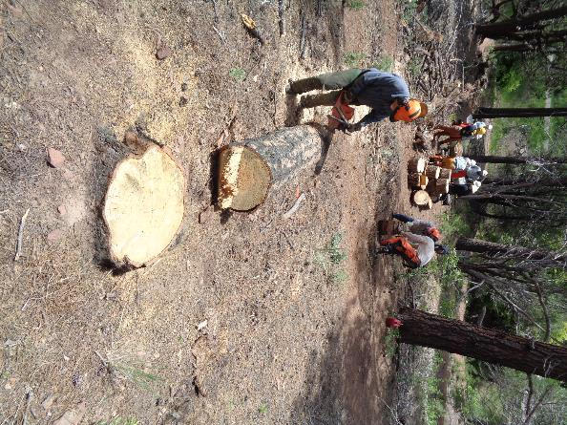

The complete operation in Cienega PA – bucking a log, moving it down

to the Lou Romero’s splitter, and loading the split wood on wheelbarrows

to haul to Joe Meade’s trailer and truck.

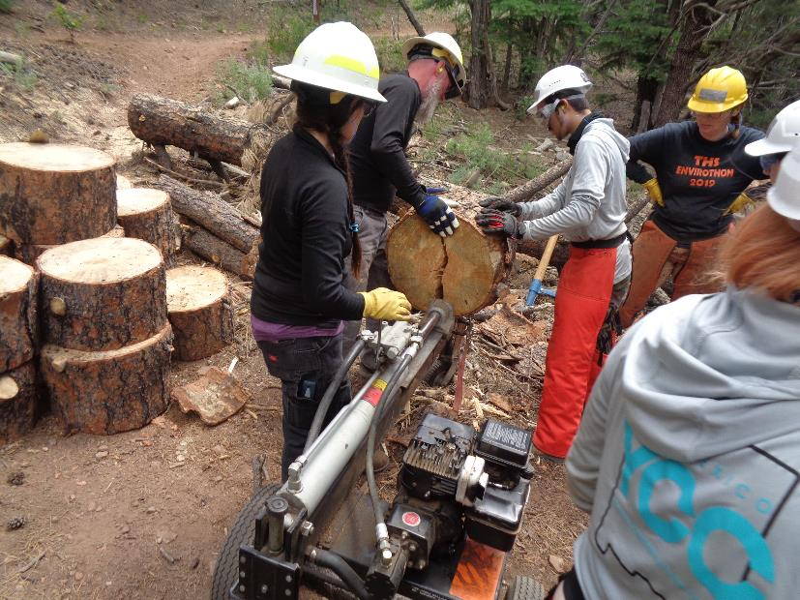

Splitting a round into two halves.

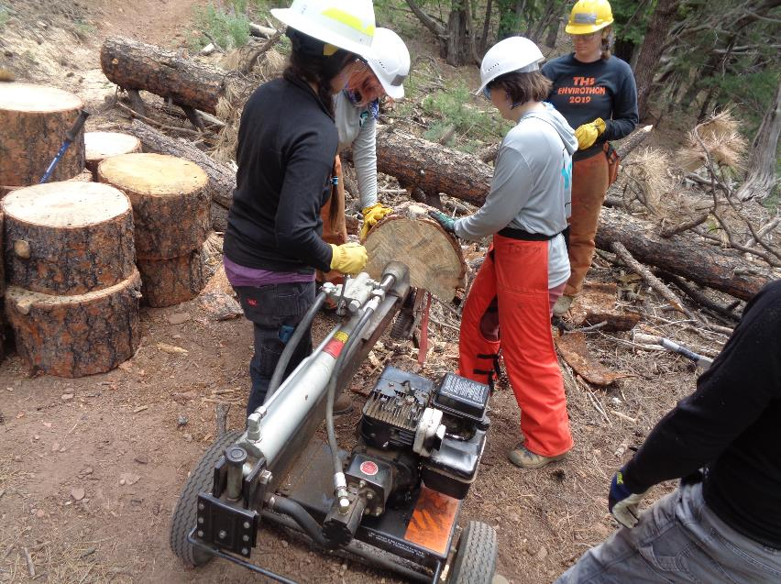

Splitting the half-round into quarters.

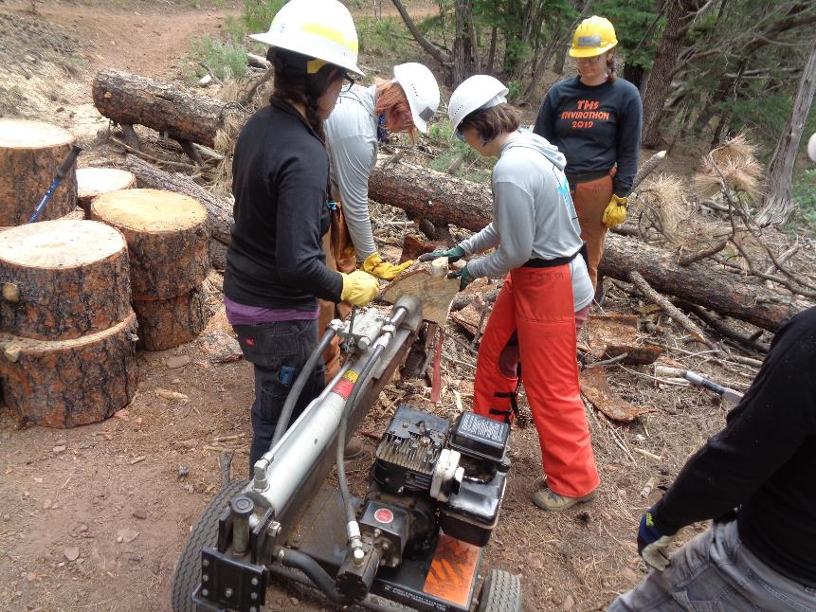

Splitting the quarter into eighths.

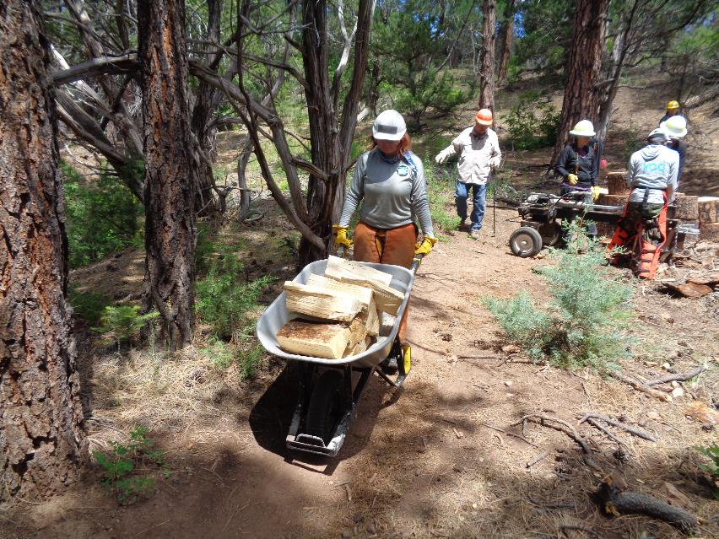

This TT/YCC crew member is hauling the wood to the trailer and truck.

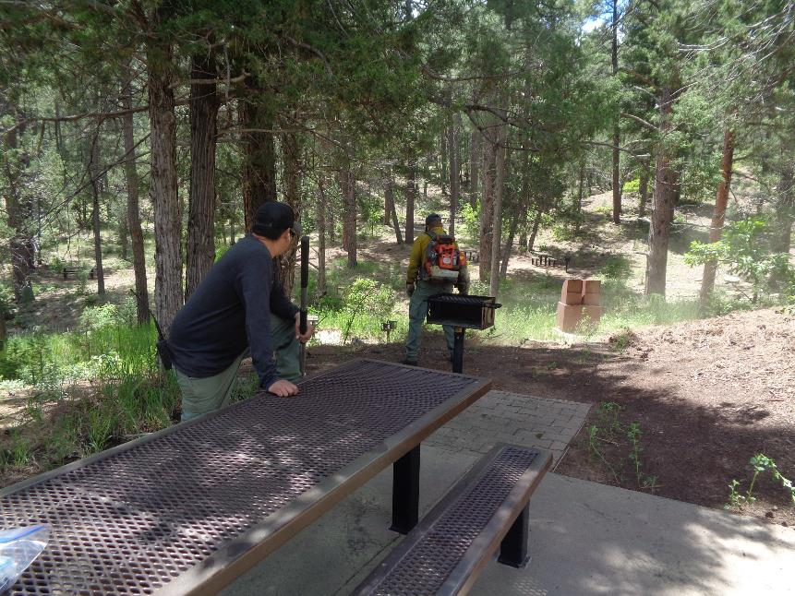

Sandia Ranger District fire fighters were cleaning Cienega PA where we had lunch.