**Report of FOSM Project to Work with TTYL/YCC Crew Processing Donation Wood**

**at Two Sites in Cienega Canyon Picnic Area on Wednesday, June 7, 2023**

Sam Beard and Lou Romero

June 9

On Wednesday, June 7, thirteen FOSM members worked with seven TTYL/YCC (Talking Talons Youth Leadership/Youth Conservation Corps) members processing donation wood at two sites in Cienega Picnic Area. Near the intersection of Acequia Trail and Cienega Picnic Road, the TTYL/YCC crew and FOSM volunteers continued limbing, bucking, splitting, and loading the wood on Joe Meade’s truck and trailer. After processing the two large logs at the first site, the crew and volunteers moved up the picnic area road and processed a large white fir that Steve Roholt had felled several weeks ago. After the truck and trailer were filled, the group ate lunch at the picnic tables near the first restroom. The wood was delivered to the Mountain Christian Church Wood Ministry woodlot on Sandia Haven Road where the TTYL/YCC crew stacked the split wood.

TTYL/YCC crew members were Jared Moyers, Crew Leader, Kineo Memmer, Assistant Crew Leader, Olivia Lopez, Ella Cook, Levi Gloetzner, Mari Salley, and Robbie Larrison. FOSM members were Cliff Giles, Jerry Pekarek, Sim Cook, Dan Benton, Lou Romero, Joe Meade, Jory Meade, Tami Meade, Byron Garner, Scott Dietrich, Gerry Carroll, Glenn Beard, and Sam Beard.

Project photographs are presented below.

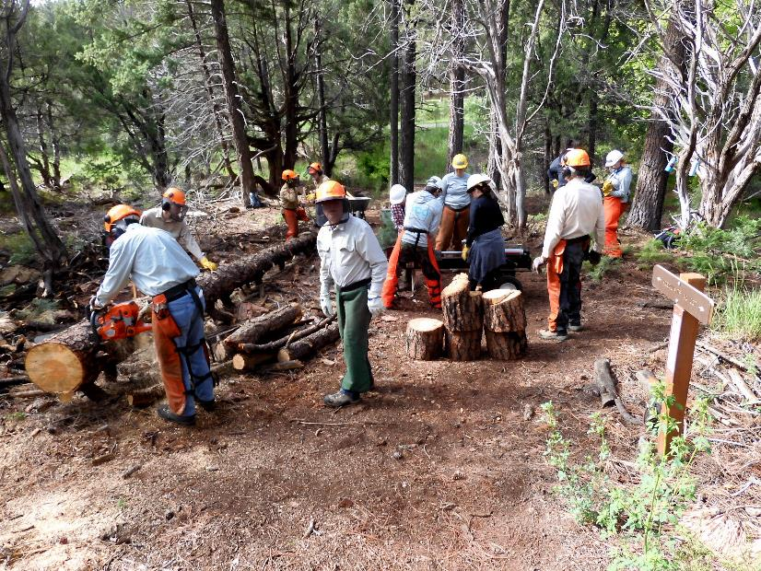

FOSM sawyers bucking the large log on the left and FOSM volunteers and TTYL/YCC crew splitting the rounds.

Photo by Dan Benton

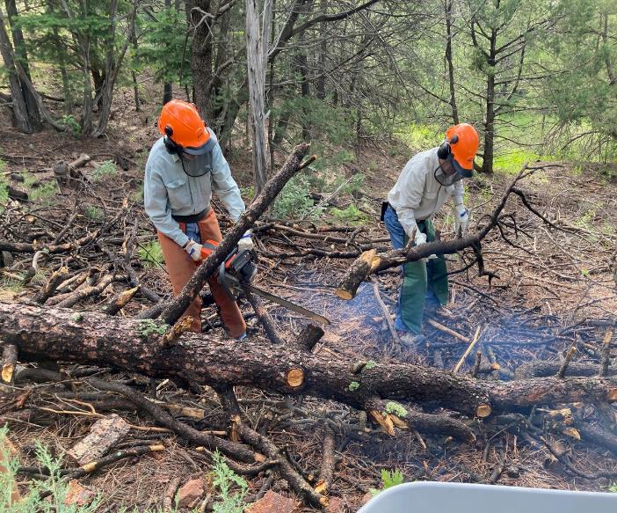

Byron Garner limbs log with a chain saw while Jerry Pekarek swamps at Acequia Trail in Cienega Picnic Area.

All photos by Cliff Giles unless noted otherwise

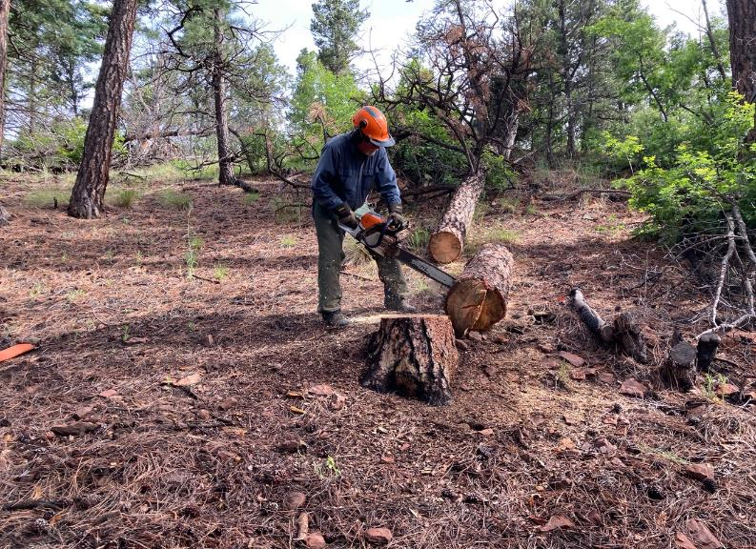

Jerry Carroll bucking a log at Acequia Trail.

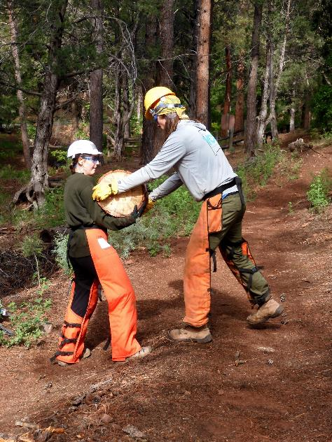

TTYL/YCC crew members moving rounds down to the splitter.

Photo by Dan Benton

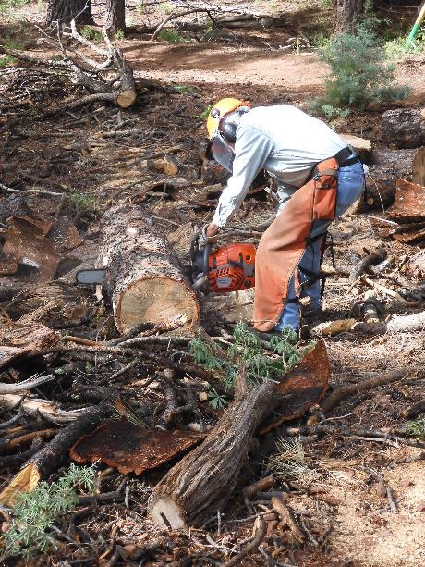

Byron Garner bucking a large log. Photo by Dan Benton

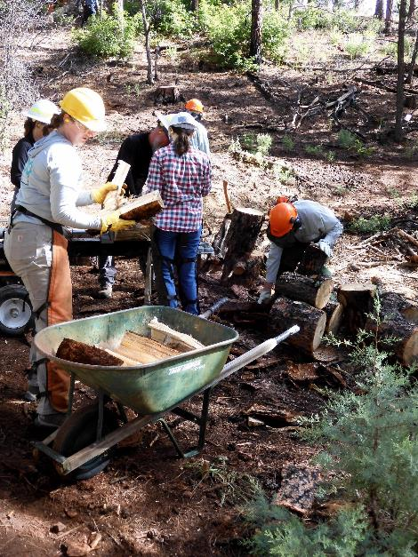

TTYL/YCC crew members helping split rounds and loading split wood

in a wheelbarrow. Photo by Dan Benton

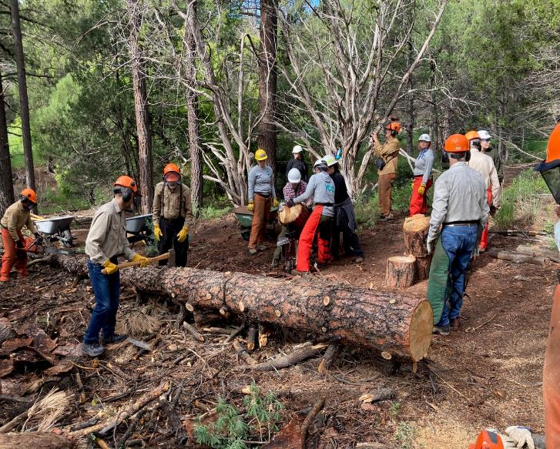

Bucking of log continues as splitting of rounds begins.

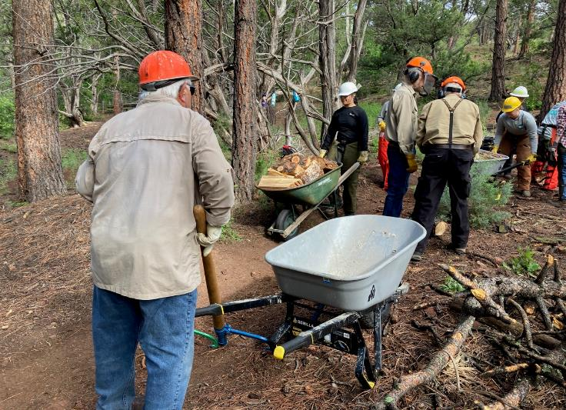

Lou Romero watches as Olivia transports split wood in a wheelbarrow.

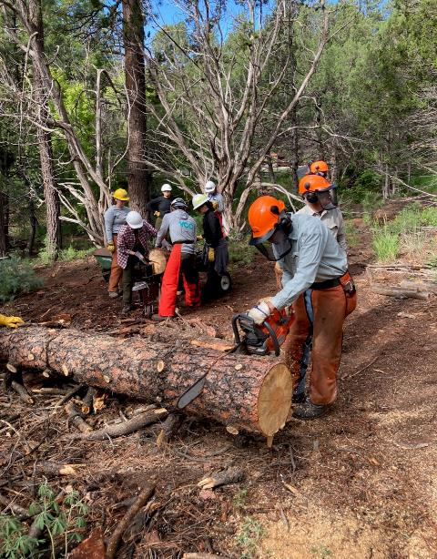

Byron Garner bucks a log while splitting is underway.

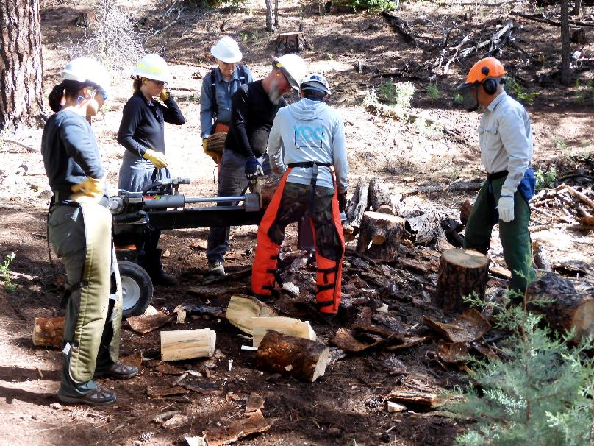

FOSM volunteers and TTYL/YCC crew members splitting donation wood with Lou Romero’s splitter.

Photo by Dan Benton

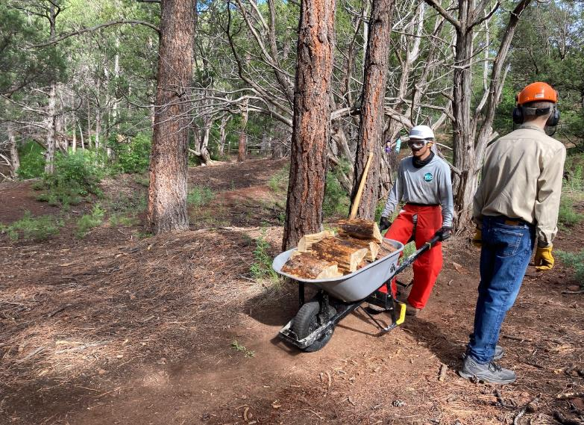

Levi transports a load of split wood.

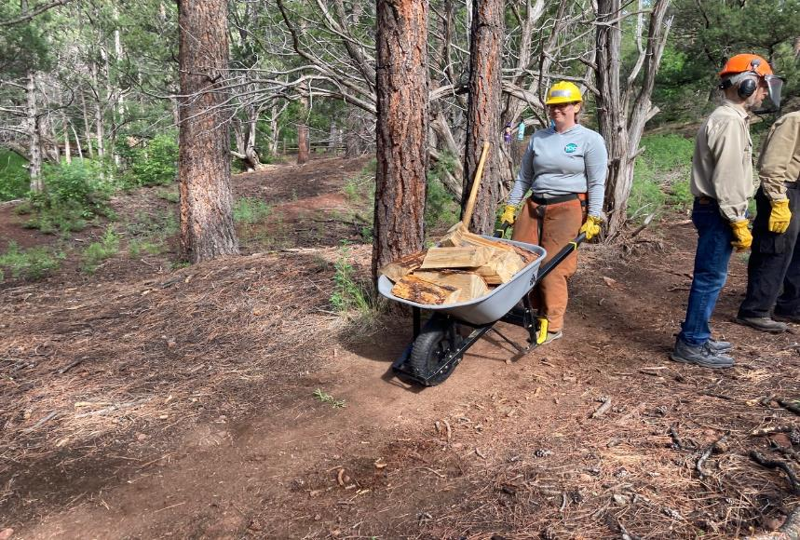

Kineo with a wheelbarrow full of wood.

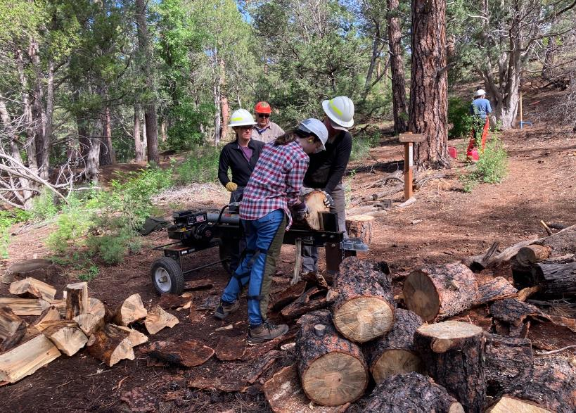

Robbie helps Tami Jo and Jory split wood

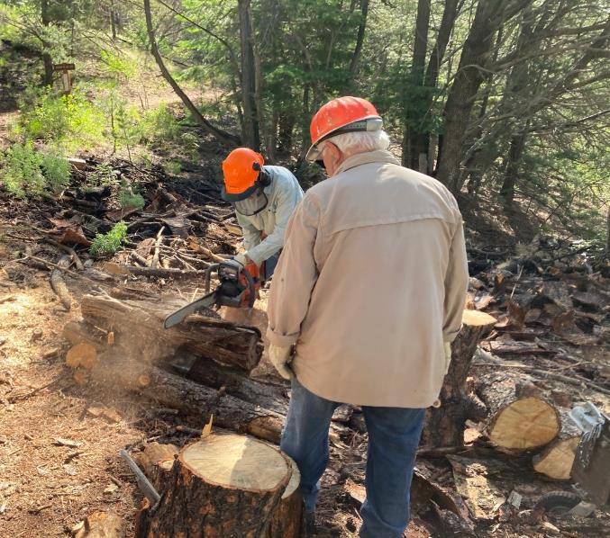

Byron bucks some small logs while Lou observes.

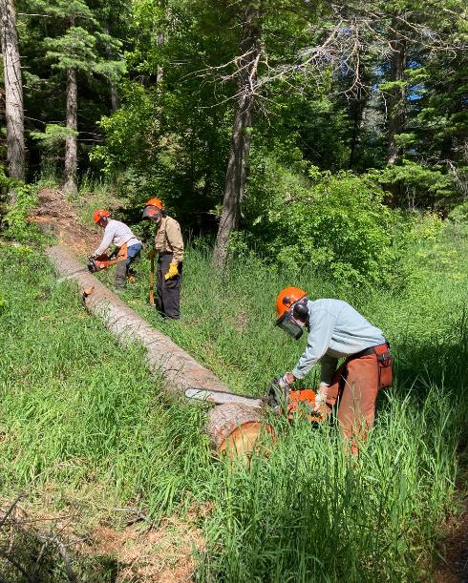

Steve and Byron buck a log beside the road between first and second restrooms in Cienega PA.

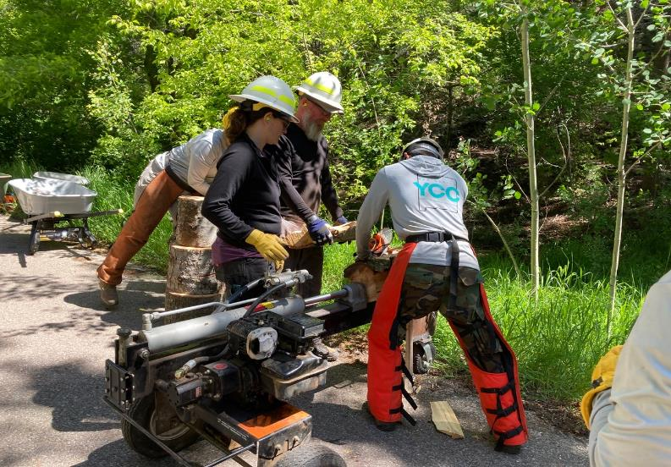

Levi helping Tami and Jory split wood on Cienega PA road.

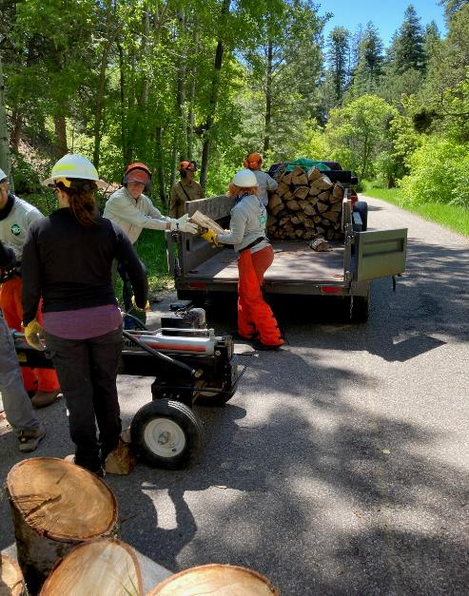

Handing split wood from the splitter to the trailer.

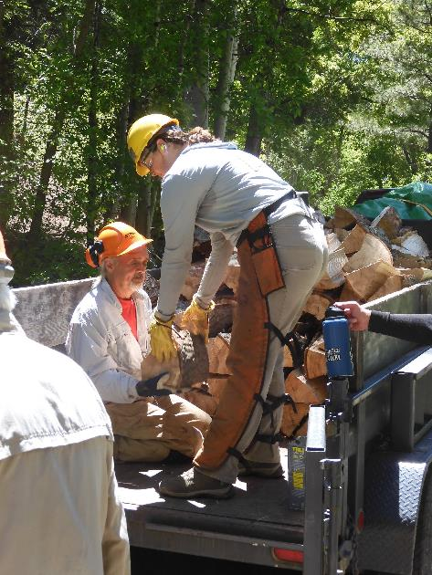

Kineo handing split wood to Joe Meade who will stack it in the trailer.

Photo by Dan Benton

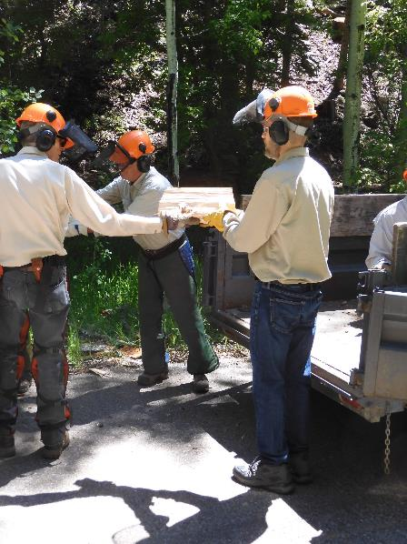

Sim Cook handing wood to Glenn Beard who will pass it to Joe Meade

in the trailer. Photo by Dan Benton

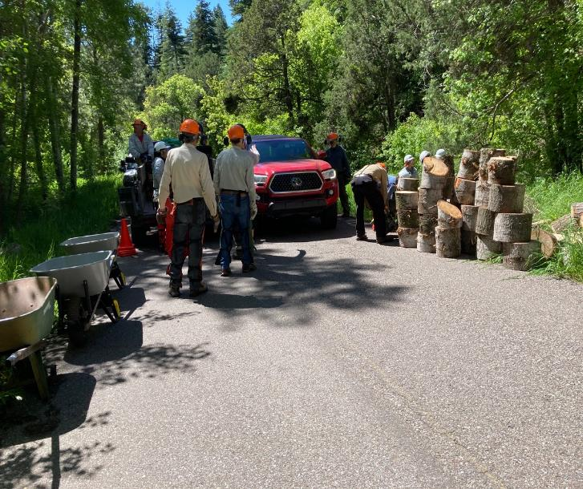

Truck moving up Cienega PA road between the splitter and a stack of logs.

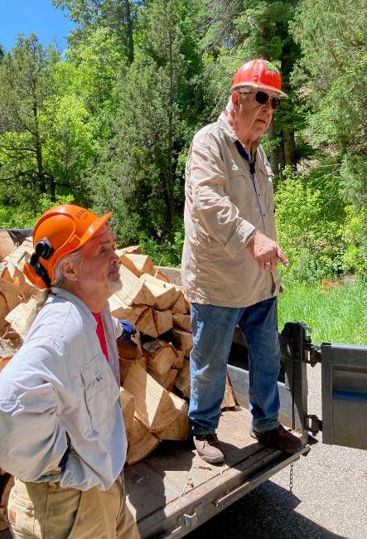

Lou and Joe thanking the TTYL/YCC crew for their work.

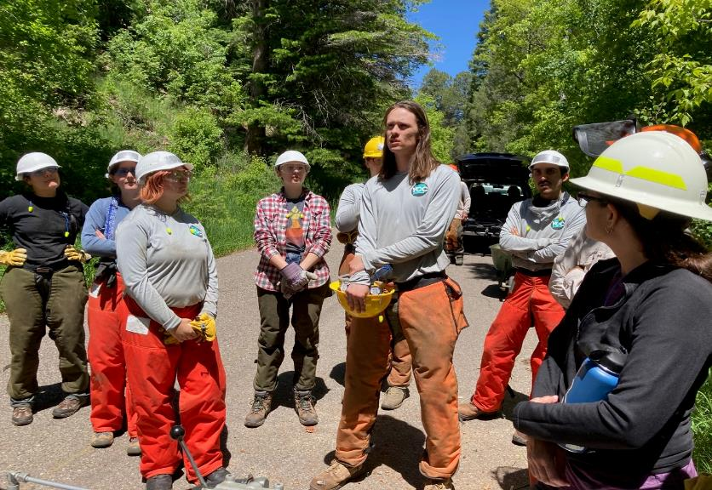

Jared thanking FOSM for the opportunity to work on this project.

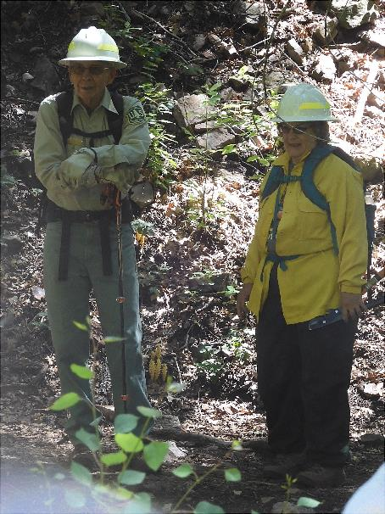

Bob and Sally Lowder on Acequia Trail. Photo by Dan Benton