Monday Trail Crew Report: June 12, 2023

Byron Garner

On June 12 the Monday Trail Crew hiked Ellis to the 10K junction with a return loop by way of Survey to remove two trees reported by Galbraith and construct a root ball reroute. After proceeding one half mile from Ellis trail head we encountered an 18" spruce which was the "trophy tree" of the day - a good case study of top binding green wood. A wider than usual clearance was provided to accommodate skiers on a fast slope. Continuing on past 10K junction we encountered the 12" aspen at suspended shoulder height and supported by another 12" aspen laying parallel to the trail but not intruding - an interesting situation requiring careful study and multiple cuts. A short distance ahead and now on Survey, we arrived at a work site ( reported by Galbraith) that included a 15" and a 19" aspen that had been previously cleared but needed additional work due to the elevated ends close to the trail edges. This was going to be work, so time to rest and refuel with a good lunch, good company and good conversation. Afterwards and four laborious cuts later the work was done and we were on to our last task of the day - the root ball reroute further up Survey . With a little minor engineering and backfill the trail was restored and we continued on with an enjoyable hike on a beautiful day and were rewarded with numerous clusters of Calypso orchids and other wild flowers - another great and classic early summer day on the mountain. And then there was the "pyro-drama" at 10K that was just beginning to assert it's potential. The crew included Rene Archer, Rav Nicholson, Jamey Browning, Dave McCreery, Ken Wilson, Sim Cook, Cleve Sharp, and John Cooper. Photo credits: Rene Archer, Jamey Browning and John Cooper. Trail notes: Rene Archer

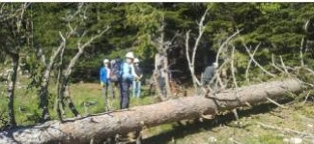Archer

The crew begins to tackle the spruce on Ellis

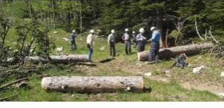Archer Basking in the satisfaction of success

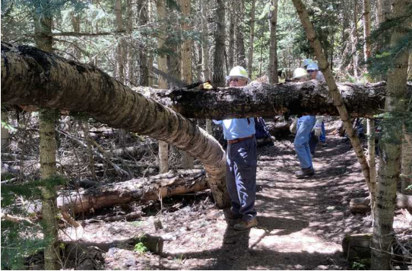Browning

Dave facing the challenge

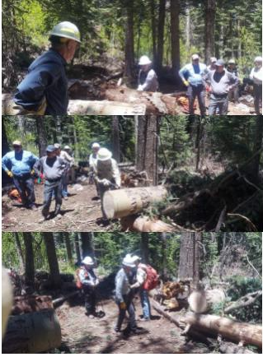Archer

Remedial work to open the trail more

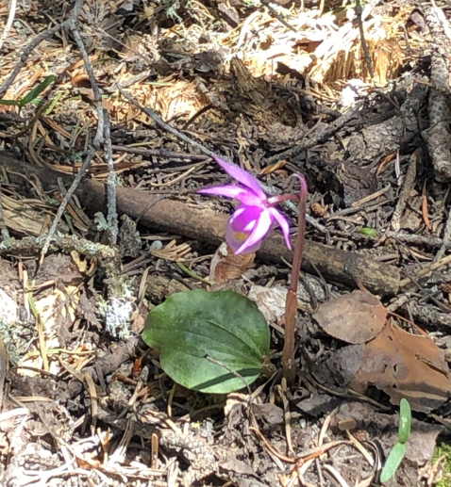Cooper

Calypso

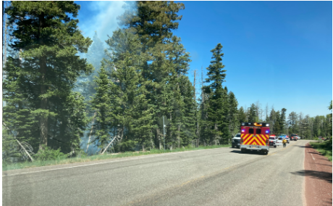Browning

10K fire