**Report of FOSM/SRD Project at La Madera Gate to Install a Limiter**

**and Steel Pipe Fences on June 12, 13, and 14, 2023**

Joelle Hertel, Sam Beard, and Dan Benton

June 16, 2023

On Monday through Wednesday, June 12 through 14, FOSM volunteers, Sandia Ranger District personnel, and TTYL/YCC (Talking Talons Youth Leadership/Youth Conservation Corps) crew members completed a project to remove half of a vehicle gate, install a steel pipe limiter with a width of 3 feet, and install a welded steel pipe fence on both sides of the gate/limiter. The purpose of the project was to support the District's Travel Management Plan that prohibits motorized vehicles on this part of the District. Vehicles were able to bypass the old gate to get onto the pipeline road, and this project was intended to remedy that. The FOSM Project Leader was Joelle Hertel. Installation of the fence required drilling holes 10 feet on center, placing and leveling vertical posts, and filling the holes with concrete. Twenty-foot-long horizontal rails were welded to the vertical posts which were set 4 feet above the ground.

The location of the project is shown on the map on page 2. The gate is located about 2 miles north of the village of La Madera.

The USFS personnel working on the project were Manny Chavez, Russell Berman, and Jeff Cervantes. The TTYL/YCC crew members were Jared Moyers, Crew Leader, Kineo Memmer, Assistant Crew Leader, Olivia Lopez, Ella Cook, Levi Gloetzner, Mari Salley, and Robbie Larrison.

The FOSM members working on this project were Dan Benton, Joelle Hertel, Mike Madden, Glenn Beard, and Sam Beard.

Project photos are presented below.

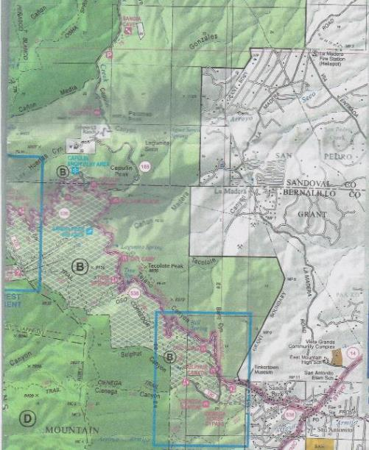

The La Madera Gate Project was located about one mile west of the La Madera Fire Station

where the pipeline (dashed line) crosses the National Forest boundary in the upper right corner

of the map. The large red arrow at the top of the map is pointing at the location of the project

on the National Forest boundary. All photos by Sam Beard unless noted otherwise

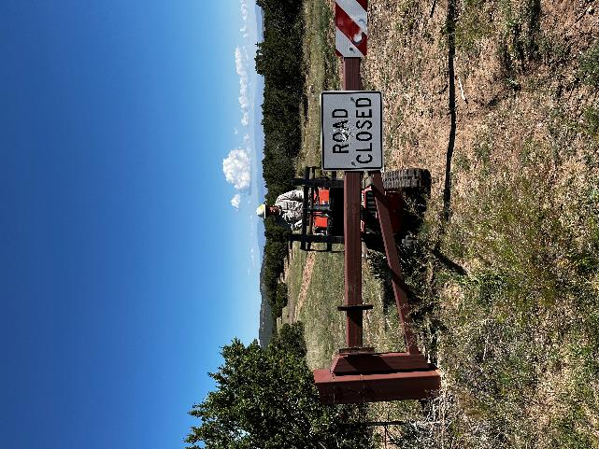

Using the skid steer to remove the left part of the vehicle gate at the start of the project.

The bolts securing the gate to the post had been removed. Photo by Joelle Hertel

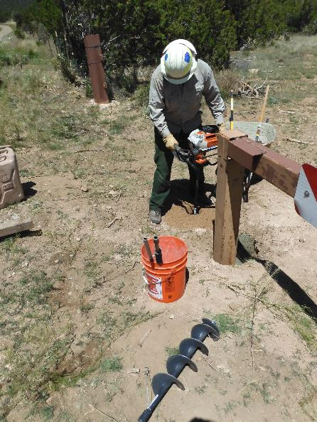

Russell Berman using the FOSM power auger to drill a hole for one side

of the limiter. Photo by Dan Benton

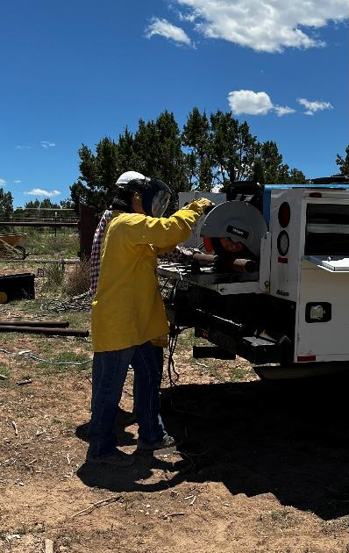

One of the TTYL/YCC crew members cutting steel pipe. Photo by Joelle Hertel

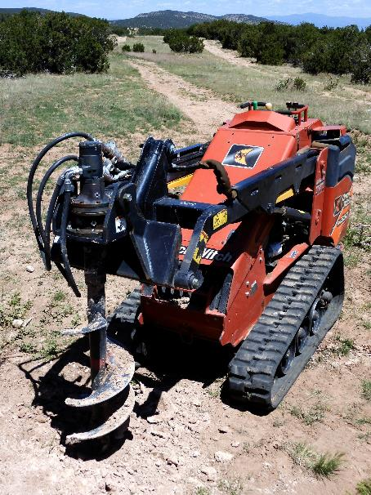

The Sandia Ranger District skid steer that was used to lift the disassembled gate

and drill holes for posts. Photo by Dan Benton

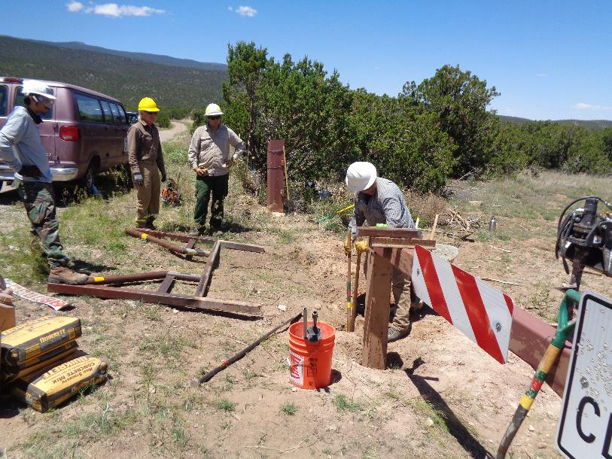

Completing a post hole with manual post hole diggers.

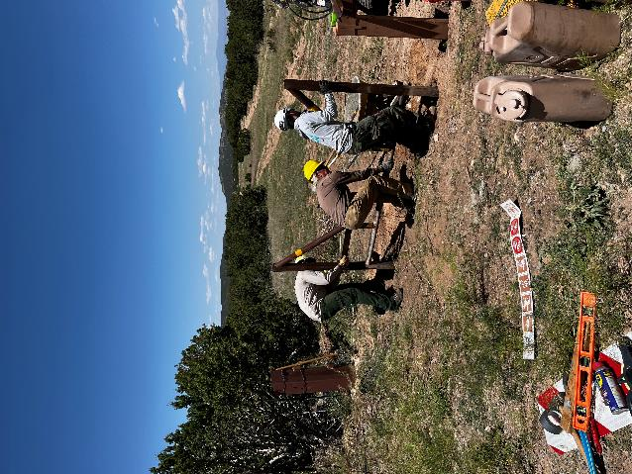

Installing the steel pipe limiter where the left part of the gate had been. Photo by Joelle Hertel

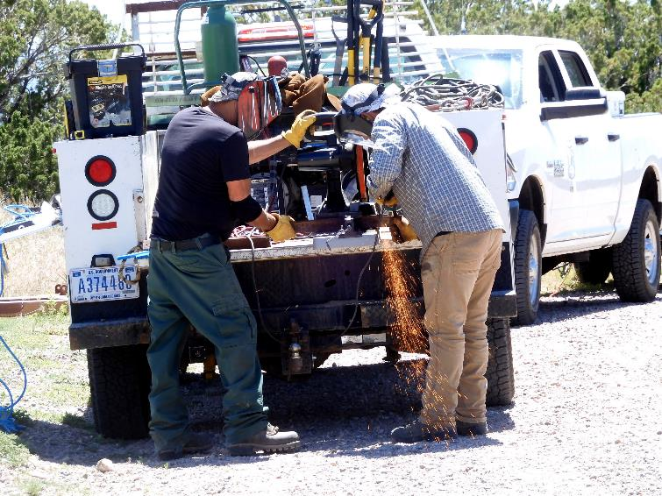

Manny Chavez (L) and Jeff Cervantes cutting steel pipe. A generator in the pickup provided electrical power for the project.

Photo by Dan Benton

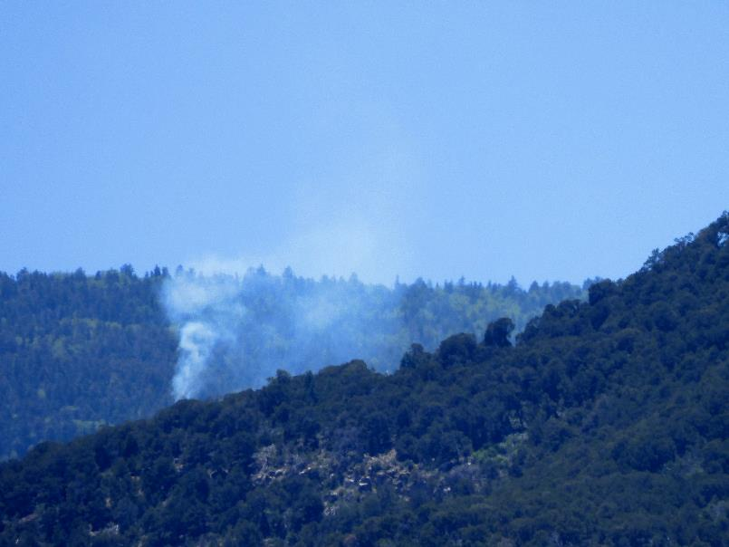

Smoke from the 10K Fire near the Crest Highway shortly after it started. Photo by Dan Benton

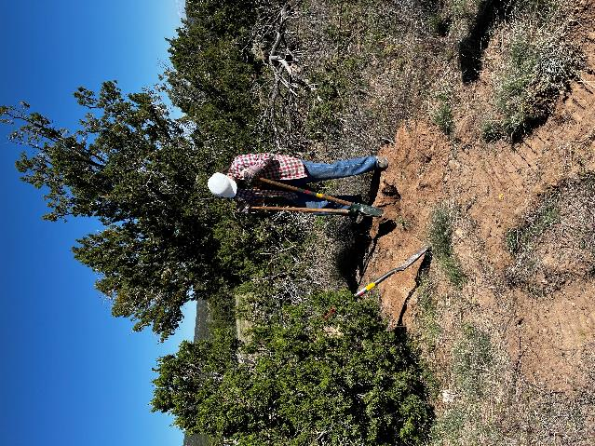

A TTYL/YCC crew member digging a post hole on the east fence. Photo by Joelle Hertel

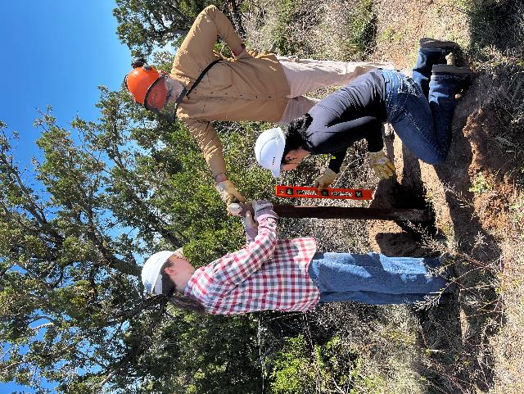

Two TTYL/YCC crew members helping Dan Benton align a post.

Photo by Joelle Hertel

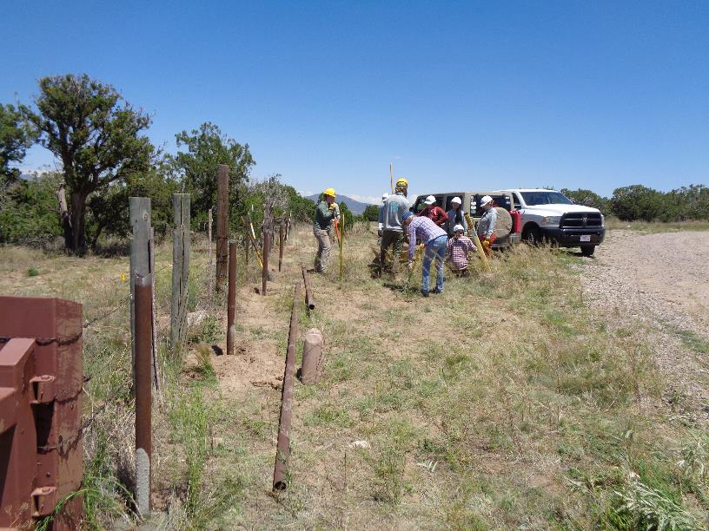

Posts for the 100-foot welded pipe fence installed along the National Forest boundary to the east. 20-foot sections of the steel pipe

are lying on the ground. The pipe is actually surplus drill stem from southeastern N. M. that was donated to the SRD years ago.

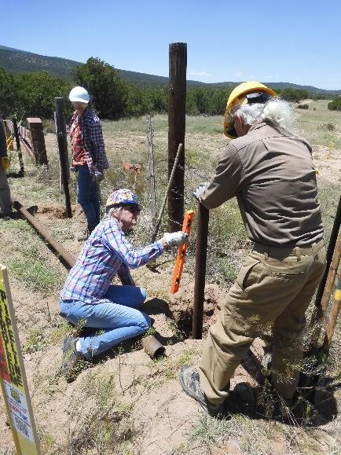

Joelle Hertel and Mike Madden setting a post on the east fence.

Concrete will be poured around the post. Photo by Dan Benton

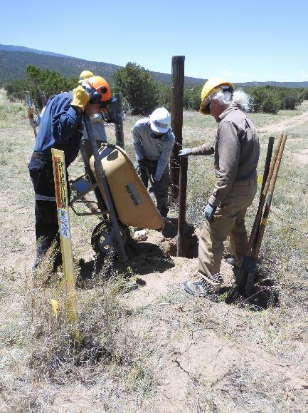

Pouring concrete around a post. Photo by Dan Benton

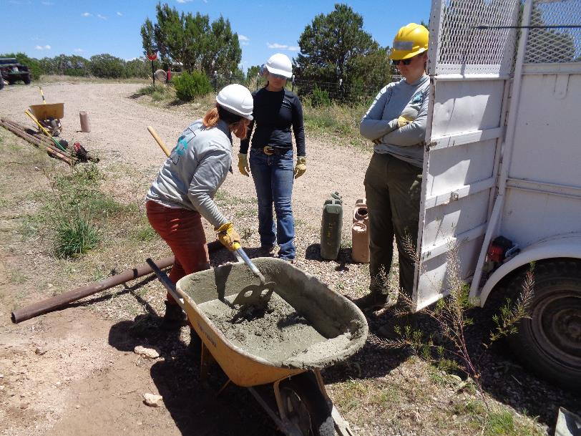

A TTYL/YCC crew member mixing concrete for one of the 22 posts that were install at the site.

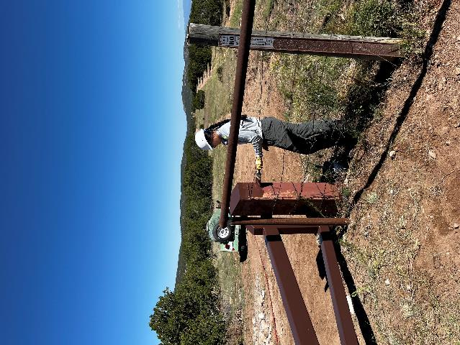

A TTYL/YCC crew member painting a fence post with USFS brown paint.

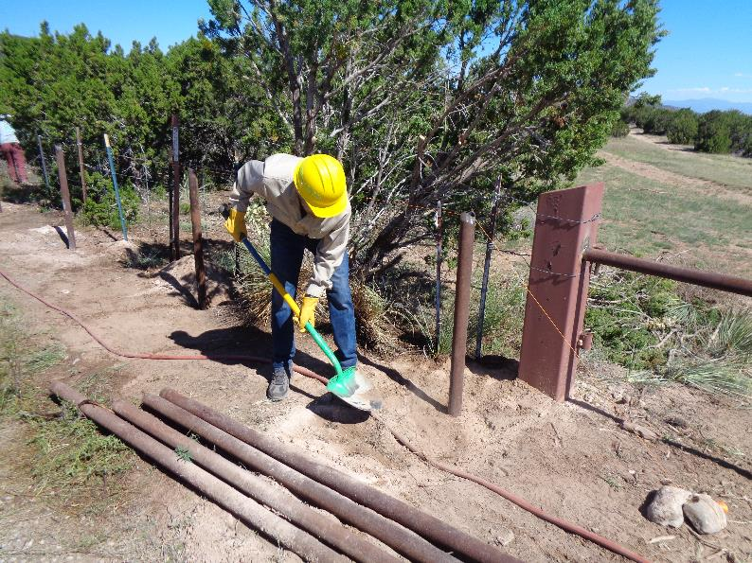

Glenn Beard shoveling dirt into a post hole after the concrete had been poured.

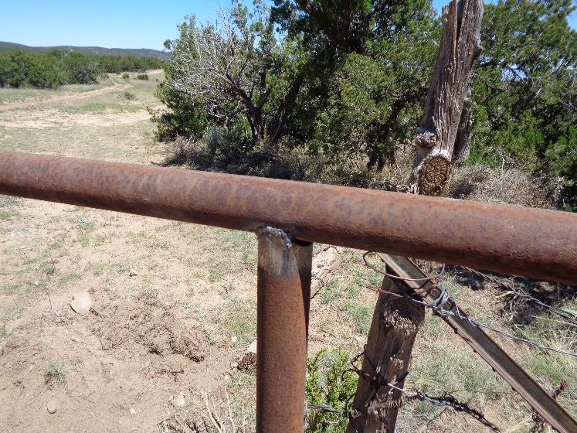

A typical weld on the steel pipe fence. At the request of Manny Chavez, a professional welder volunteered to weld the horizontal

pipes to the steel posts.

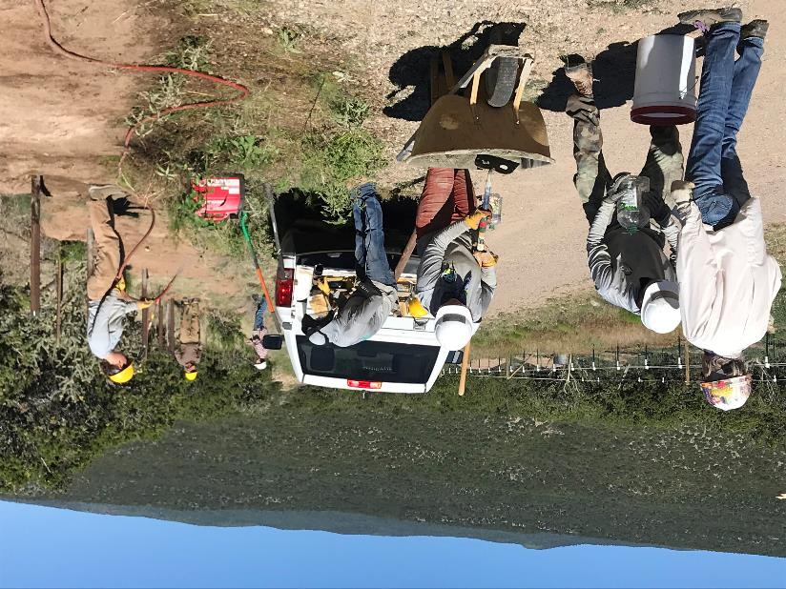

L to R: Activity along the west pipe fence – filing gallon jug with water, mixing concrete, grinding rust off of a steel pipe,

and spraying water on plants to reduce the possibility of fire from the welding. Photo by Dan Benton

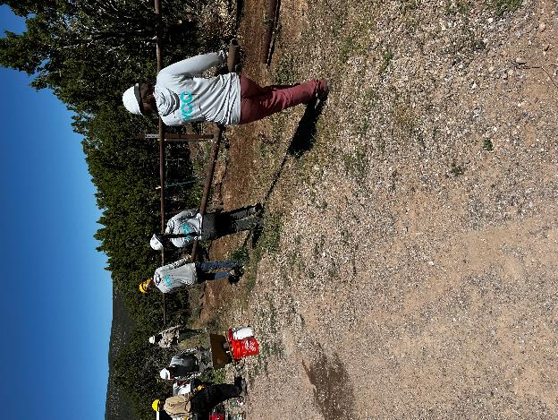

Three TTYL/YCC crew members carrying a pipe to the west fence.

Photo by Joelle Hertel

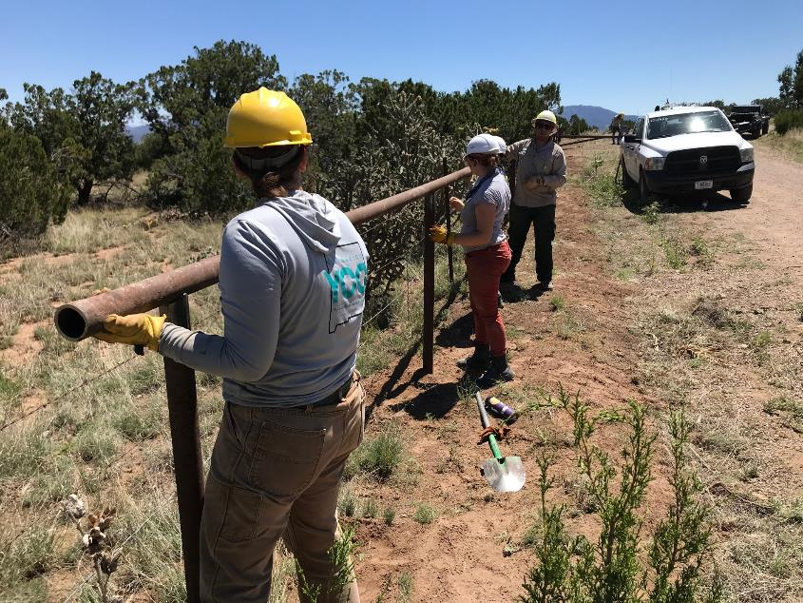

Laying the last piece of pipe on the posts at the west end of the fence. Photo by Dan Benton

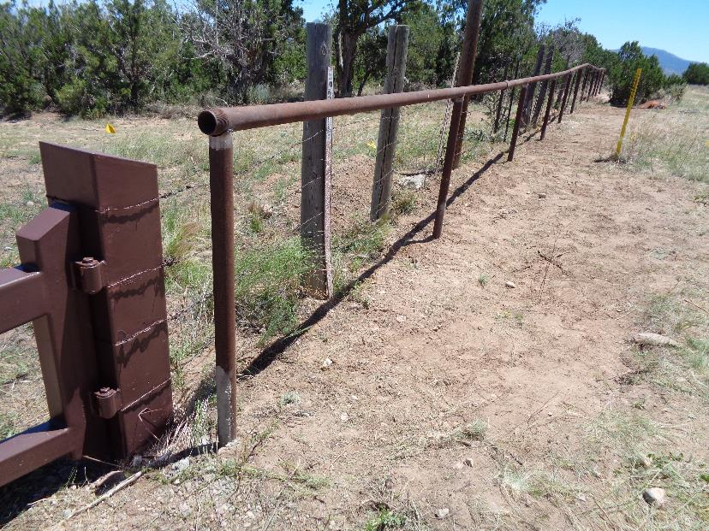

The completed 100-foot pipe fence along the east National Forest boundary.

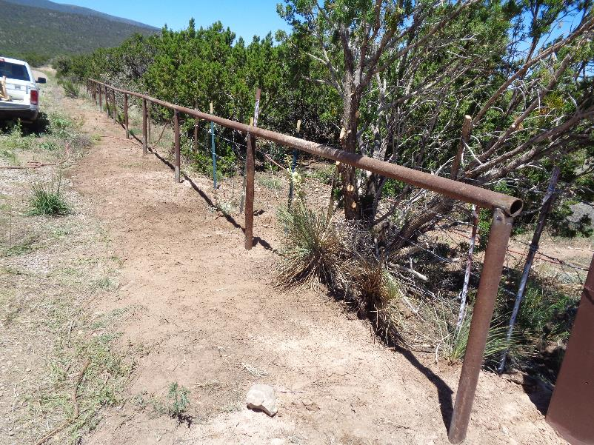

The pipe fence along the west National Forest boundary.

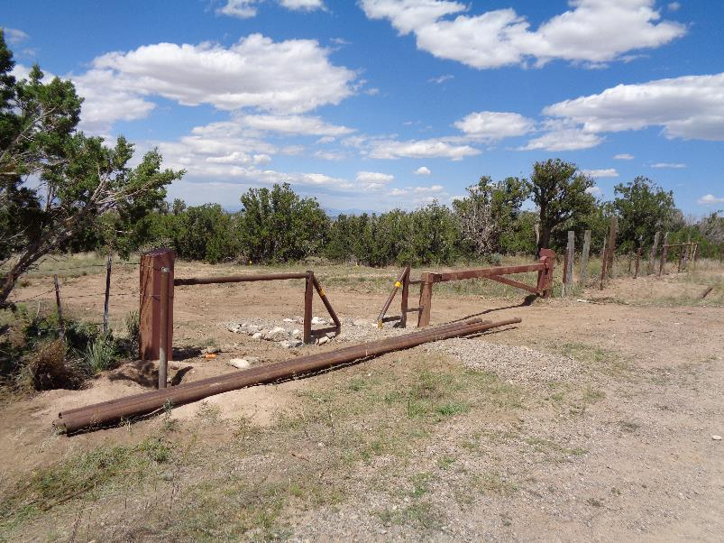

The pipe limiter installed beside the remaining vehicle gate limits access to the National Forest to vehicles less than 3 feet wide.

Sandia Ranger District personnel made six welded joints to install the limiter and pipe left of the limiter.

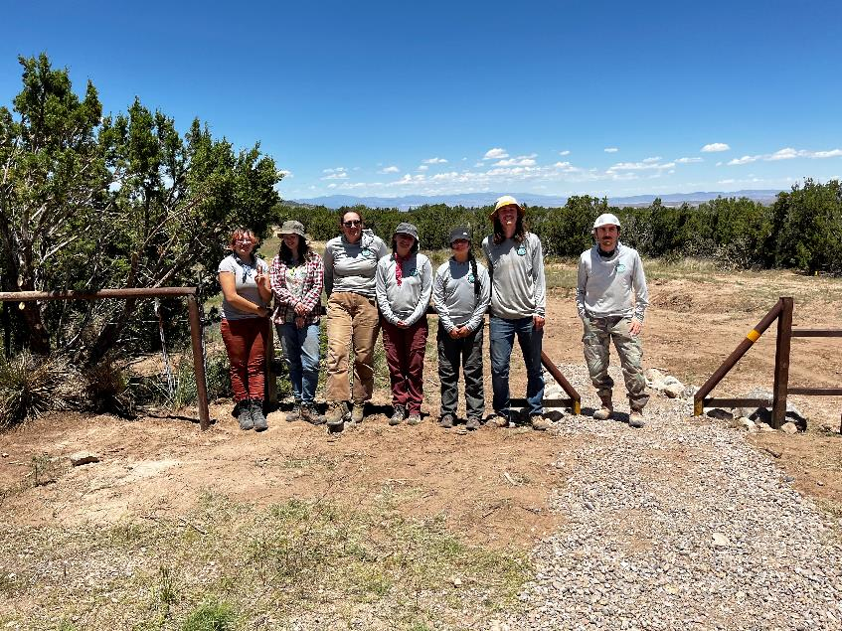

The seven members of the TTYL/YCC crew at the completed gate. Photo by Joelle Hertel