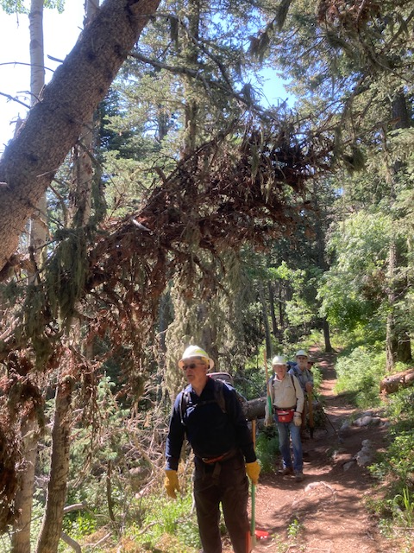
This brushy hang-up was looming over Rocky Point
trail. It might clear a hiker, but certainly not
someone on horseback.
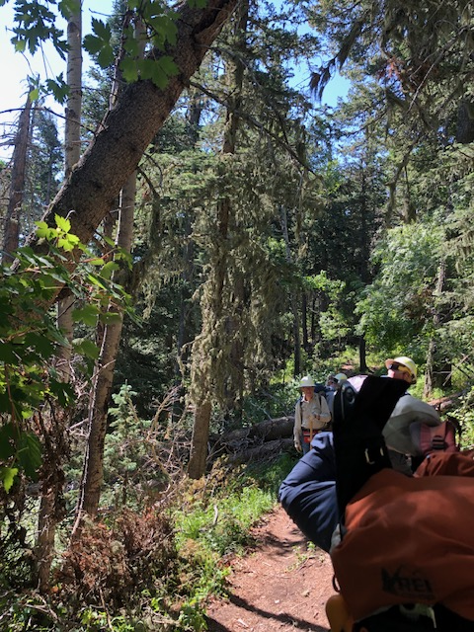
Brushy hang-up in previous photo is no more.

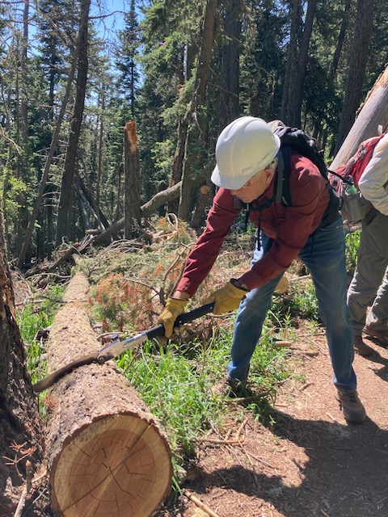
This previously cut log was protruding into the
trail tread. John cut it back to provide safer
clearance.
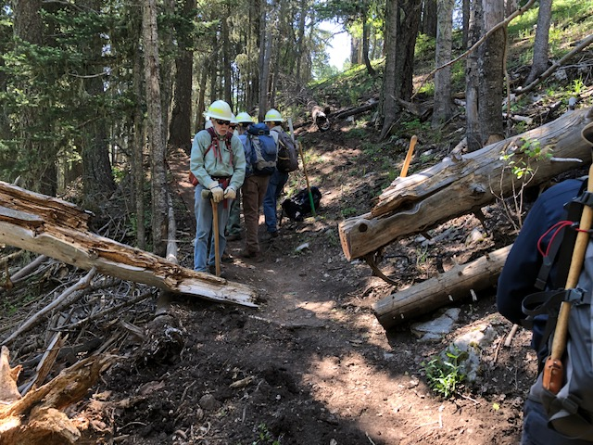
At this location of Crest Trail 130 South, a couple of old fallen trees present a hazard to hikers as they protruded into
the trail.

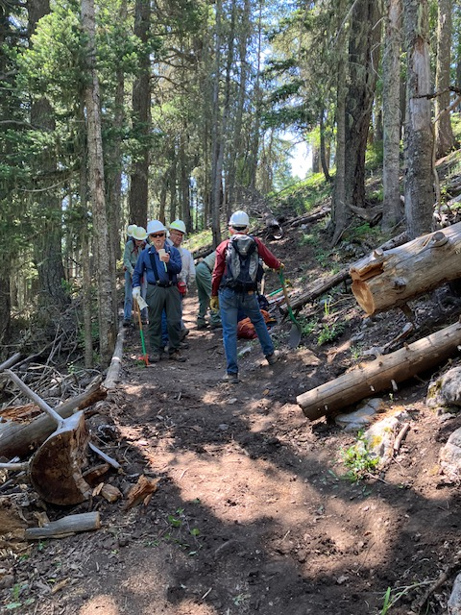
The hazards in the preceding photo have been removed.
The lower log at the right was firmly in place and
on the ground. Due to the width of the trail at that
point it was not deemed a hazard.

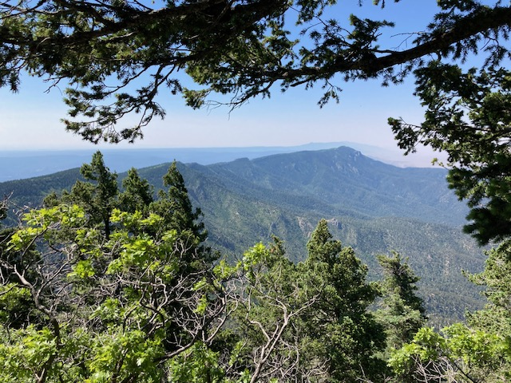
This is the view looking south from the first “big switchback” on Crest Trail 130 downhill from the upper tram terminal.
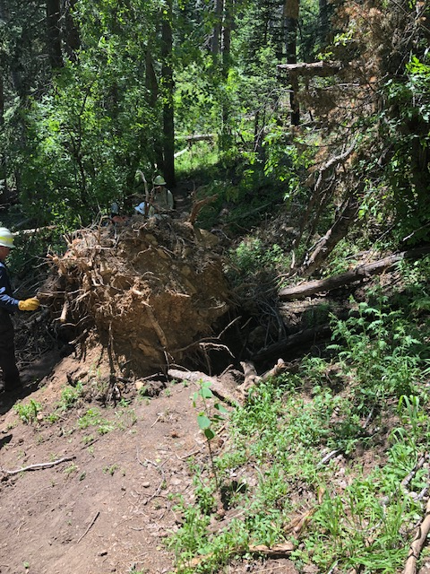
This view looking south shows where the root ball
of the large fallen tree has destroyed the trail at
this point. A deep hole exists where the trail once
was. The re-route will go around the root ball and
curve around to where the crew member in the white
hard hat is standing in the background. The huge
double trunk of the fallen tree extends downhill to
the left.
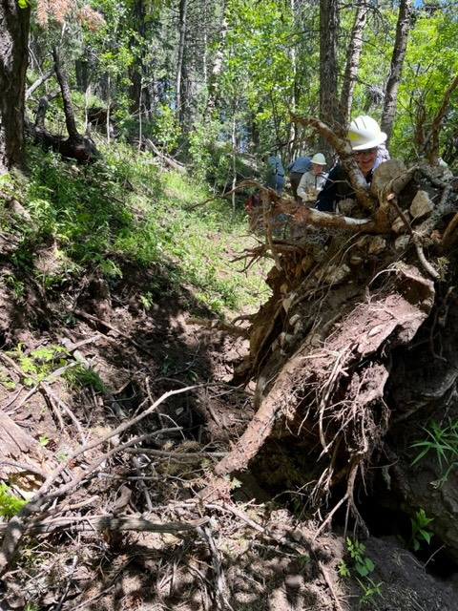
This photo looking north provides a closer look at the
big hole left by the root ball.

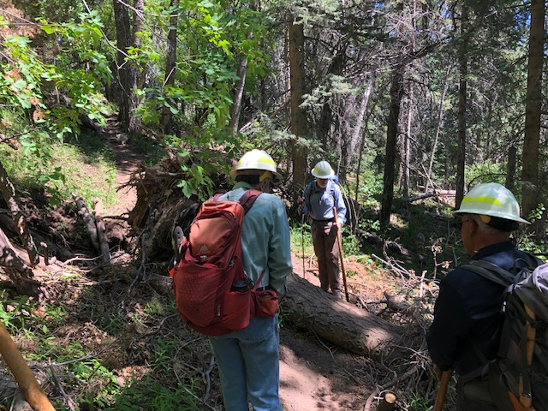
The crew looks at one of the bypass trails that developed for hikers to navigate around the fallen tree. The double trunk was not easy to step over at this point as it was more than 24 inches wide here. Another walk-around had developed far uphill to the left in the photo. It was very long and steep.

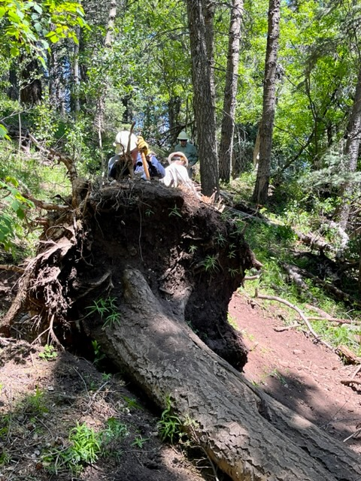
This is a closer view of the downhill side of the root
ball. The crew quickly ruled out trying to cut away the
trunk at this point to provide passage due to its huge
size and unsafe location below the root ball.

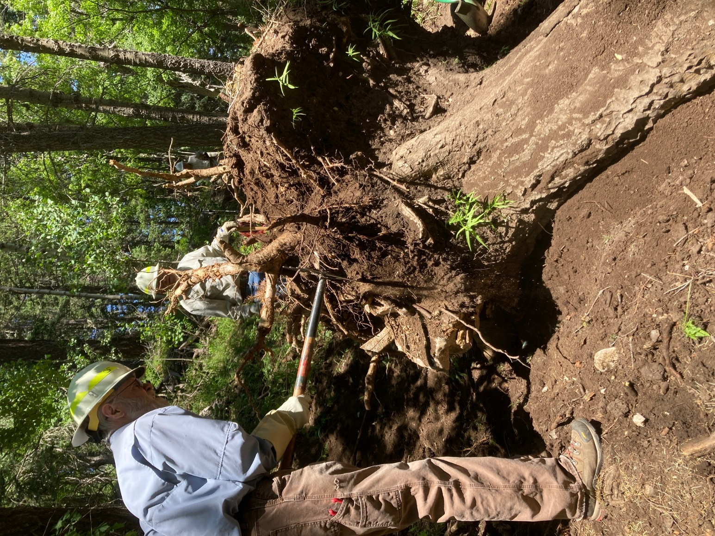
The dirt attached to the bottom of the root ball and
the numerous rocks it contained were knocked away with
hand tools and left to fall into the root ball hole to
help fill it up.
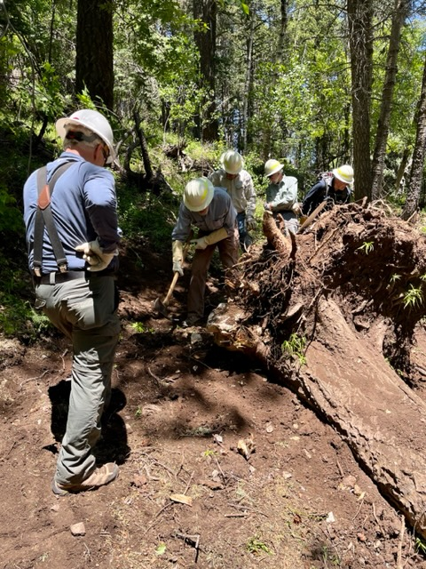
There were not a lot of easily located rocks in this
area but enough were found to provide a good foundation
for the trail re-route.

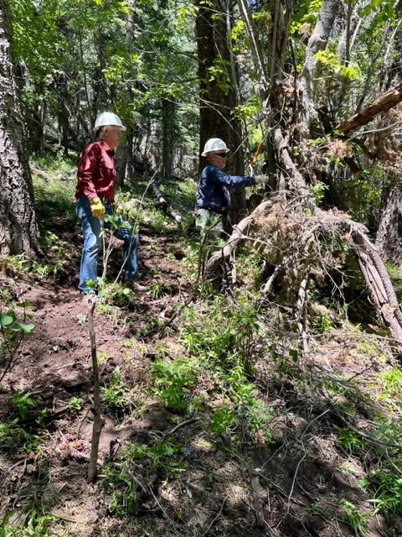
Jamey hacks away at a jumble of fallen branches and small
broken tree trunks that were in the way of the re-route
south of the root ball.

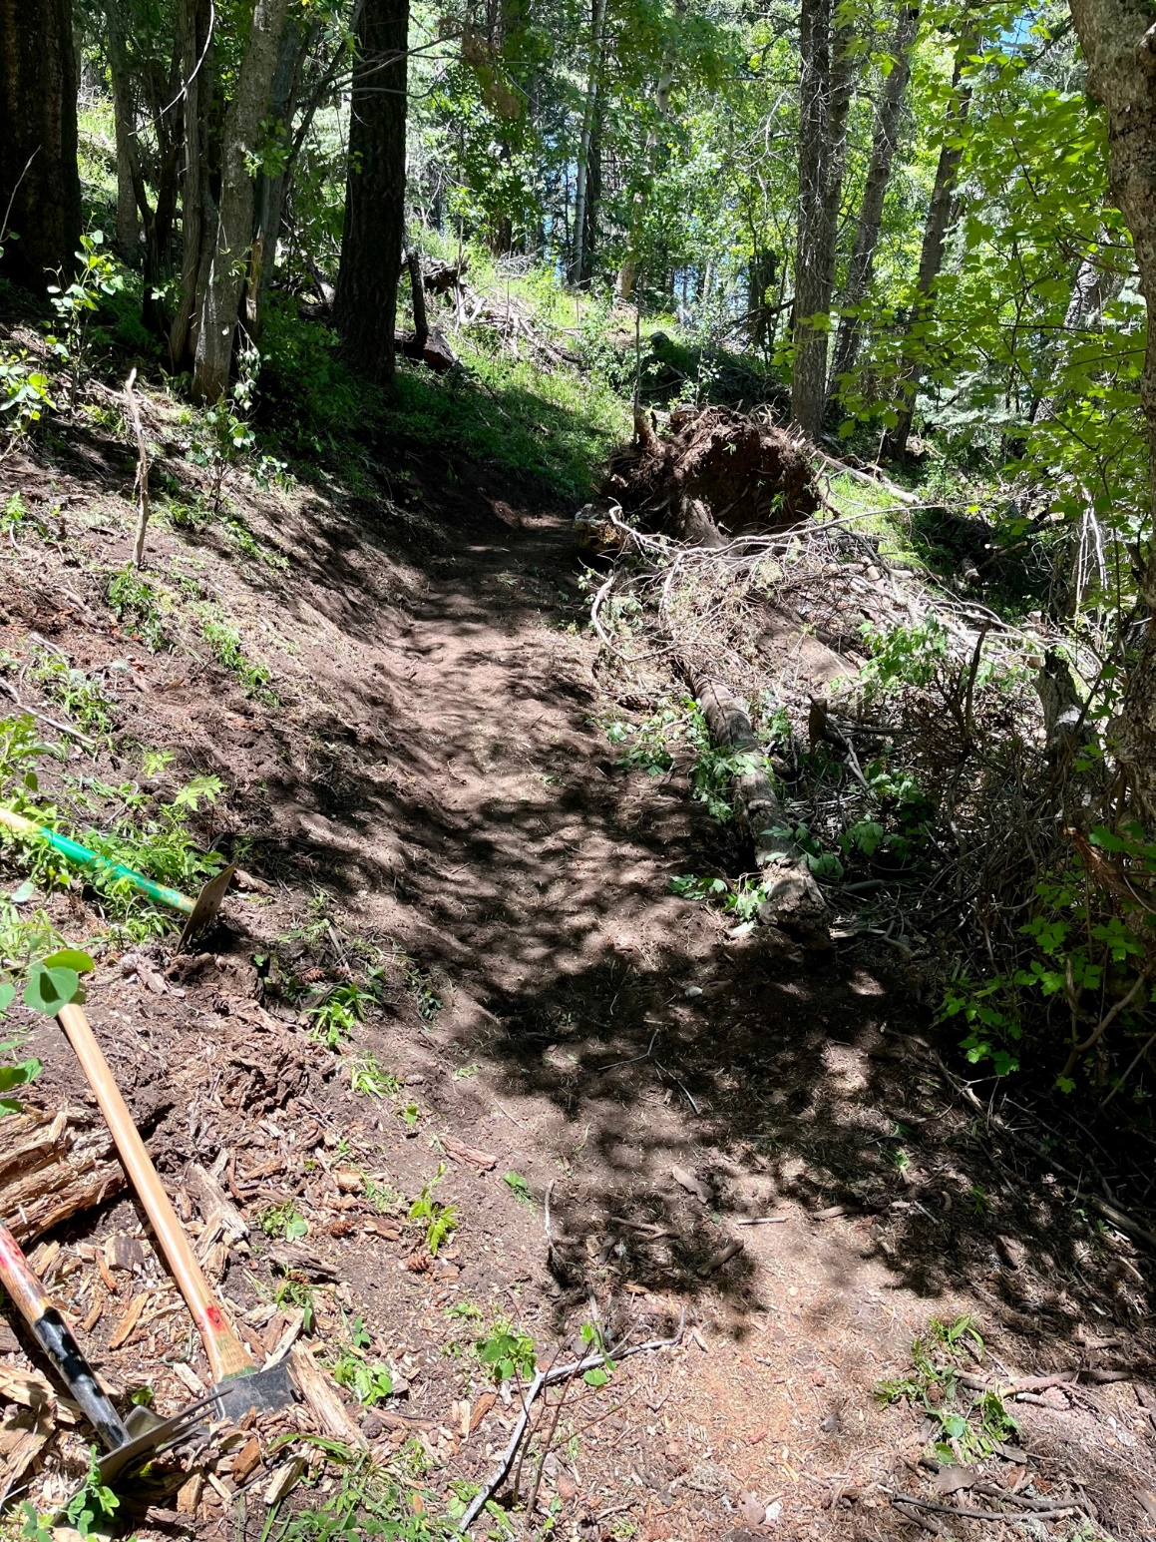
This view looking north shows the downhill portion of
the completed re-route. The remains of the root ball
can be seen to the right of the trail. The debris being
cut away in the previous photo was located below the lighter gray tree trunks in the upper left corner of this picture.

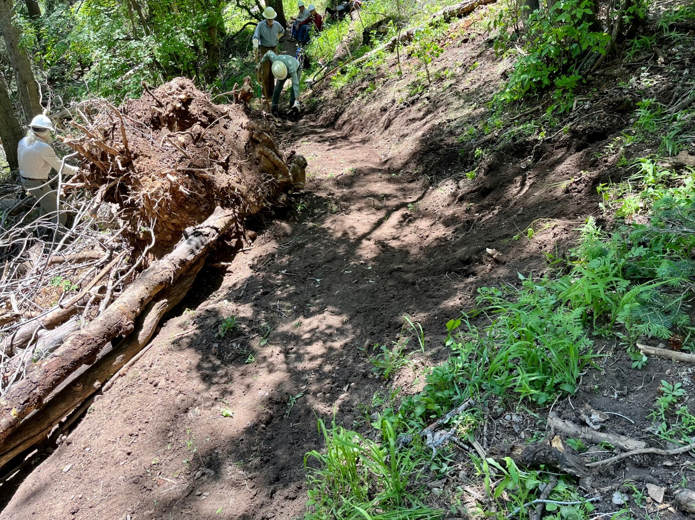
This photo of the completed re-route is looking south past the root ball which no longer looks as menacing as it did before work started on it.

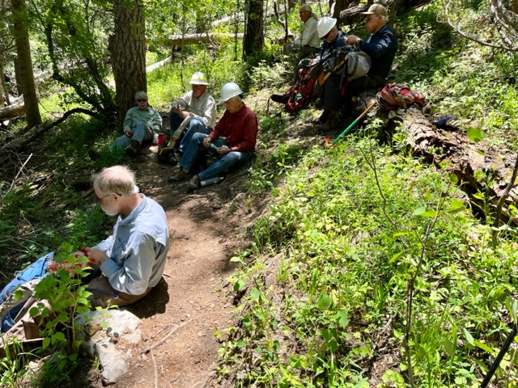
Lunch time and a well deserved break after a morning of hard work.

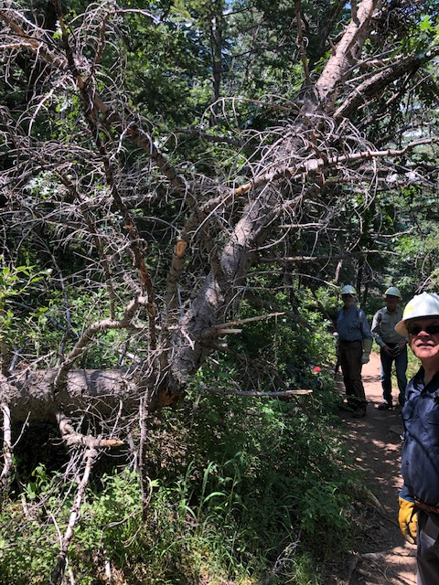
This broken hangup is located adjacent to Tree Spring
Trail near the junction of Oso Corredor Trail. It
appeared to be sufficiently supported at this time.
Since it was getting late in the day work on this tree
was deferred.

