**Report of FOSM Project Processing Donation Wood on Old Highway at Nine Mile Picnic Area**

**on Wednesday, July 5, 2023**

Lou Romero and Sam Beard

On Wednesday, July 5, nine FOSM volunteers continued processing the donation wood piled on the Old Highway at Nine Mile Picnic Area. Approximately 50 trees were felled recently in the picnic area. Fourteen trees were hazard trees felled for safety, and more trees were felled as part of the reconstruction of this facility.

Joe Meade and Lou Romero hauled three dump trailer loads to the Mountain Christian Church Wood Ministry woodlot on the west side of NM-14 about one-half mile south of the Triangle. The crew loaded the 1.5-cord trailer in 15 to 20 minutes. While Joe and Lou delivered the loads to the woodlot (45 minutes round-trip), other crew members continued to split the largest rounds (over 8" diameter) and create easy to handle piles that Lou could back the trailer to.  Jerry Carroll continued to buck the longer pieces into 12” to 15" lengths.

The volunteers working today were Dan Benton, Sim Cook, Cliff Giles, Steve Roholt, Eric Russell, Joe Meade, Jerry Carroll, and his neighbor, Francis Algermissen, and Lou Romero.

Project photos are presented below.

Photos are by Cliff Giles unless noted otherwise.

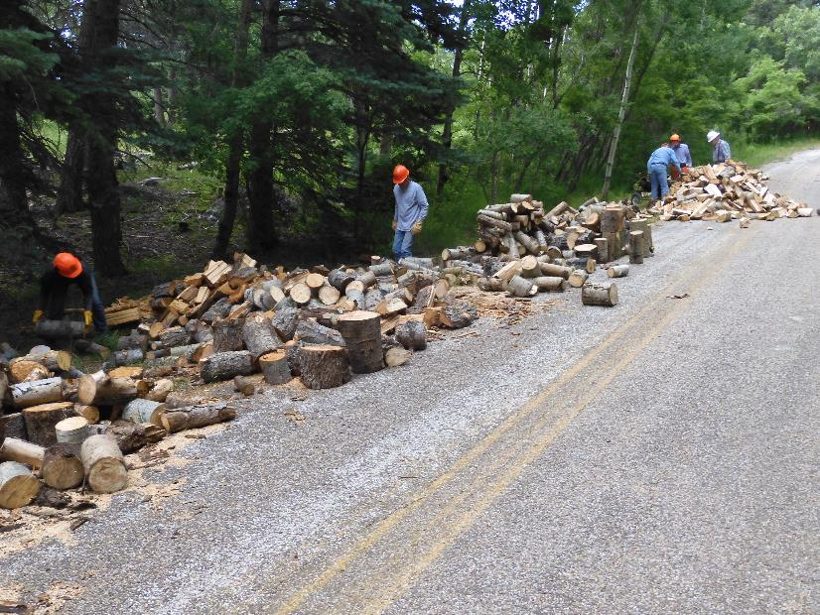

The large number of wood piles along the Old Highway adjacent to Nine Mile Picnic Area

Photo by Dan Benton

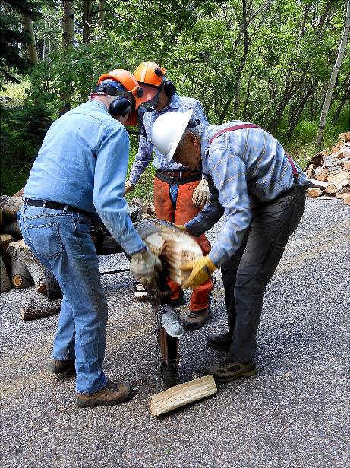

Splitting the larger pieces of wood with Lou Romero’s power splitter. Photo by Dan Benton

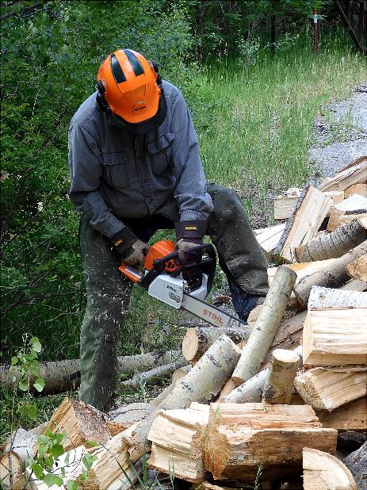

Jerry Carroll using his new Stihl chain saw to cut long pieces of wood

to a length of 12 inches for easier handling. Photo by Dan Benton

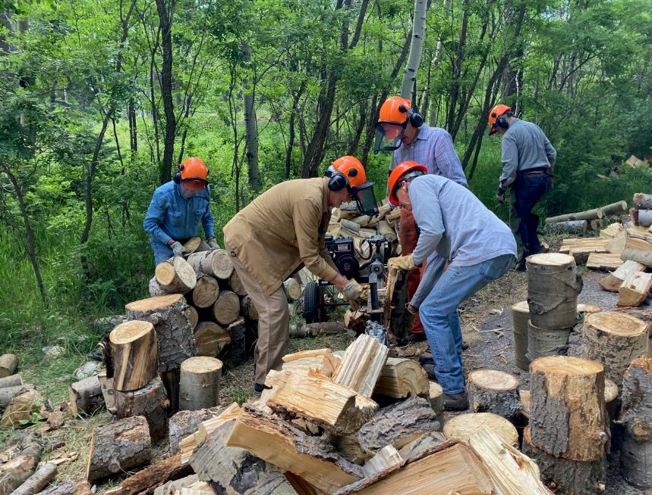

Dan, Sim, and Francis split wood while Eric and Jerry stack larger pieces.

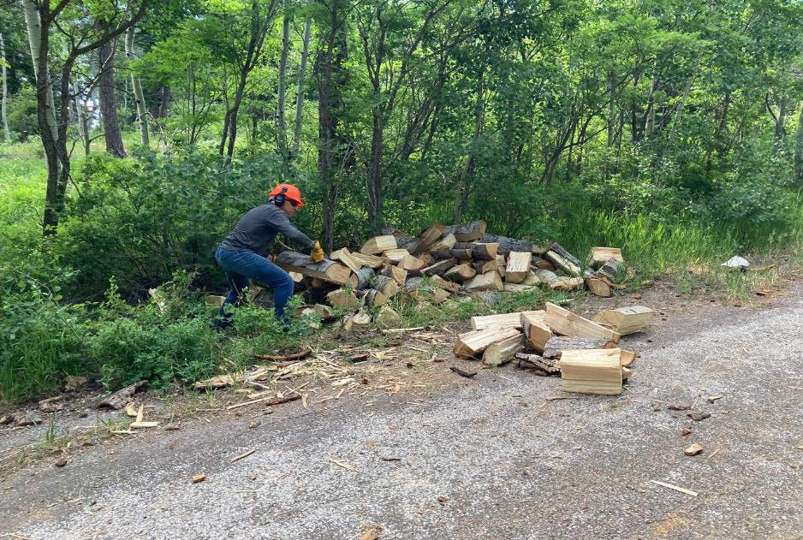

Steve Roholt throwing wood from the ditch onto the pavement for easier loading on the trailer.

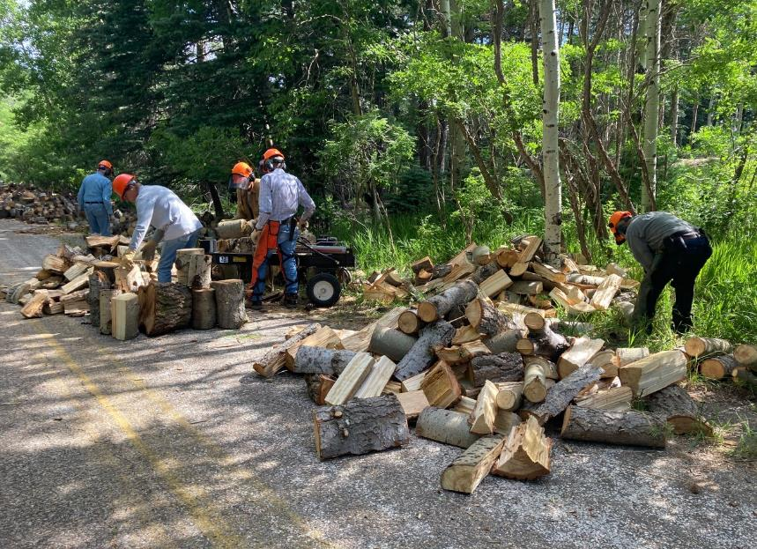

Francis, Dan, and Sim splitting rounds while Eric and Steve collect them.

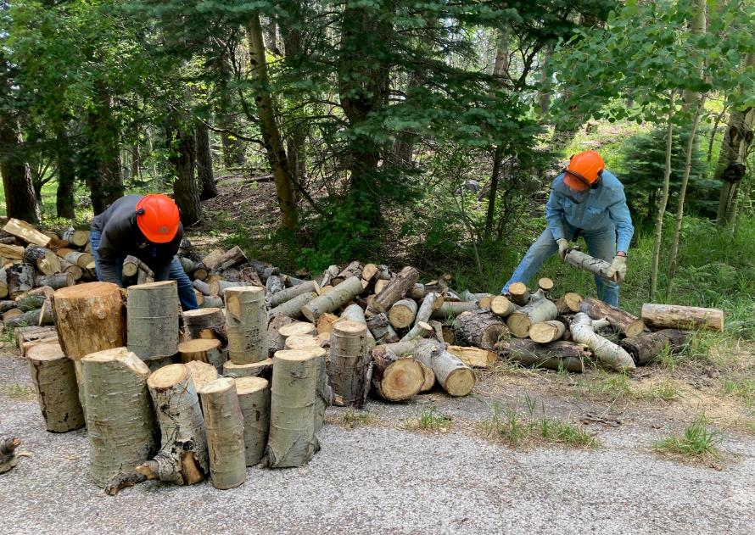

Steve and Eric separating the small pieces from the large rounds that will be split

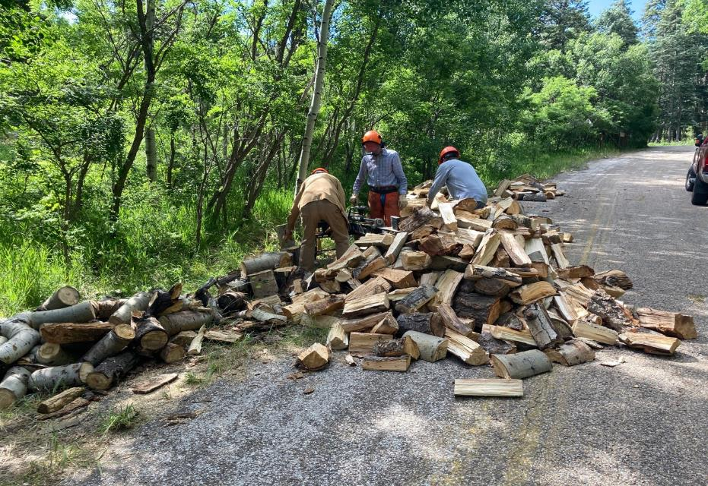

Dan, Sim, and Francis creating a large pile of split wood.

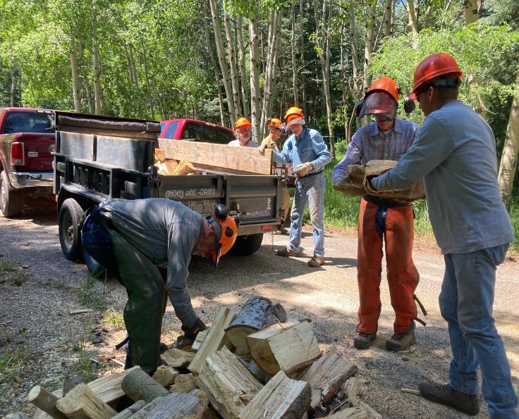

Jerry, Joe, Dan, Eric, Sim, and Francis loading wood into trailer.

USFS fire fighters call this method of handling wood “chaining.”

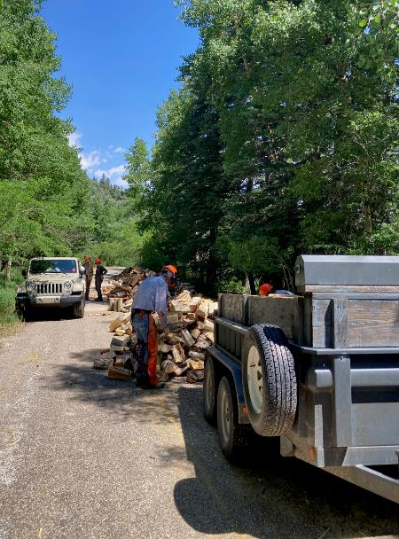

Dan, Steve, and Sim impressed by large piles of wood remaining after collecting three trailer loads.

Each load on Joe Meade’s trailer is 1.5 cords of donation wood.