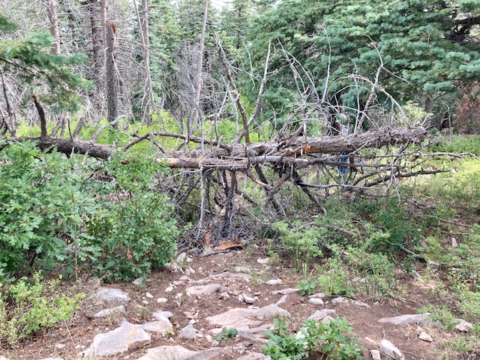
This is the two-tree tangle that had blocked Capulin Peak Trail. It was located just below the spot where the trail re-entered the forest after a sharp left turn above the site of the old fire tower. This view is looking downhill.

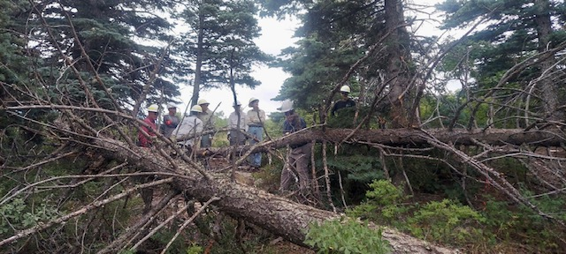
This is a view of the two fallen trees looking uphill. They did a great job of completely blocking the trail. After a discussion about the safest way to get this mess out of the way, the first steps in its removal are underway.

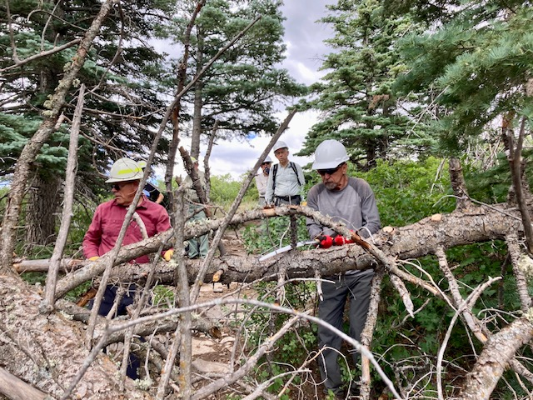
These trees provided the crew with a lot of opportunities to do some serious limbing which is always necessary before the large portions of fallen trees can be safely cut away. Ken takes his turn at the task.

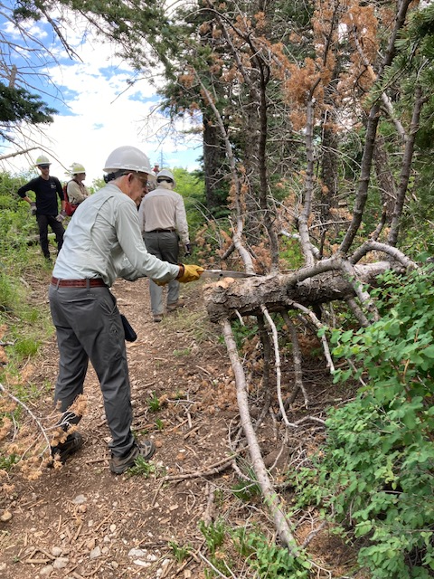
John completes the limbing on the last remaining
portion of the fallen trees before it is moved away from the trail.
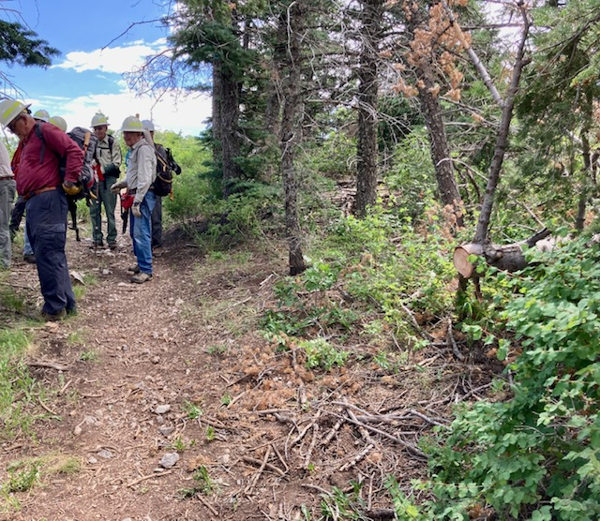
The blockade has been cleared and the crew prepares to resume the hike to check out the remaining portion of the trail.

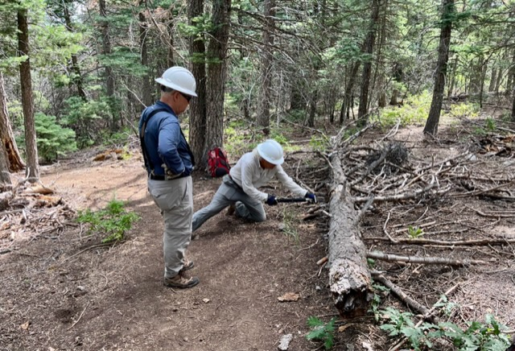
In addition to removing the two fallen trees, the crew did some basic “housekeeping” which included cutting away encroaching shrubs such as oak and several other species. Hazards like previously fallen trees that had slumped down near the trail or previously cut trees whose ends were now a bit too close to the tread were cut back. Bill makes the cut while Jamey waits to help move the hazard away.
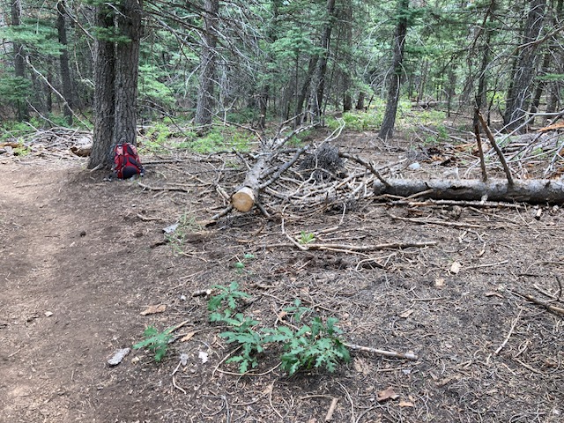
The hazard shown in the previous photo has been cut away.

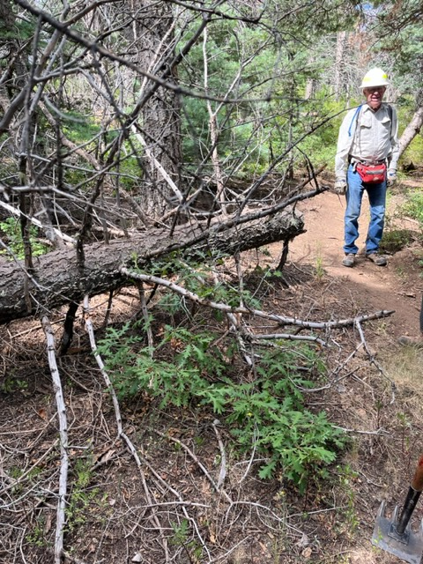
A large tree whose cut end is too close to the trail.
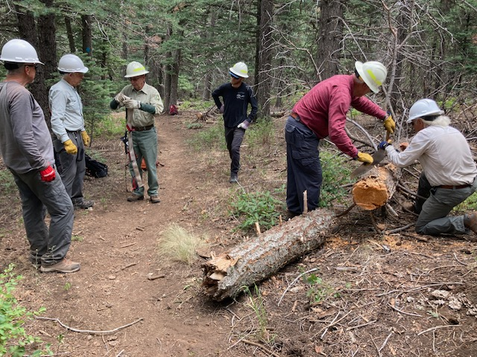
After using a crosscut saw, the hazard shown in the previous photo has been cut away.

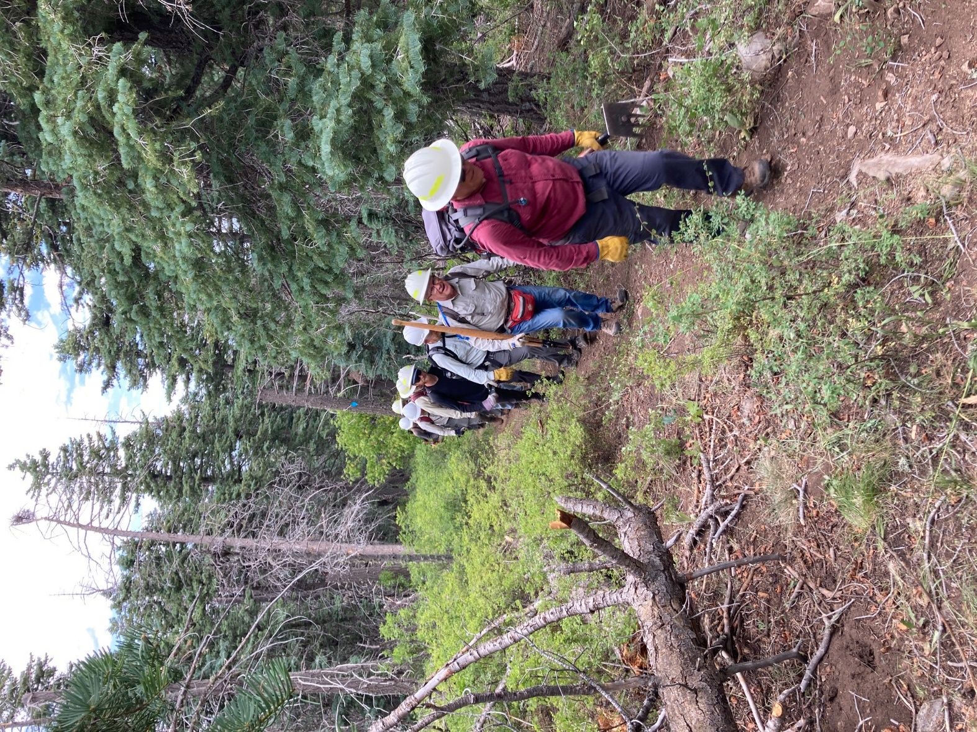
“Return of the Lost Patrol” After a morning’s work, the
crew returns to the Capulin Picnic Area for lunch.

