**Report of Scout Troop 9 Service Project with FOSM Volunteers on Saturday, July 15, 2023**

**By Lou Romero**

**Plan A** - Sam Beard and I had planned to continue hauling loads of wood from the large Nine Mile Picnic Area wood pile as we had promised Julie Padilla, Sandia Ranger District Recreation Staff Officer. Today, we had planned for the Scouts to help us load and haul at least two trailer loads. We still have approximately seven dump trailer loads left to finish. We worked with this Scout Troop last summer and had promised a follow-up project this summer.

Unfortunately, the main gate accessing the Nine Mile Picnic Area restoration site was locked when we arrived this morning. We had been promised that the contractor’s lock would have been changed to a Forest Service Yale lock yesterday (Friday), but it did not happen. The contractor’s Master lock was still in place, and FOSM was not allowed to have a key for that lock.

**Plan B** – Fortunately, Sam had a Plan B in his hip pocket. He and Michael Arndt had earlier bucked three dead/down white fir trees in the Capulin Snow Play Area and today bucked a large white fir in Capulin Picnic Area. Even though we were not able to work Plan A, we still managed to provide a meaningful morning project with spontaneous Plan B. The four Scouts and three parents loaded and hauled one trailer load to the Mountain Christian Church Wood Ministry woodlot and also stacked some wood. Next winter, the Wood Ministry volunteers will donate this wood to East Mountain families who need wood to heat their homes.

**Participants were:**

Scoutmaster - Jason Buelow

Scouts - Caleb Groff, William Weil, Alexandria Sider, and Luke Buelow

Adults - Chris Weil and Matt Groff

FOSM Volunteers - Cliff Giles, (Photographer), Michael Arndt (sawyer), Sam Beard, and Lou Romero

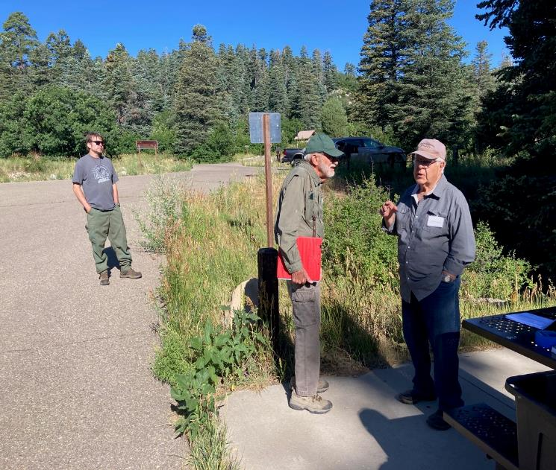

Sam and Lou decide to load wood in the Snow Play Area and Capulin Picnic Area, because they did not have

a key to unlock the Master Lock on the main gate at Nine Mile Picnic Area. All photos by Cliff Giles.

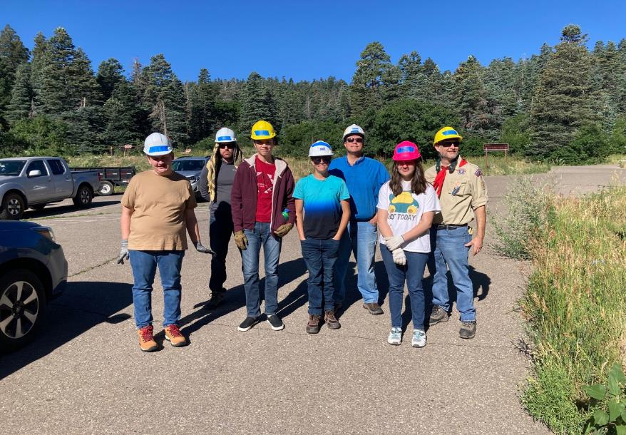

Troop 9 Scouts and their family members. L to R: Luke Buelow, Matt Groff, Caleb Groff, William Weil,

Chris Weil, Alexandria Buelow, and Jason Buelow.

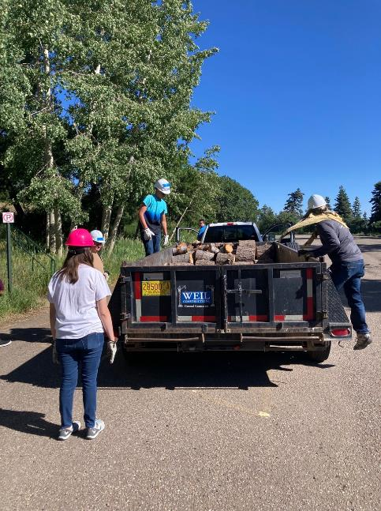

Alexandria, Luke, William, and Matt loading rounds into trailer

in Snow Play Area parking lot.

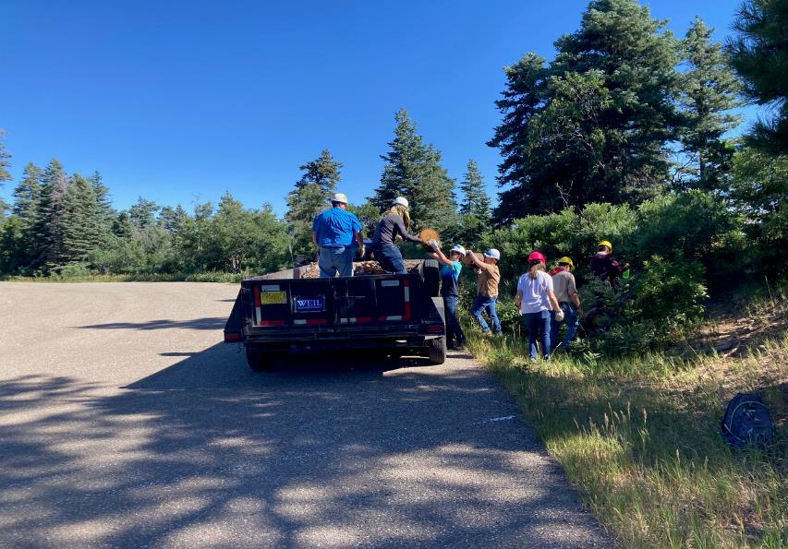

William handing Matt a round in Snow Play Area.

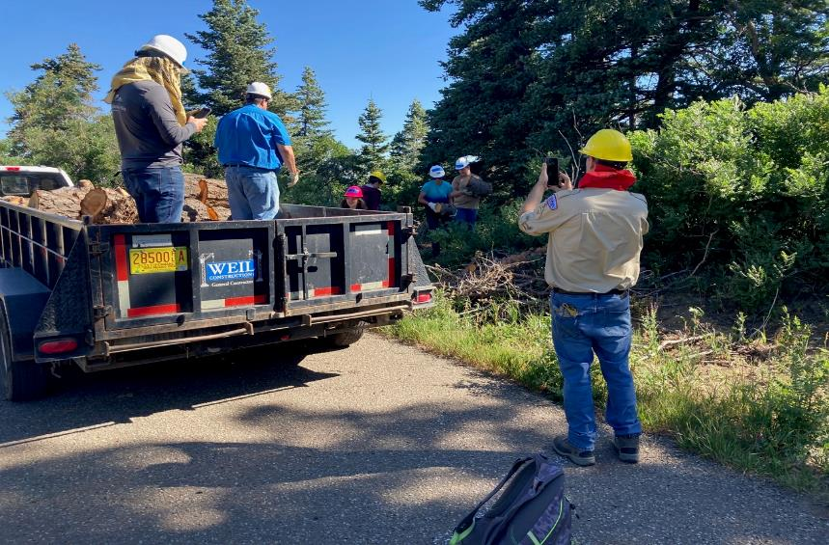

Jason taking a photo in lower Snow Play Area parking lot near where two dead trees fell.

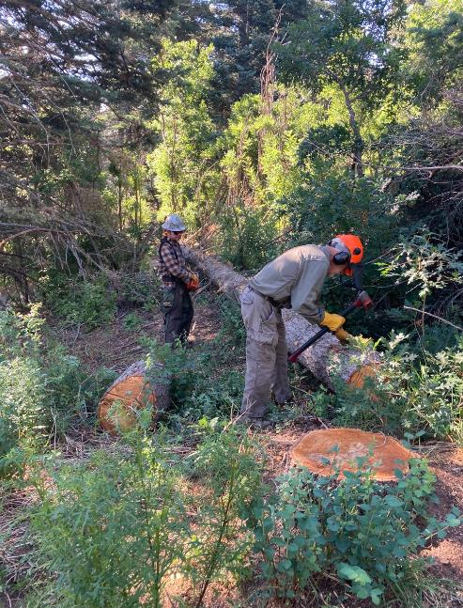

Sam using an axe to mark log for bucking while Michael waits with chainsaw

in Capulin Picnic Area. Rounds were cut 12 inches long so that they would not be too heavy.

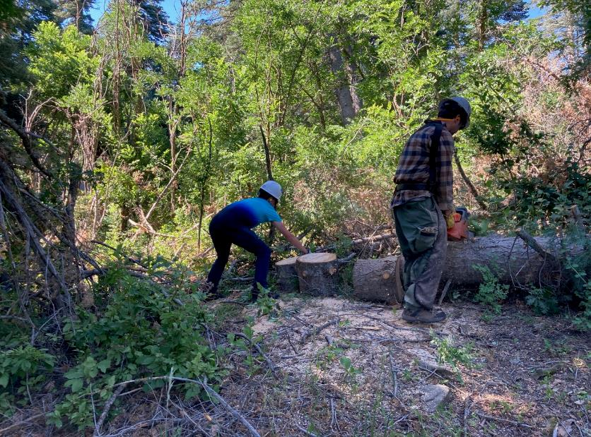

William reaching for round while Michael bucks log.

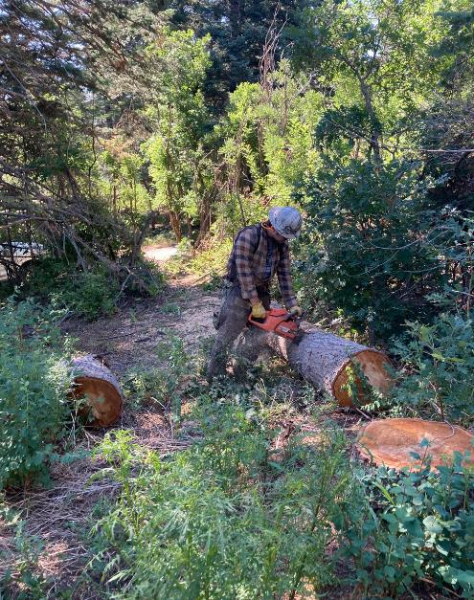

Michael has almost finished bucking the long log.

He also bucked the large log behind him.

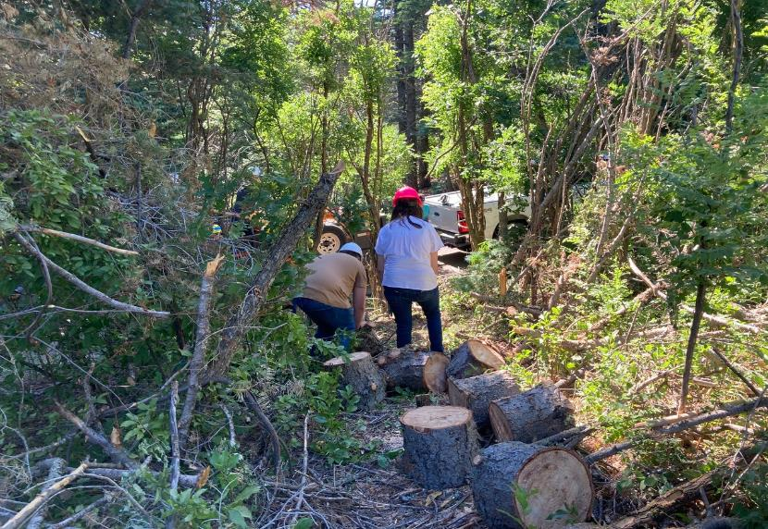

Luke and Alexandria rolling rounds downhill.

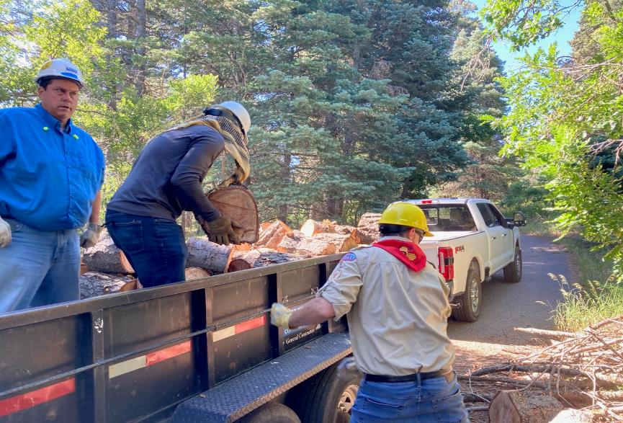

Chris, Matt, and Jason loading rounds into trailer on the road leading to the Bird Log below Capulin Picnic Area.

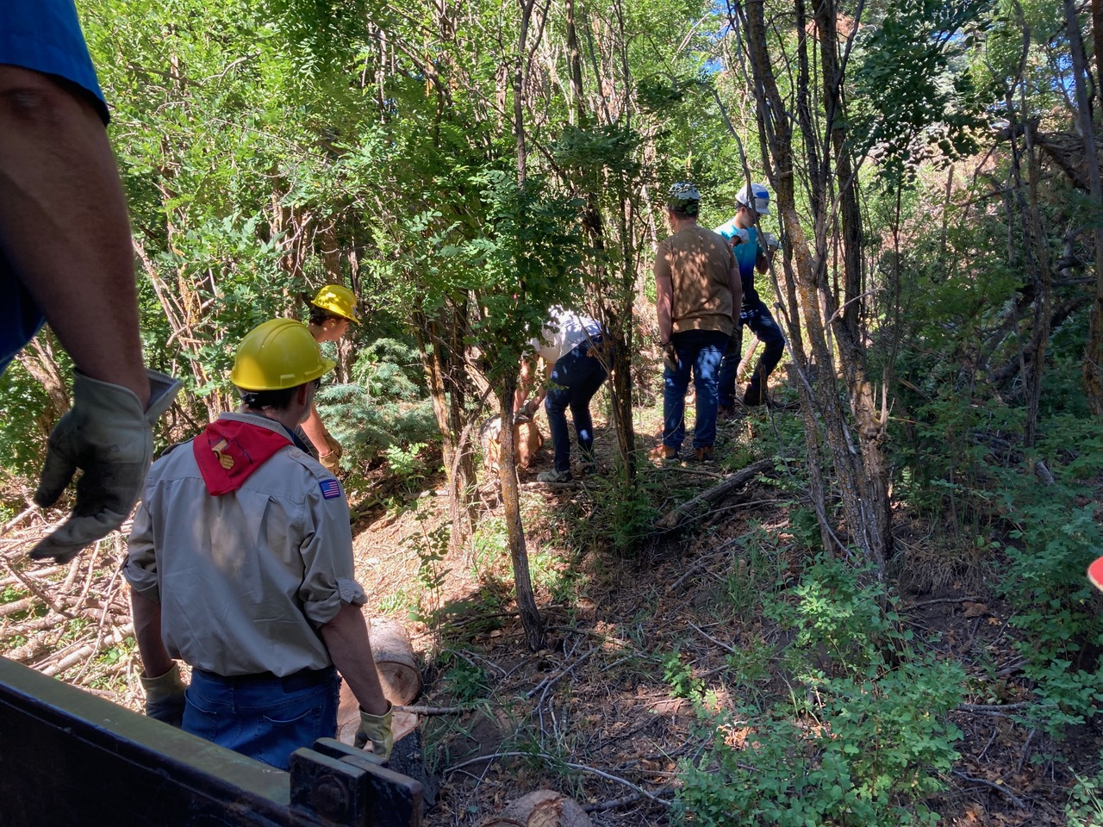

Alexandria rolling a round downhill.

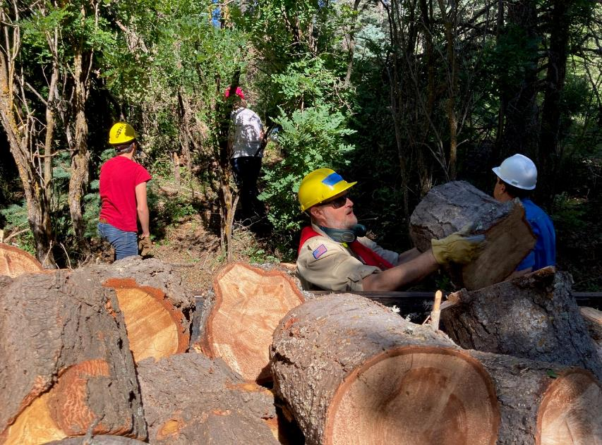

Jason loading round into trailer.

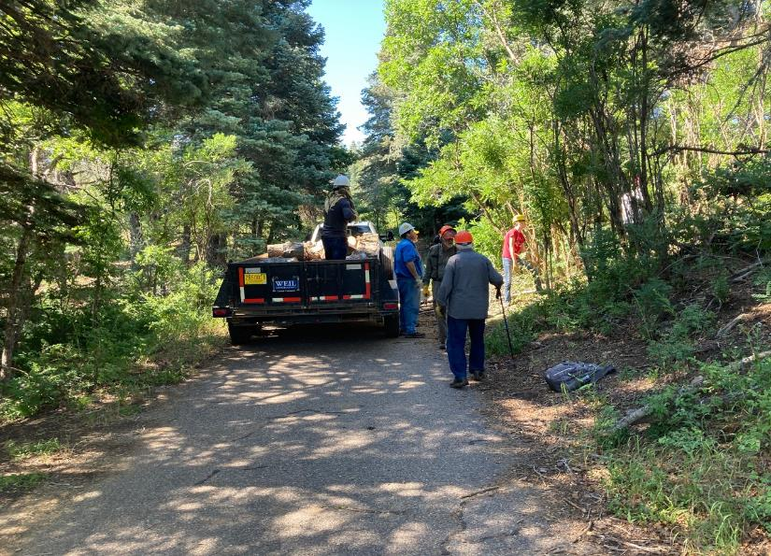

Troop rolling rounds downhill while Sam and Lou observe.

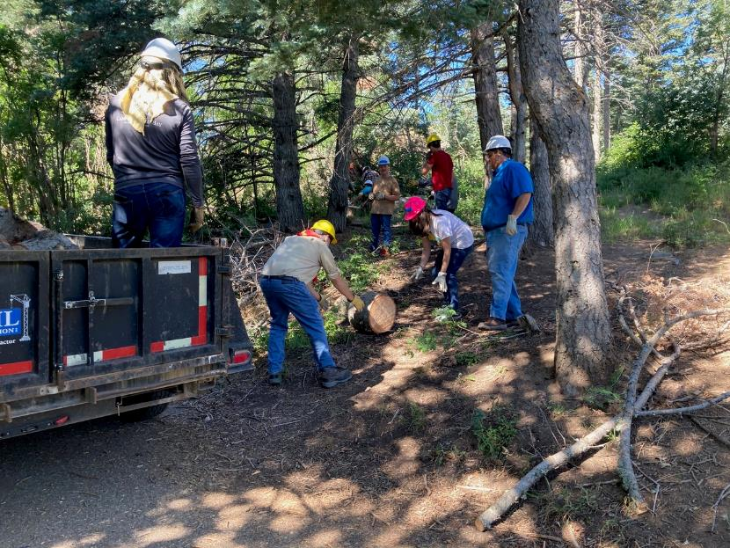

Rolling a round downhill to the trailer.

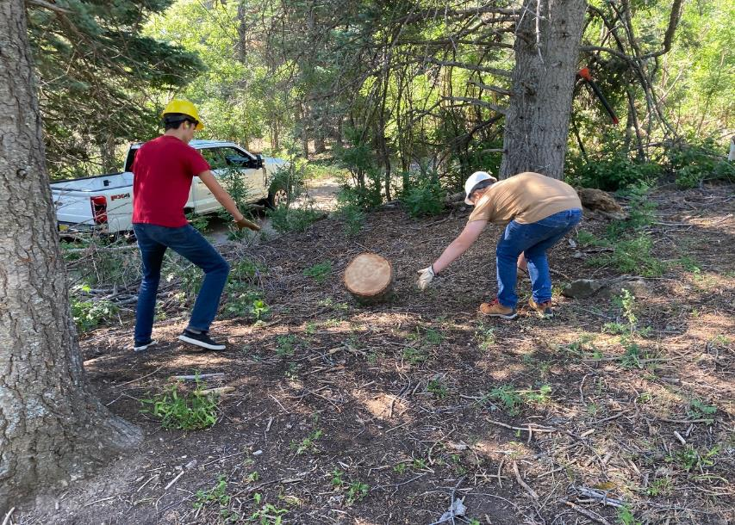

Caleb and Luke rolling round downhill.

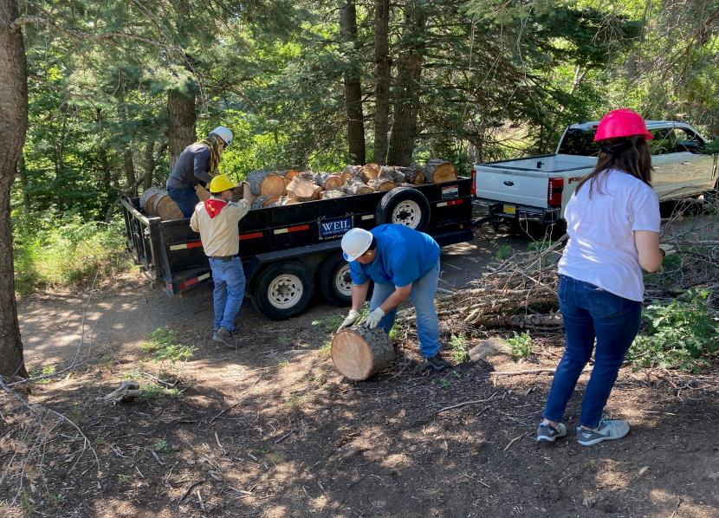

Chris waiting to hand round to Jason

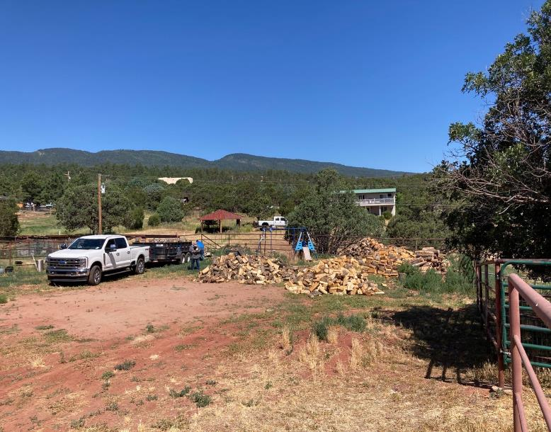

Truck and trailer in Mountain Christian Church woodlot.

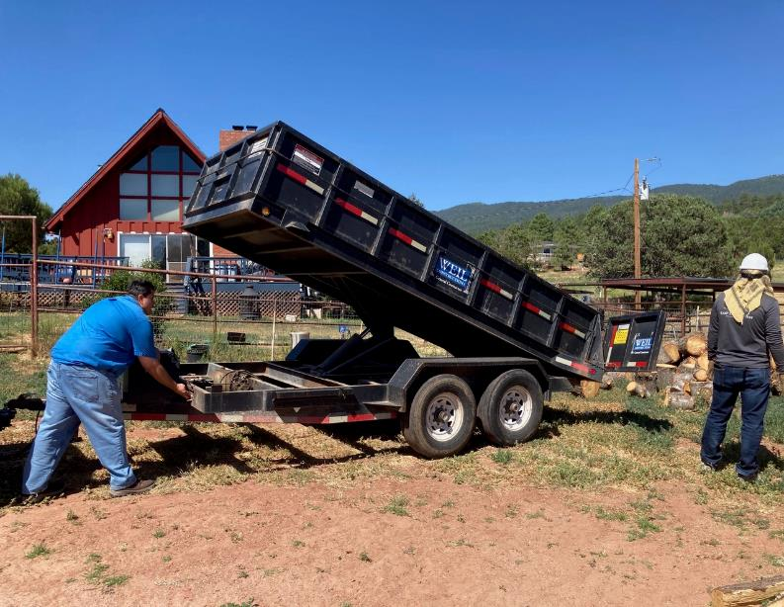

Chris dumping wood from trailer.

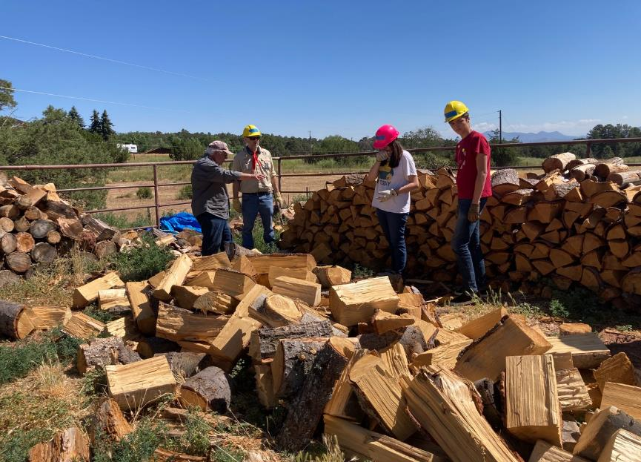

Lou instructing Scouts on how to stack wood.

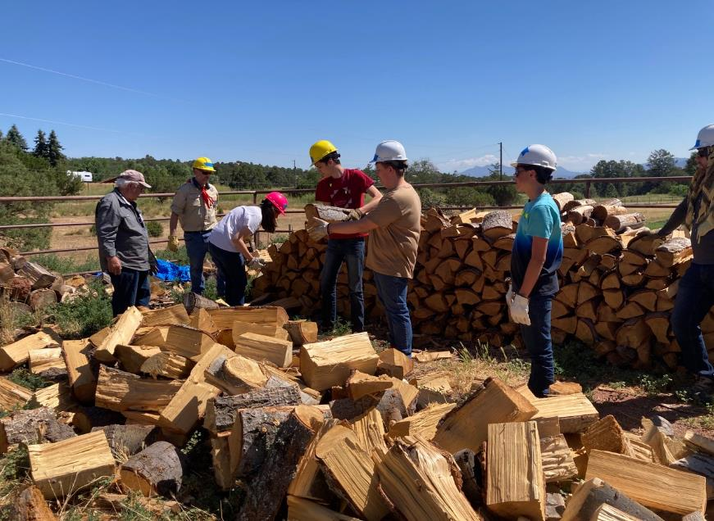

Scouts passing wood from one person to another while Alexandria stacks the wood.

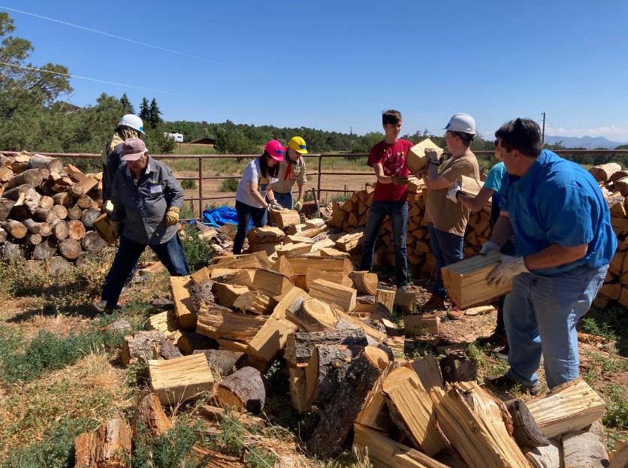

Chris helping the Scouts stack wood.

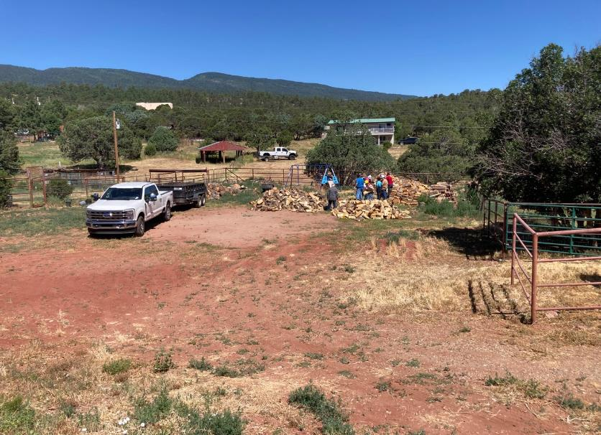

The trailer load of wood has been dumped in the woodlot, and the Scouts are completing the project by stacking the wood.