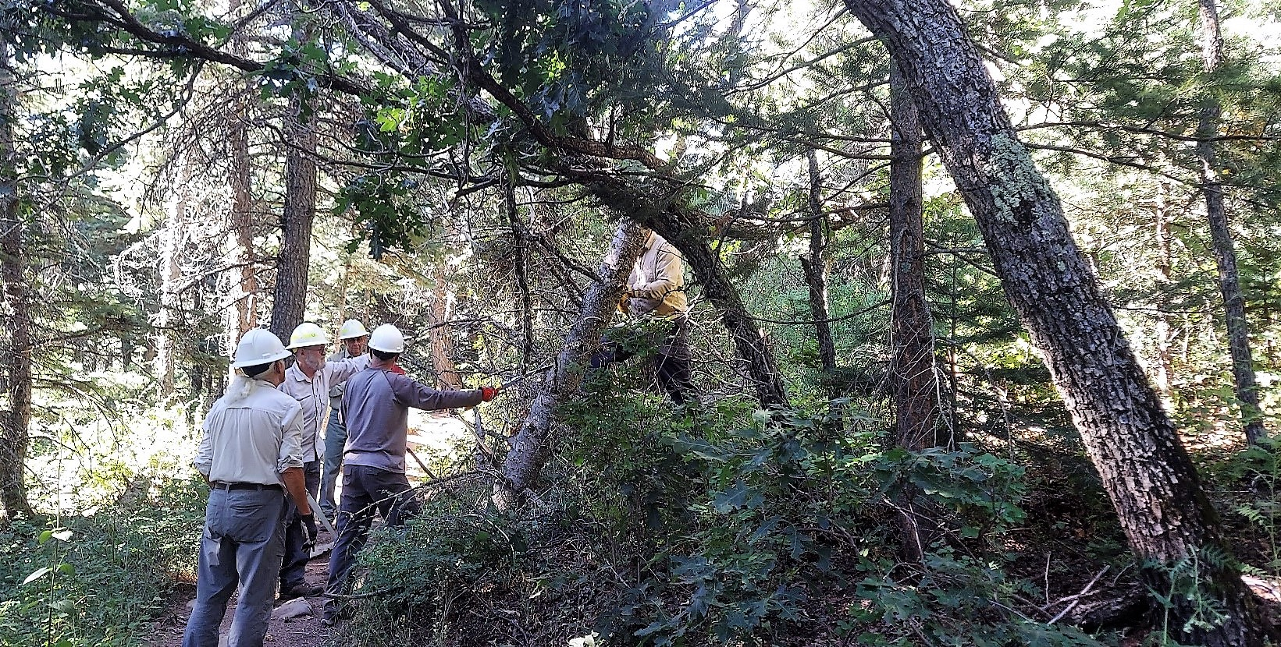
The crew is analyzing a complex fallen tree hangup located above the upper margin of Tree Spring trail a short distance uphill from the Oso Corredor Trail junction. This hazard was removed.

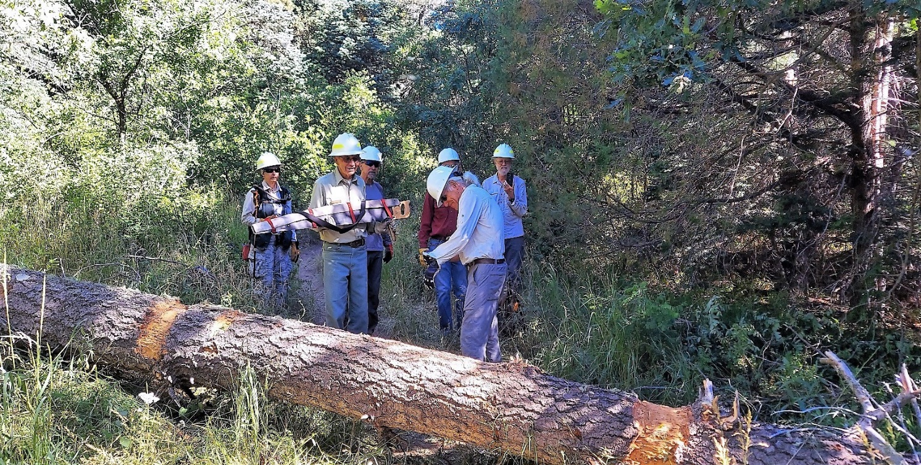

This 16-inch diameter fallen fir was blocking Oso Corredor trail a short distance south of the Tree Spring junction.
Bark was removed before the two cuts were made to clear the log. The crew is preparing to remove the protective sheath from the crosscut saw.

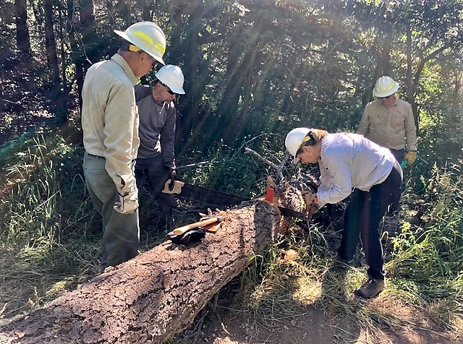
Rene removes the tip handle prior to completion of the cut.

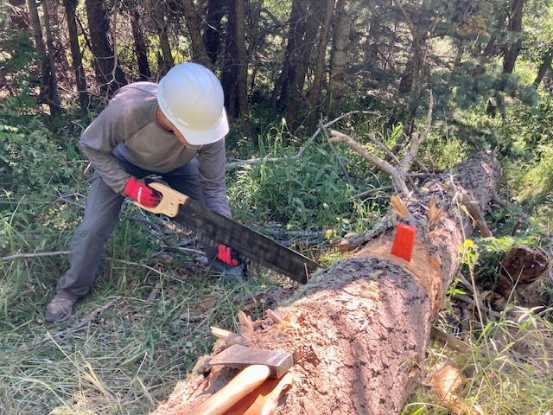
Using his gloved hand to support and guide the saw, Ken completes the cut.

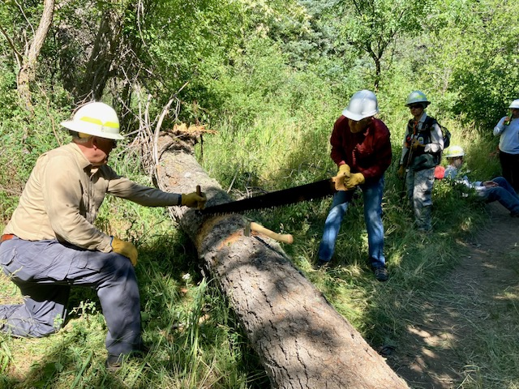
David and John slowly begin the second cut.

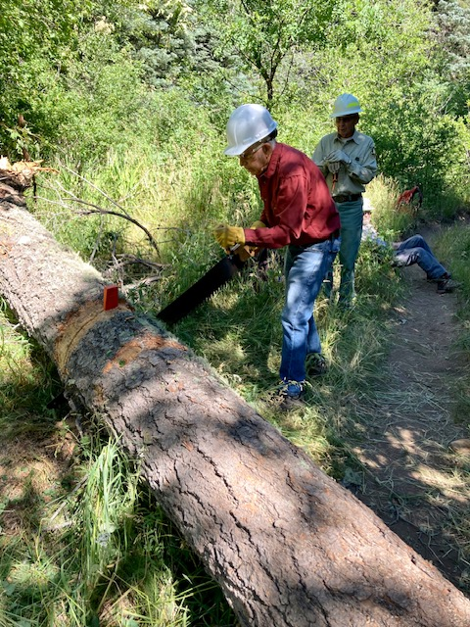
John is close to finishing the second cut. When
crosscut saws are used, pieces of wood are placed
on the ground beneath the kerf(cut) to protect the
teeth of the saw in case it drops to the ground as
the cut is finished.

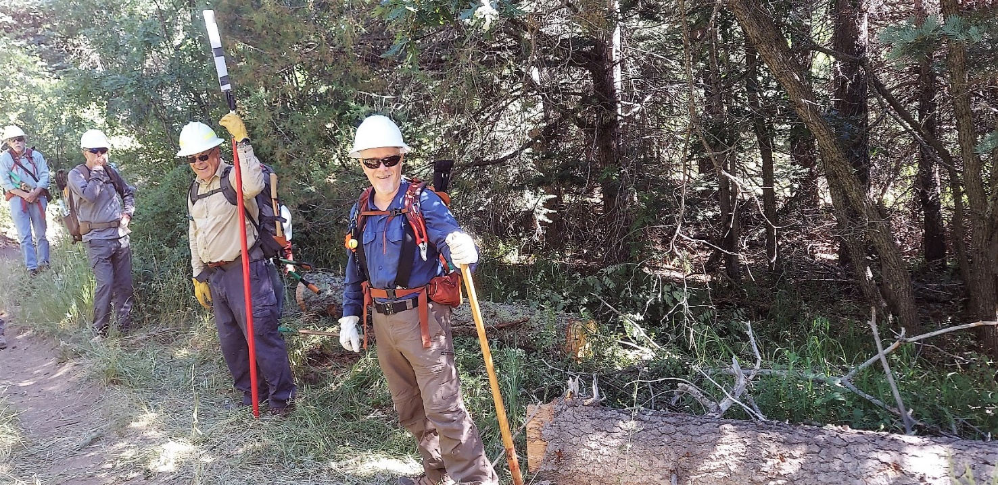
Obstacle removed… Oso Corredor Trail is clear.

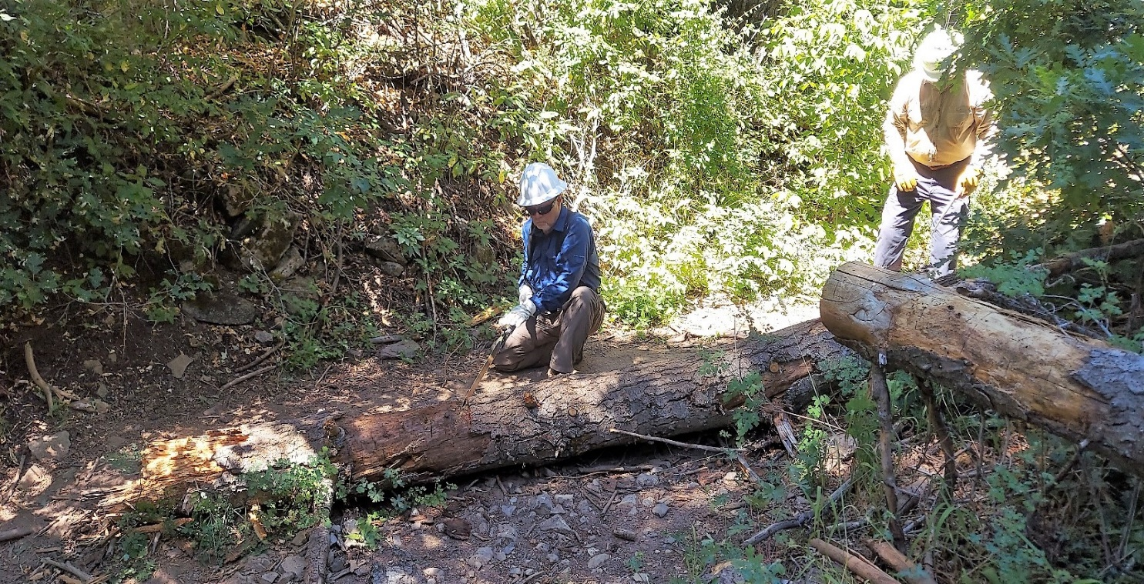
This tree was fallen across most of Bill Spring Trail. There was about 18 inches of clearance around the bottom end otherwise it had to be stepped over. Although it does not show in this view, the log also served as a natural water bar and had a buildup of silt on the uphill side which diverted water out of the bottom of the drainage where there is already considerable erosion. Only the bottom two feet or so of the log were cut away to provide safe passage around the bottom end and to preserve the function of the water bar.
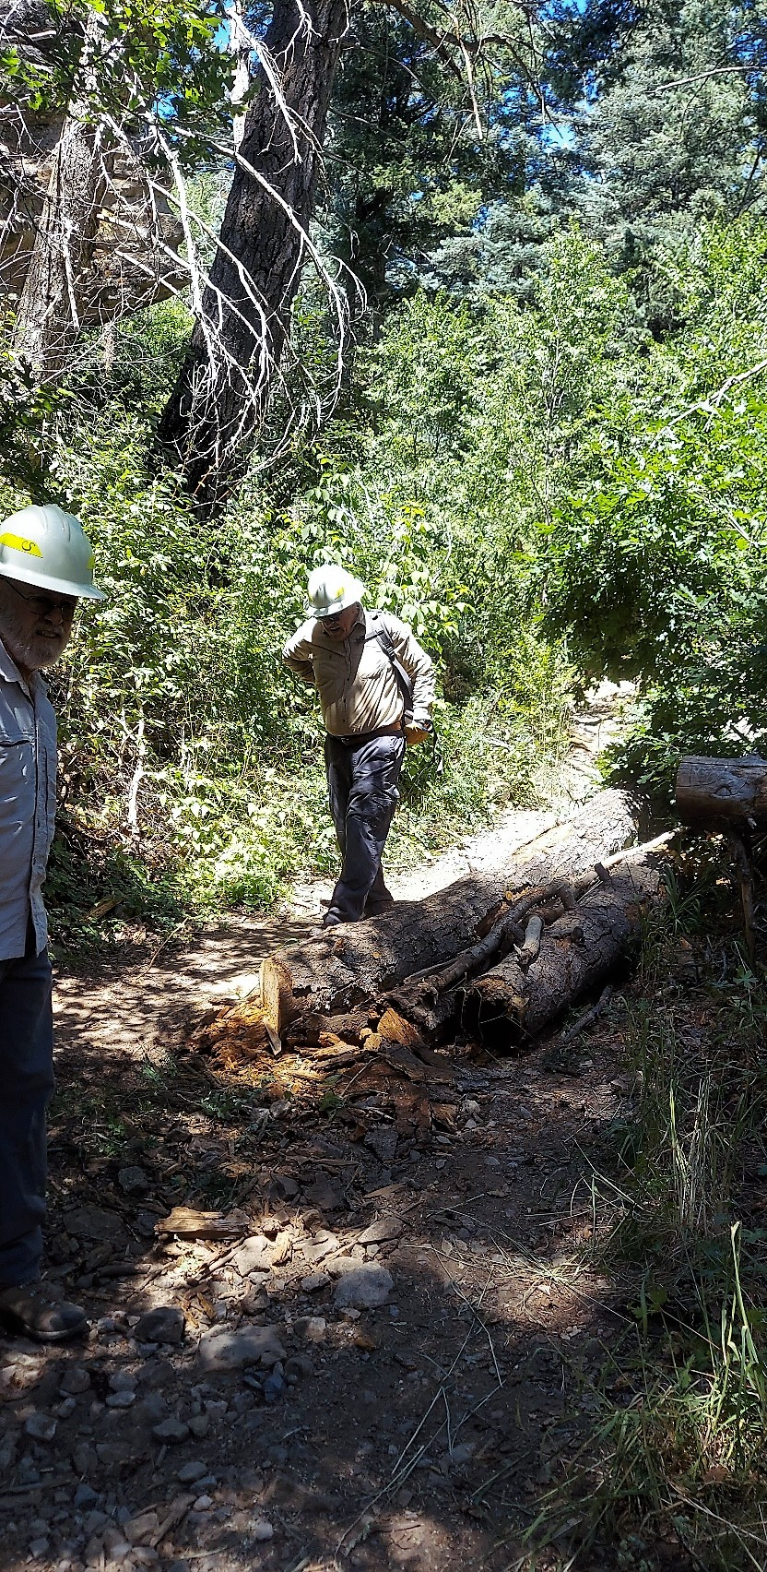
Logs and other materials were placed behind the water
bar log to support it and guide users out of the
drainage, thereby narrowing the trail at this point.
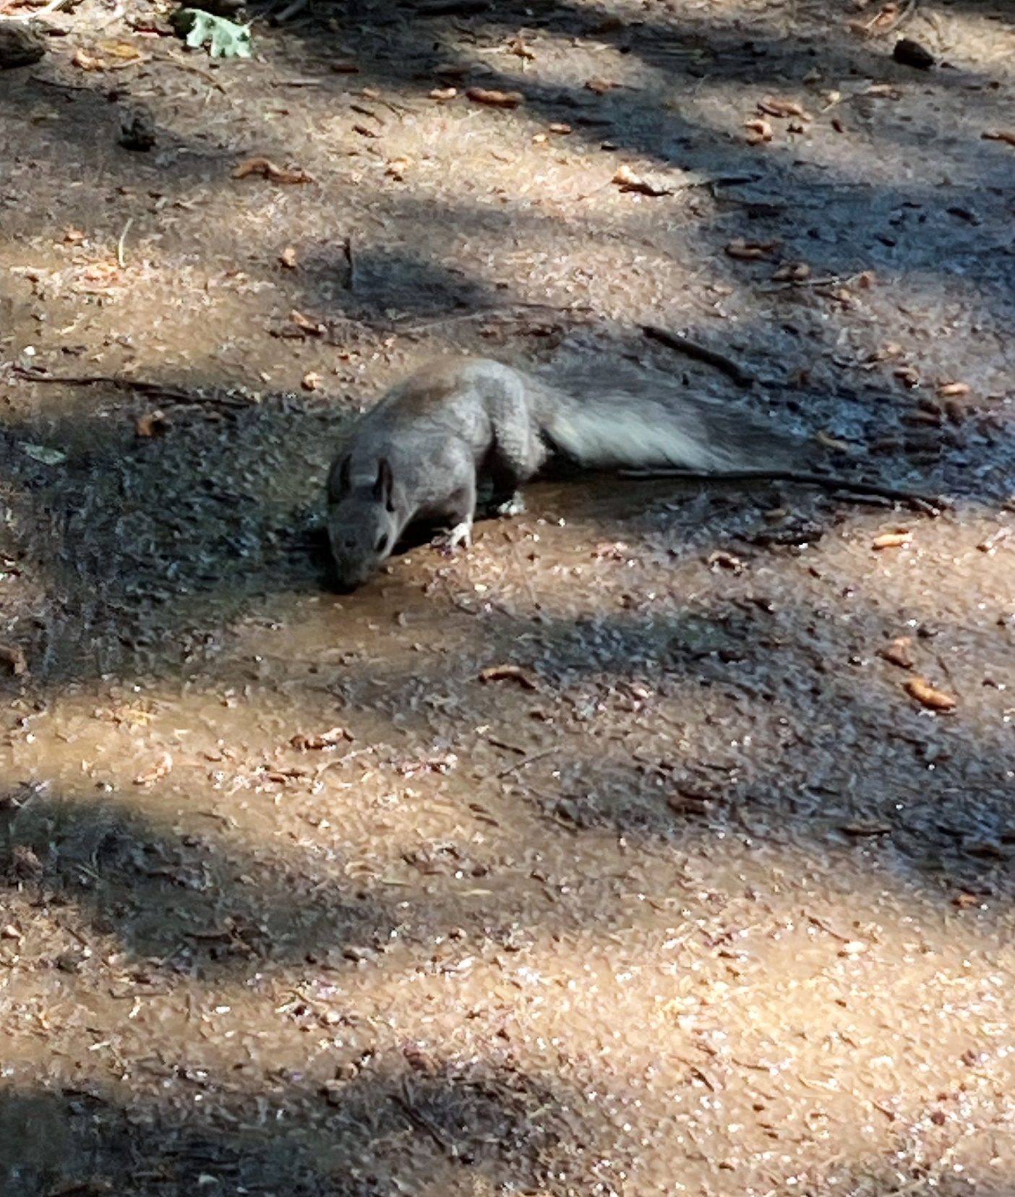
There is still some water flowing along Bill Spring Trail and this squirrel is taking advantage of that on a hot day.

