**Report of Two FOSM Projects on Wednesday, July 19, 2023**

Lou Romero and Sam Beard

July 20, 2023

On Wednesday, July 19, eight FOSM volunteers worked on the two follow projects:

1. **Hauling Donation Wood to Two Church Woodlots** -- Yesterday, July 19, FOSM volunteers hauled three loads of donation firewood from the old highway site at the 9 Mile Picnic Area. Two dump trailer loads were delivered to the Hopkins woodlot, and one load went to the new Oliver woodlot. Joe Meade, once again, donated the use of his dump trailer and truck for this project. We estimate that there are still approximately 6+ more trailer loads of wood to be hauled.
2. **Unloading a New Sign Board in Doc Long Picnic Area** – Recently, the information board at the first kiosk in Doc Long Picnic Area was removed from the partially decayed timbers supporting it. These parts were found in the SRD Storage Yard near the shop. Don Carnicom designed a new board support structure using pressure treated 2x6s and 2x4s. The four pressure-treated 2x6s, two 2x4s, and four steel-framed information panels are very heavy. Don hauled the sign board to Doc Long PA on his trailer, and, while Lou Romero and Joe Meade were hauling the first load of wood to a woodlot, six volunteers were required to move the new sign board from Don’s trailer to the vertical posts that will eventually support the sign. The sign was then placed on the concrete surface and two lag screws were installed so that the sign would not fall over. Don will organize a project to lift the sign three feet and bolt it to the posts later.

FOSM volunteers were Jerry Carroll, Cliff Giles, Dan Benton, Don Carnicom, Jamey Browning, Sam Beard, Joe Meade and Lou Romero.

Project photos are presented below.

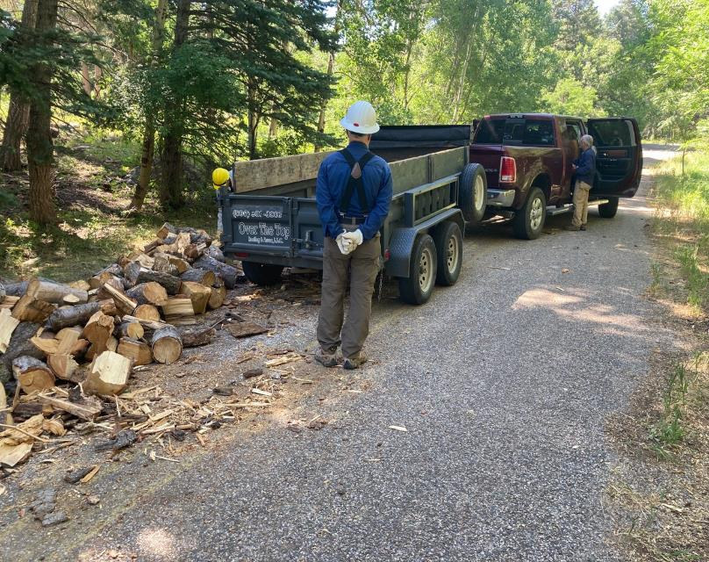

The trailer was loaded with firewood at this location on the old highway adjacent to Nine Mile Picnic Area on Wednesday.

All photos by Cliff Giles

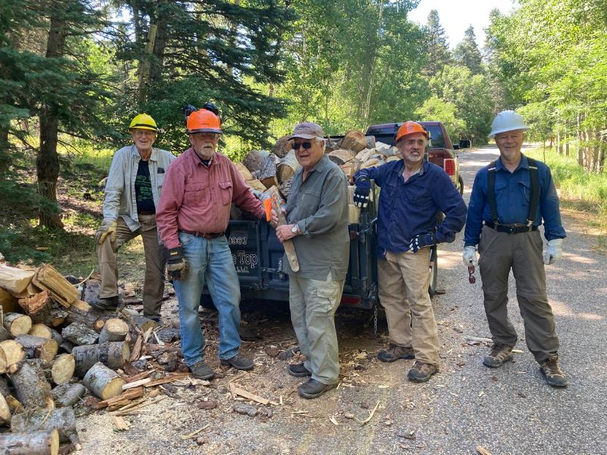

The trailer has been loaded with firewood that will be hauled to one of the woodlots owned by a member of the Mountain

Christian Church where the Wood Ministry will distribute it to needy East Mountain families. L to R: Dan Benton, Jerry Carroll,

Lou Romero, Joe Meade, and Jamey Browning.

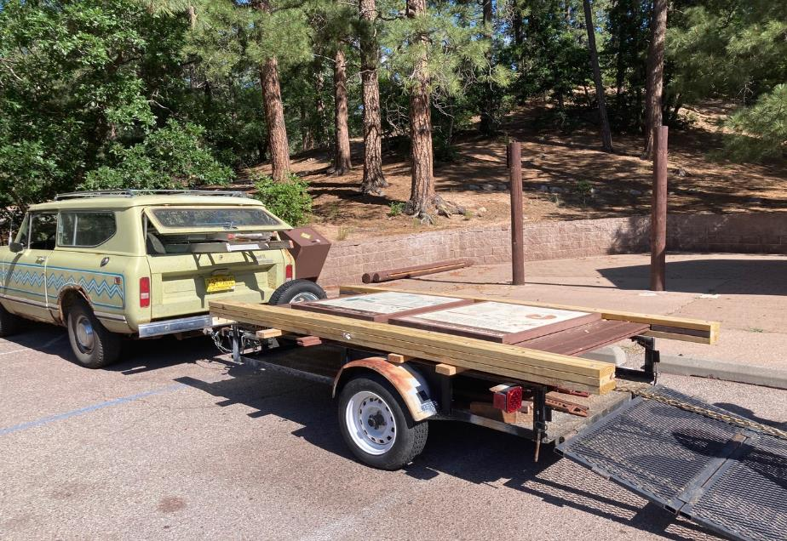

The new sign board with four steel-framed panels was designed and fabricated by Don Carnicom. On Wednesday morning,   
Don hauled it to the first restroom in Doc Long Picnic Area. All photos by Cliff Giles

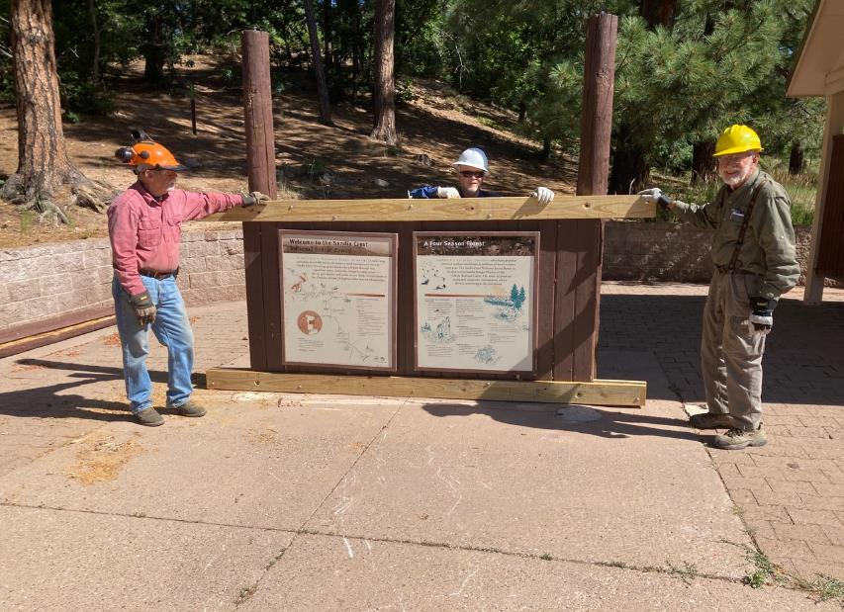

Six volunteers moved the sign from the trailer to the two posts that will eventually support it. Don installed two large lag screws in the top

2x6s and posts to support the sign until he can organize a crew to lift the sign 3 feet and bolt it to the posts. L to R: Jerry Carroll, Jamey Browning,

and Sam Beard.