Report of FOSM Crew Painting Boards and Kiosks at Horse Trailer Parking Lot,

in Sulphur Canyon Picnic Area, and in Cienega Canyon Picnic Area

on Tuesday, August 15, 2023

Sam Beard

August 17, 2023

On Tuesday, August 15, Mike Madden, Gordon Eatman, and Sam Beard painted information boards, kiosks, and trash containers in Horse Trailer Parking Lot, Sulphur Canyon Picnic Area, and Cienega Canyon Picnic Area. The items painted in each site were (1) Horse Trailer Parking Lot: two large boards, two small boards, and one trash container; (2) Sulphur Canyon PA: one large kiosk; (3) Cienega Canyon PA: two large kiosks.

Photos are presented below.

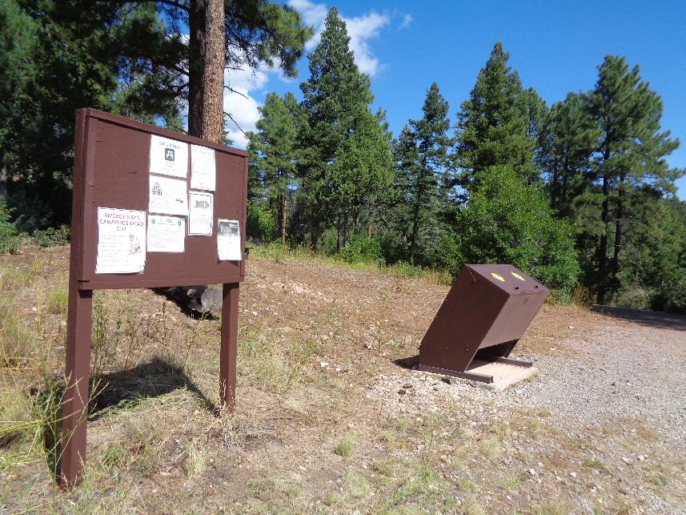

A large information board and trash container painted with USFS brown paint in the Horse Trailer Parking Lot. All photos by Sam Beard

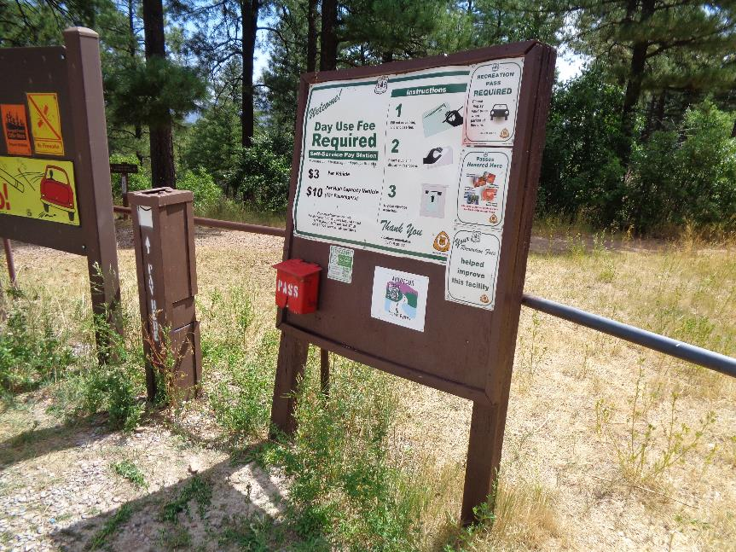

A second large board painted in the Horse Trailer Parking Lot.

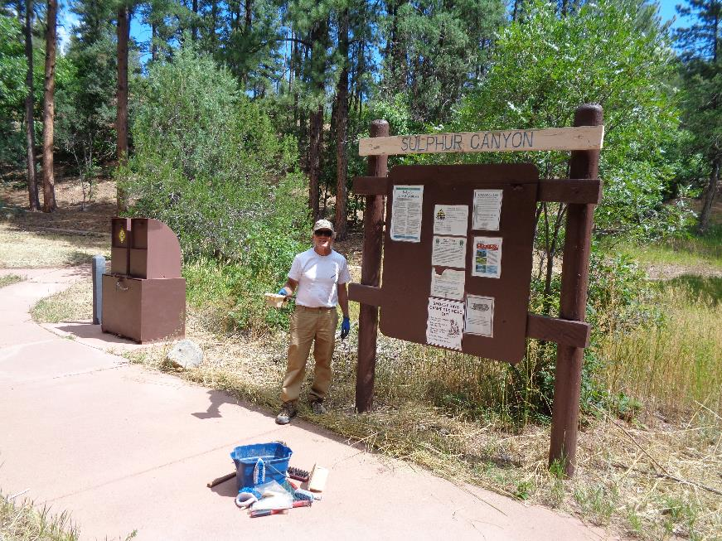

A kiosk painted in Sulphur Canyon Picnic Area.

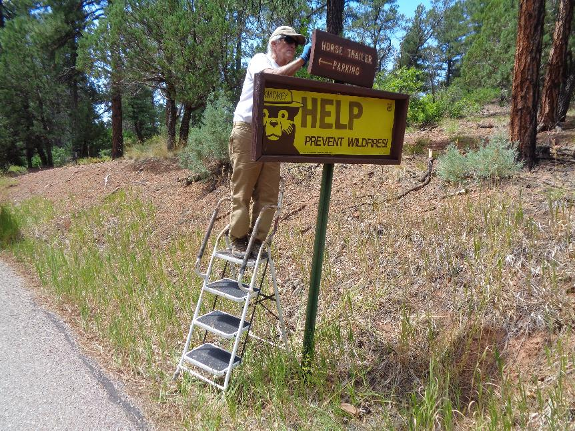

Mike is painting this sign on the road to Cienega PA.

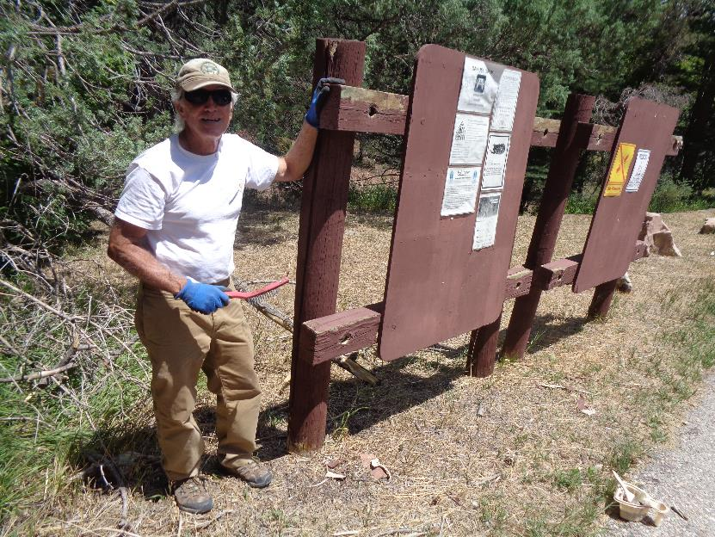

Two kiosks in Cienega PA that need paint. See the timber with the bare area at Mike’s left hand.

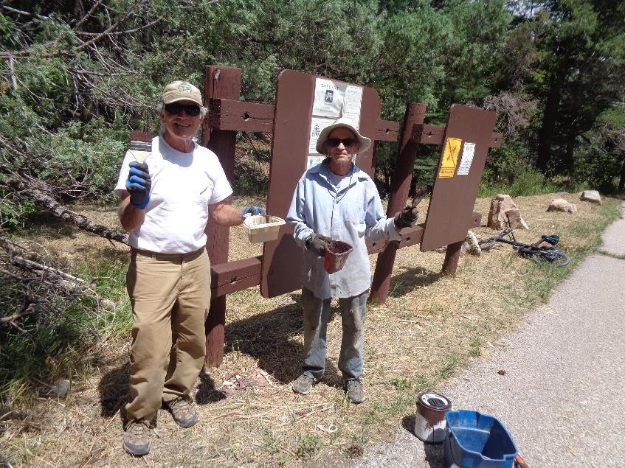

Mike and Gordon at the kiosks that have just been painted.

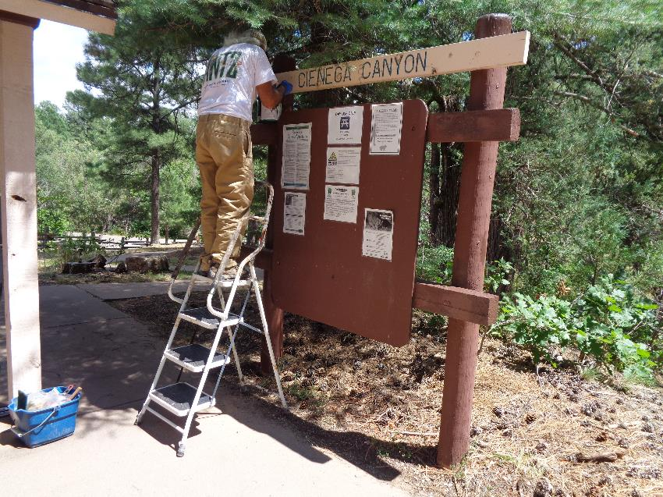

Mike painting a kiosk at the lowest restroom in Cienega PA.