**Report of FOSM Project to Haul Donation Wood from Nine Mile Picnic Area**

**to a New Woodlot Located South of Frost Road on Wednesday, August 16, 2023**

Sam Beard

August 17

On Wednesday, August 16, a total of eight FOSM members and three church members completed the project to haul a very large pile of fire wood from the old highway at Nine Mile Picnic Area to the new woodlot for the Mountain Christian Church Wood Ministry. This woodlot is located at the home of Michael Oliver, the present leader of the Wood Ministry program to donate fire wood to families who need it in the East Mountain area. We enjoyed working with church members again as we did many years ago when FOSM started processing wood that was donated by the Sandia Ranger District. Lou Romero made the arrangements with Michael to use his trailer and have other church members to help load and unload the wood. This joint effort was very successful in that we were able to haul a large volume of wood in one day.

On Wednesday, we moved two loads with a 16-foot-long trailer and 4 loads with pickups. The new woodlot is located on Rider Road that is south of Frost Road that leads east from the intersection of NM-14 and NM-536 at the Triangle.

Project photos are presented below.

The FOSM volunteers working on Wednesday were Cliff Giles, Sam Beard, Dan Benton, Eric Russell, Jerry Carroll, Don Carnicom, Lou Romero, and Jamey Browning. The church members working on the project were David Radloff, Daniel Kuehn, and Michael Oliver.

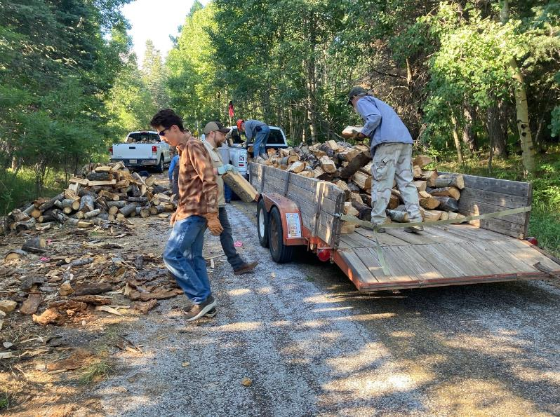

Loading the 16-foot trailer on the old highway near Nine Mile Picnic Area. All photos by Cliff Giles.

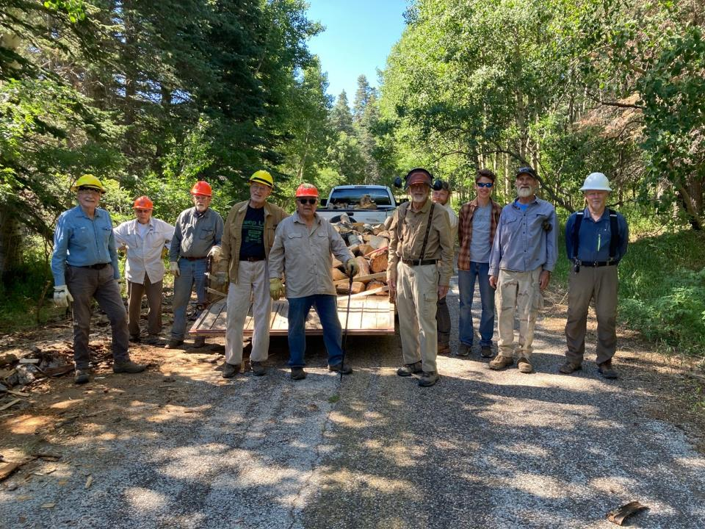

The FOSM crew members were left to right: Eric Russell, Don Carnicom, Jerry Carroll, Dan Benton,

Lou Romero, Sam Beard, and Jamey Browning (at the right side of the group). Michael Oliver is the gentleman with the beard

beside Jamey, and two church members are between Sam and Michael.

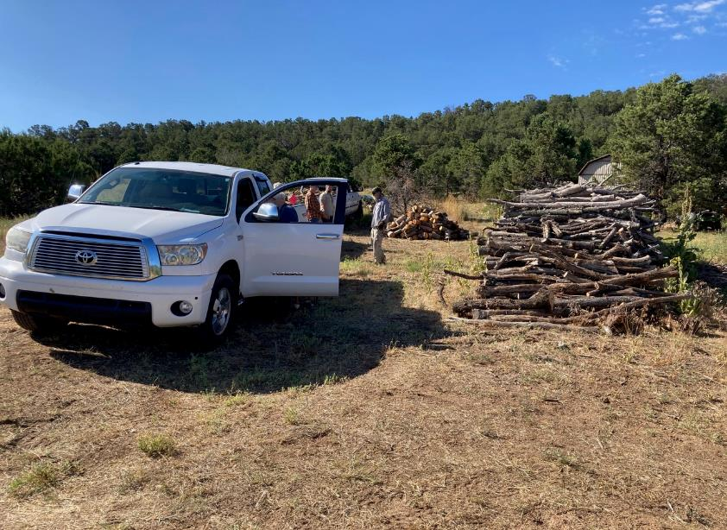

Jamey’s pickup at the woodlot at the residence of Michael Oliver.

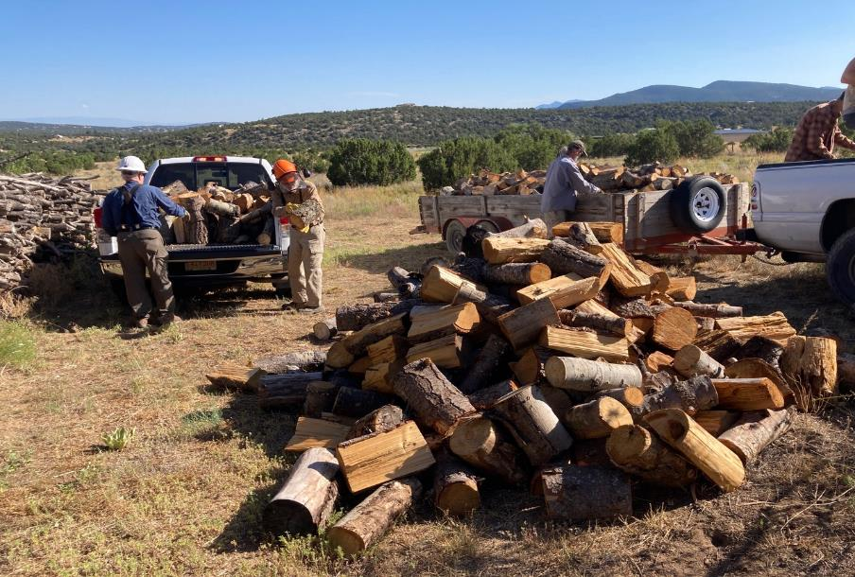

L to R: Jamey and Sam are unloading Jamey’s pickup, and Michael is unloading the long traier.

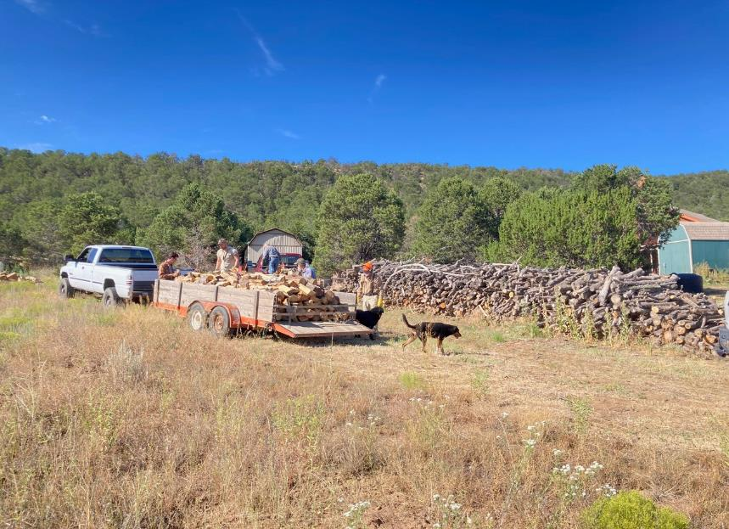

Michael’s pickup and trailer at the woodlot. To the right of the trailer is a very large pile of small diameter firewood.

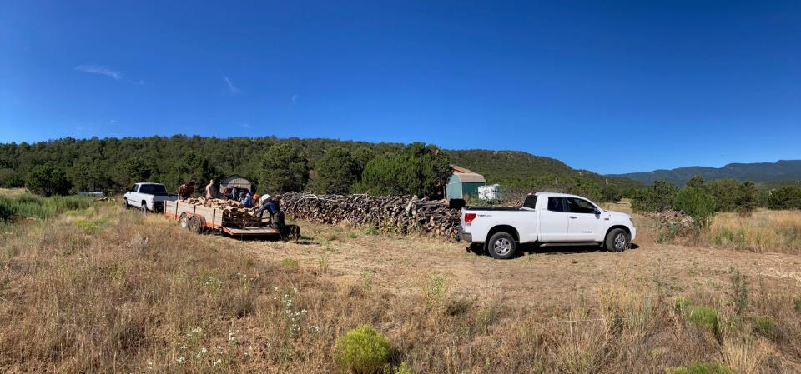

This panoramic photograph shows that the woodlot is in an East Mountain rural area.

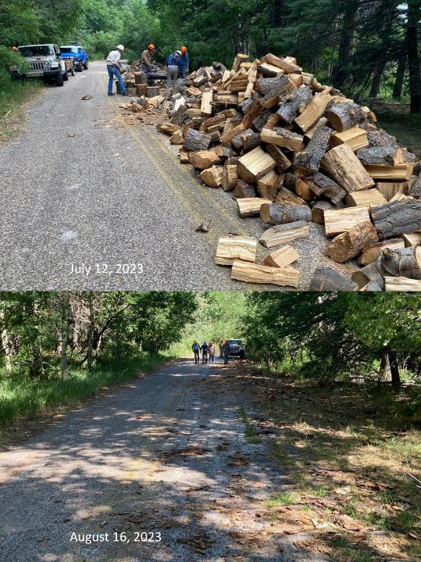

These before-and-after photographs show that some very large piles of firewood were

hauled from this site adjacent to Nine Mile Picnic Area between July 12 and August 16.