**Report of FOSM Project to Limb and Buck Logs in Cienega Picnic Area on Wednesday, August 9, in Preparation for Splitting and Hauling These Logs Later as Donation Wood**

Sam Beard

On Wednesday, August 9, eight FOSM volunteers limbed and partially bucked four logs already on the ground in Cienega Picnic Area in preparation for bucking these logs to a length of 12 inches, splitting them, and hauling this donation wood to a Mountain Christian Church Wood Ministry woodlot later. The 6-foot-long log sections were moved down to Acequia Trail so they would be closer to the splitter site.

This first task was completed early, and Lou Romero suggested hauling two pickup loads of split wood from the piles on the old highway at Nine Mile Picnic Area. After lunch at Doc Long Picnic Area, the two loads of fire wood were delivered to one of the wood ministry woodlots. FOSM thanks Jerry Carroll and Jamey Browning for hauling the wood in their pickups.

The volunteers working on this project were Lou Romero, Dan Benton, Jerry Carroll, Jamey Browning, Cliff Giles, Sam Beard, Steve Roholt, and Eric Russell.

Photos are presented below.

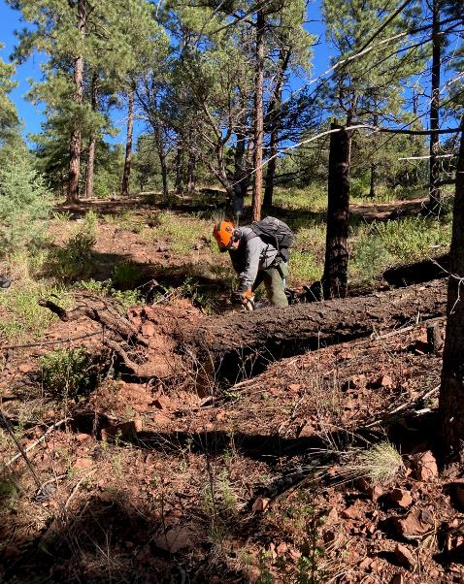

Jerry Carrell beginning to buck a log with a root ball that had blown over. All photos by Cliff Giles

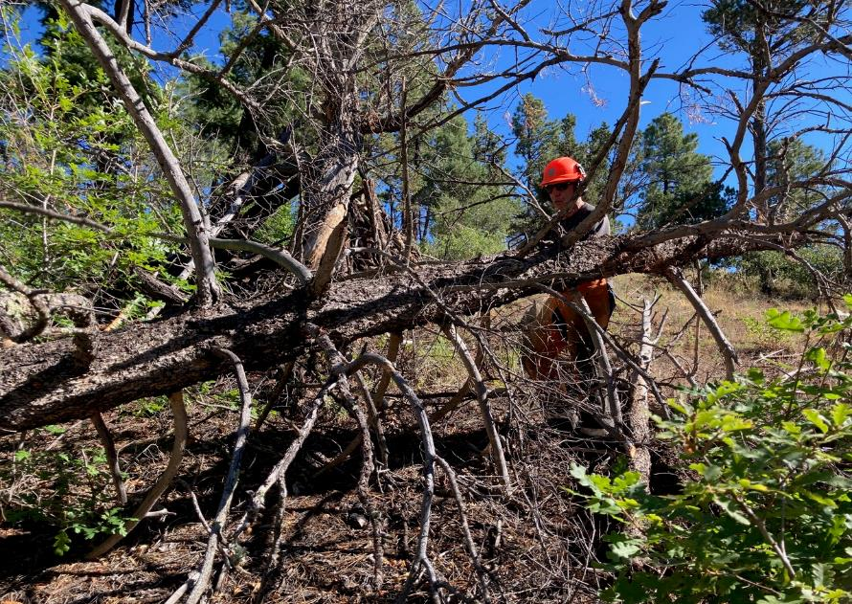

Steve Roholt using the FOSM battery-powered chain saw to limb the first log.

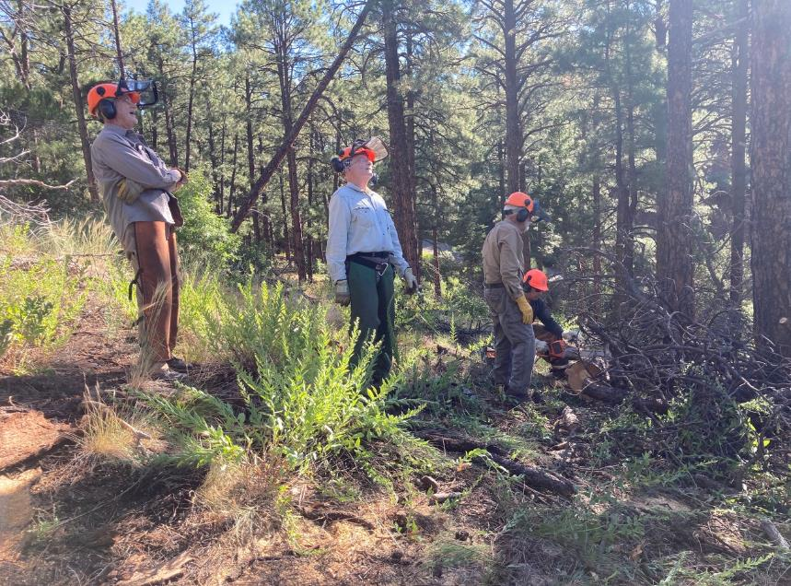

Steve making the last cut on the small end of a log with Dan Benton, Eric Russell, and Sam Beard observing.

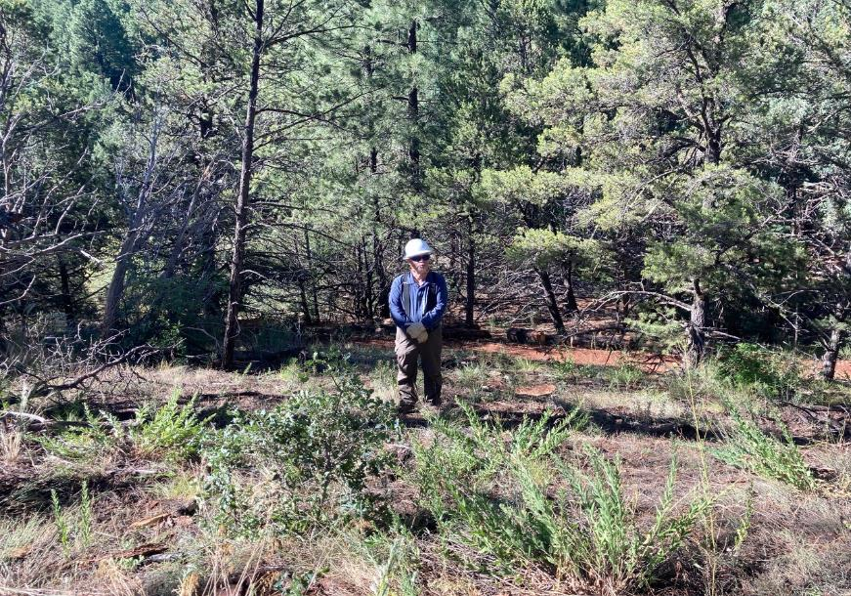

Jamey Browning was a lookout on Acequia Trail for visitors. The bucked logs were rolled down the hill to this trail

where the splitter will be later.

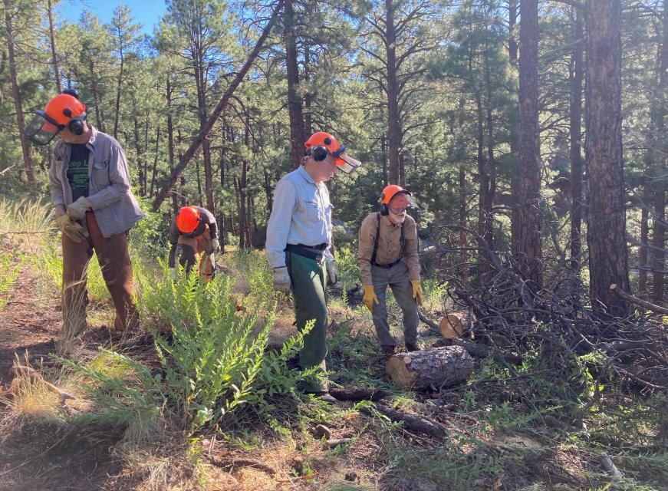

Sam Beard preparing to roll a short log down to Acequia Trail.

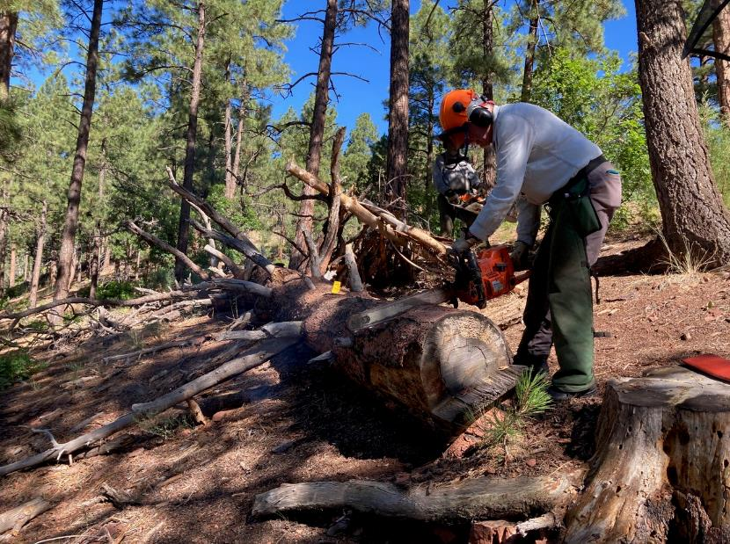

After completing the bucking of the smaller logs, the crew moved to this 24-inch log that Dan felled

several years ago. Eric is cutting off the end of the log so the quality of the wood can be evaluated.

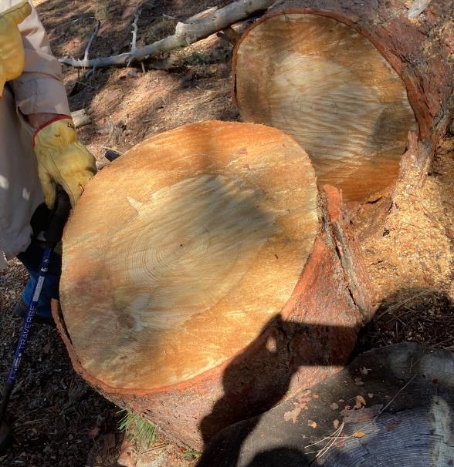

The outer wood is partially decayed, but the center wood is sound. The decision was made

to limb this log in preparation for bucking and splitting it later.

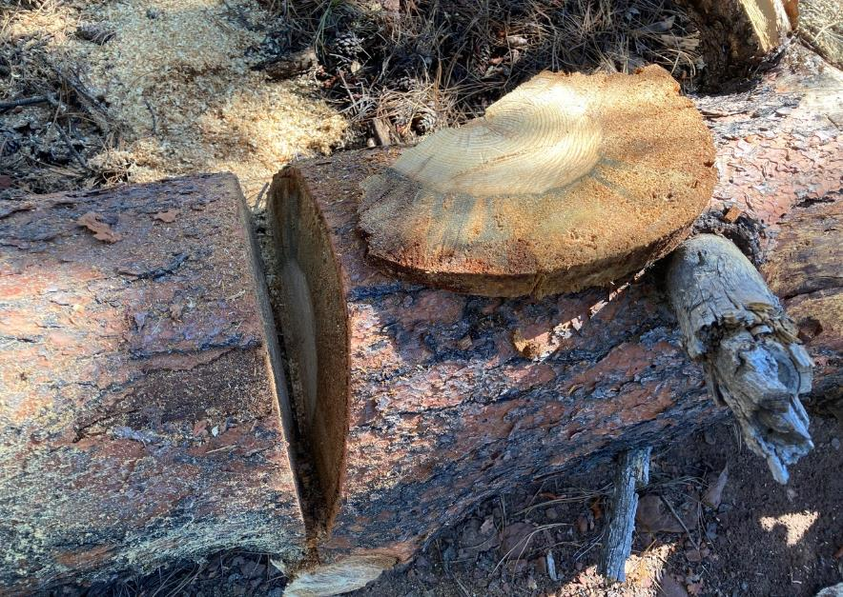

At another location on the log, the same partial decay and sound wood were found.

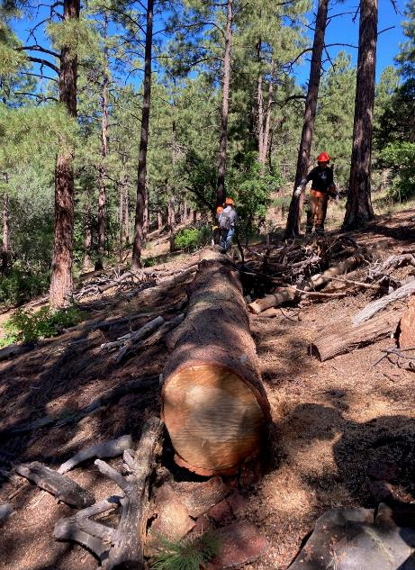

This large, long log was limbed and will be bucked later.

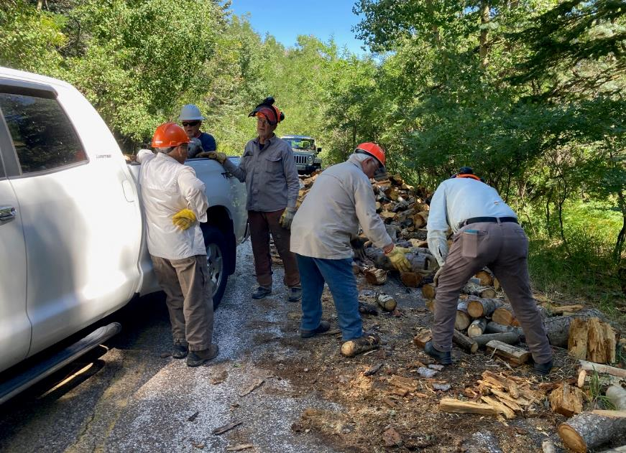

Loading Jamey’s pickup with split wood at Nine Mile Picnic Area.

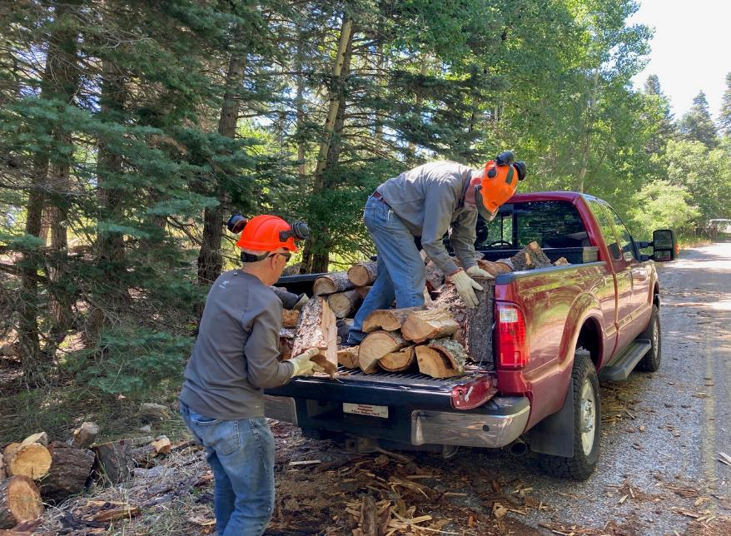

Loading Jerry’s pickup with split wood.

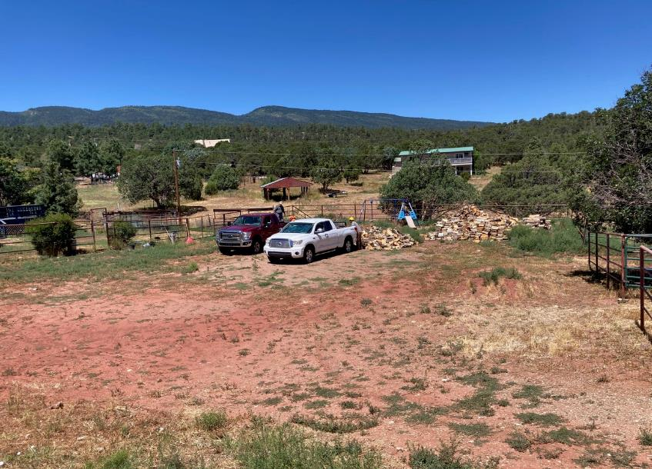

Unloading the wood in a church woodlot. Lou reported that all the wood in this woodlot was donated by the Sandia

Ranger District and processed and hauled by FOSM volunteers.

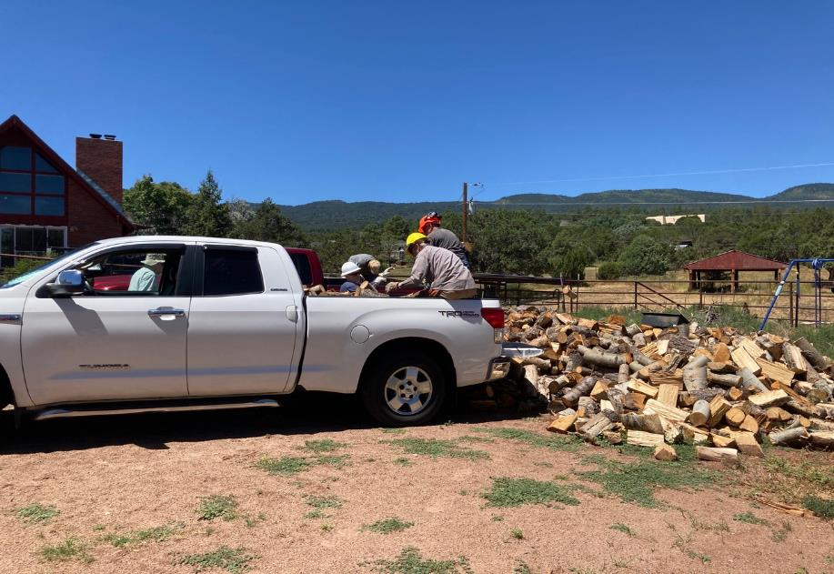

Unloading Jamey’s pickup.

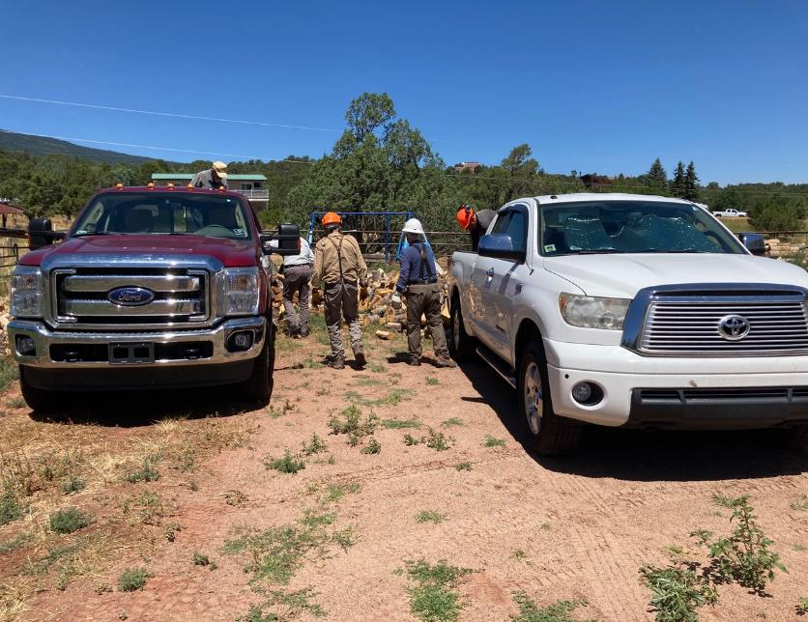

Both pickups being unloaded.