Trail Report: Monday, August 21, 2023
Byron Garner
On August 21 the Monday trail crew hiked 10K-N to the Osha Junction to remove a somewhat poorly supported ten inch leaner reported by John Cooper and Ken Smith. With a strategically placed rope and a tug team effort, the tree was down and bucked to clear the trail. Continuing on 10 K, we arrived at the main event to reassess, from a previous effort, a large Aspen (12"+) laying across the trail at shoulder height just south of Survey Trail which had been menacing trail users for some time. This tree still had a large and very much alive crown with a complex set of binds supported off the ground by three other trees a large root ball and the crown. Multiple escape routes had to be cleared of saplings and heavy debris before limbing and the strategic release of the binds could begin in order to lower the still very wet and heavy trunk for cutting and the final clearing of the trail. With a full team effort and three cuts later, the trail was once again clear and it was "Miller Time". After a restful lunch in the cool shade and a few moments to savor the results of our effort, we continued on with a return via Survey Trail . Our work also included clearing various intrusions, on the ground and elevated, and the removal of an unreported leaner. It was a great day to be on the trail with temperatures comfortably moderated by the continual drift of the clouds. The crew included Jamey Browning, John Cooper, Jerry Pekerak, Dave McCreery, Ken Wilson and Bill Perkins. Photo and trail note credit: Jamey Browning

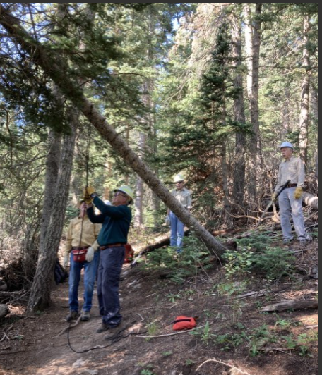
Dave leads the way and lassos our tree

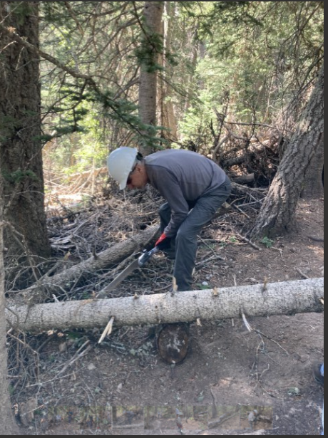
Ken finishes the job

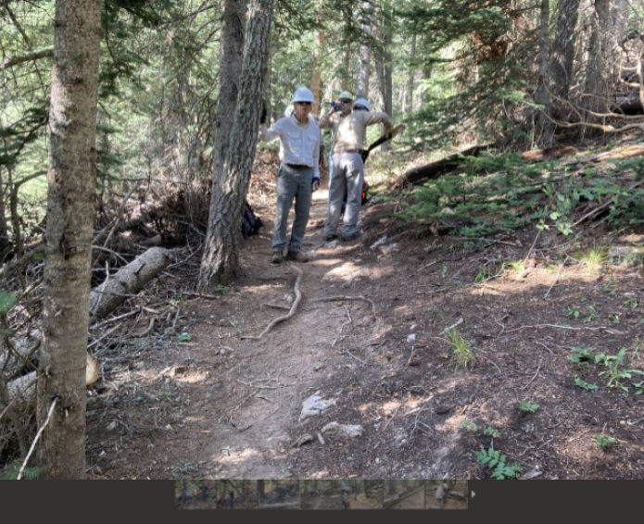
Clear and good to go

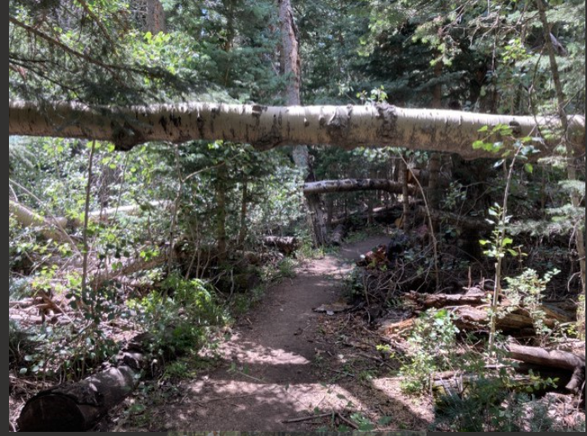
The challenge

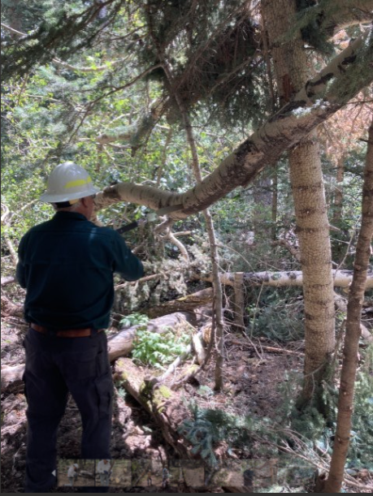

Dave ponders the possibilities

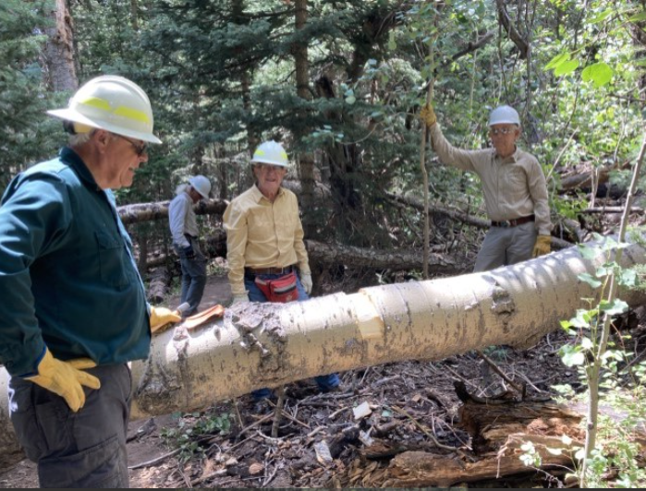

Well, where do we go from here?

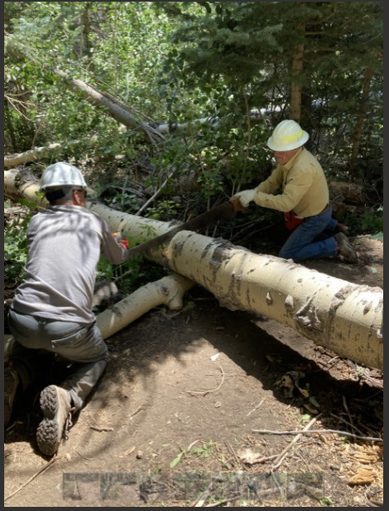
Jerry and Ken on the last lap

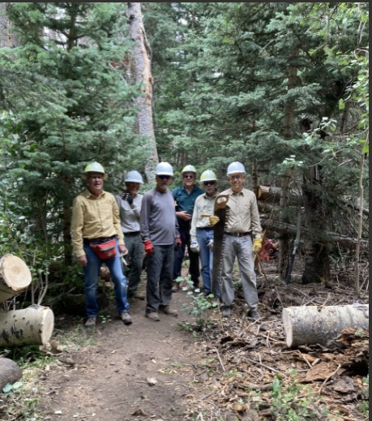
A job well done

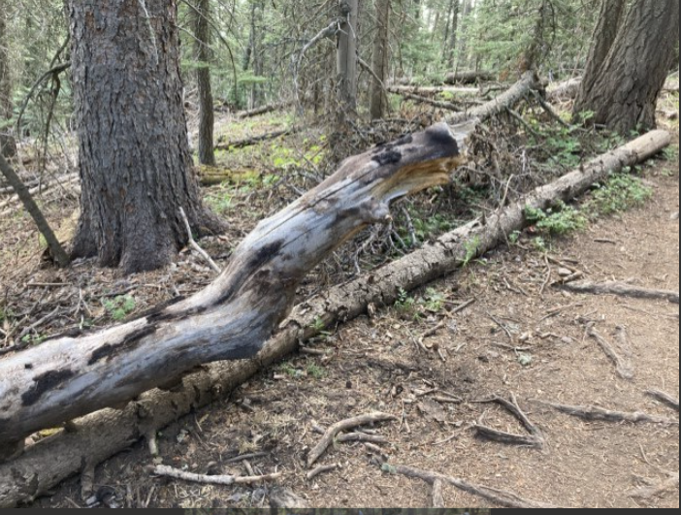
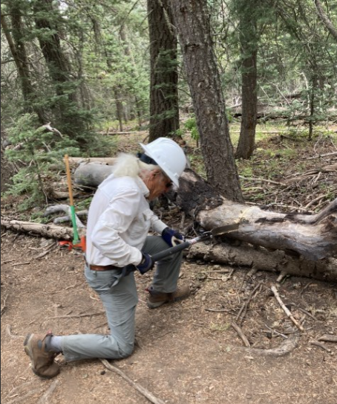
Bill clears the nasty spike
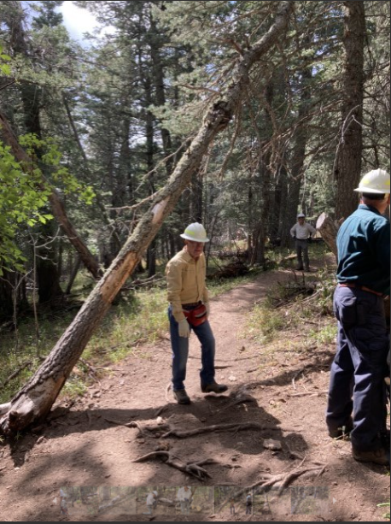
The unreported leaner
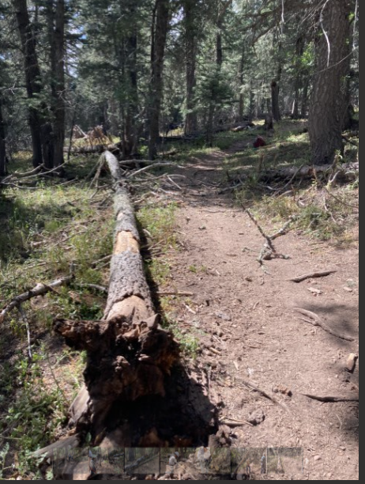
Fortunate line of fall

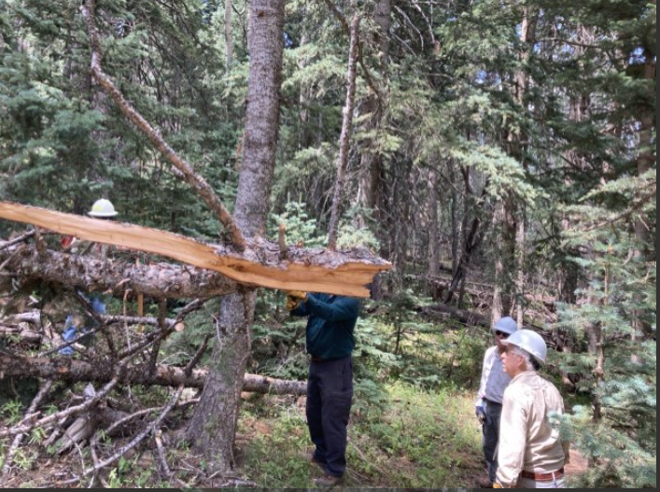
One last effort

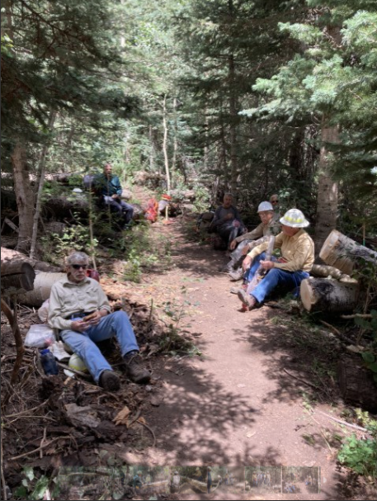
Life as it should be

