**Report of Touch Up Painting CCC Picnic Shelter at Doc Long Picnic Area and Balsam Glade Shelter on Tuesday, August 29, 2023**

Sam Beard

On Tuesday, August 29, five FOSM volunteers completed touch up painting of the CCC picnic shelter in Doc Long PA and the large shelter in Balsam Glade PA.

The volunteers working on this project were Pauline Ho, Rick Buss, Mike Madden, Gordon Eatman, and Sam Beard.

Project photos are presented below.

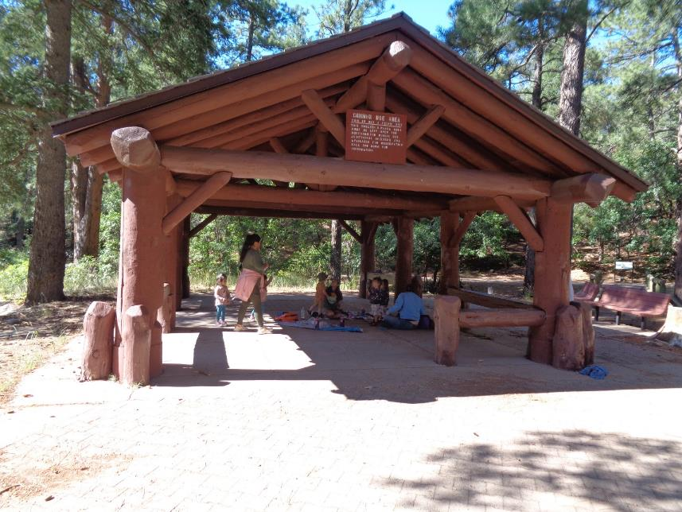

Some early morning visitors in the CCC shelter in Doc Long Picnic Area. All photos by Sam Beard

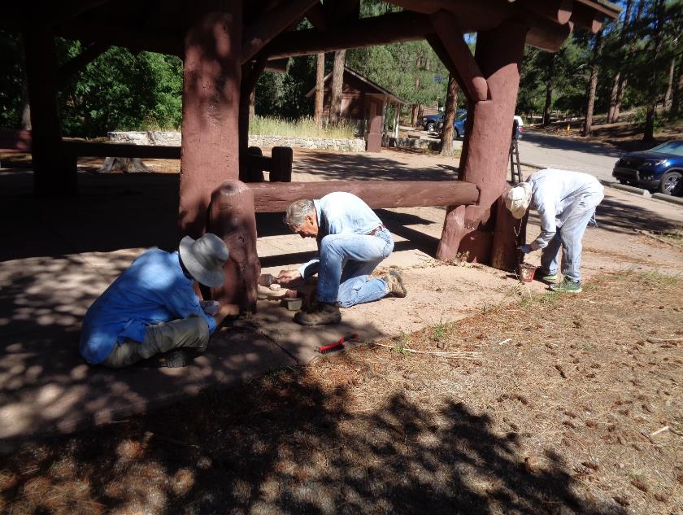

L to R: Pauline Ho, Rick Buss, and Gordon Eatman touch up painting the CCC shelter.

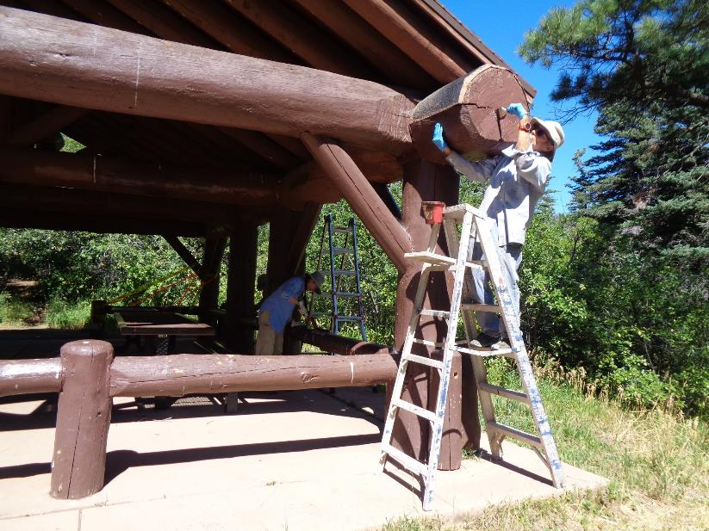

Pauline removing loose paint on a beam in the Balsam Glade picnic shelter and Gordon painting the end of a large beam.

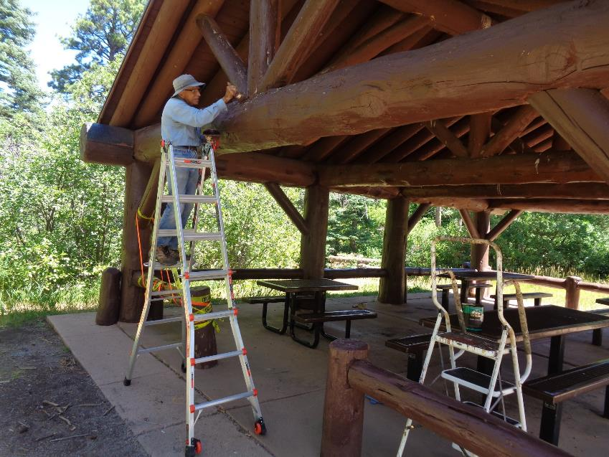

Rick painting a high large beam.

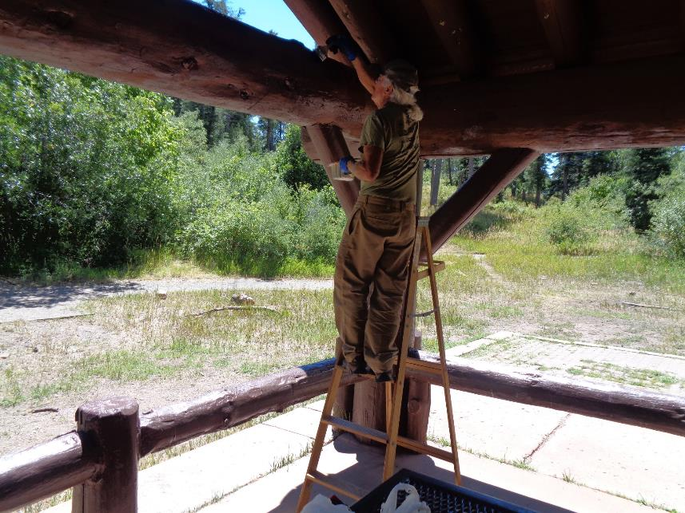

Mike Madden painting a large high beam.

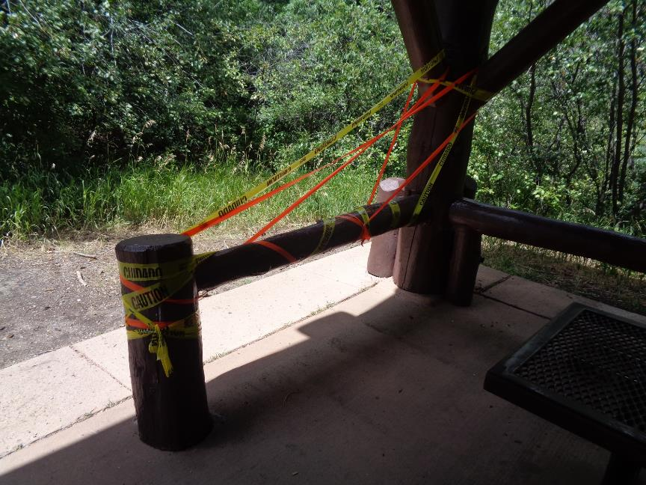

A decayed 12-inch post and beam in the Balsam Glade picnic shelter.